Bats!
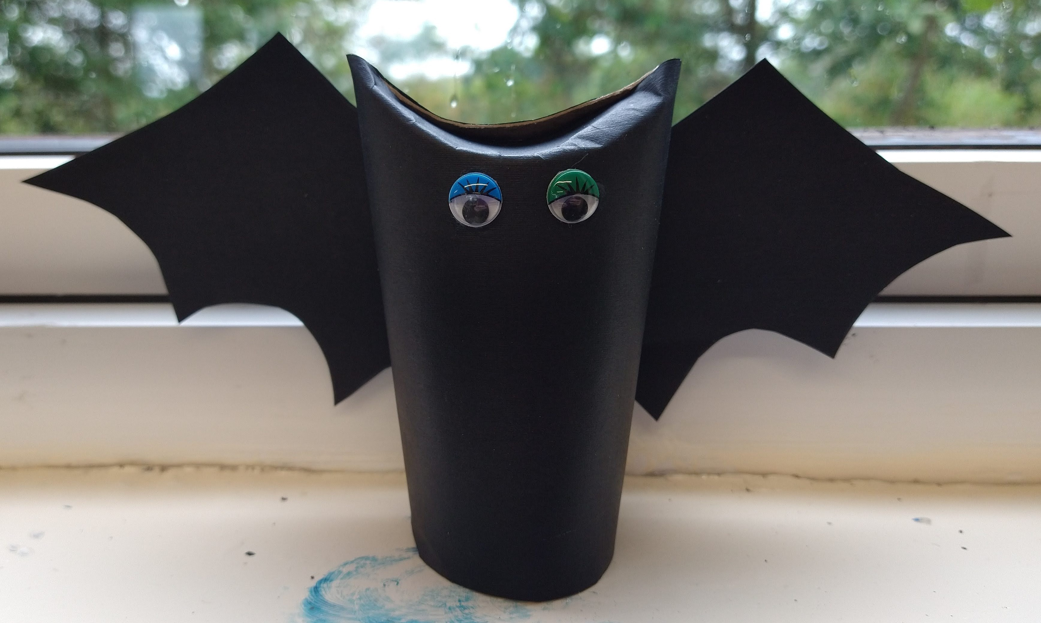
Here's a post showing you how to make your own bat.
You will need:
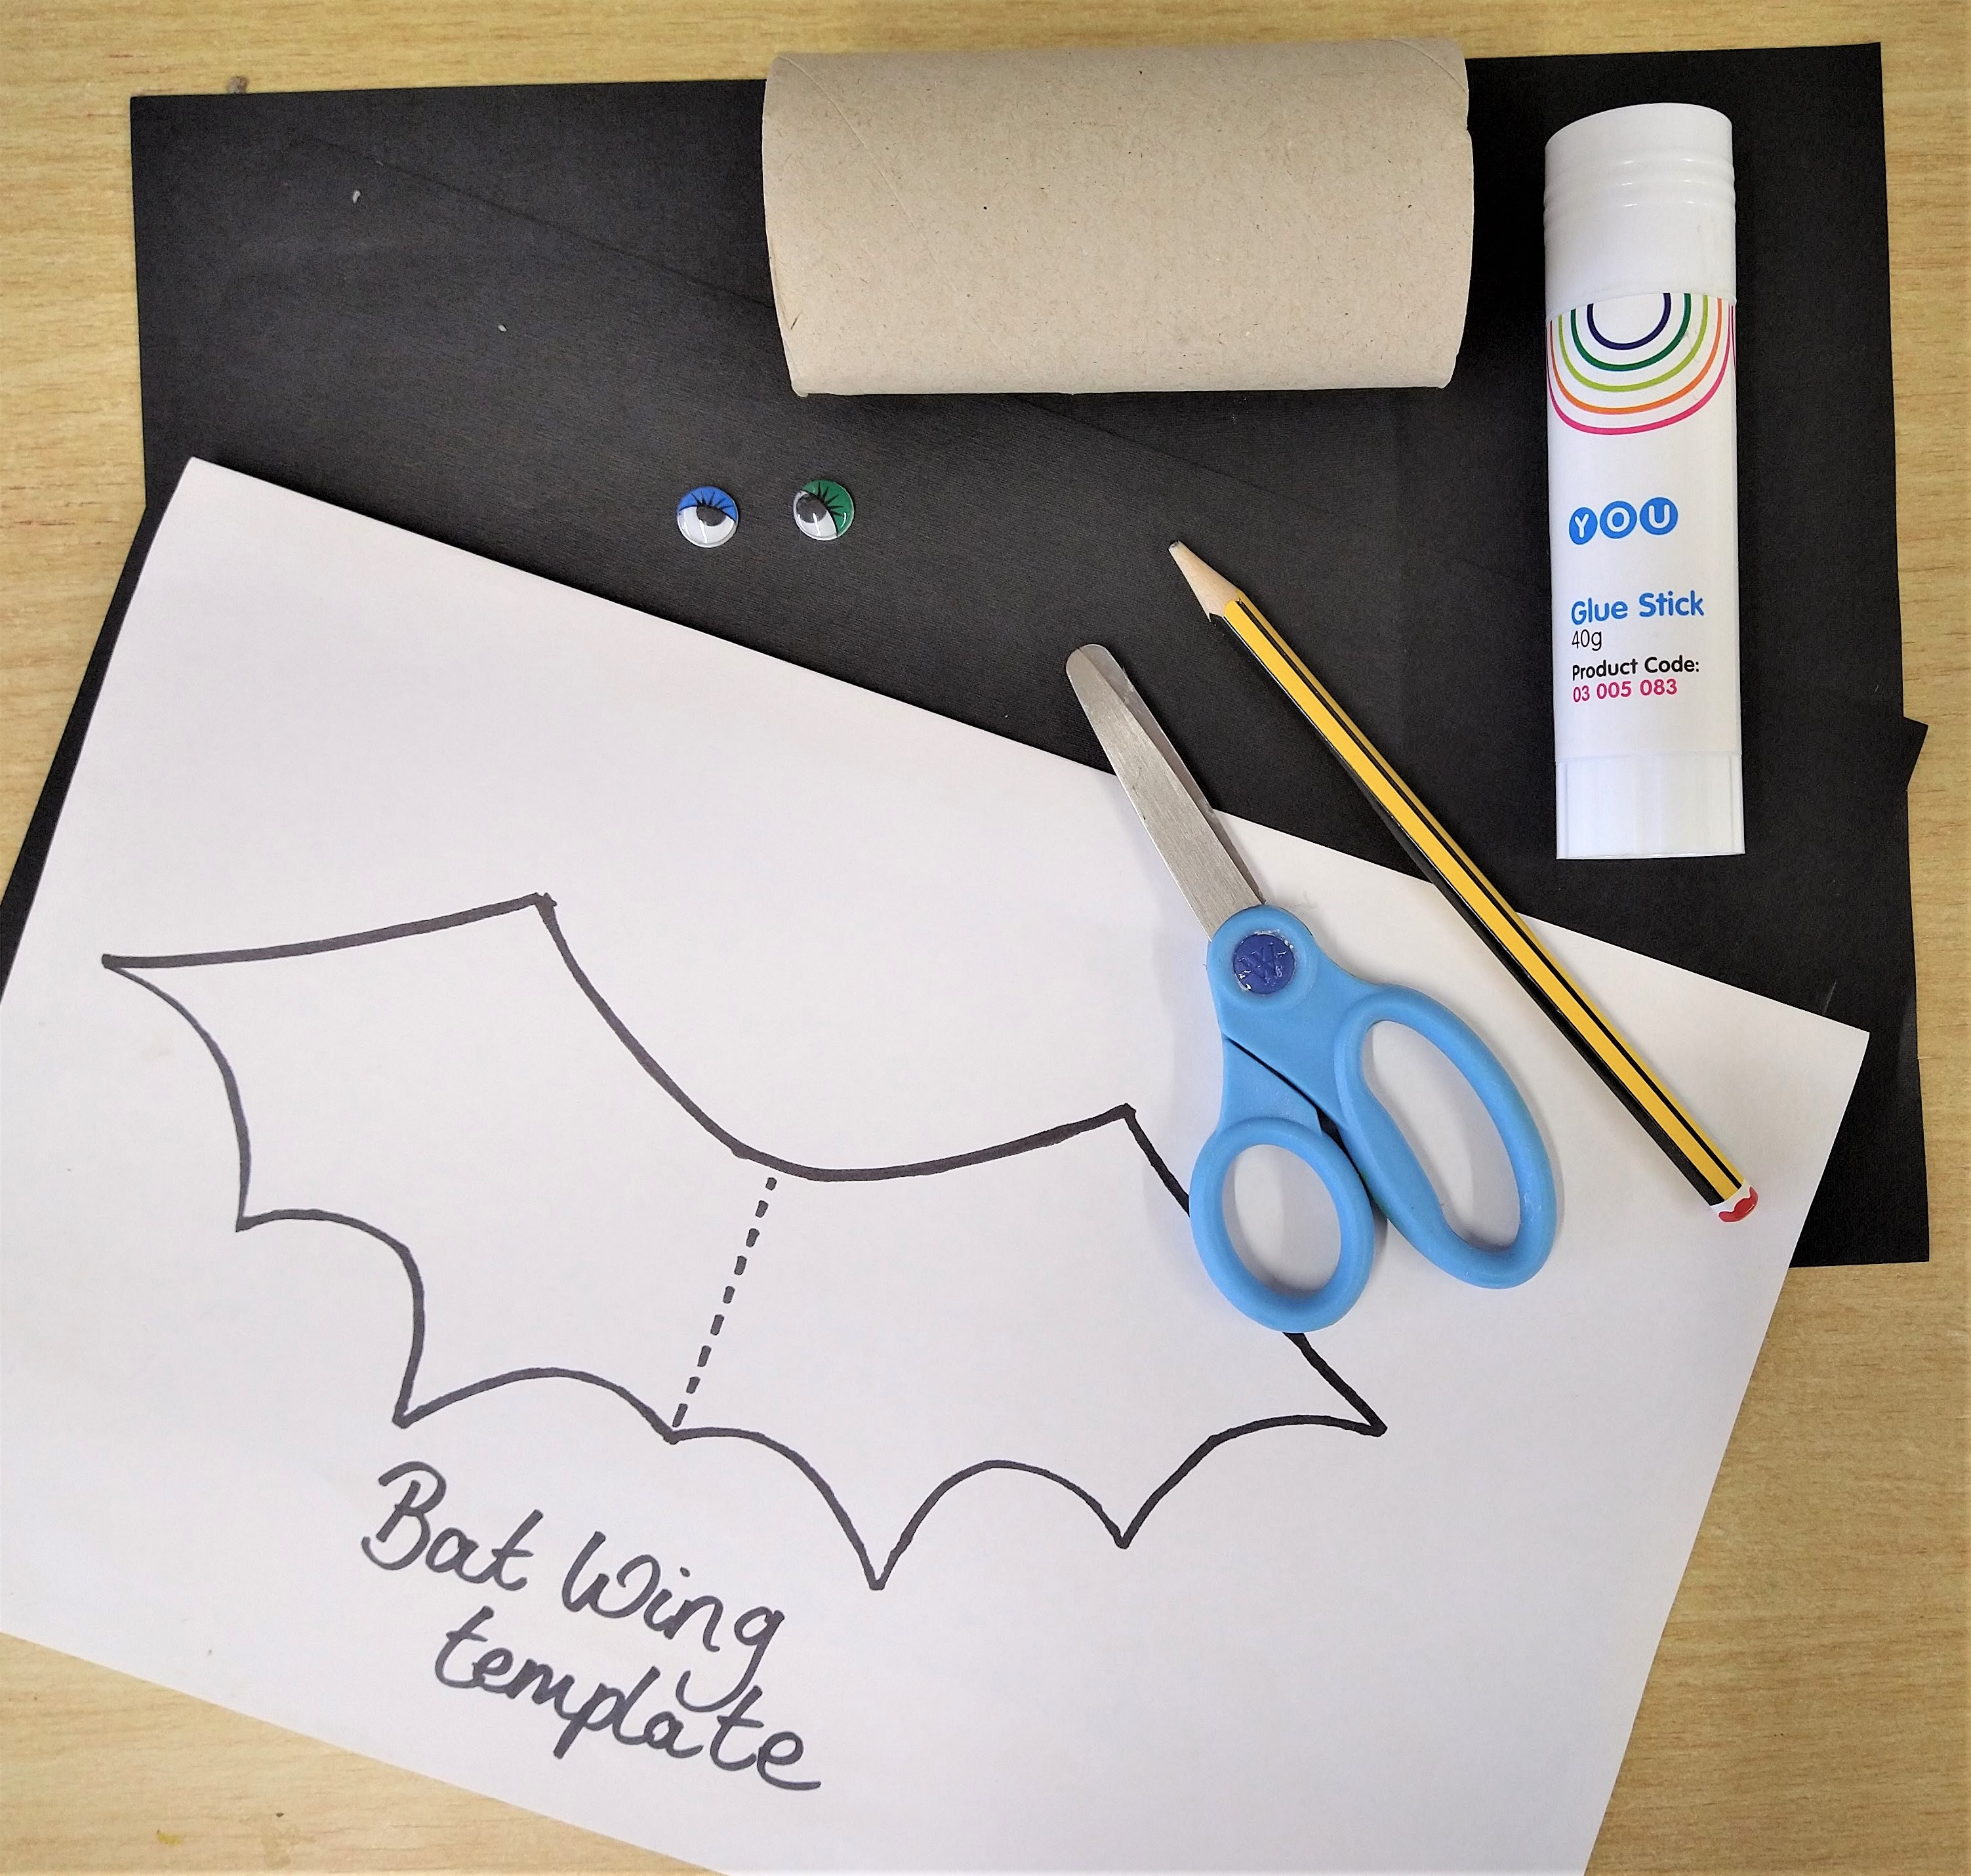
- Cardboard tube (such as a toilet roll inner)
- Black paper (we used 2 x A4 sheets)
- Glue (glue-stick is best but PVA is fine)
- Pencil
- Scissors
- Wiggly Eyes
Step 1.
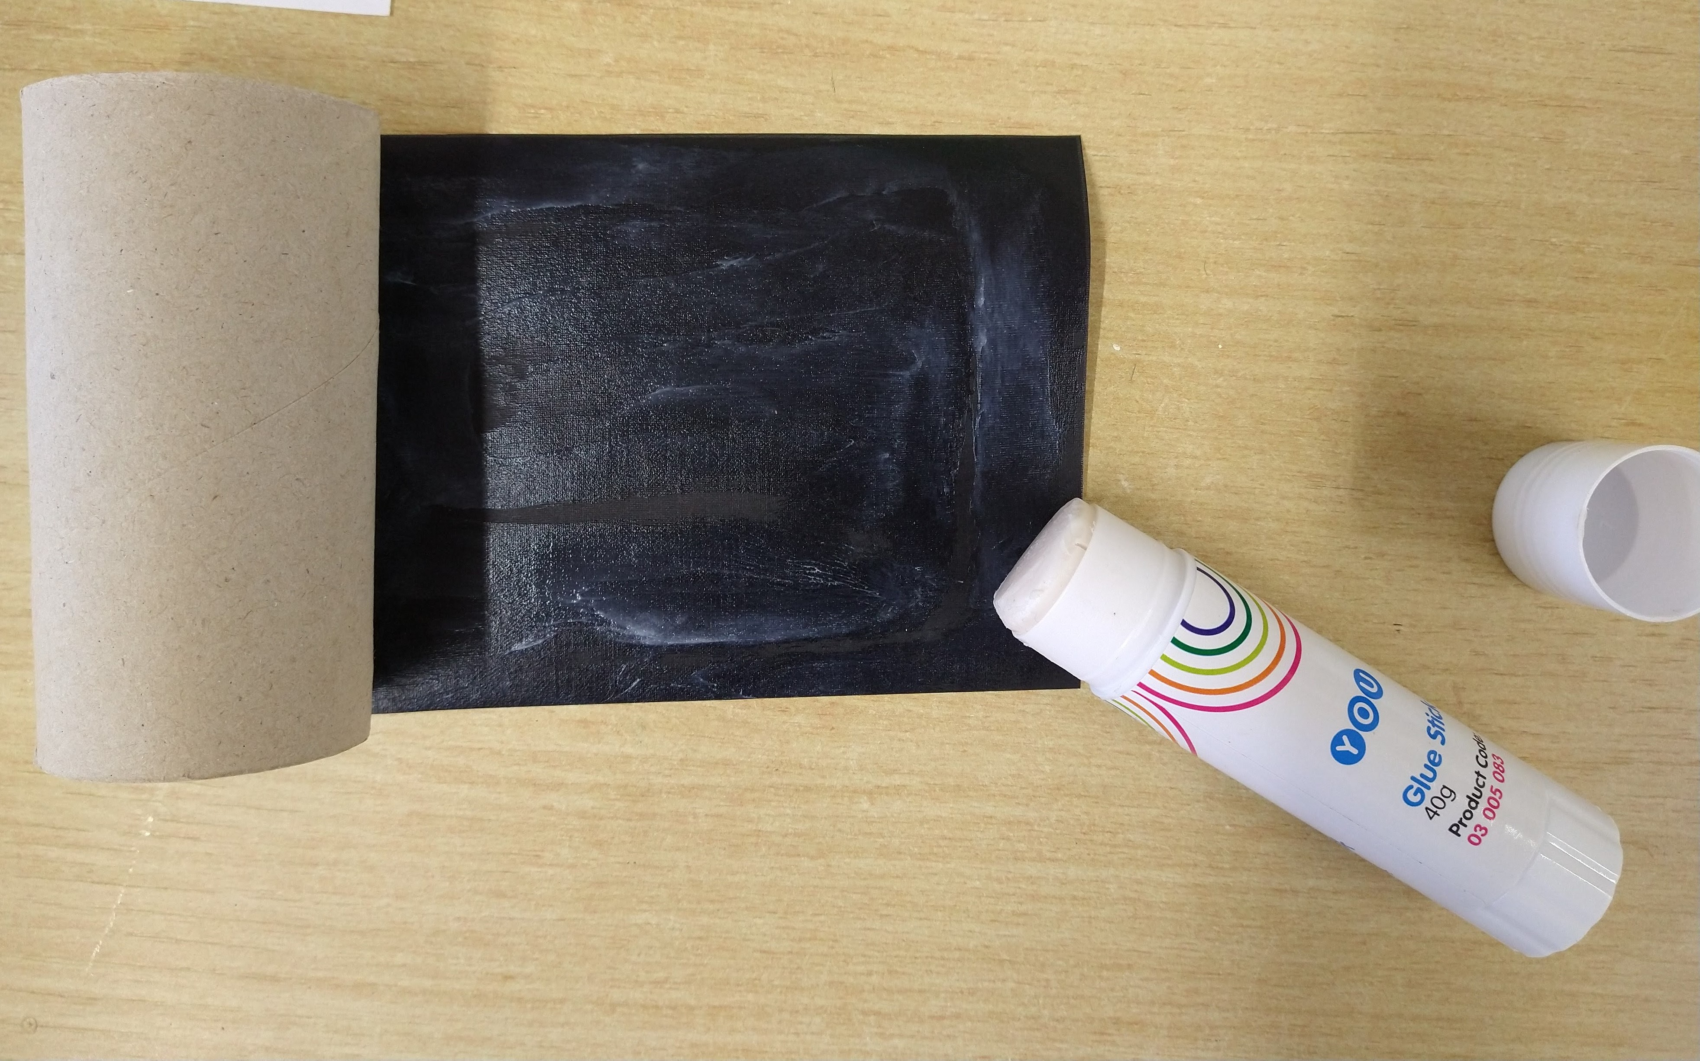
Cover your cardboard tube with black paper. If you prefer you could paint or colour it in.
Step 2.
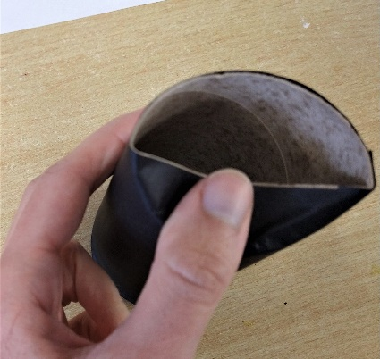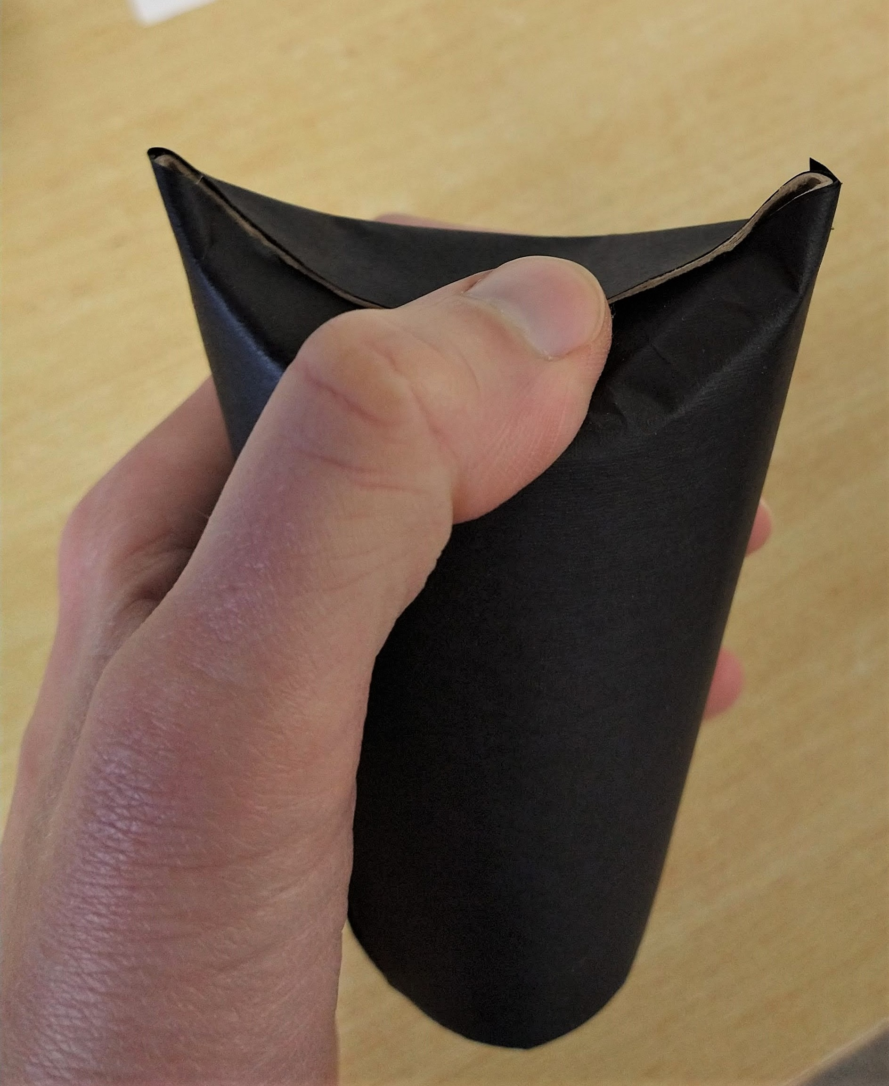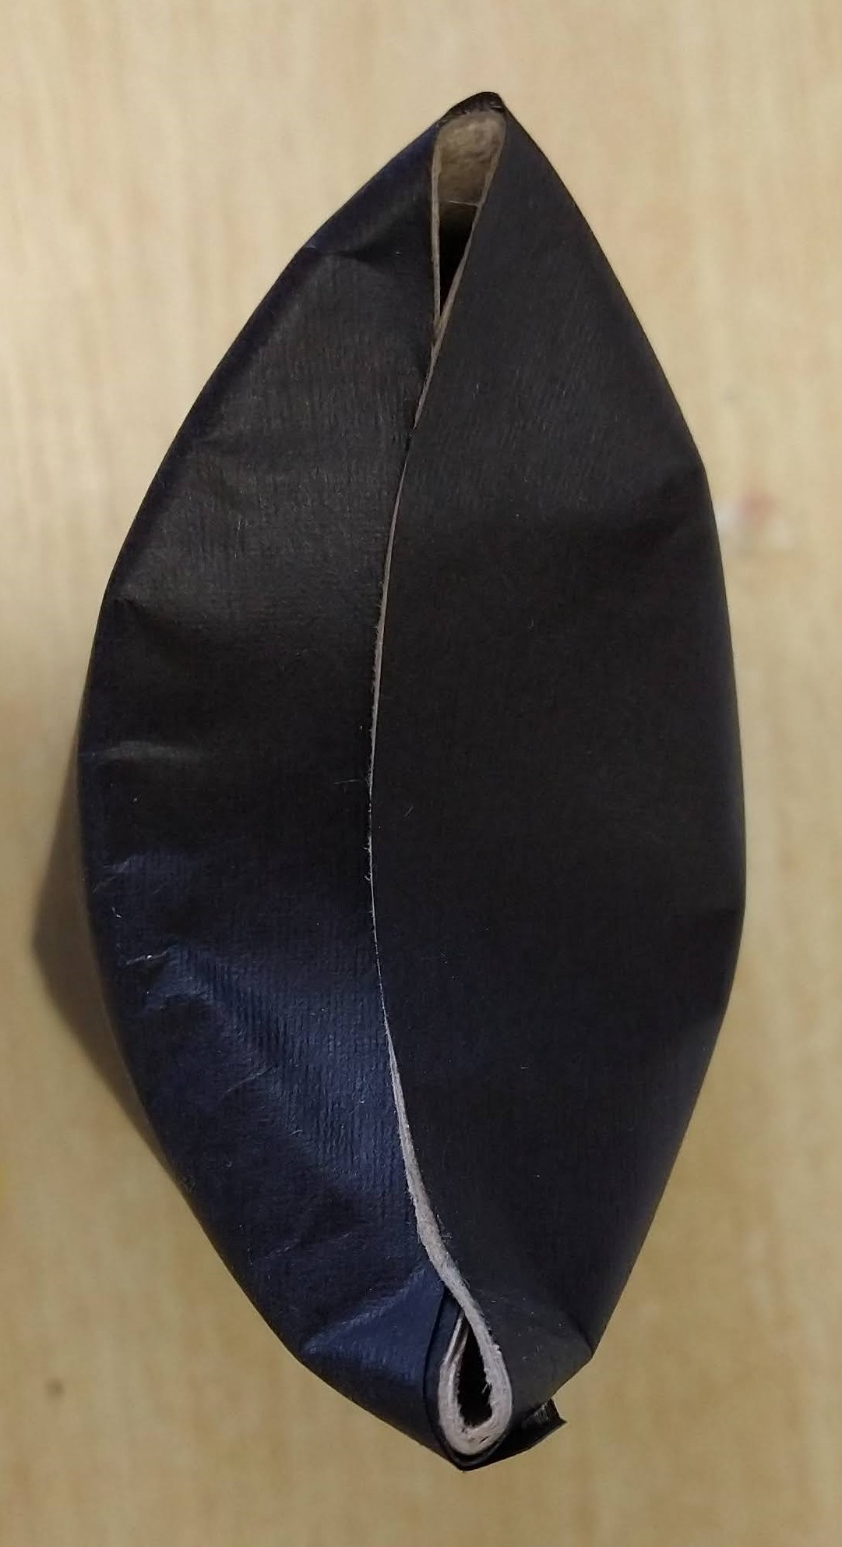
Squash one of the ends in on itself to make your bats ears, use our pictures as a guide.
Step 3.
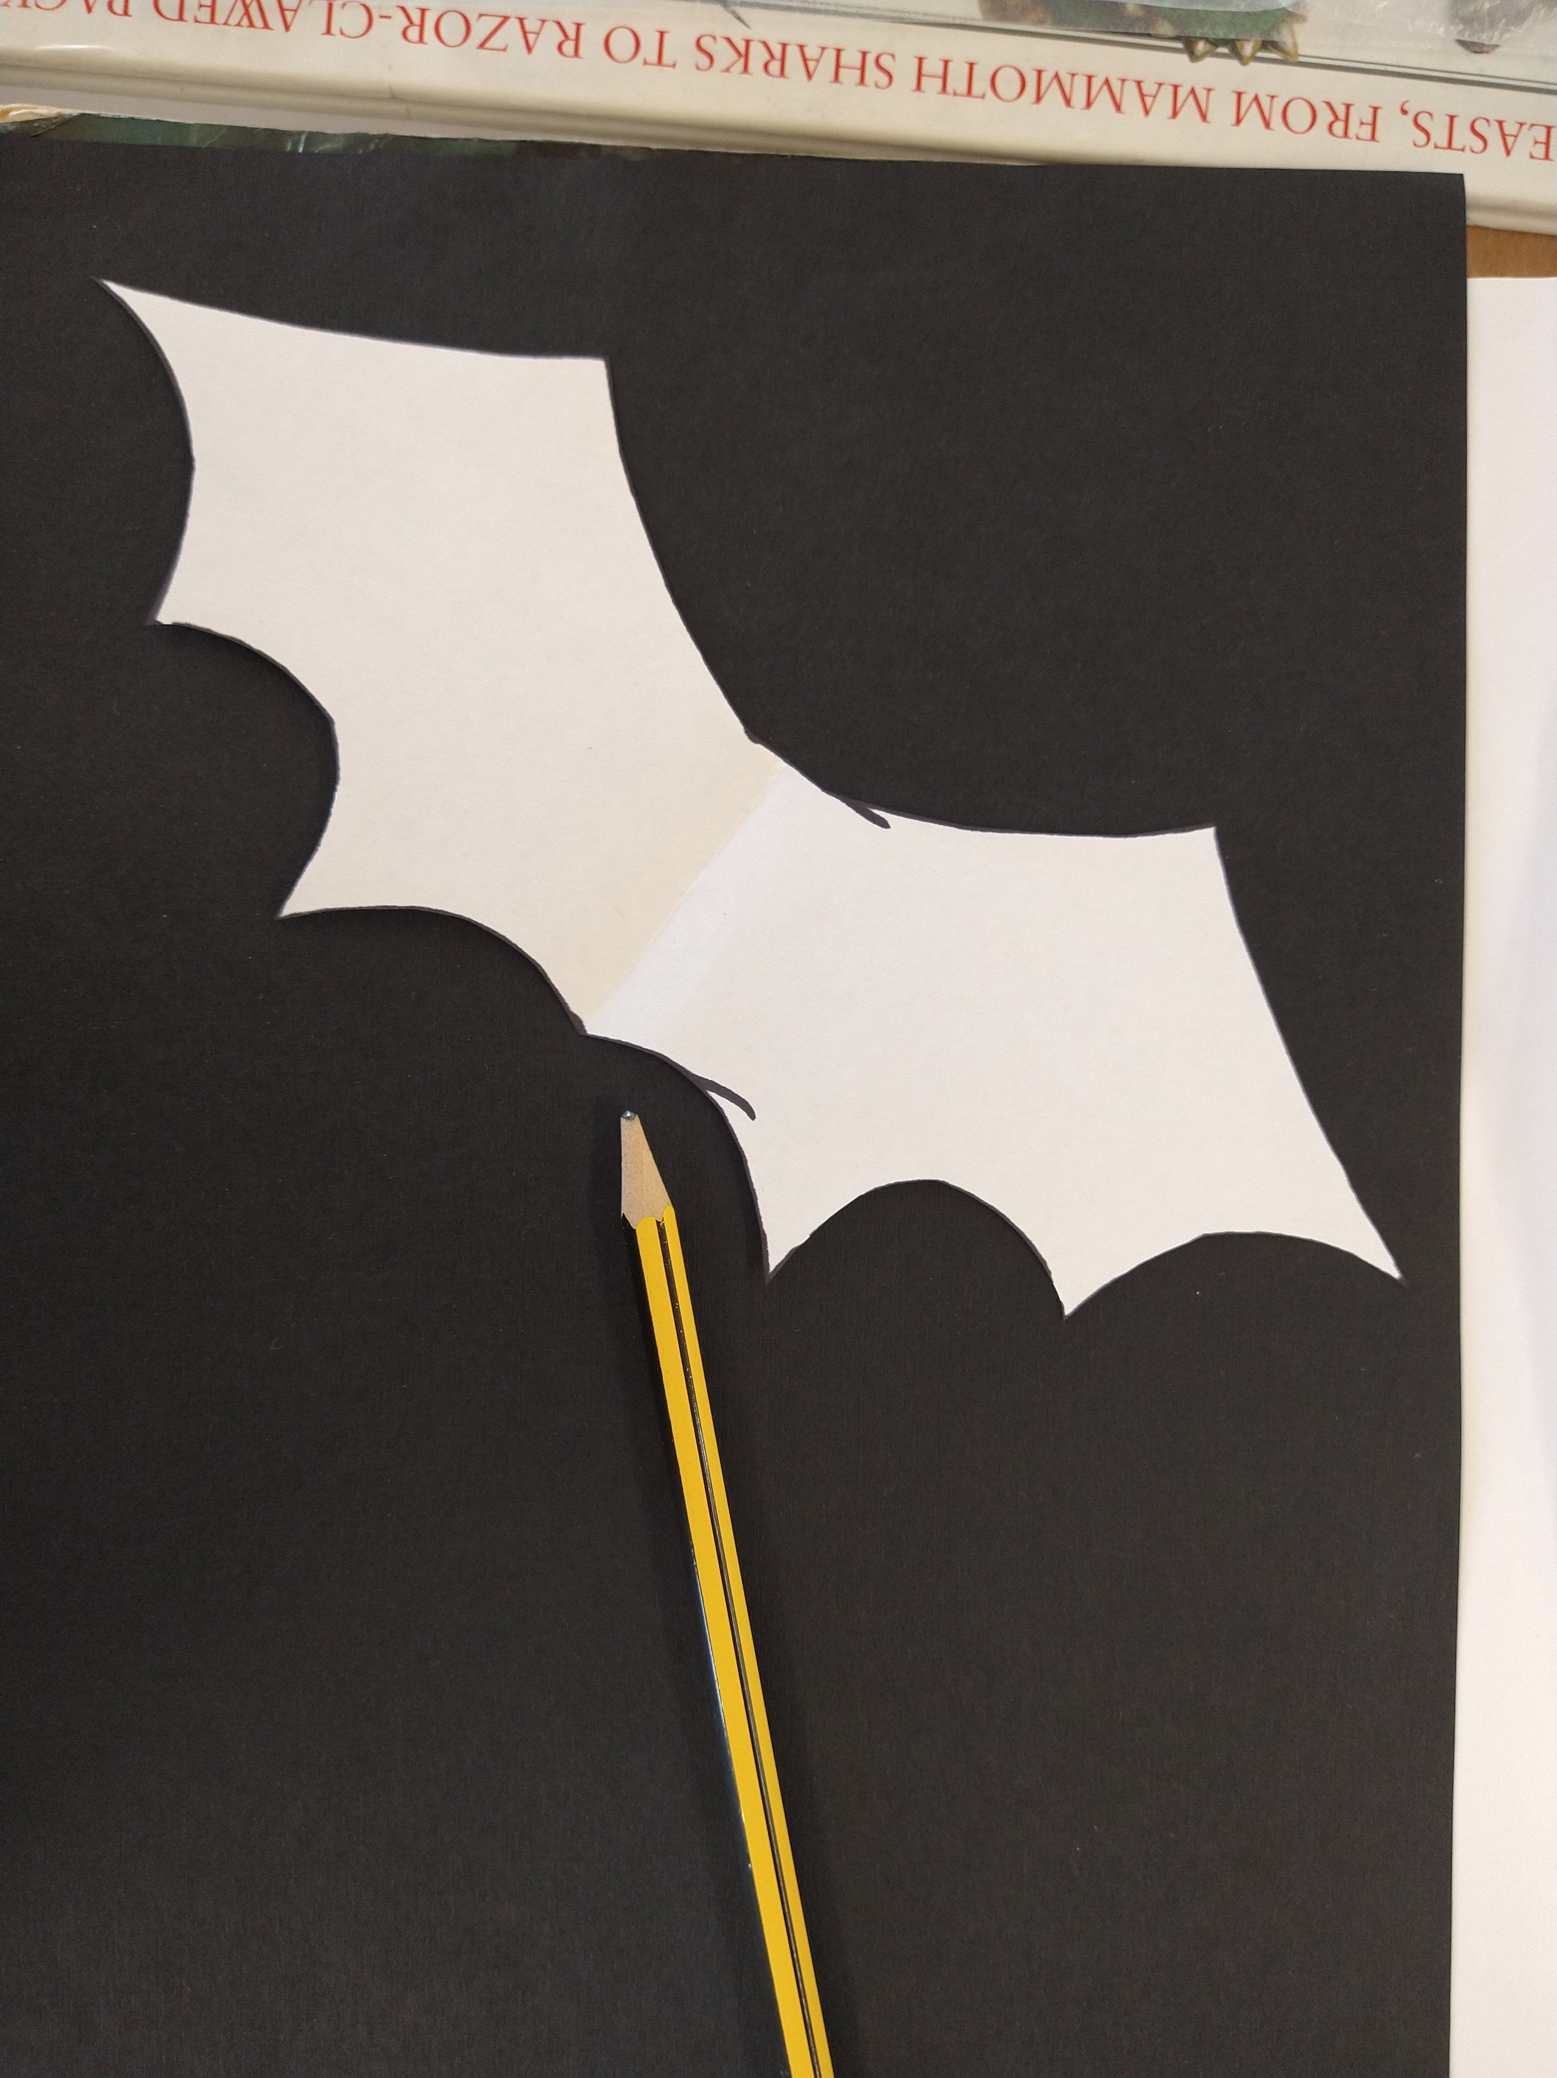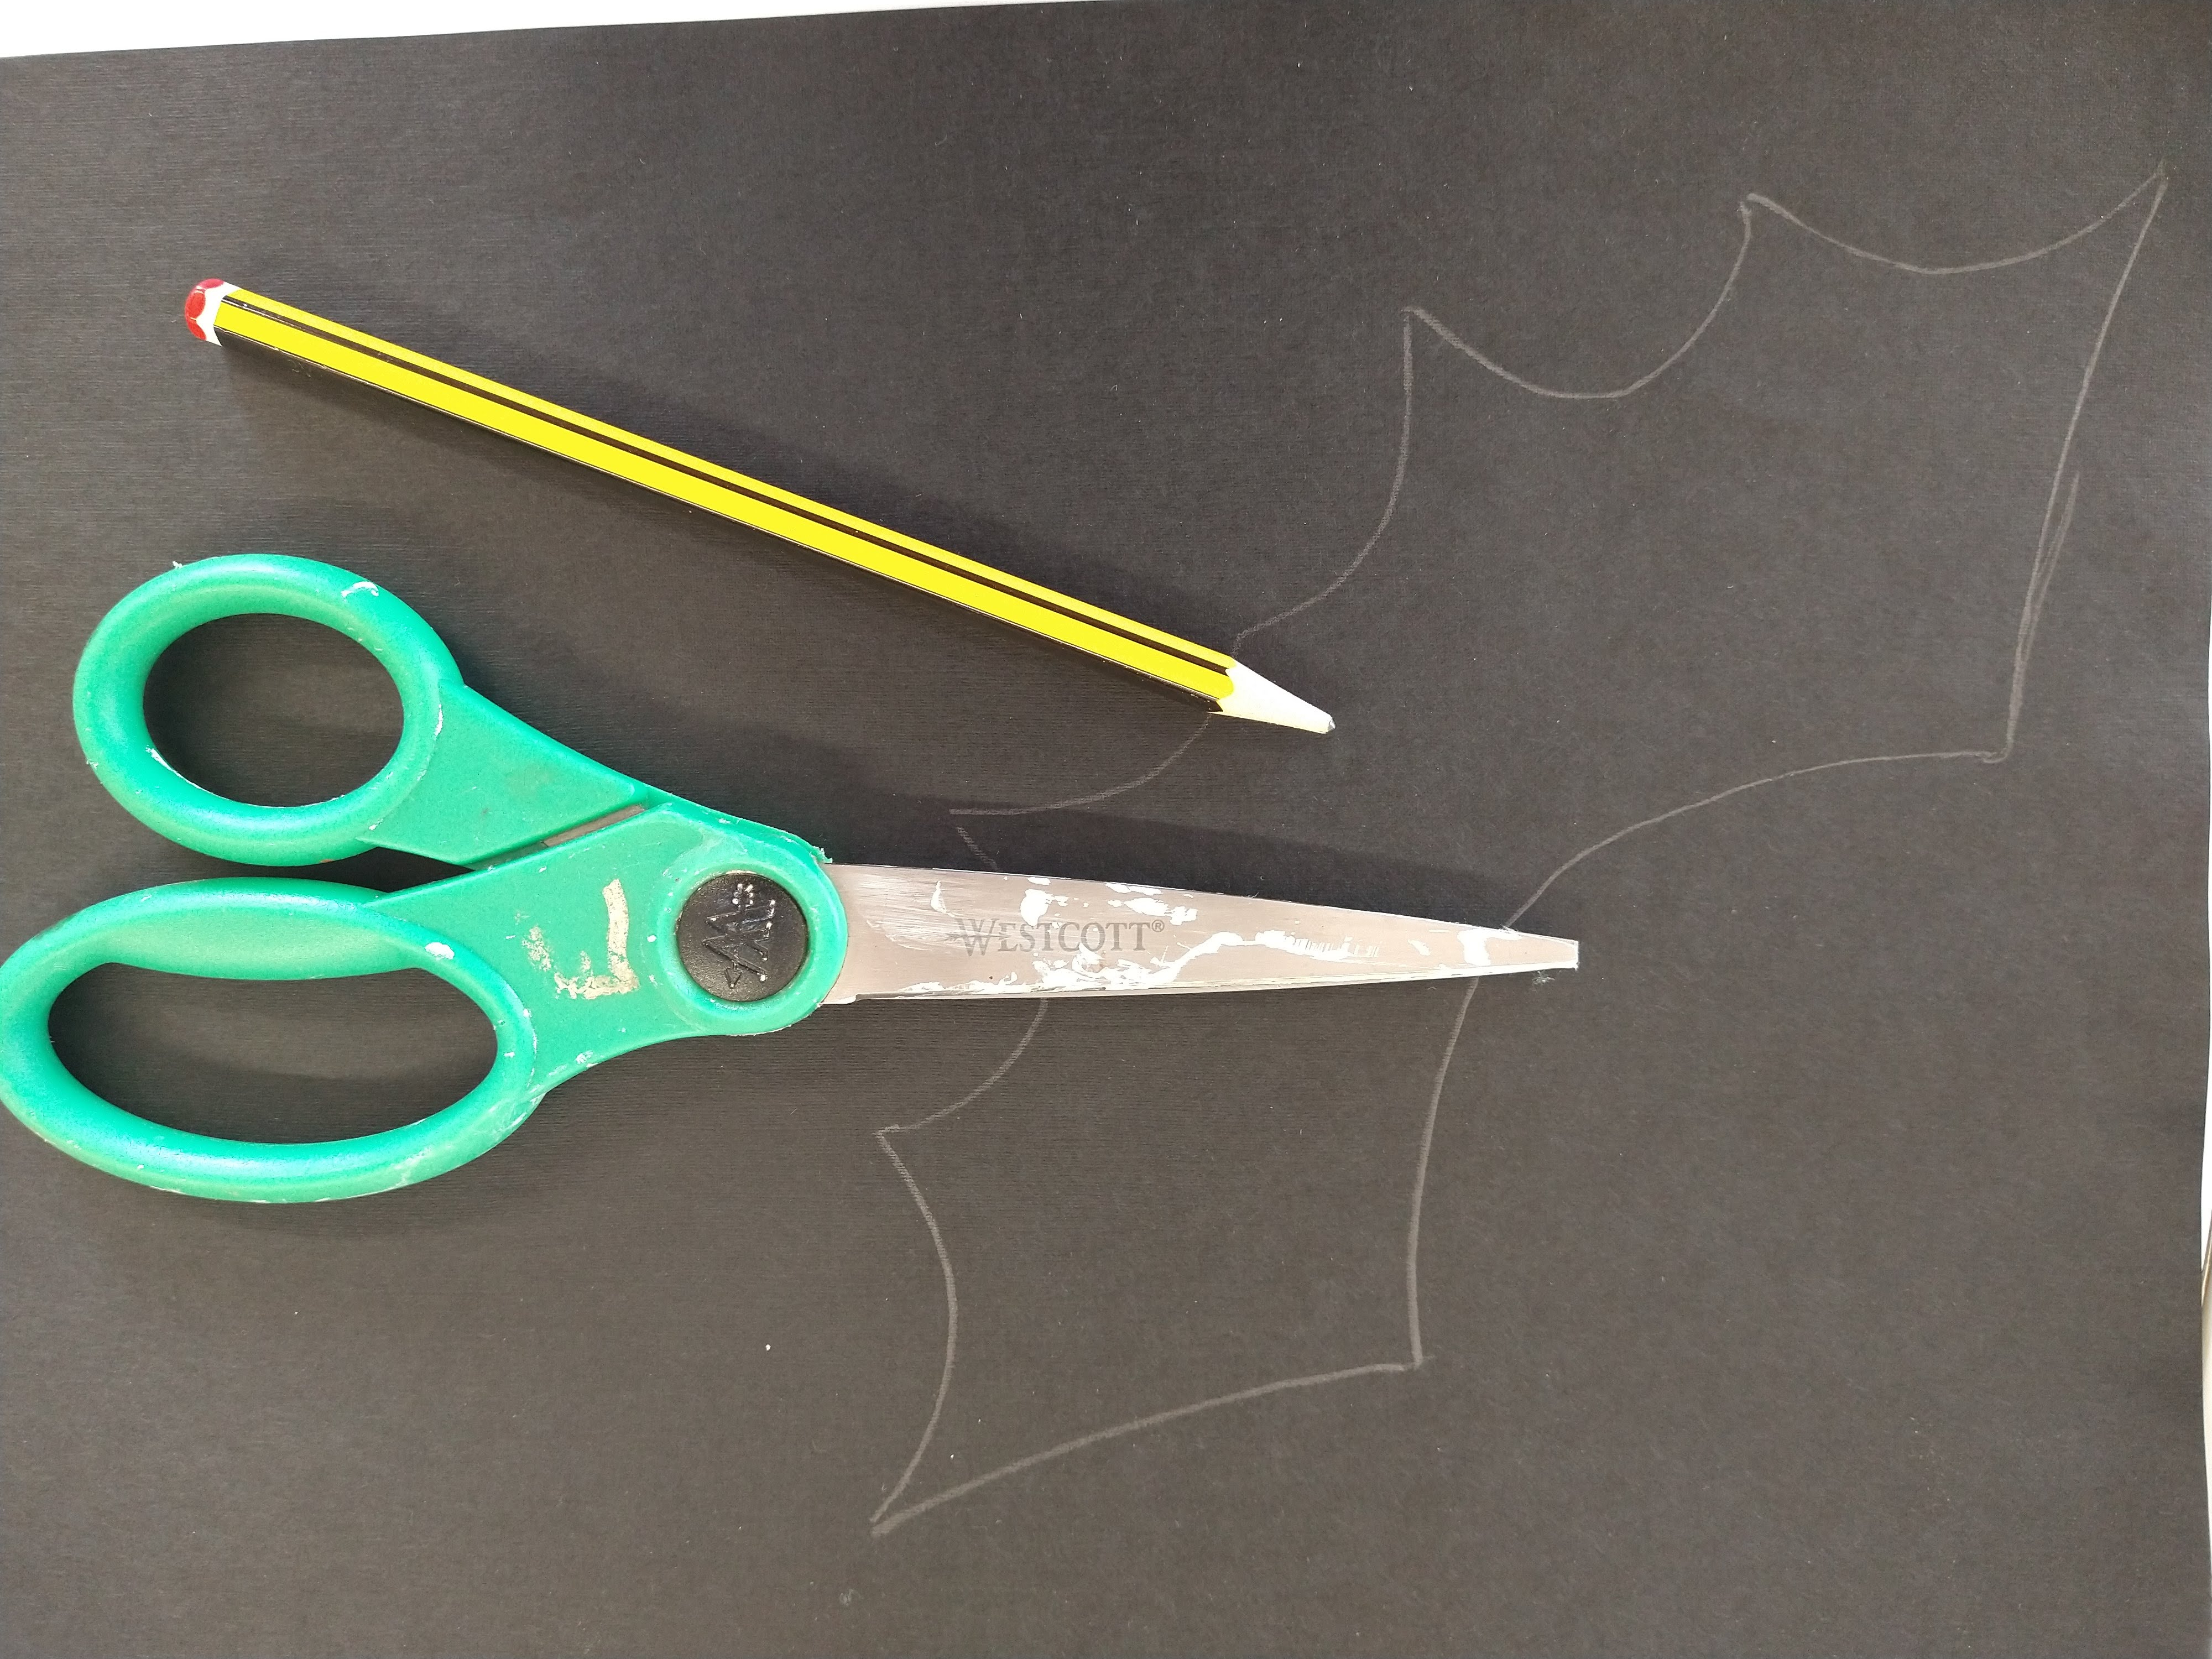
On the other piece of paper draw and cut out your bats wings. You can use our template as a guide or draw your own.
Top tip: If you fold your paper in half then you only need to draw one wing, just make sure the middle of the wing is on the fold.
Step 4.
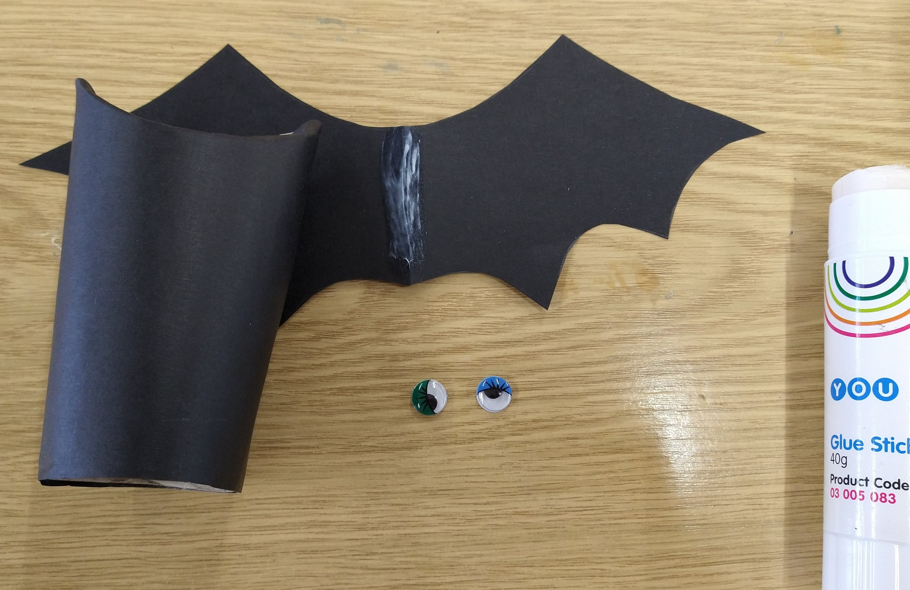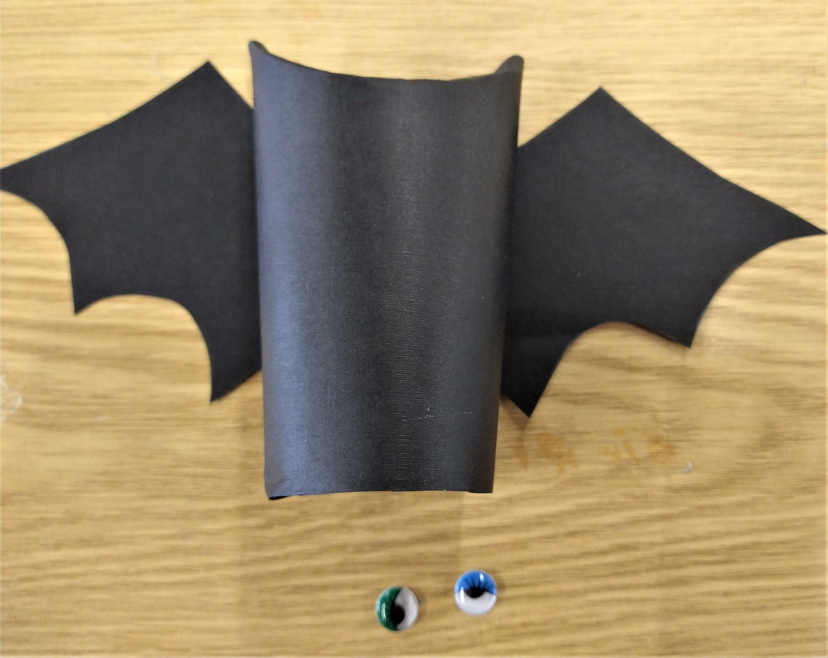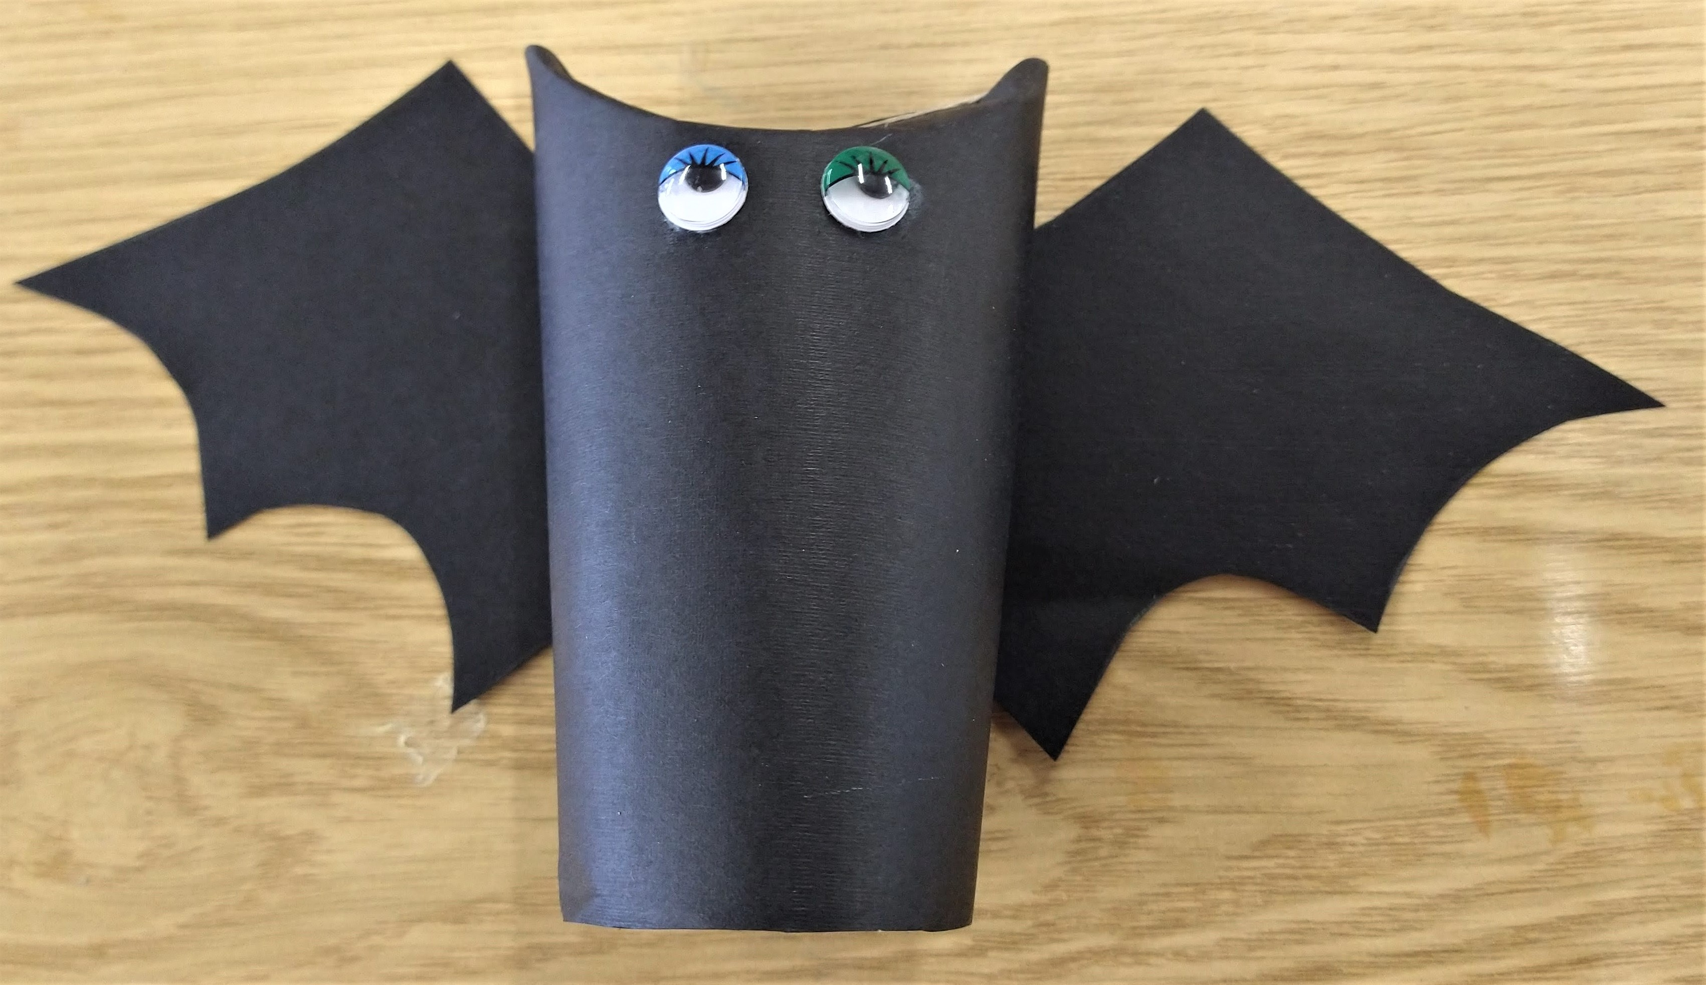
Glue the wings to the back of your bat and the wiggly eyes onto the front.
Have fun and don't forget to share your bats with us!

