Felt Leaf Coasters
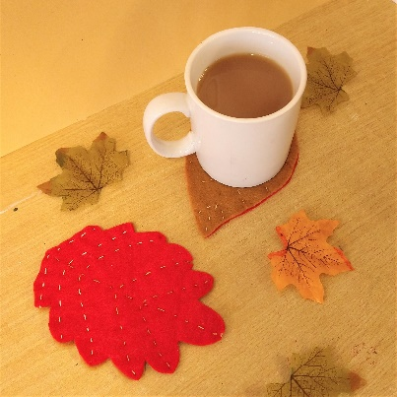
Another autumn inspired craft for you this week: some seasonal coasters for your cups inspired by autumn leaves.
You will need:
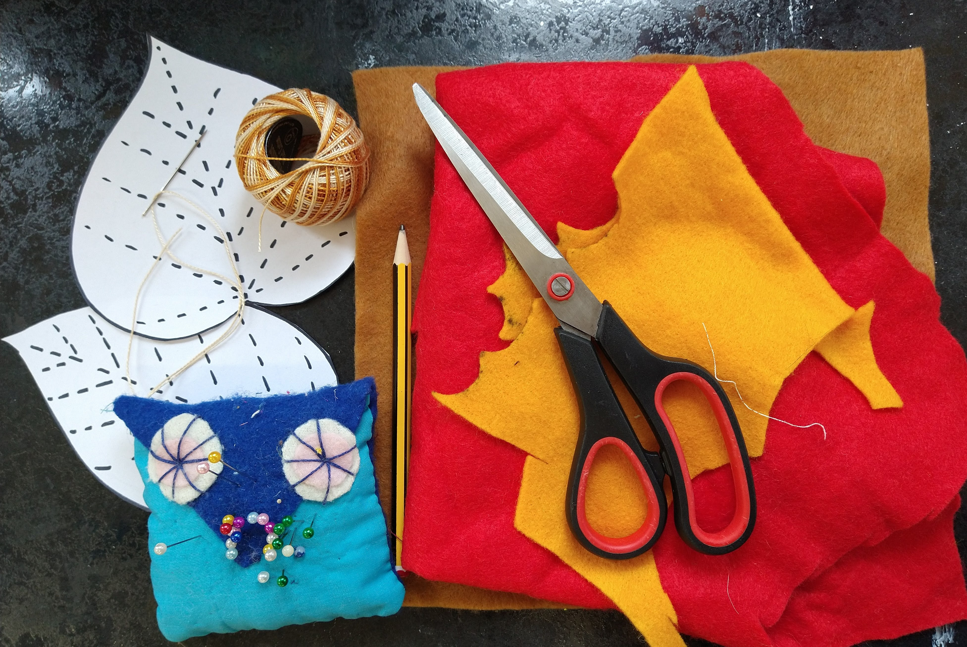
- Felt in autumnal colours
- A large leaf (to make a template, or use ours!)
- Paper and pencil
- Scissors
- Embroidery thread in autumnal colours
- Needle
- Pins
Step 1.
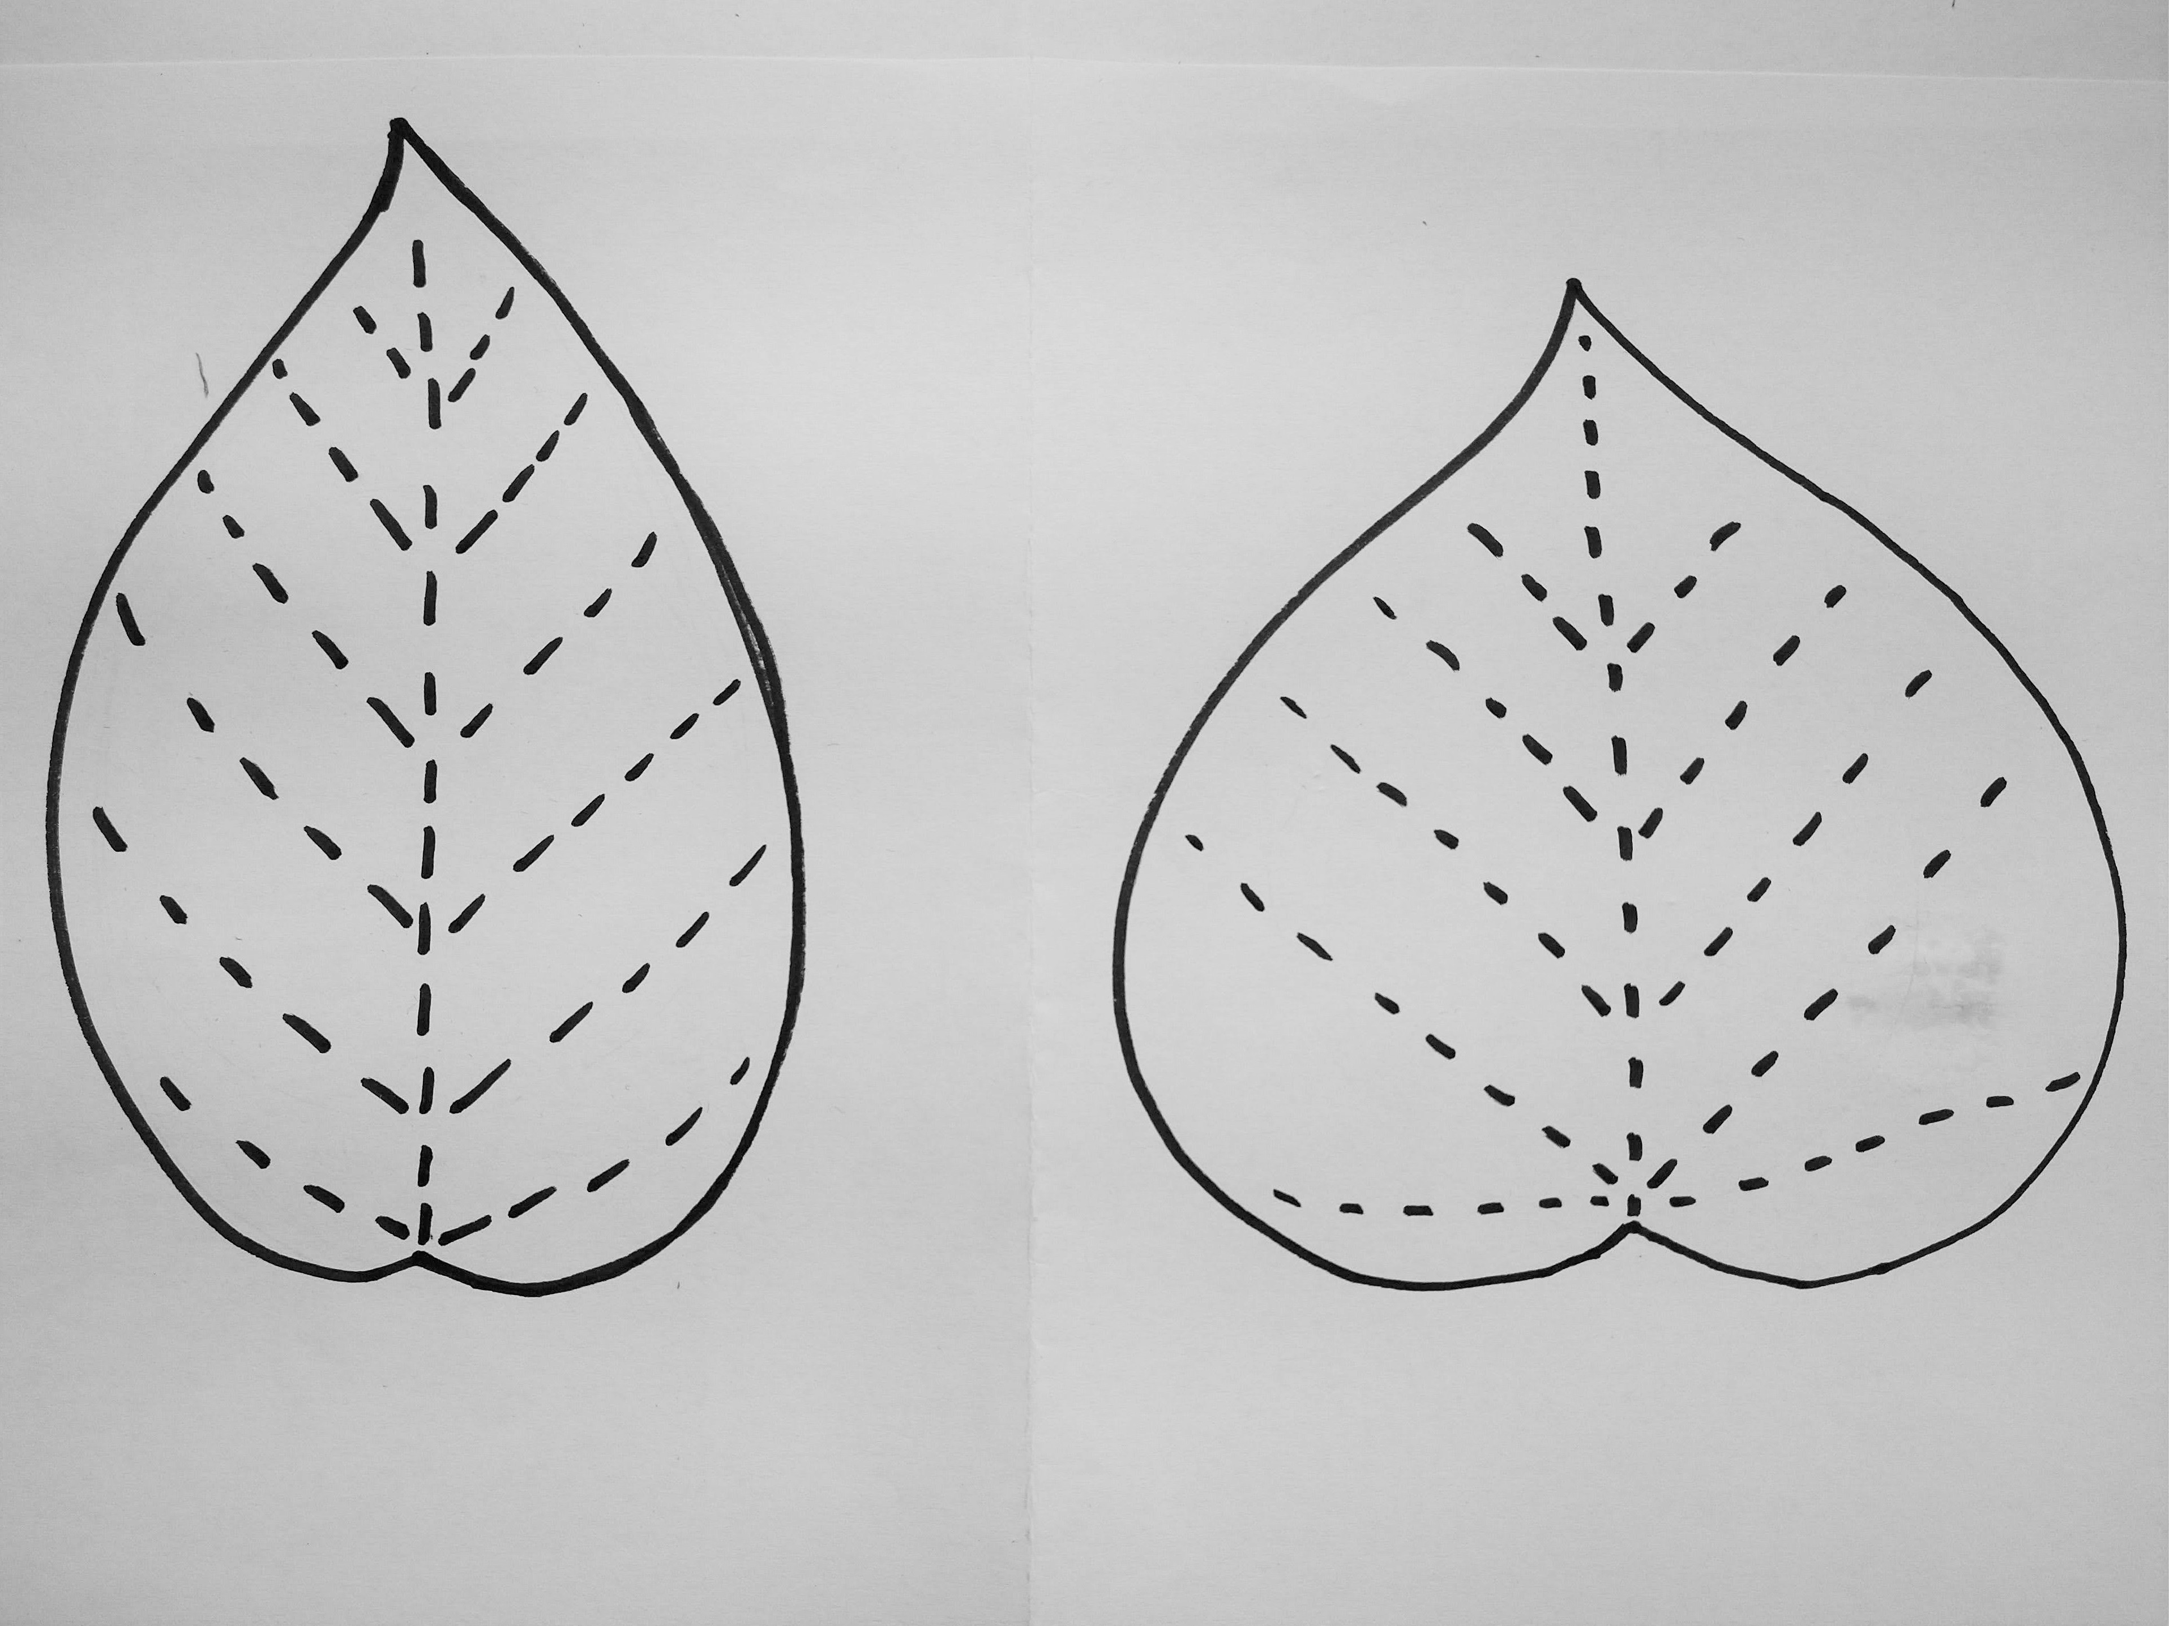
Using your leaf as a guide, make a paper template that is leaf shaped and big enough to put your cup on.
Step 2.
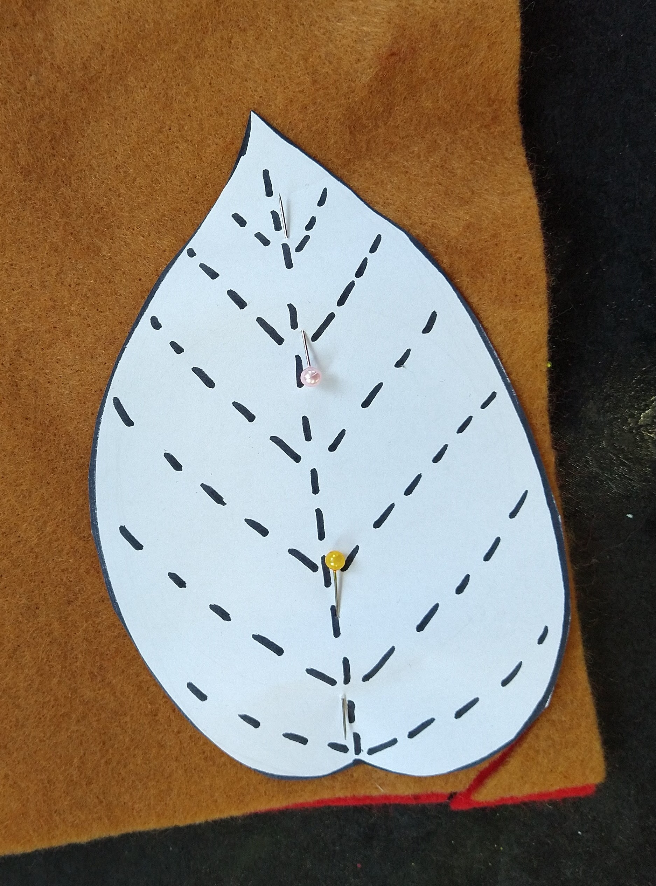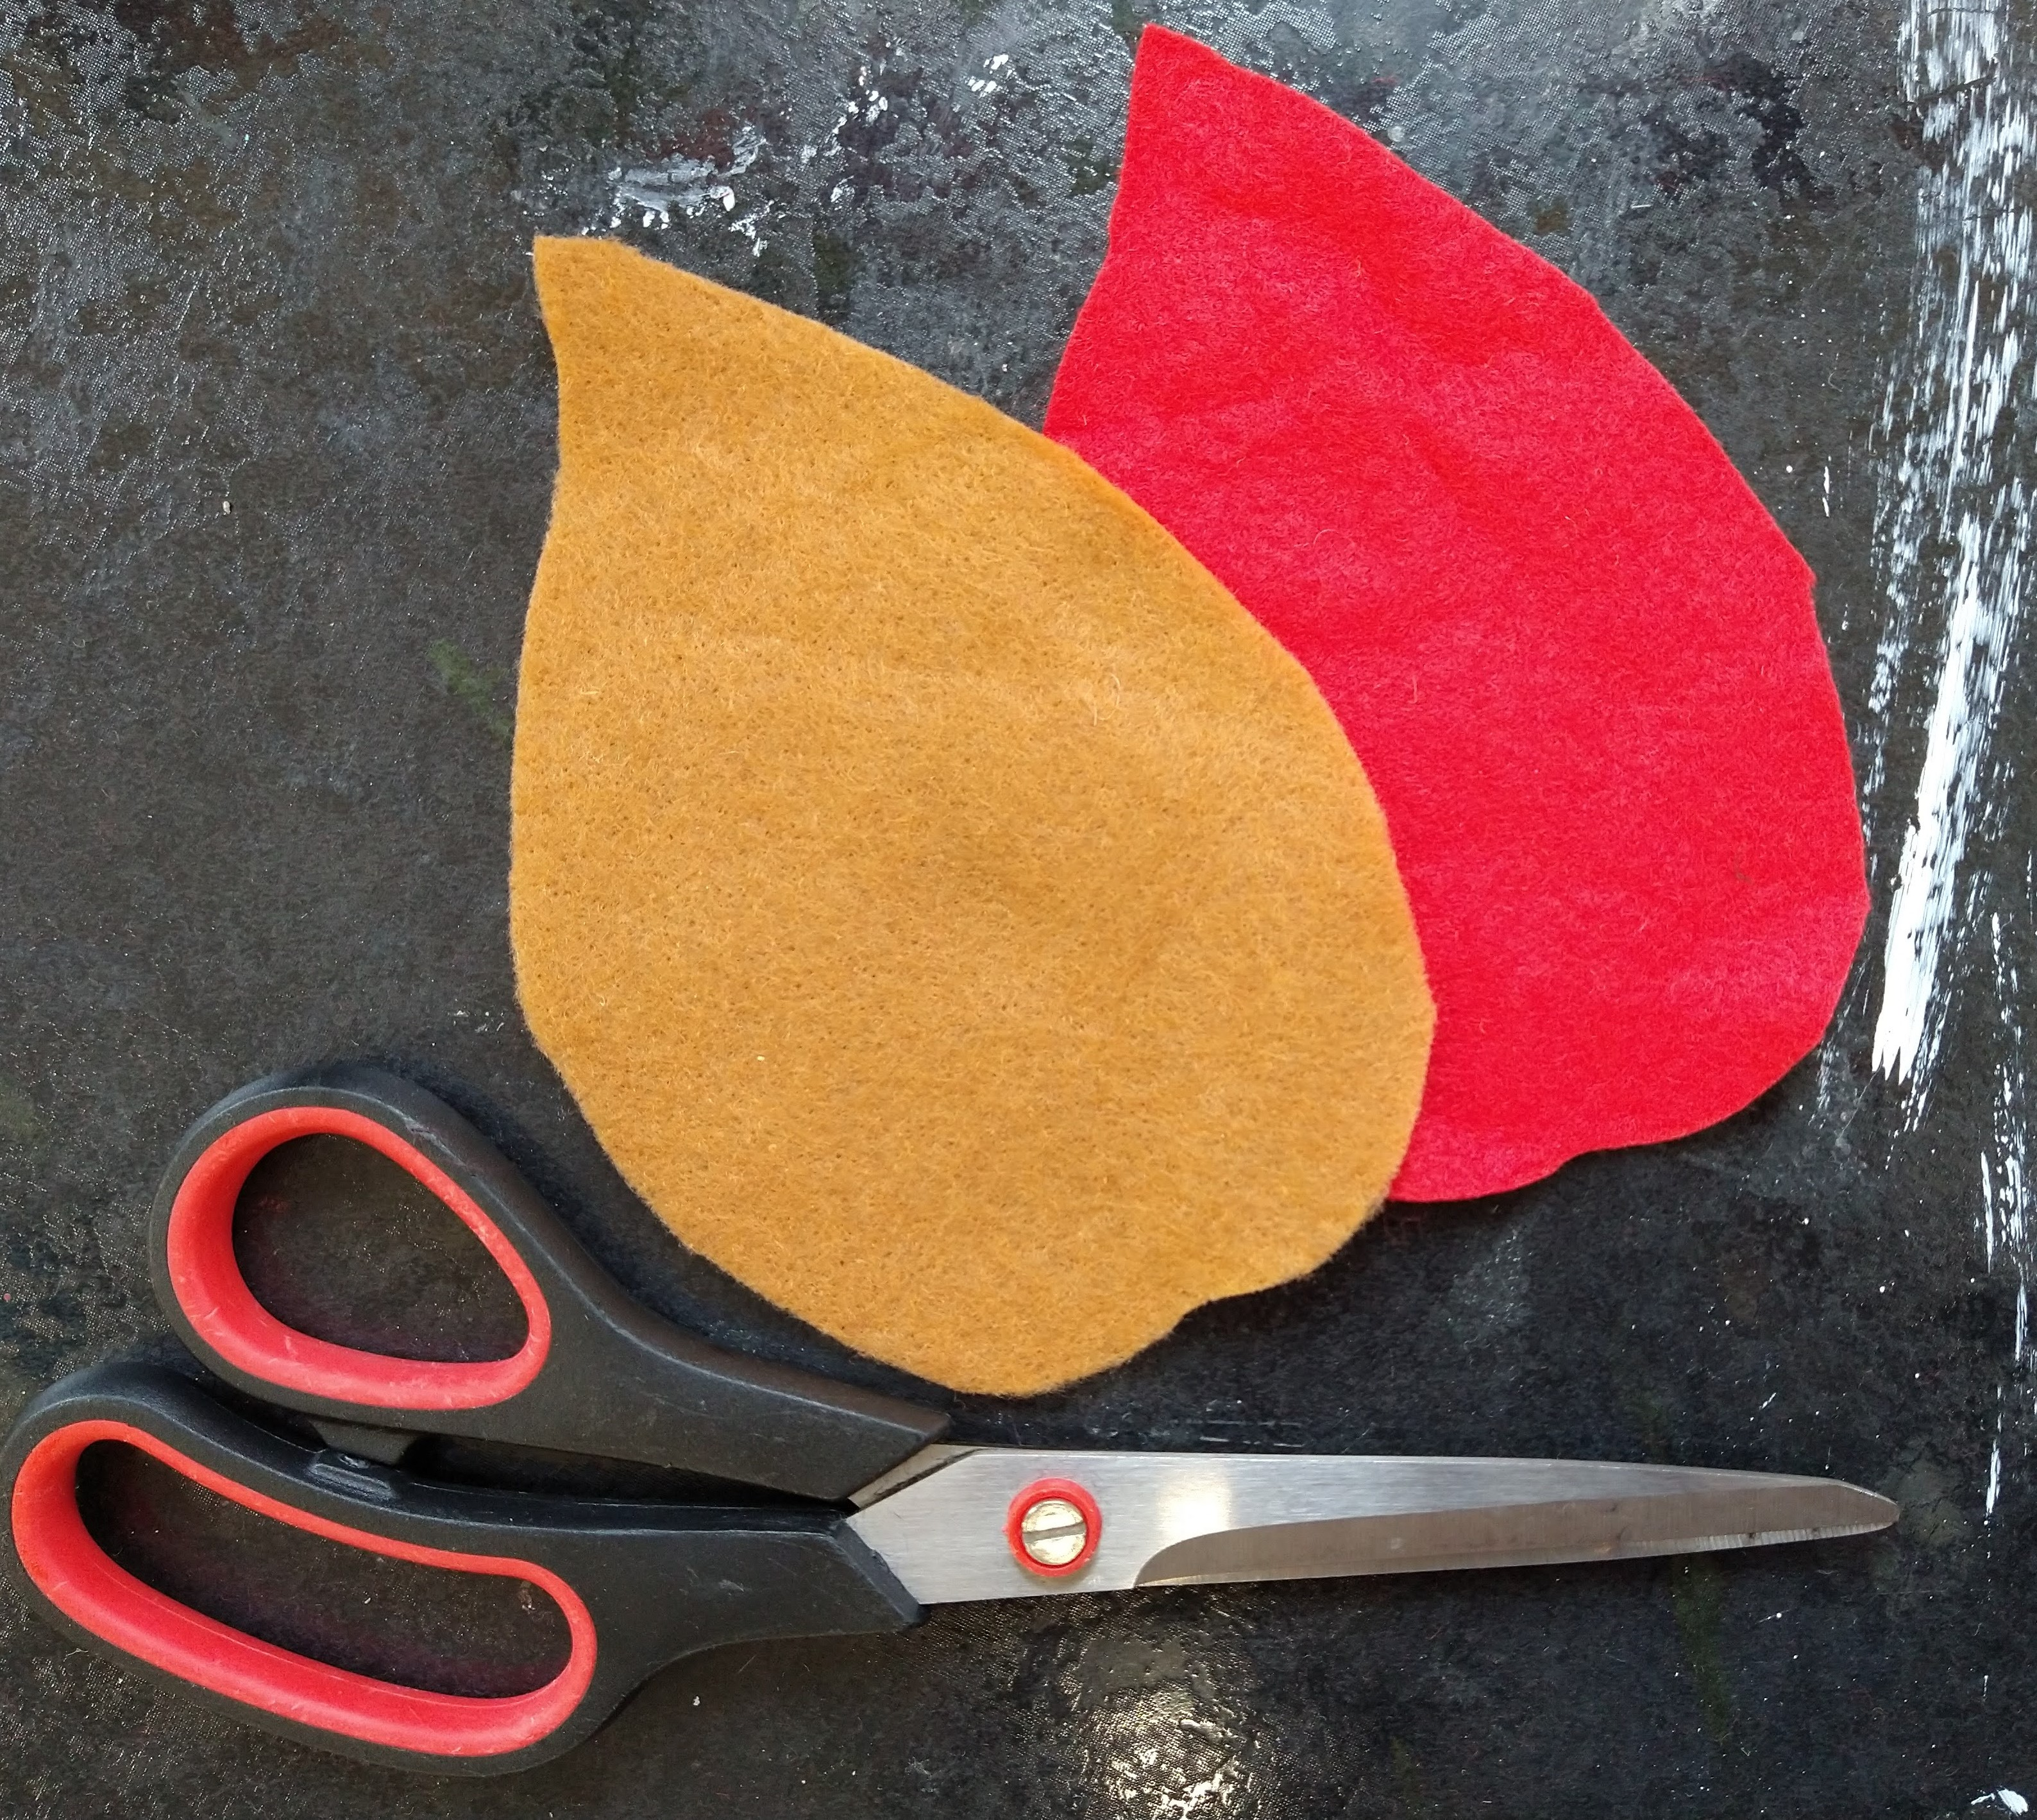
Pin the paper template to your felt and cut out two leaves. We used different colours for each side of our coaster.
Step 3.
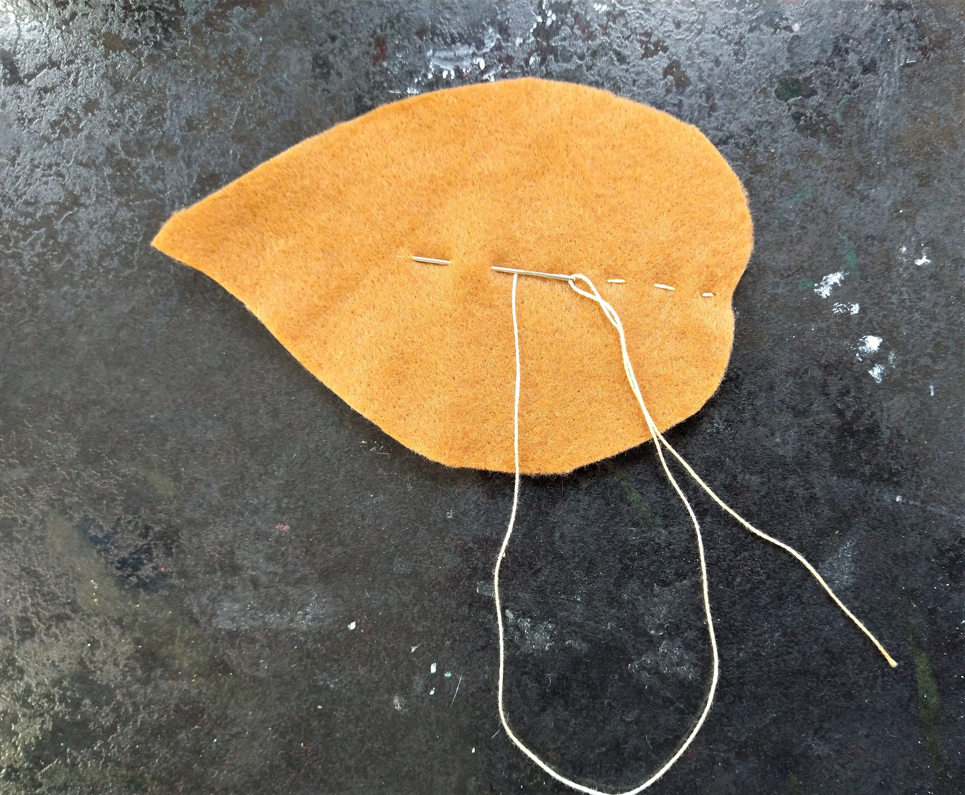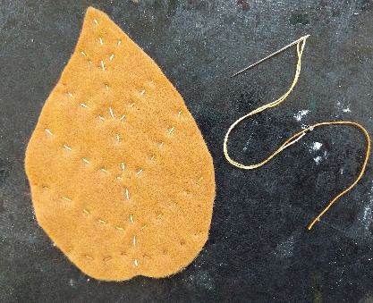
Stitch the two leaves together with running stitch, we stitched lines to look like the veins in leaves.
Step 4.
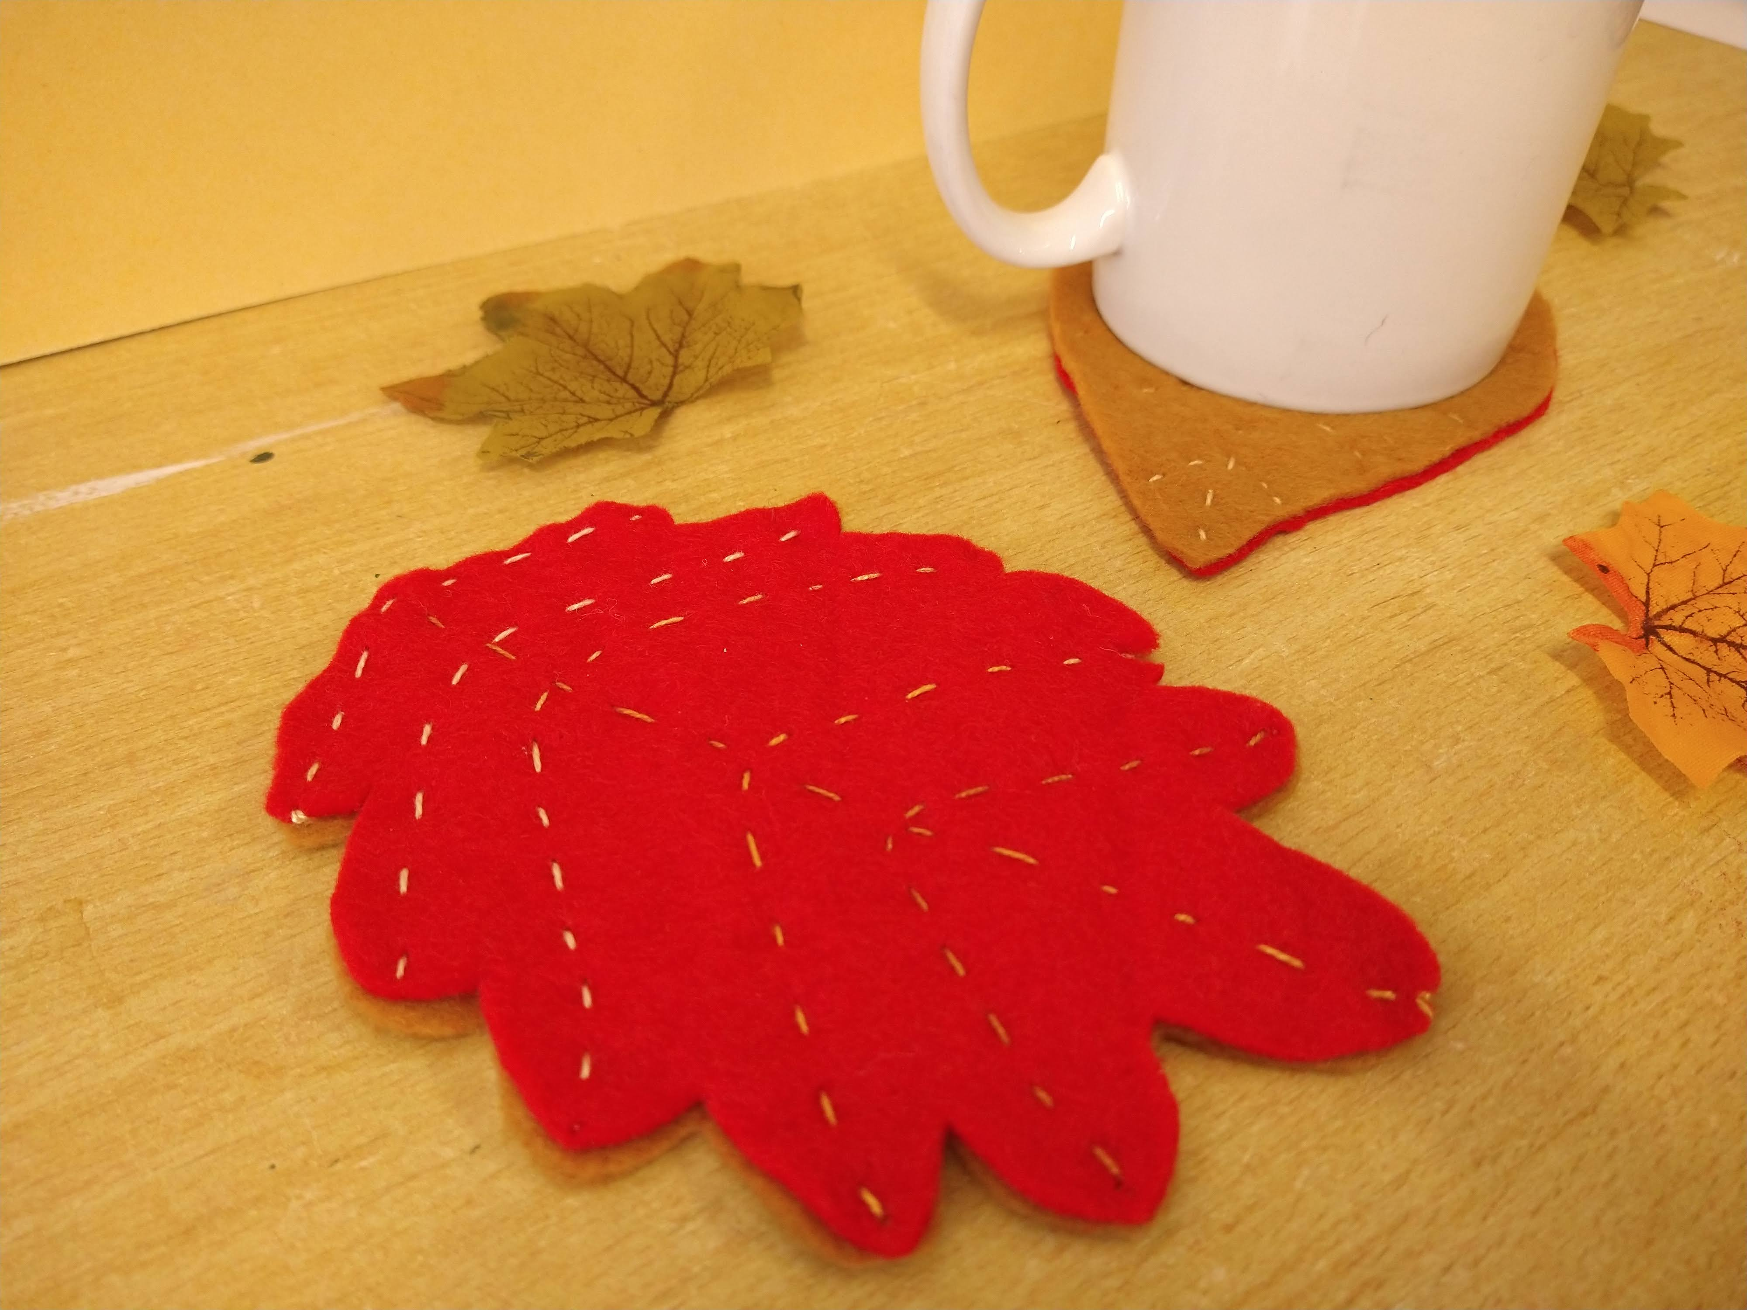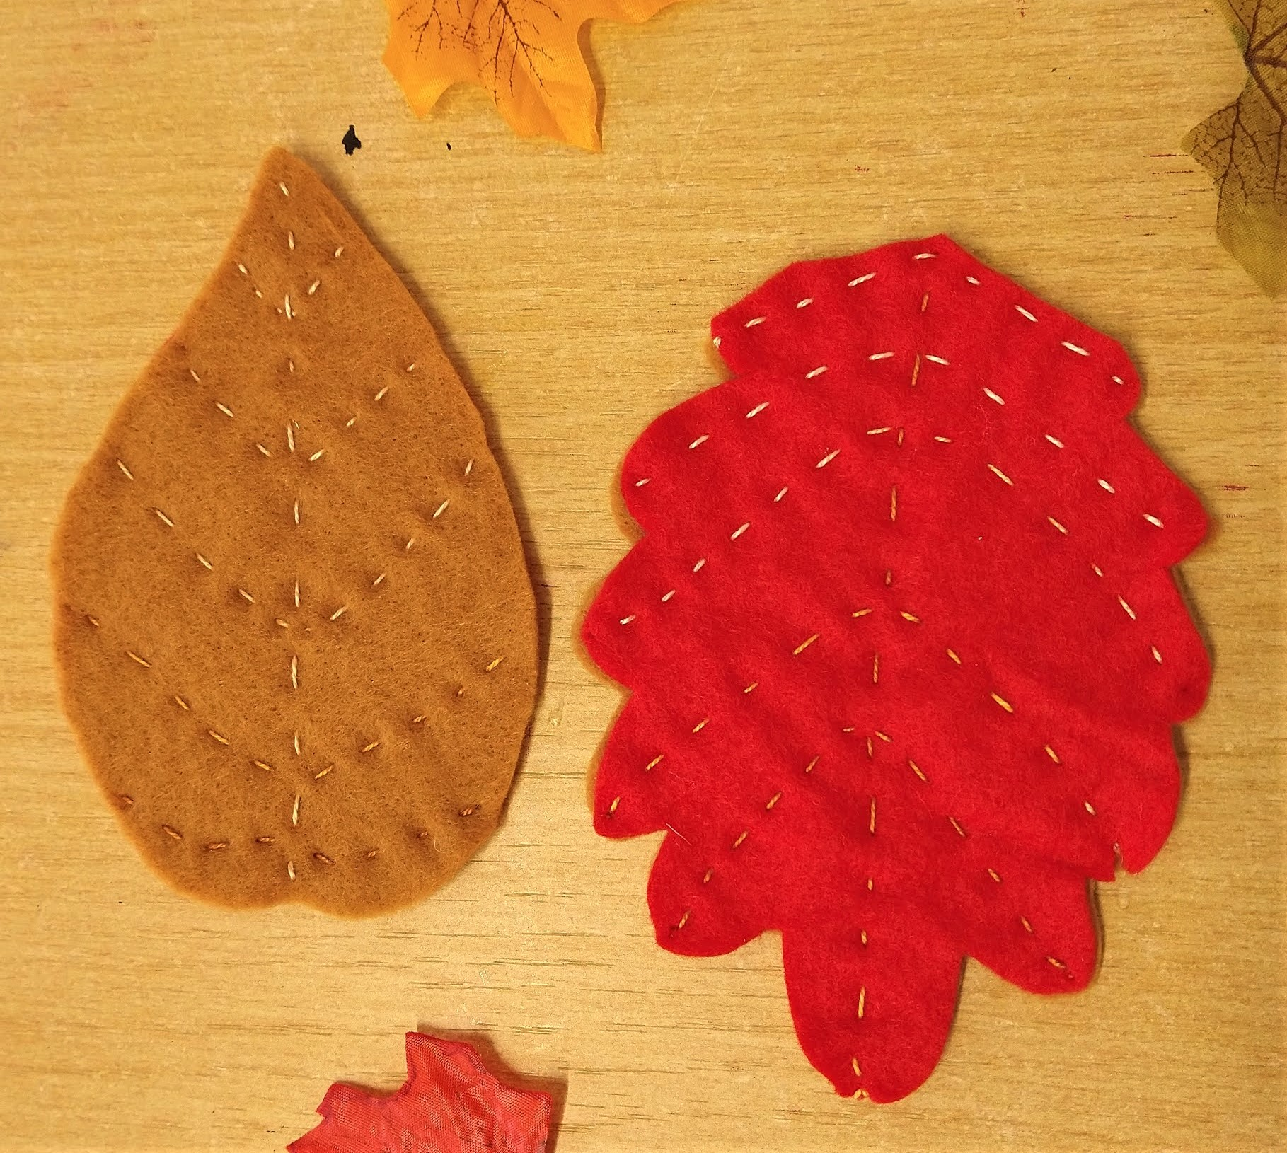
Make yourself a nice cup of tea and test out your coaster!

