Flying Dove of Peace
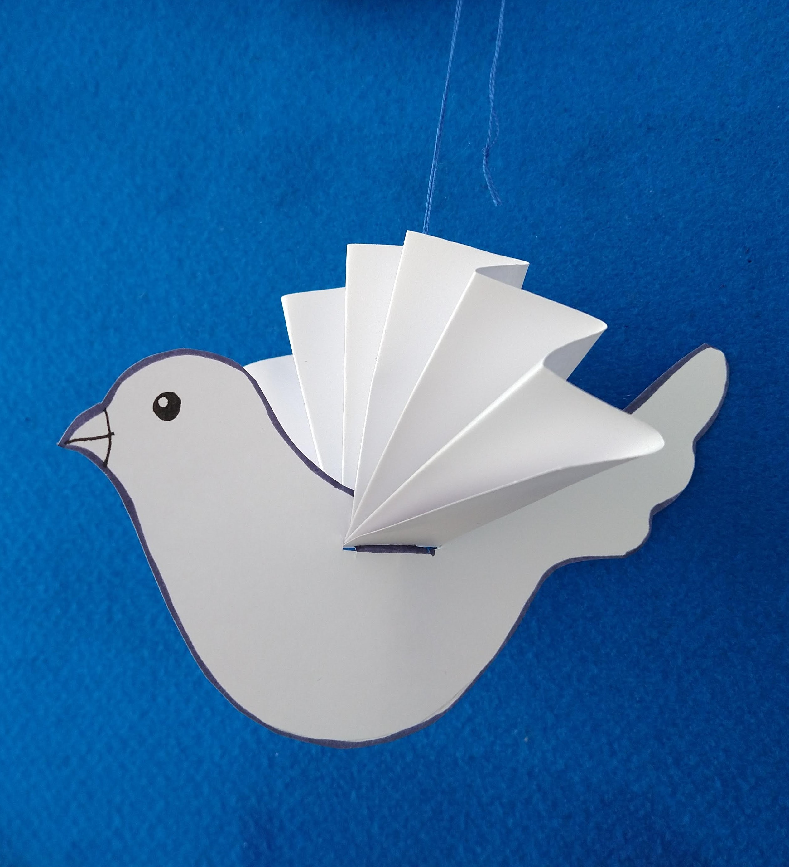
To celebrate the United Nations Day of Peace (21st September) here's a simple flying dove for you to make.
Did you know that Pablo Picasso was invited to design an emblem of peace in 1949 and he chose to create a simple drawing of a dove, based on a picture given to him by fellow artist Henri Matisse?
You will need:
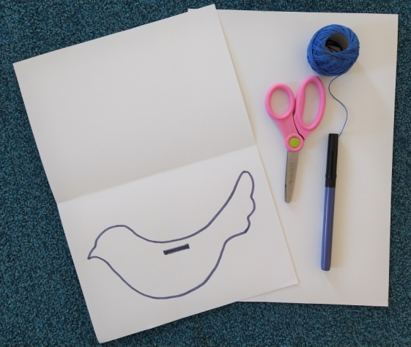
- White card
- Pencil
- Black pen
- Scissors
- String or thread and a needle
- Print out of our template
Step 1.
Print out our template (either onto card if you can or onto paper and stick the paper onto the card.)
Step 2.
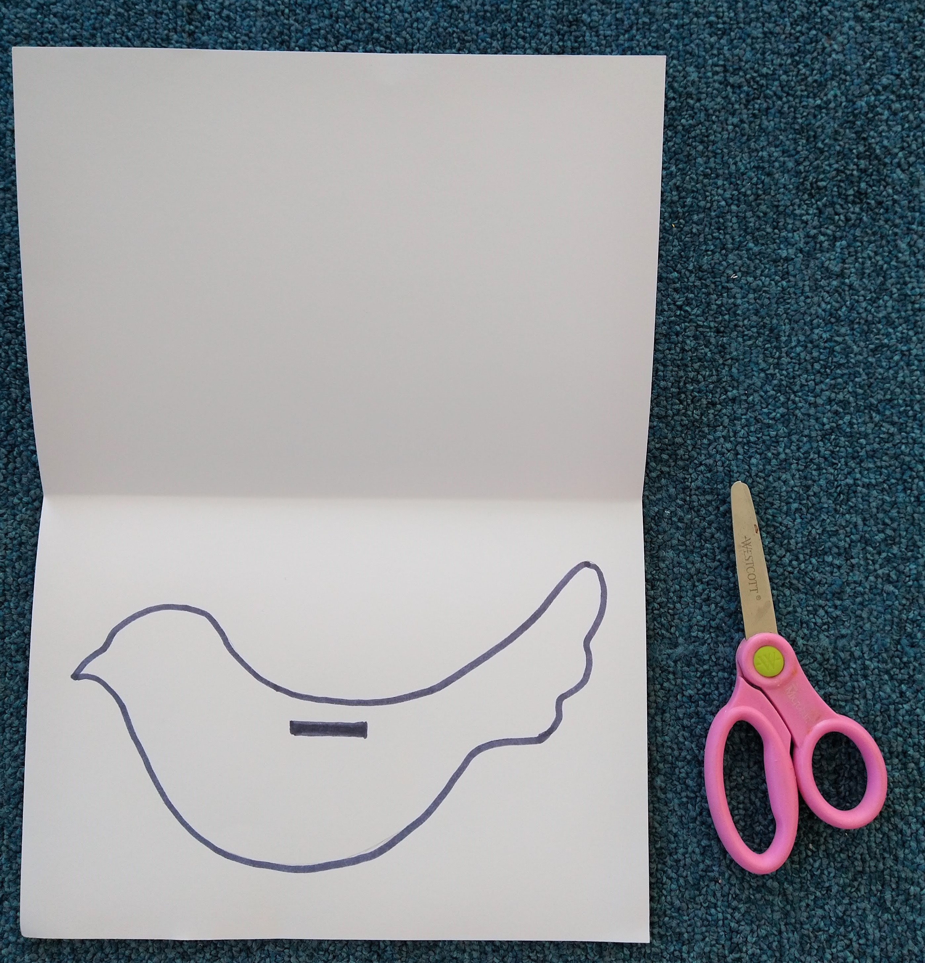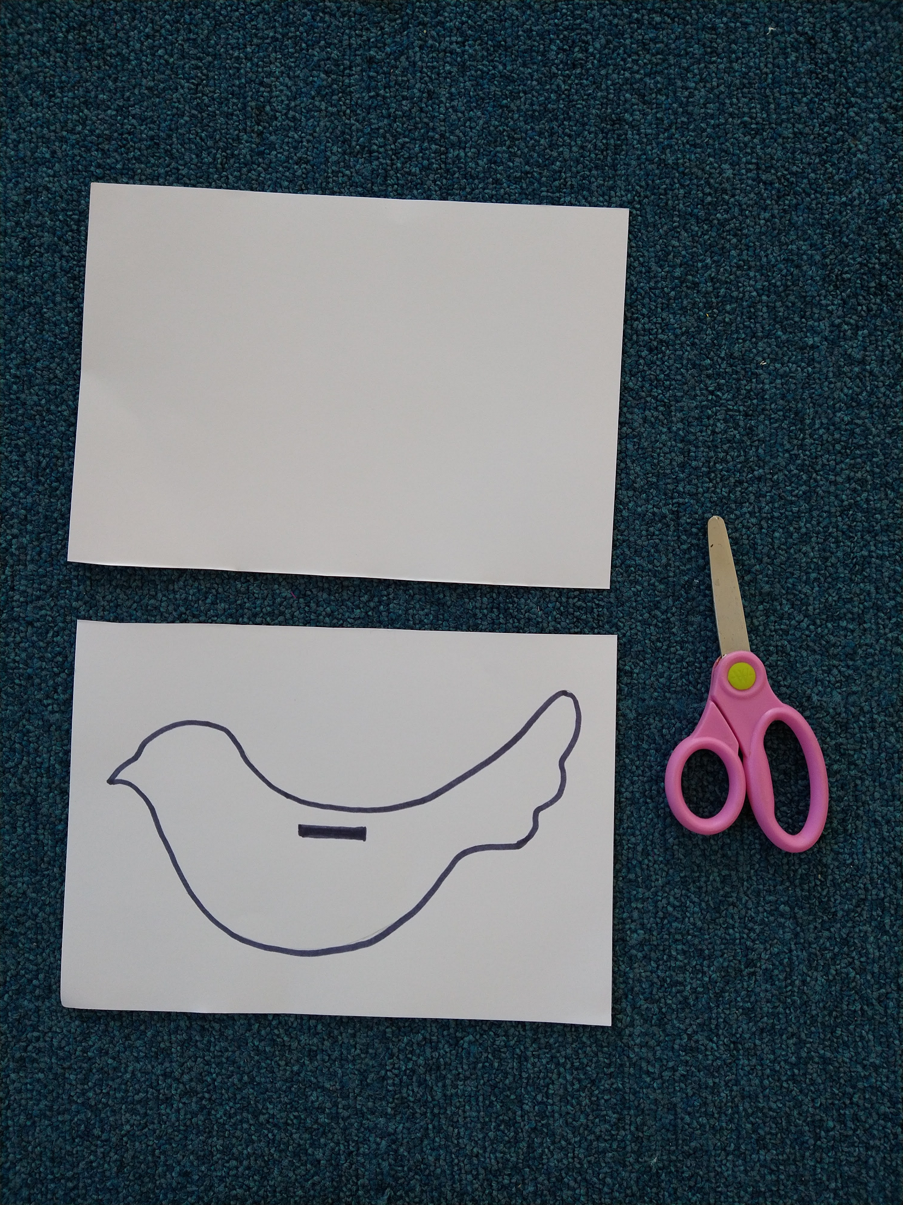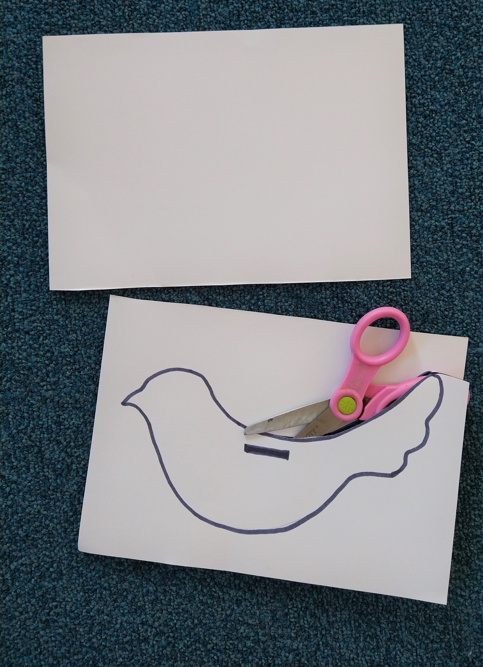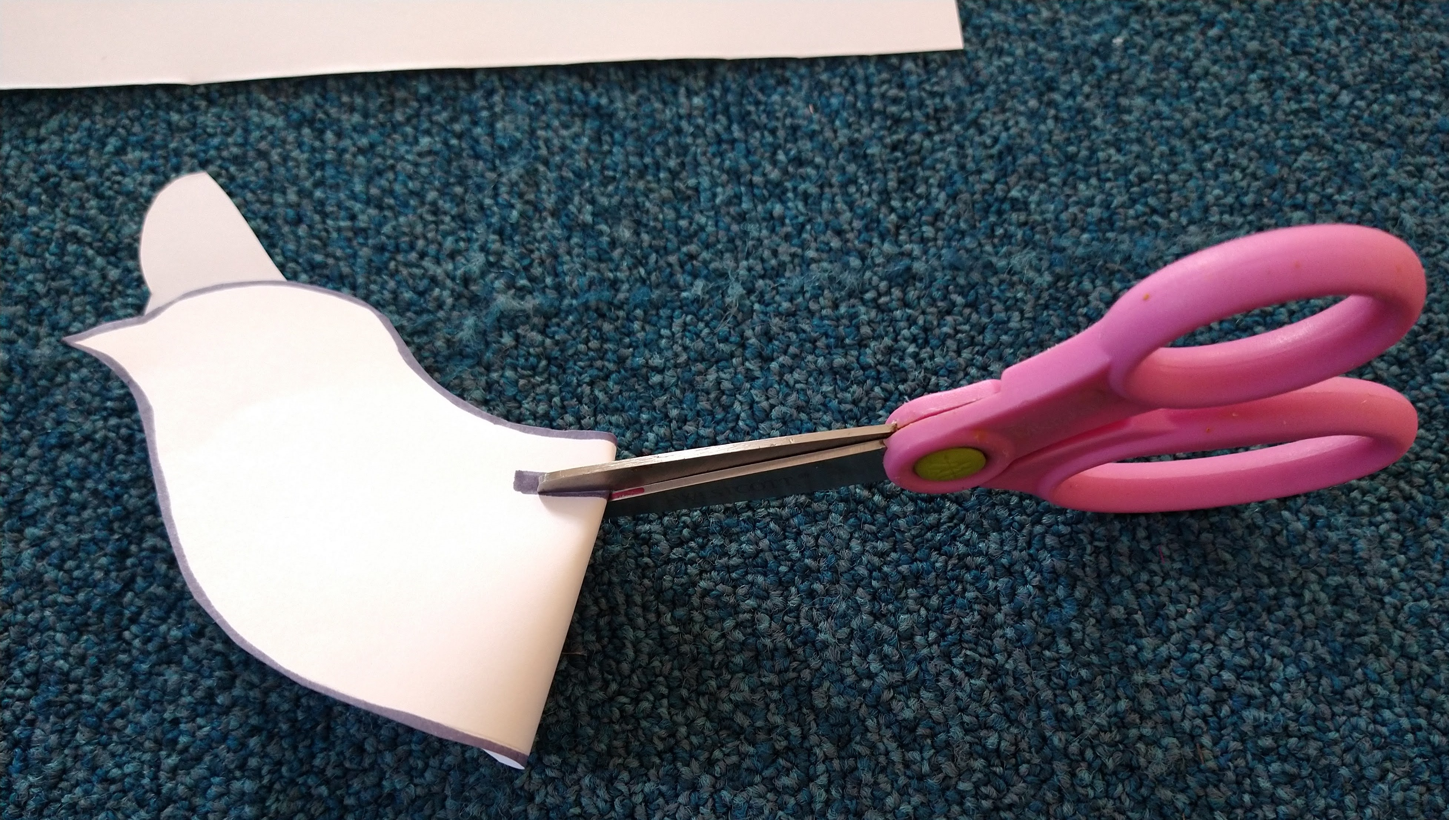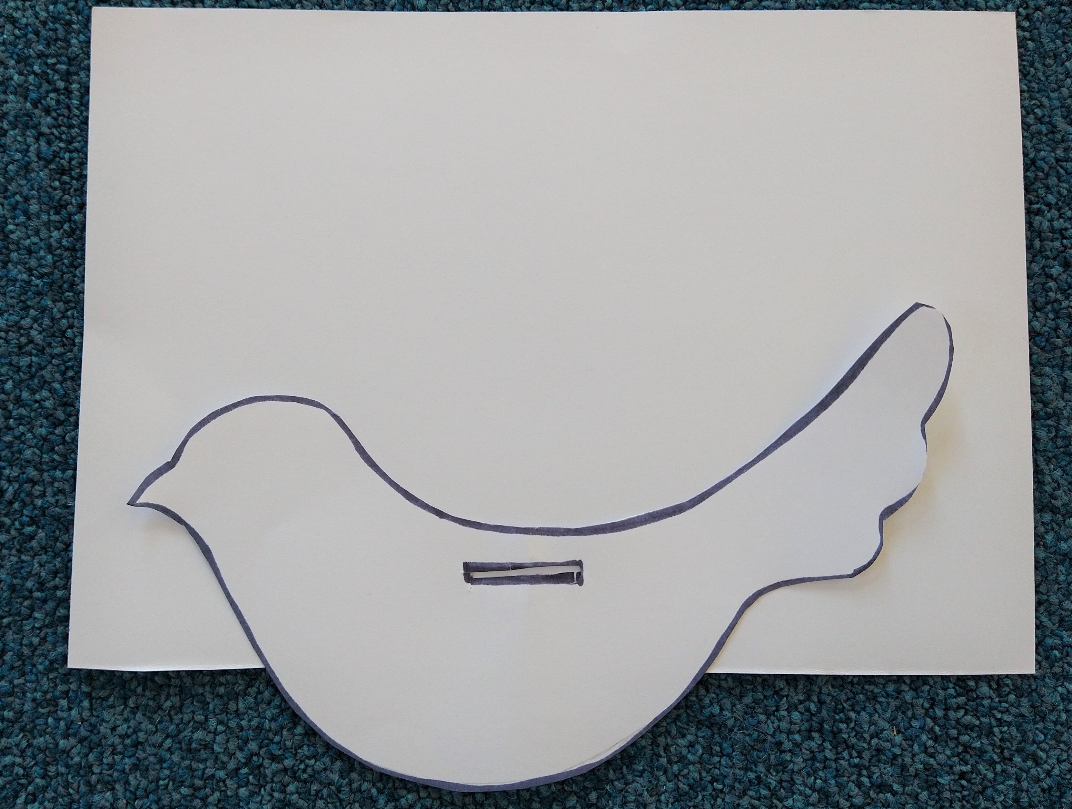
Fold the card in half so you have the dove on one half and a plain rectangle. Cut out the dove, including the slit in the back. This is easiest if you lightly fold the card and snip into first, like in the photos. At this point you can draw on some eyes and a beak if you'd like to.
Step 3.
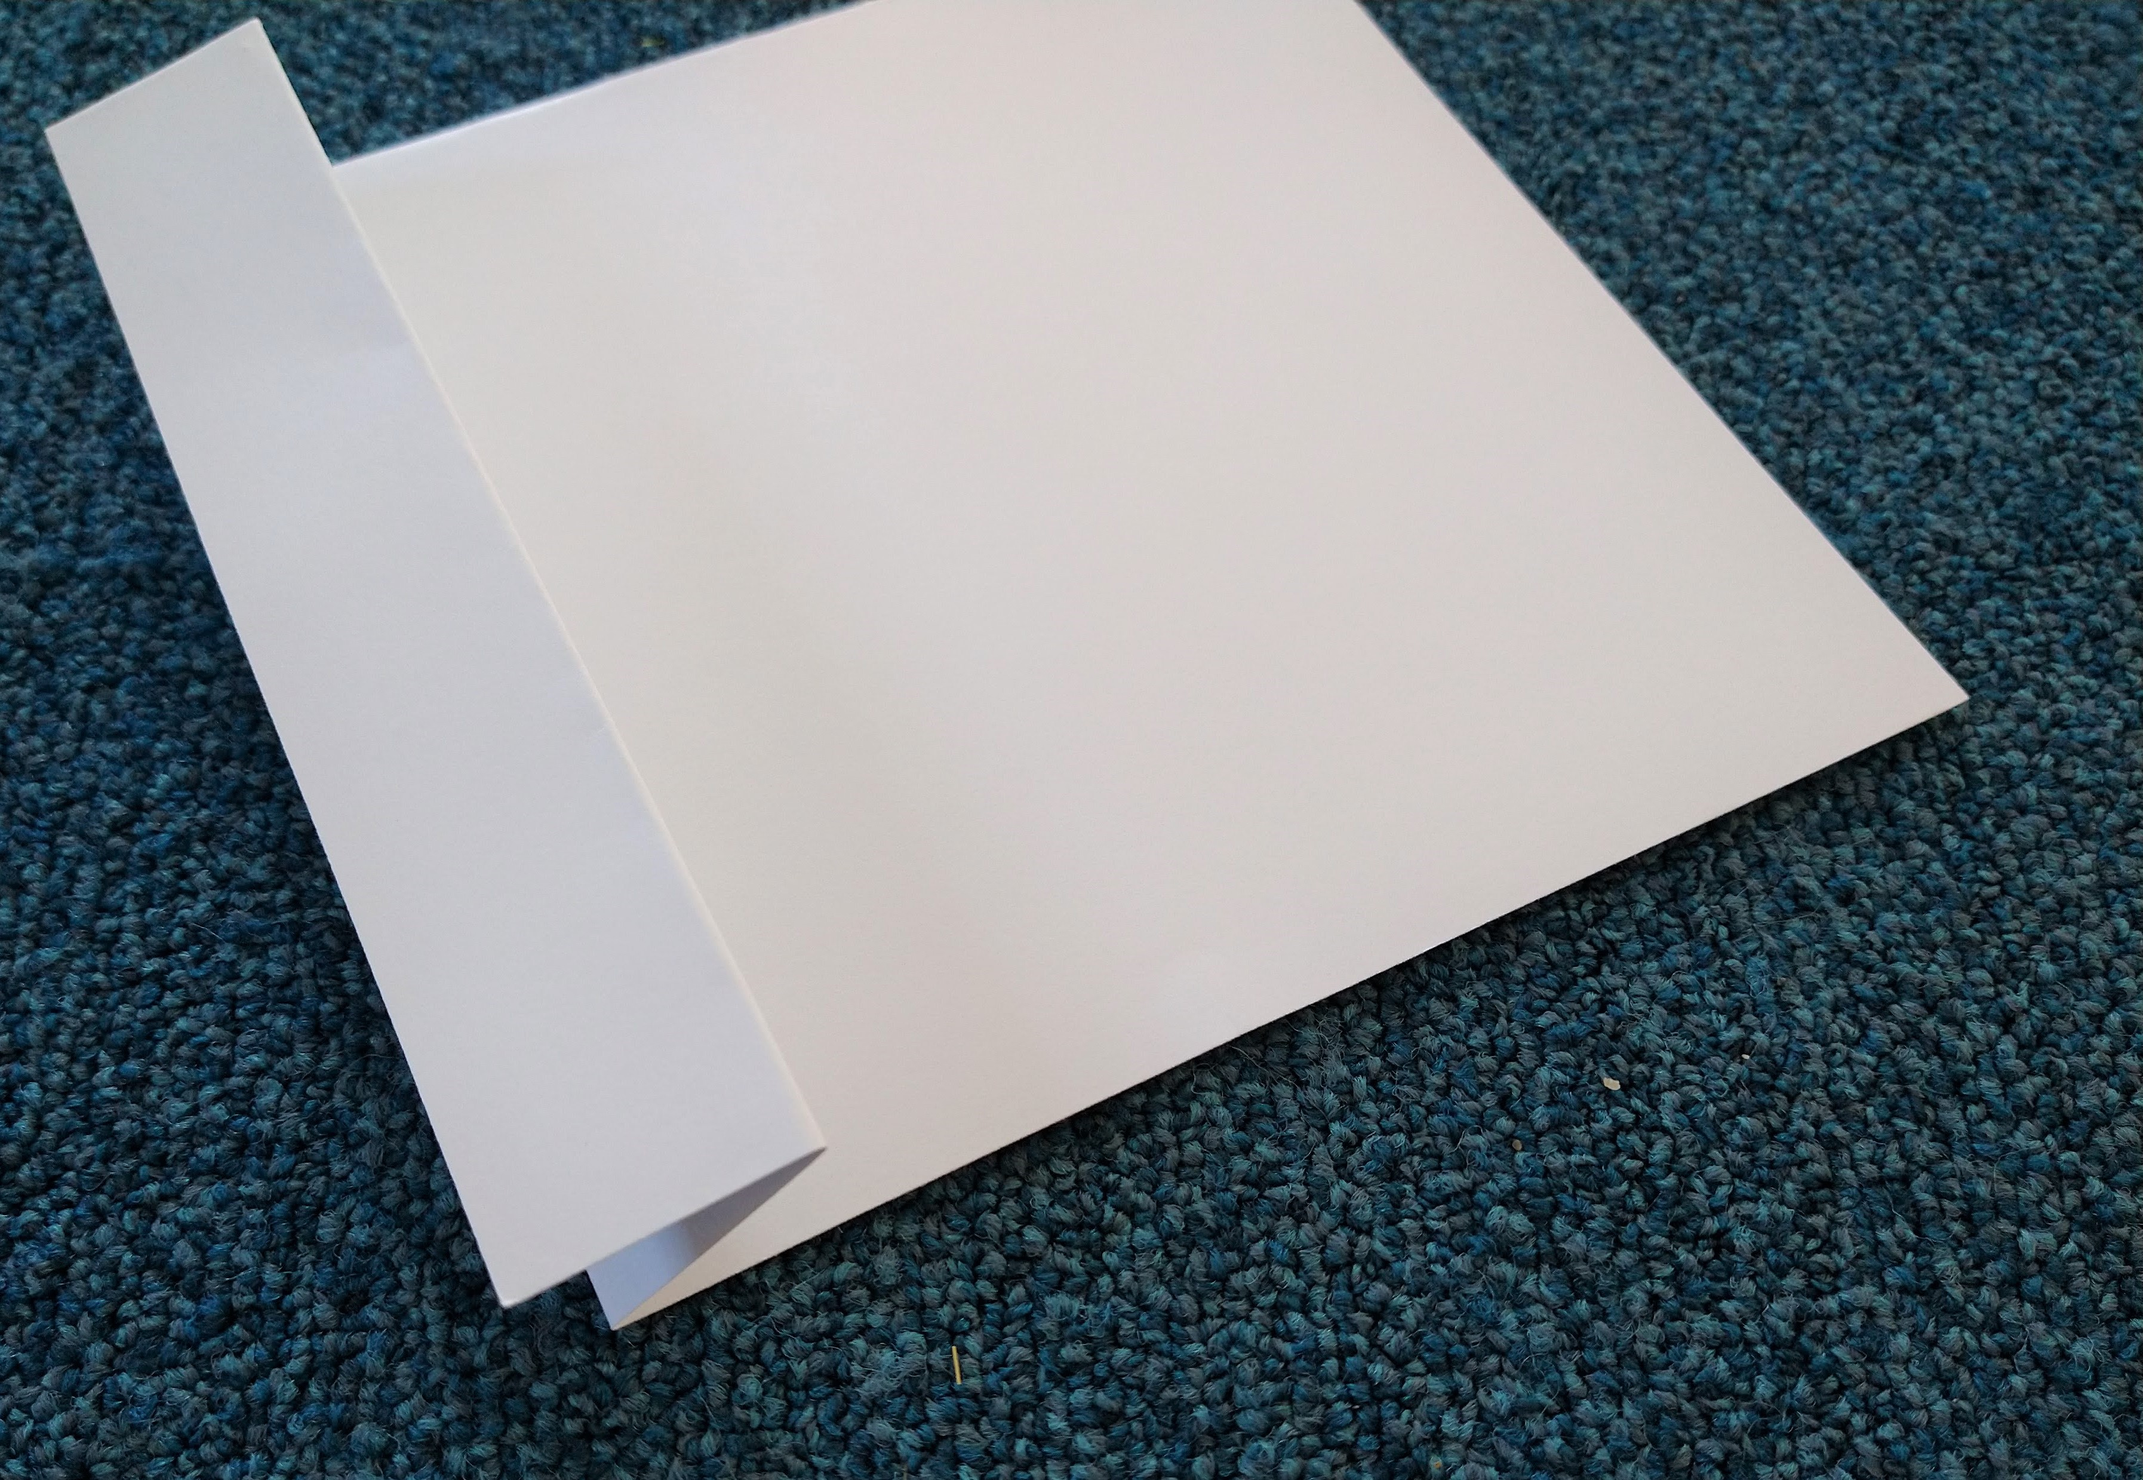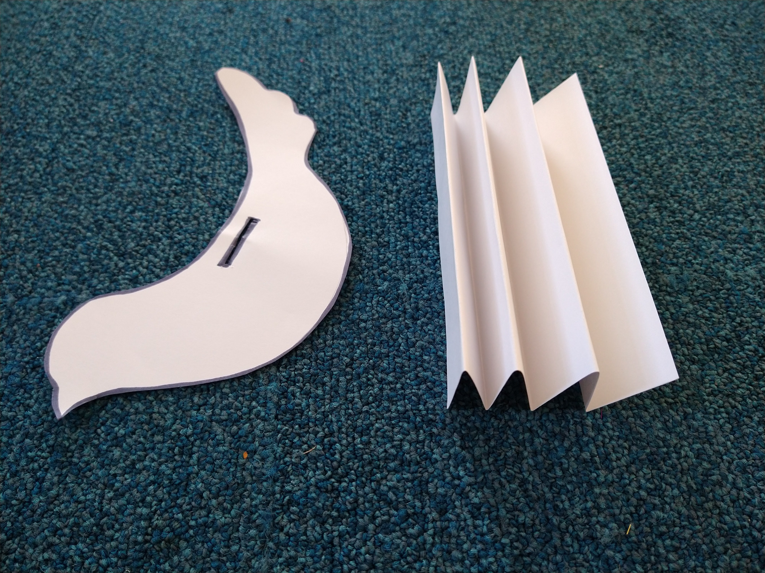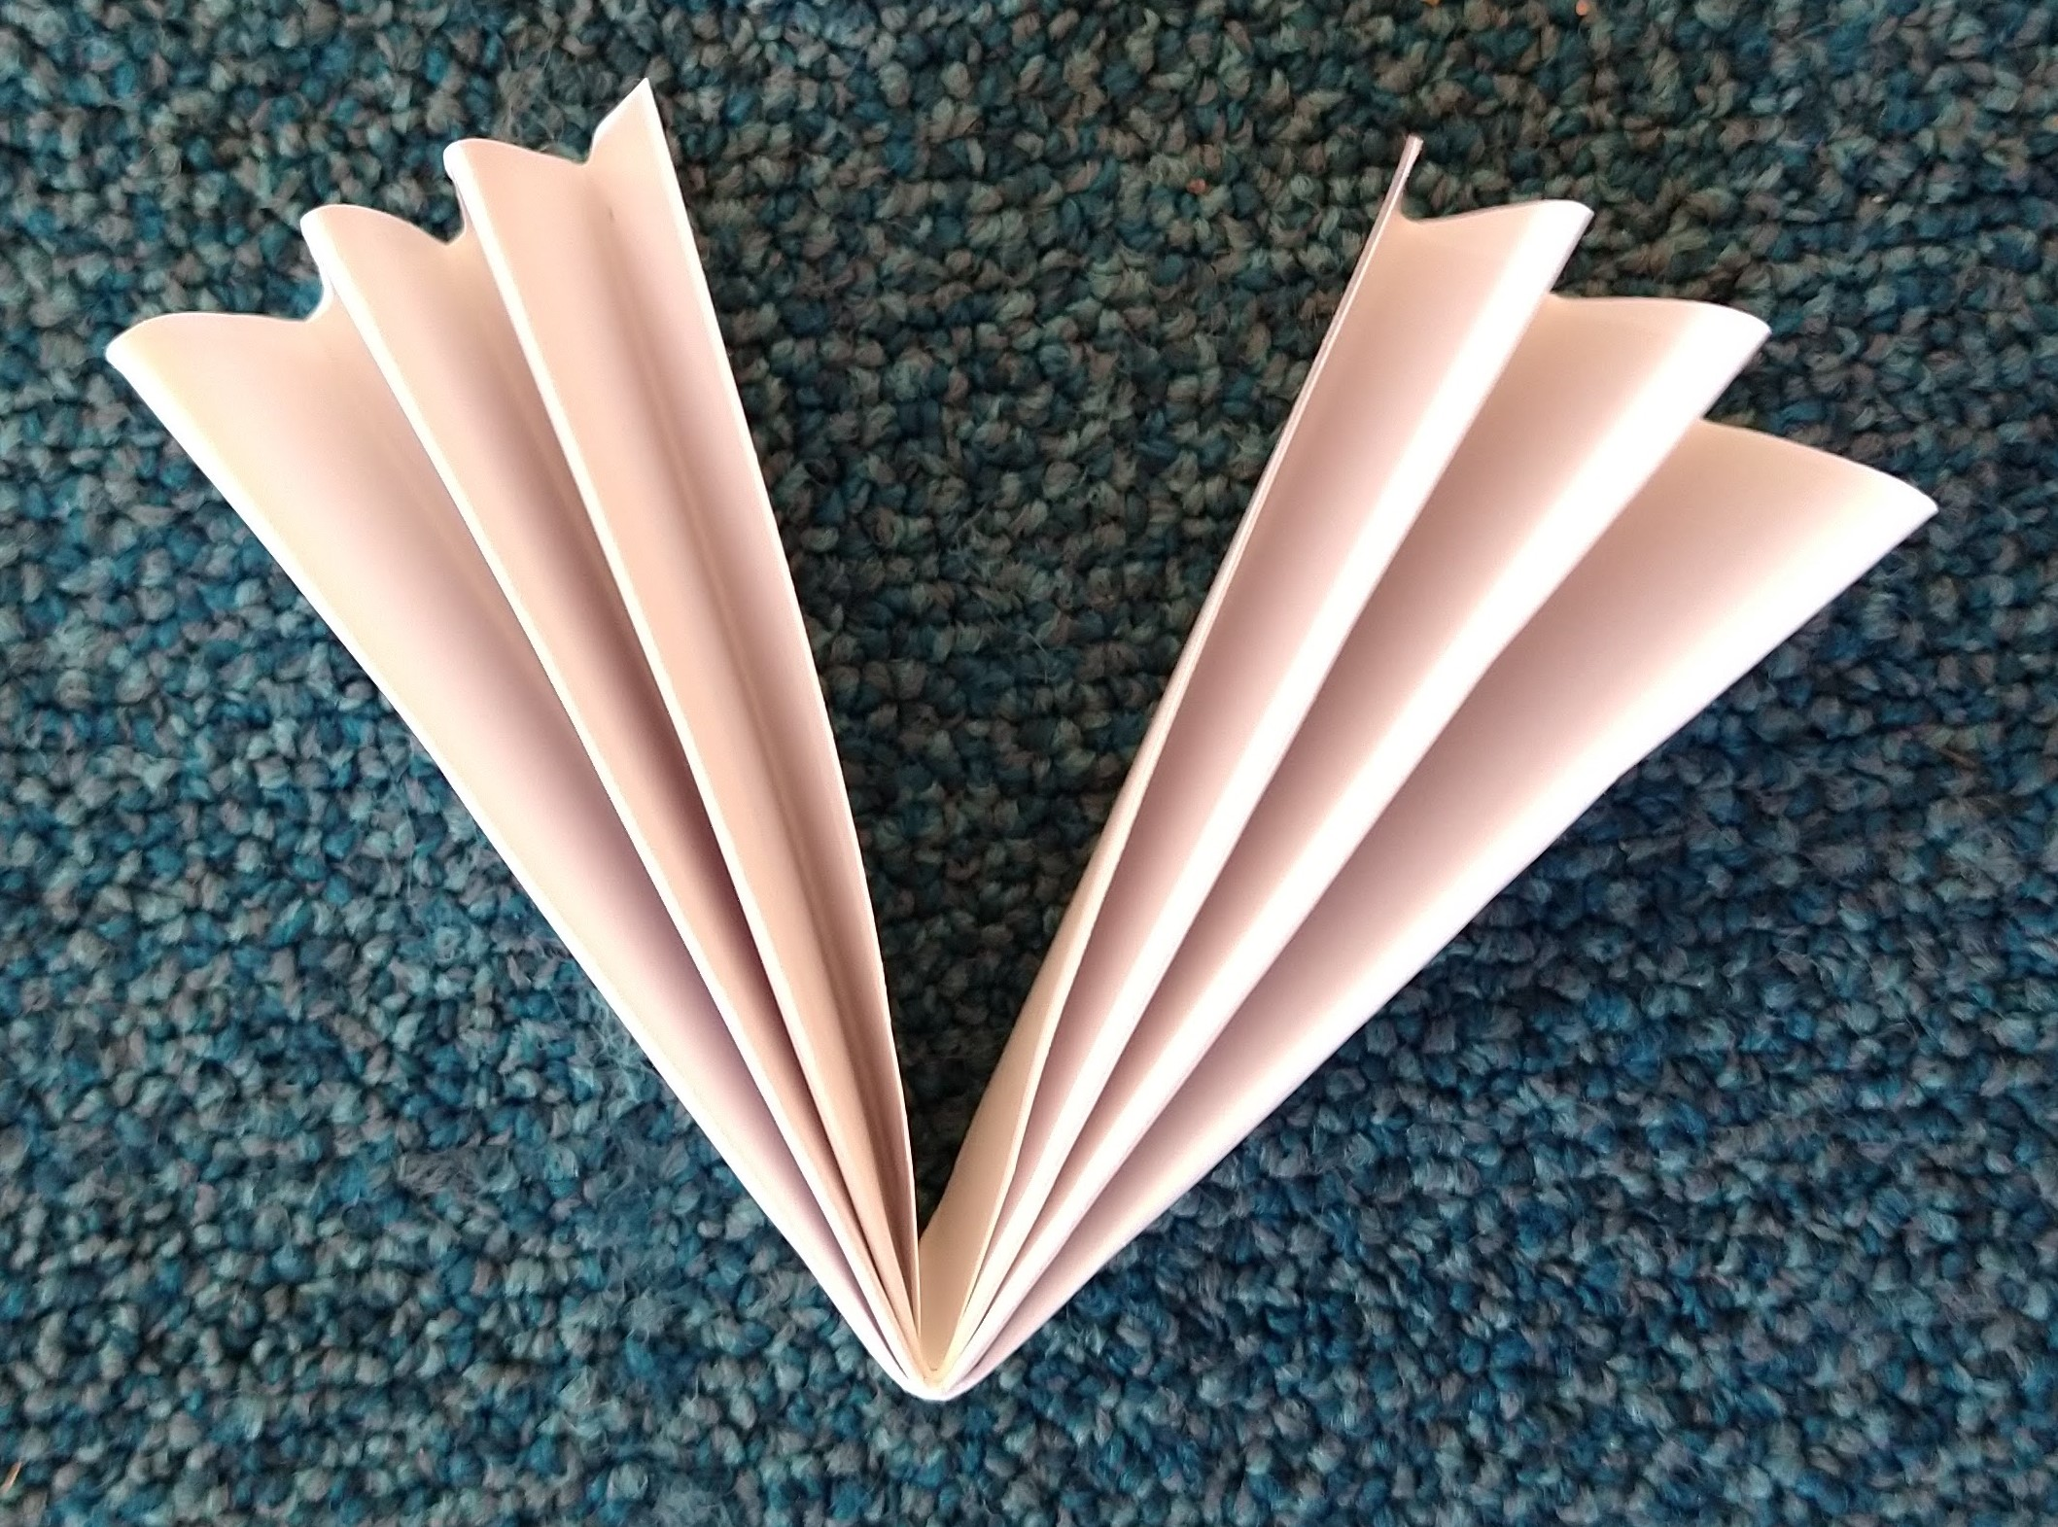
Fold the other half of the sheet of card into a concertina, like you're making a fan. Each section should be the same width as the slit in the back of your dove. Fold the concertina in half to make two wings.
Step 4.
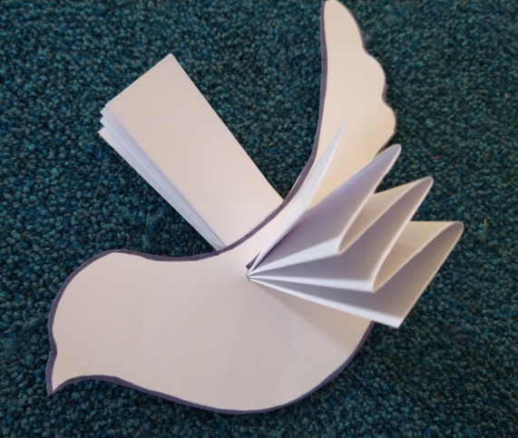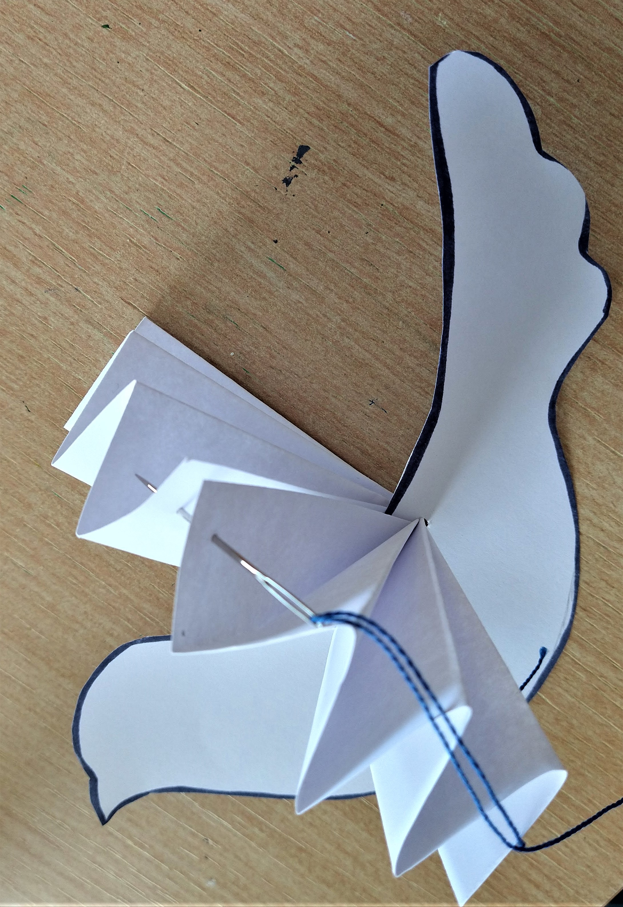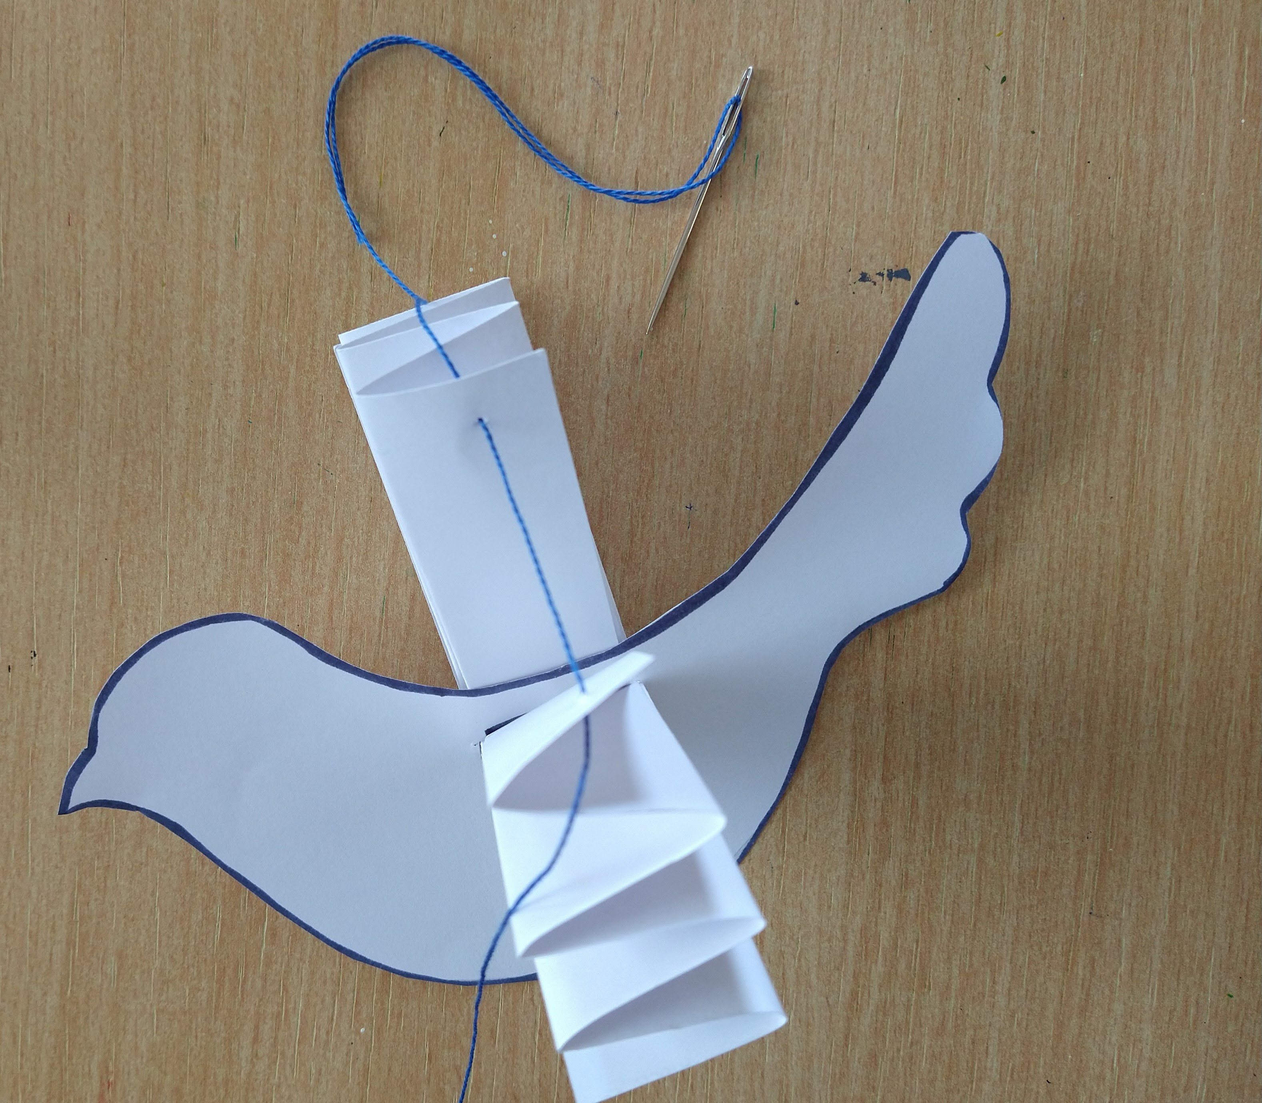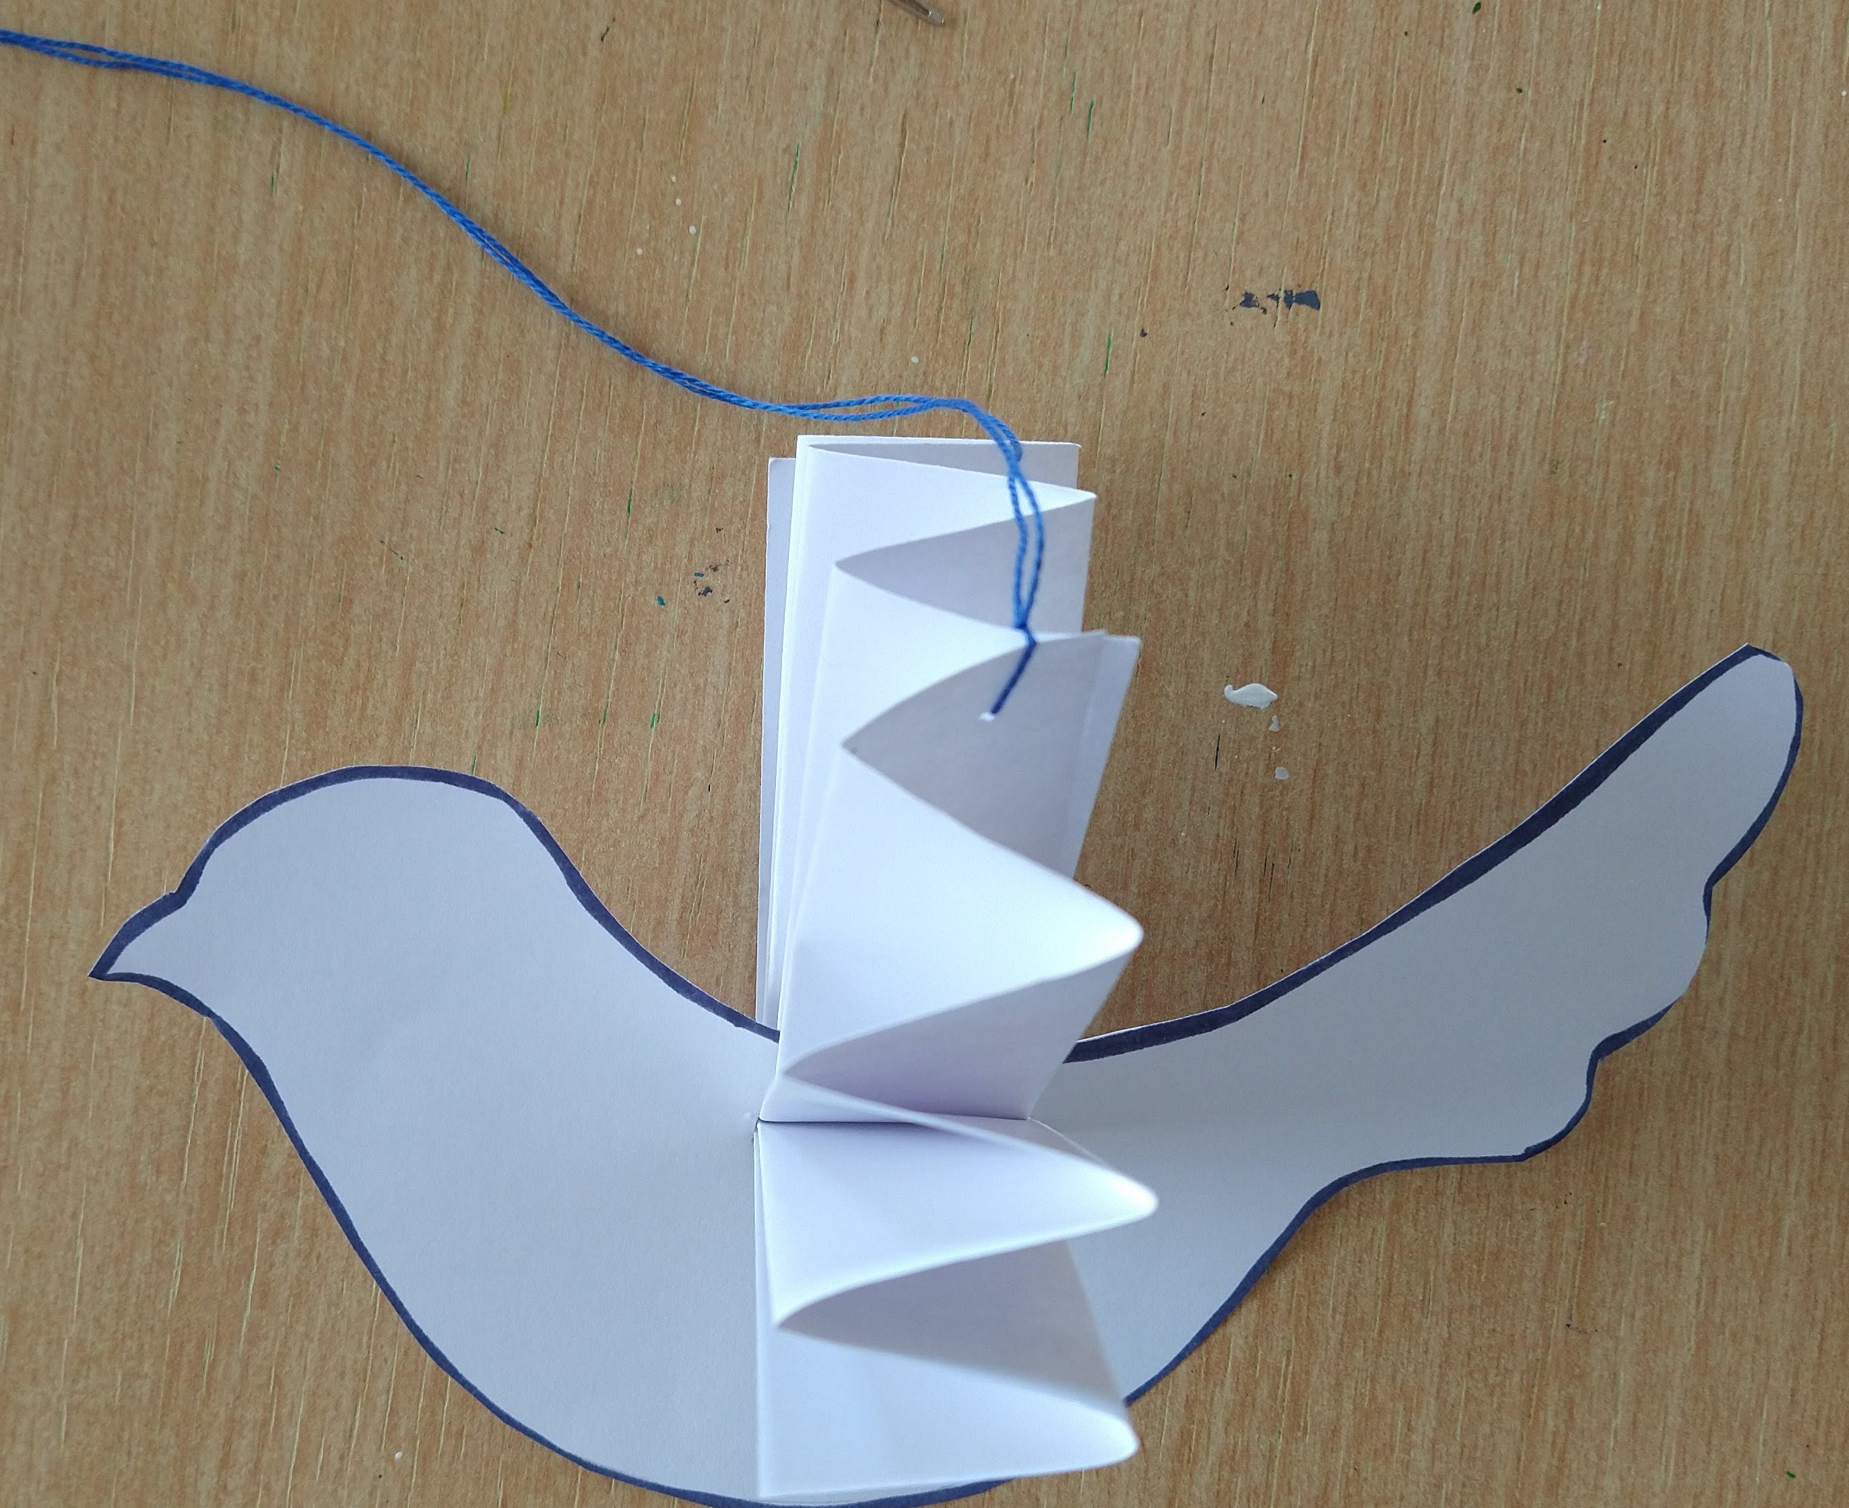
Carefully slide the concertina through the slit in the dove's back. Bring the two wings together and thread a piece of string through each side. This will hold the wings together and allow you to hang your dove up.
Have fun and don't forget to share your beautiful peaceful doves with us!

