Pom-Pom Ice Cream Cones
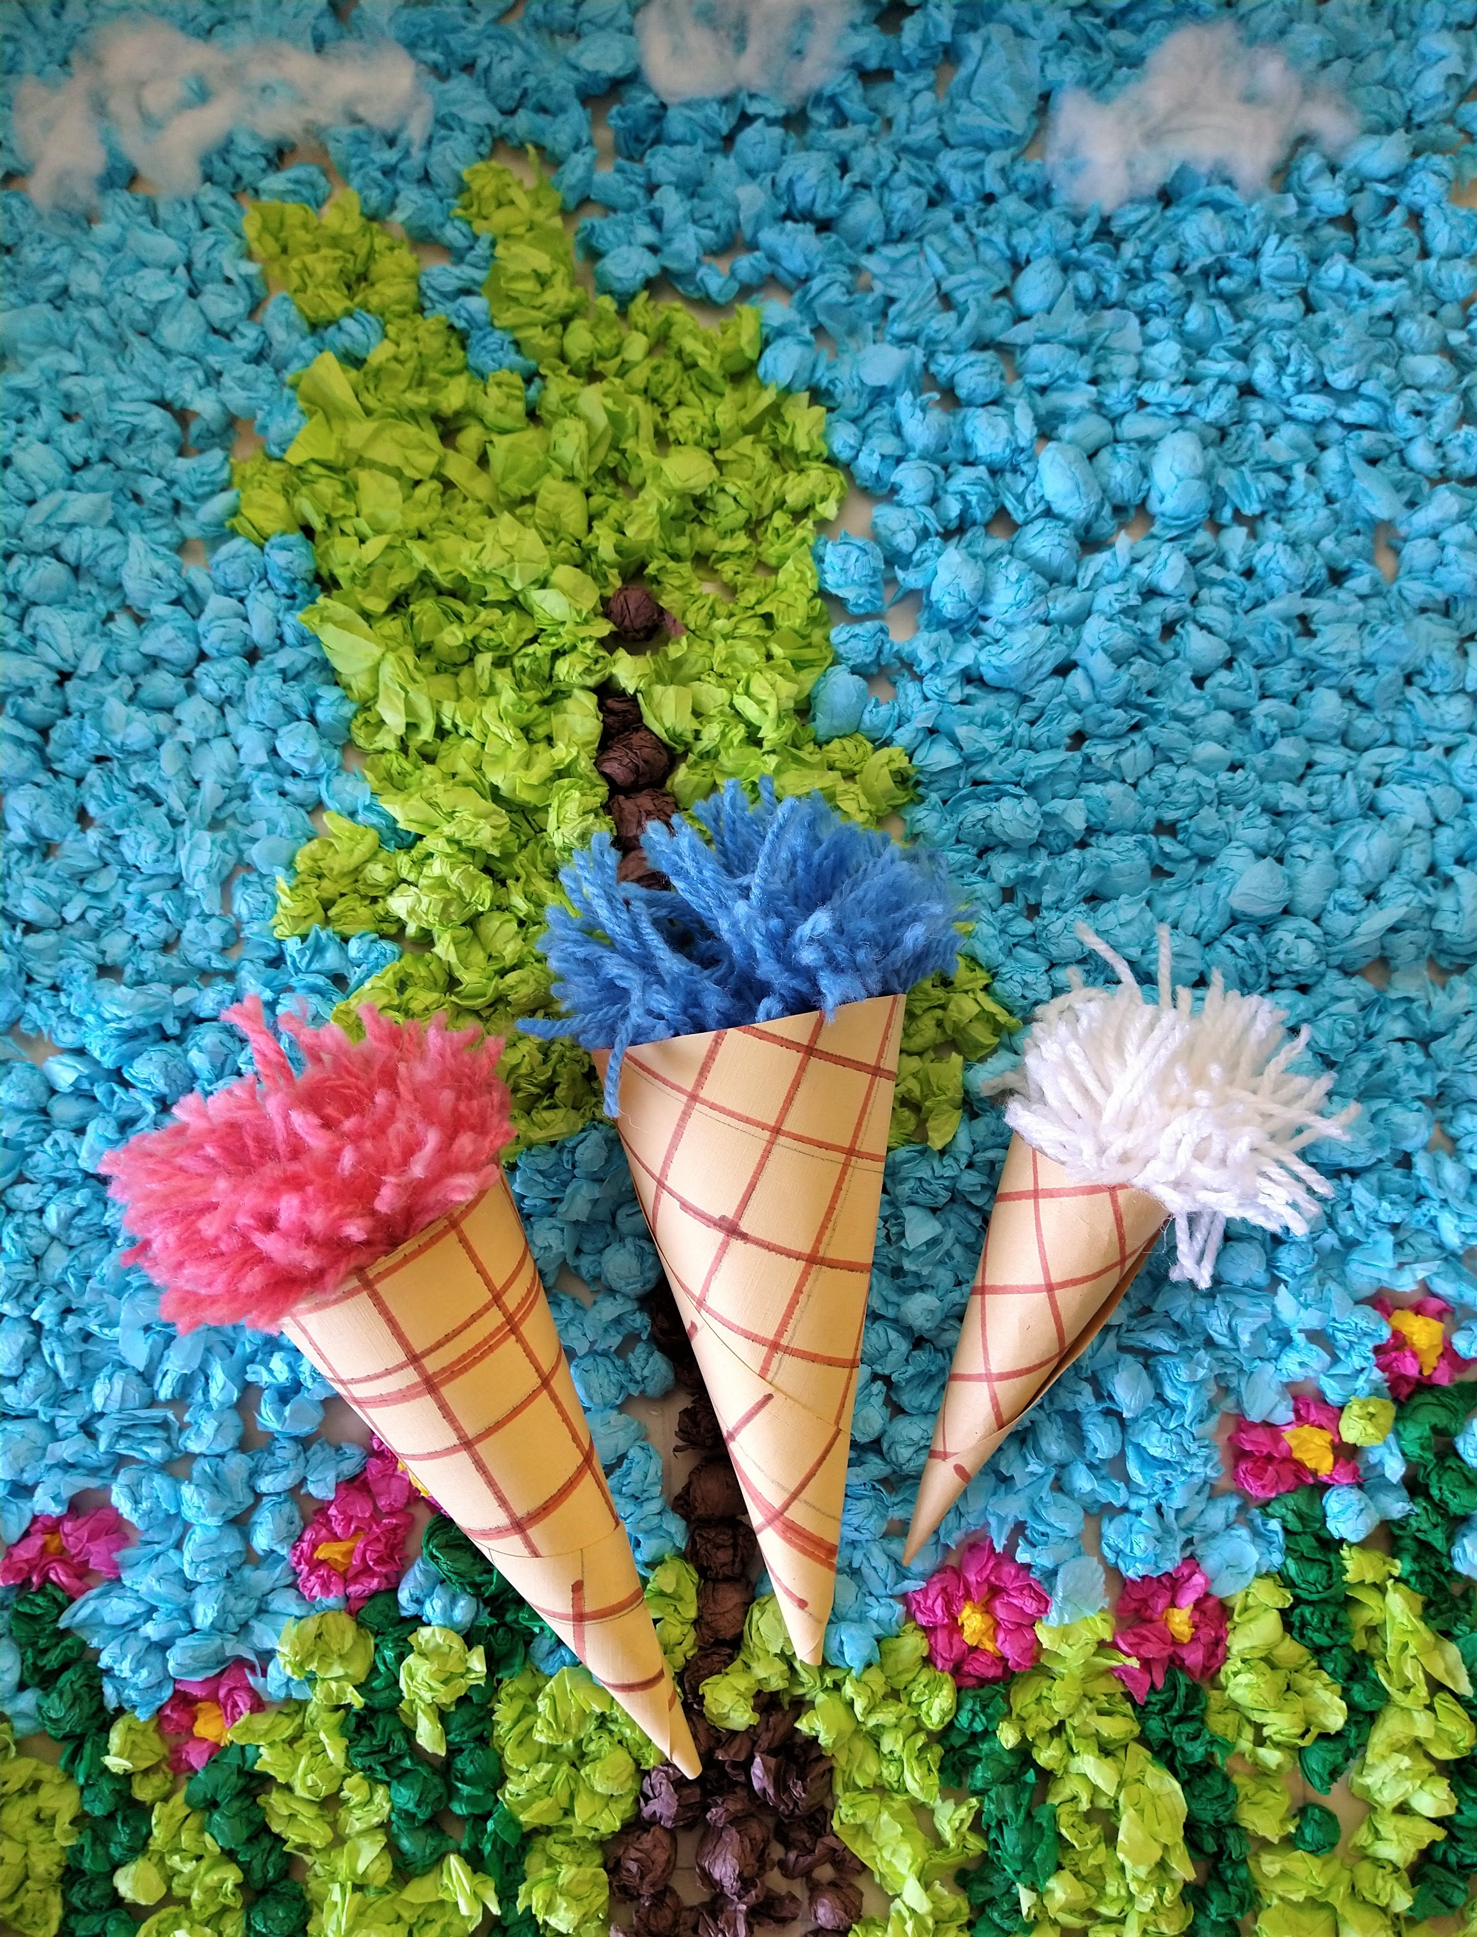
These pom-poms are fun and easy to make and you can use different colours to make them look like different flavours of ice cream! Chris and Cheryl had fun making these ones!
You will need:
- Yarn
- Card or paper, cream coloured if you have it
- Cardboard
- Scissors
- Brown Felt tip pen
- Glue stick
Step 1.
Make your ice cream (pom pom!)
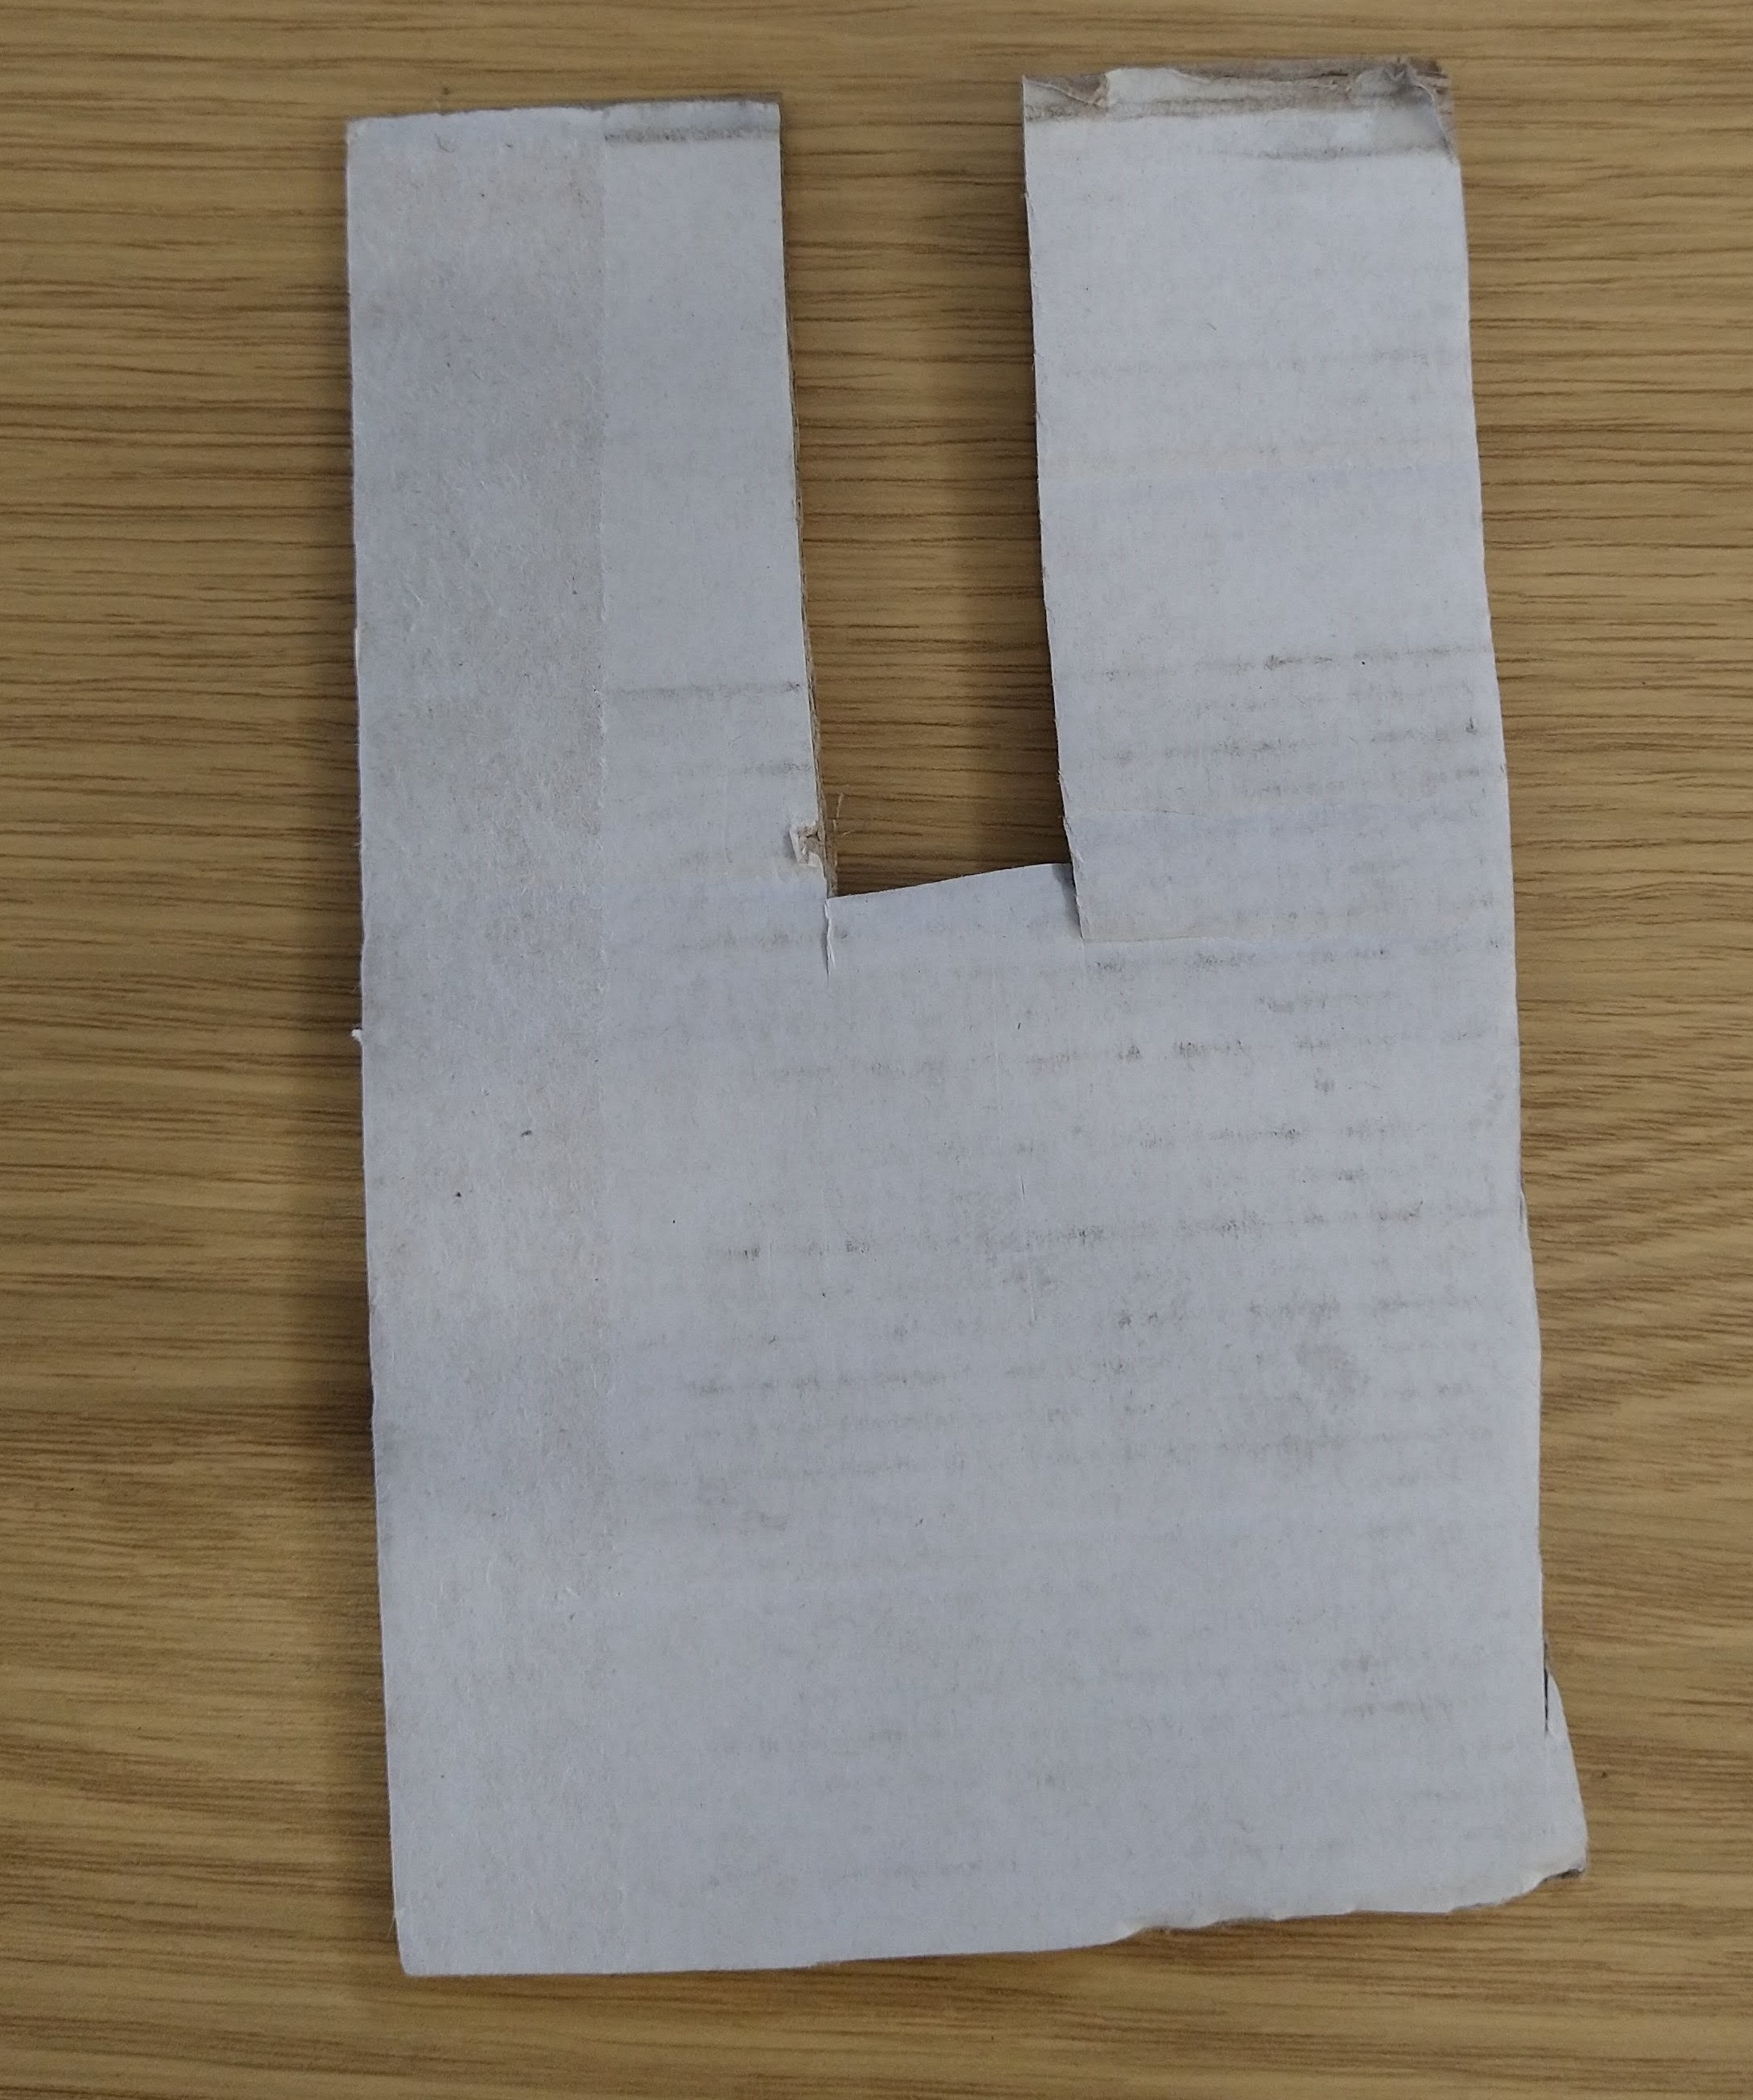
Cut a squared off 'U' shape from your cardboard.
Step 2.
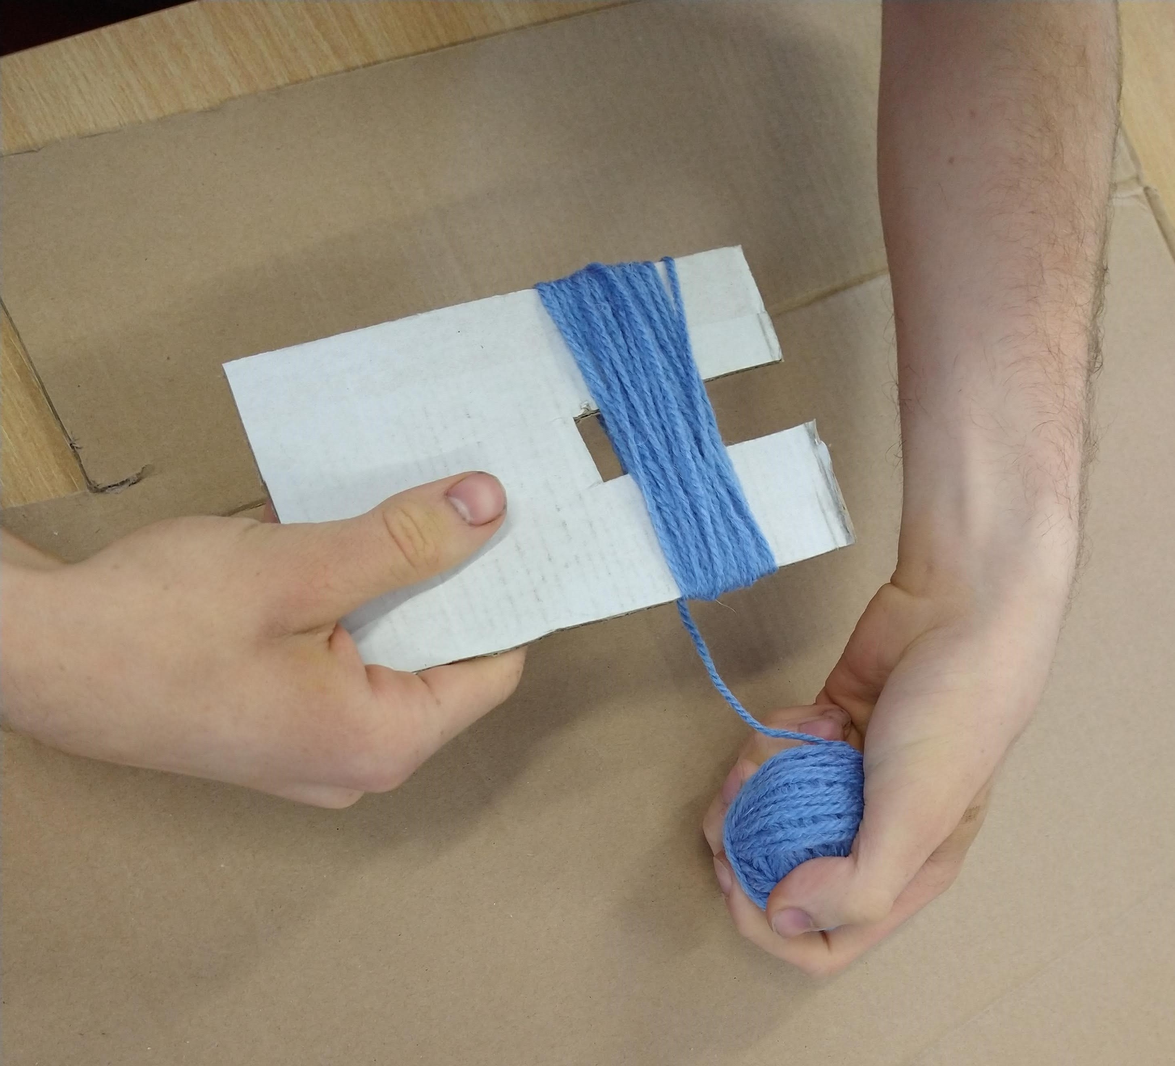
Wrap your yarn around the 'U' until it's nice and thick.
Step 3.
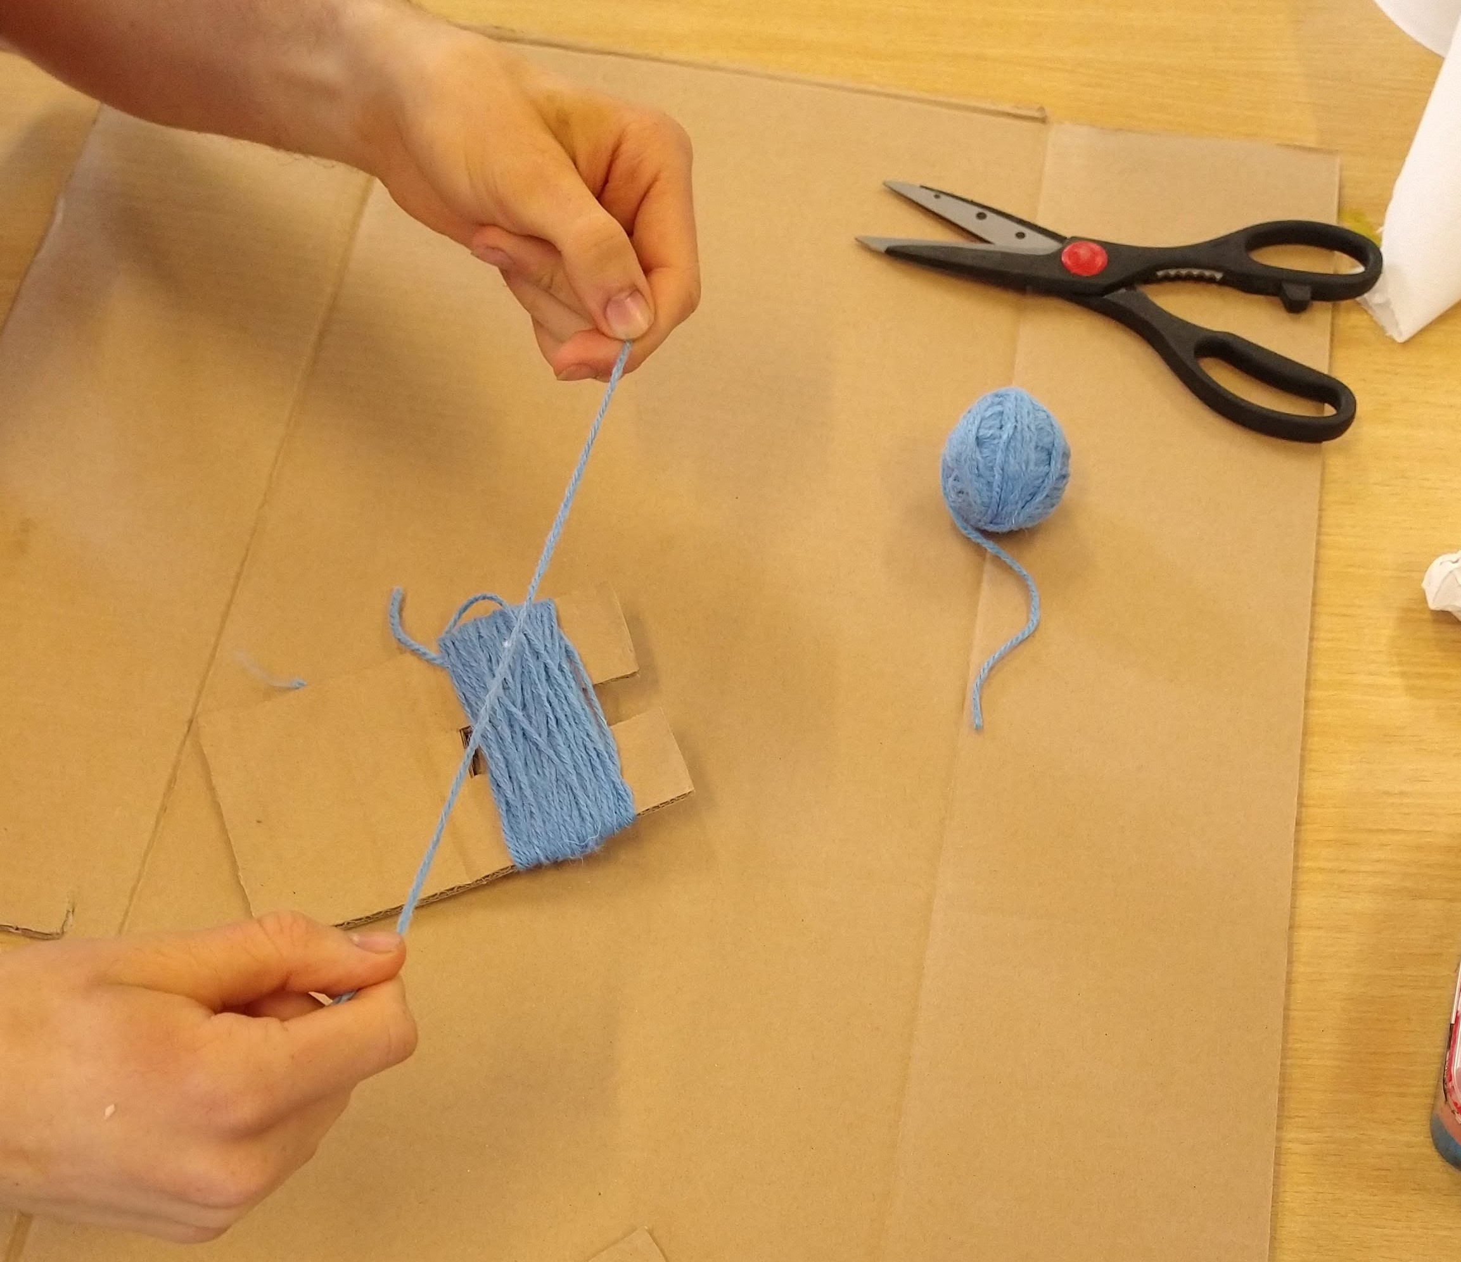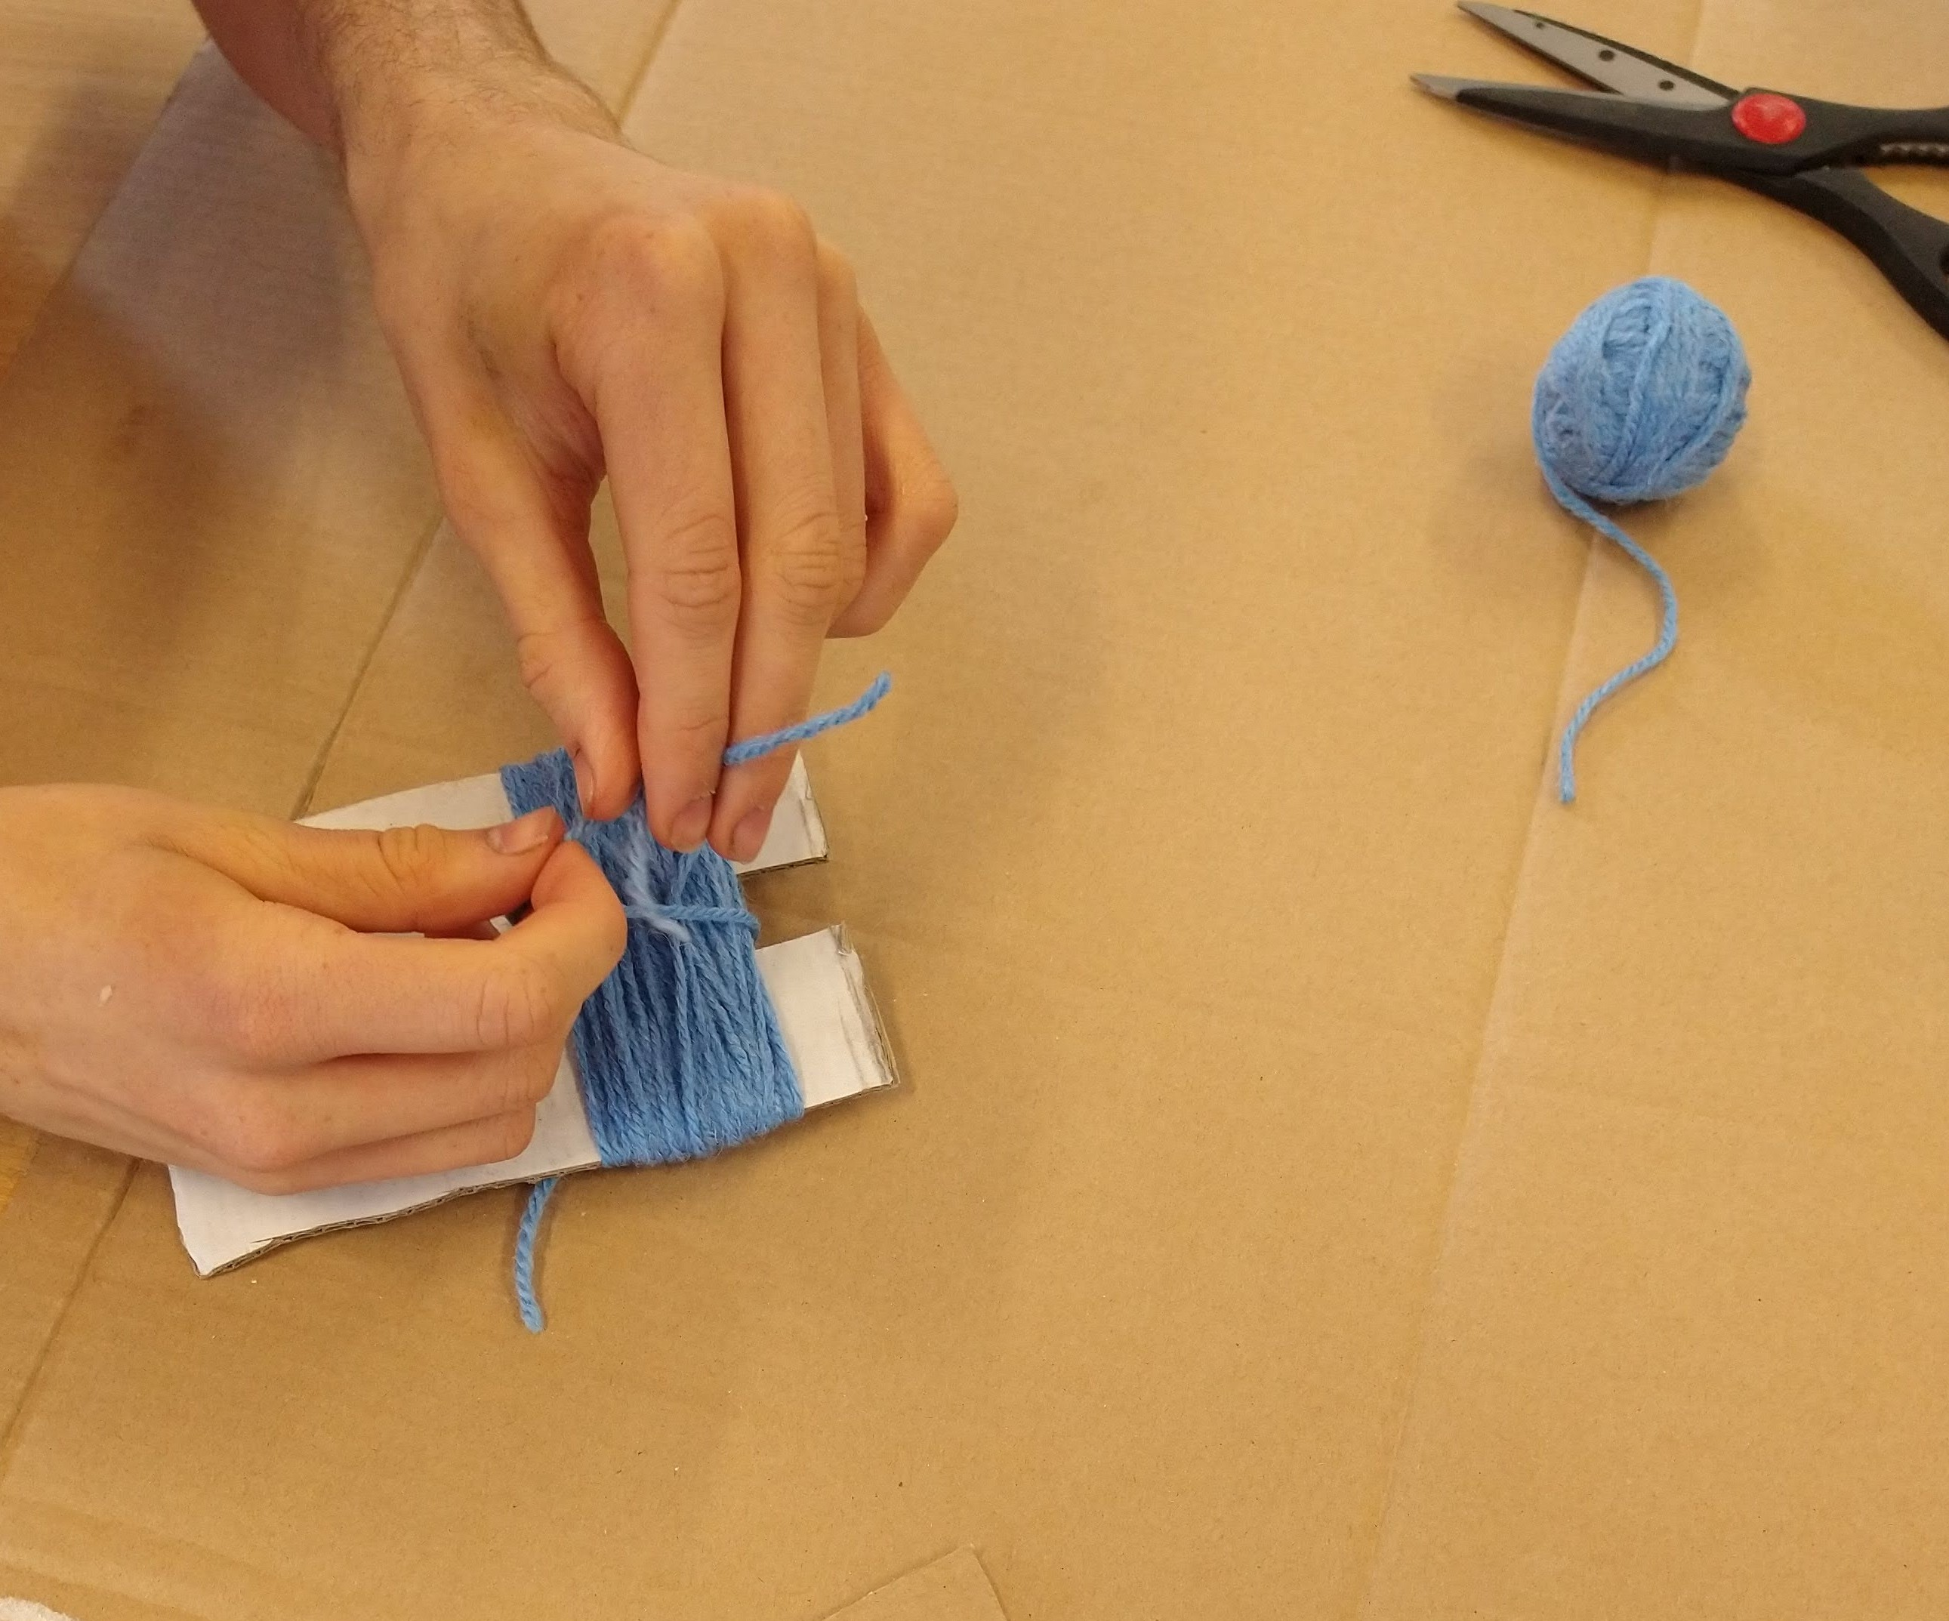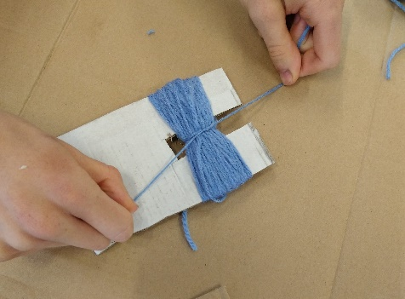
Tie a piece of yarn as tightly as you can around the middle of your yarn wraps.
Step 4.
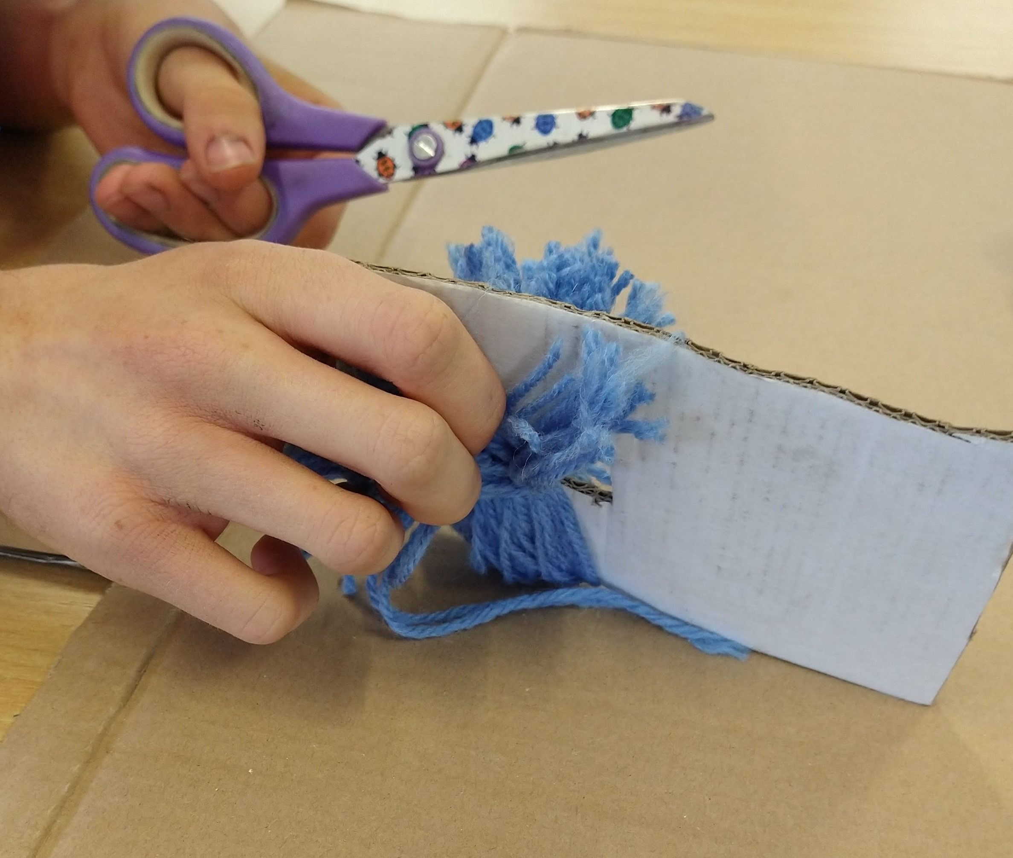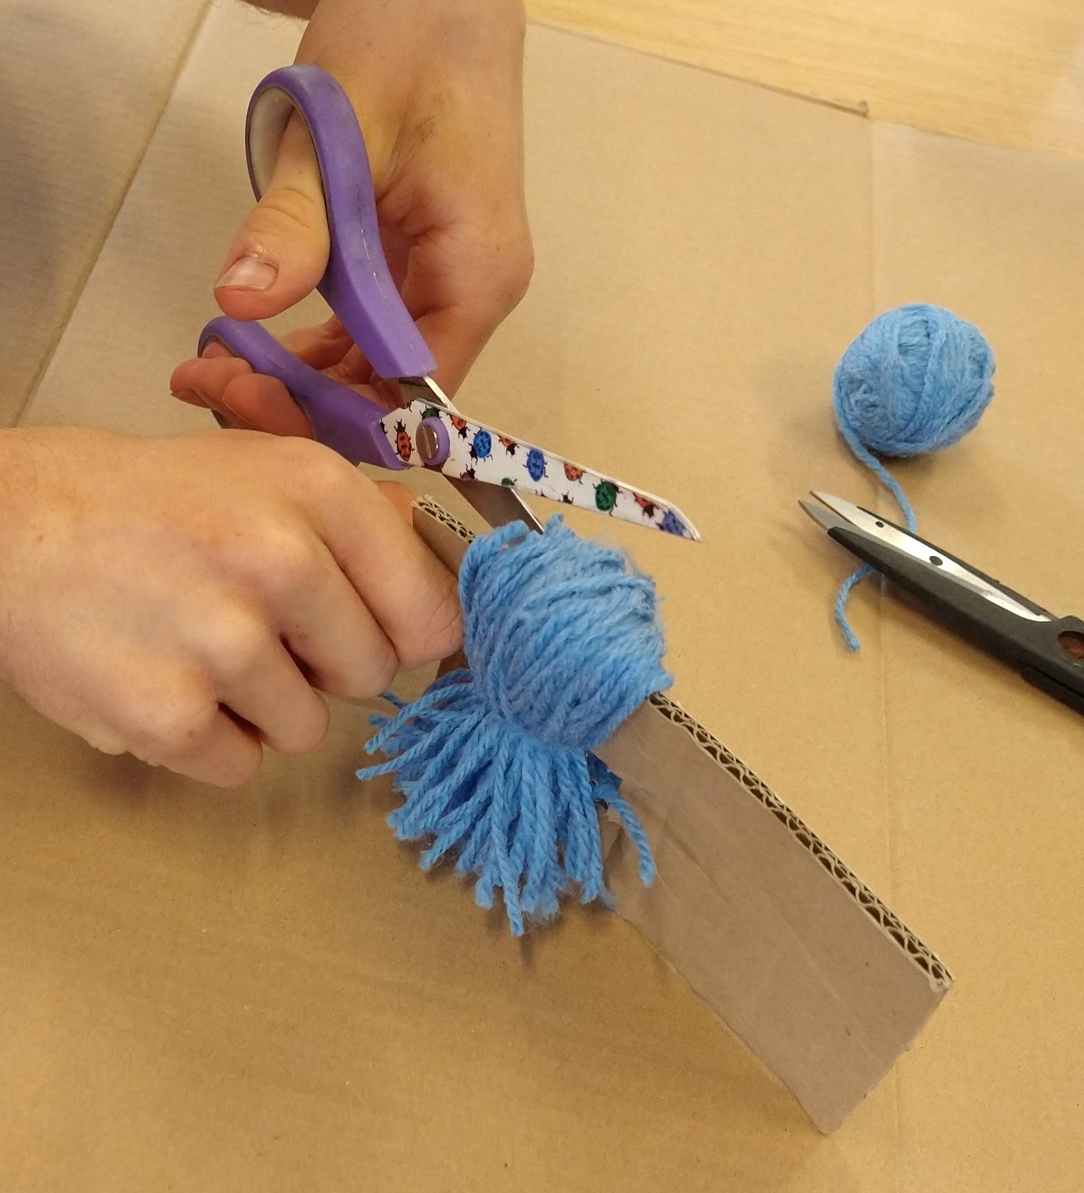
Cut each end of the yarn wrap, as shown.

Step 5.
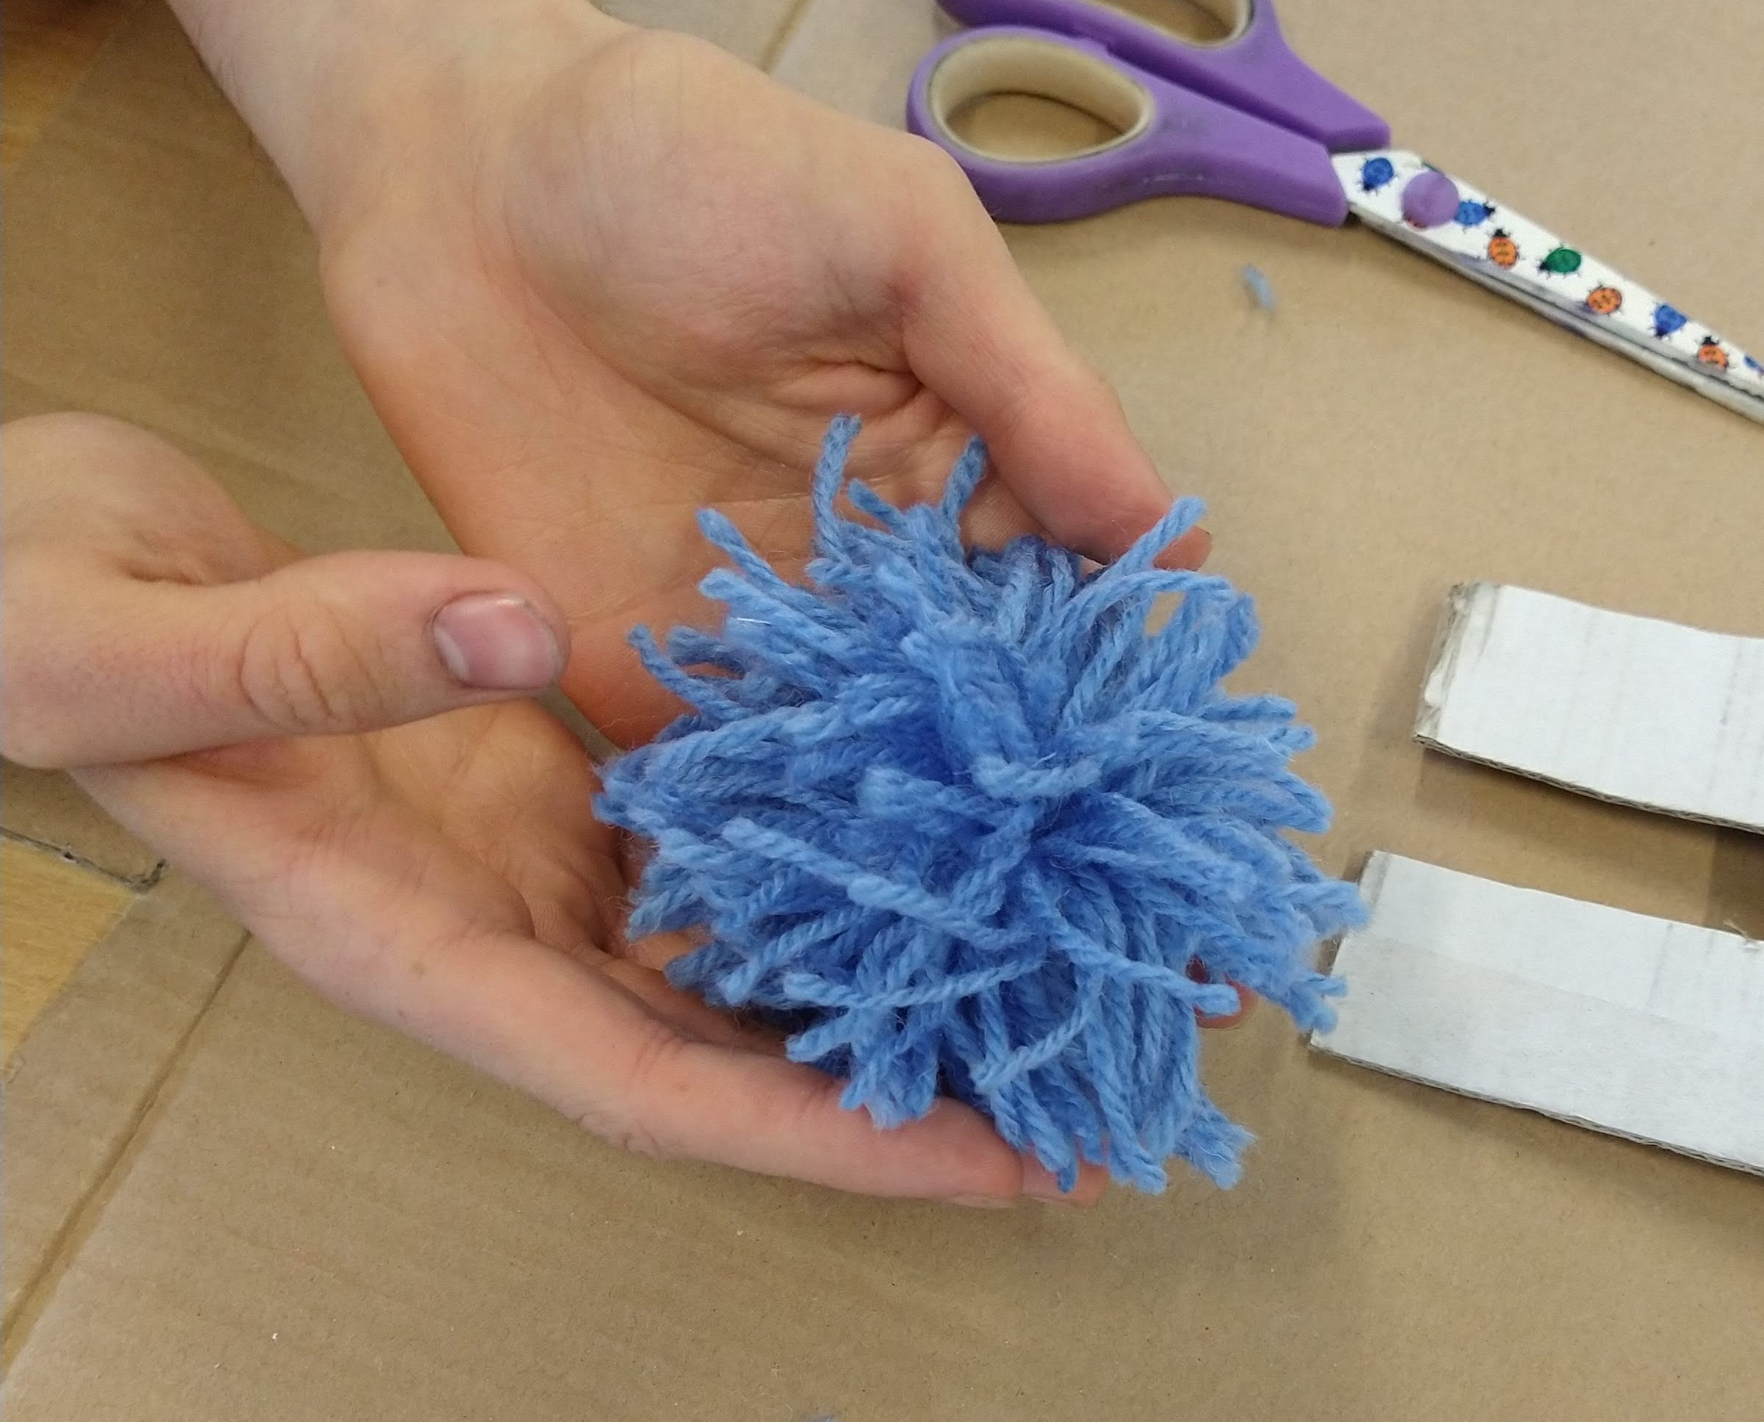
Give your pom pom a trim!
Step 6.
Make your cone!
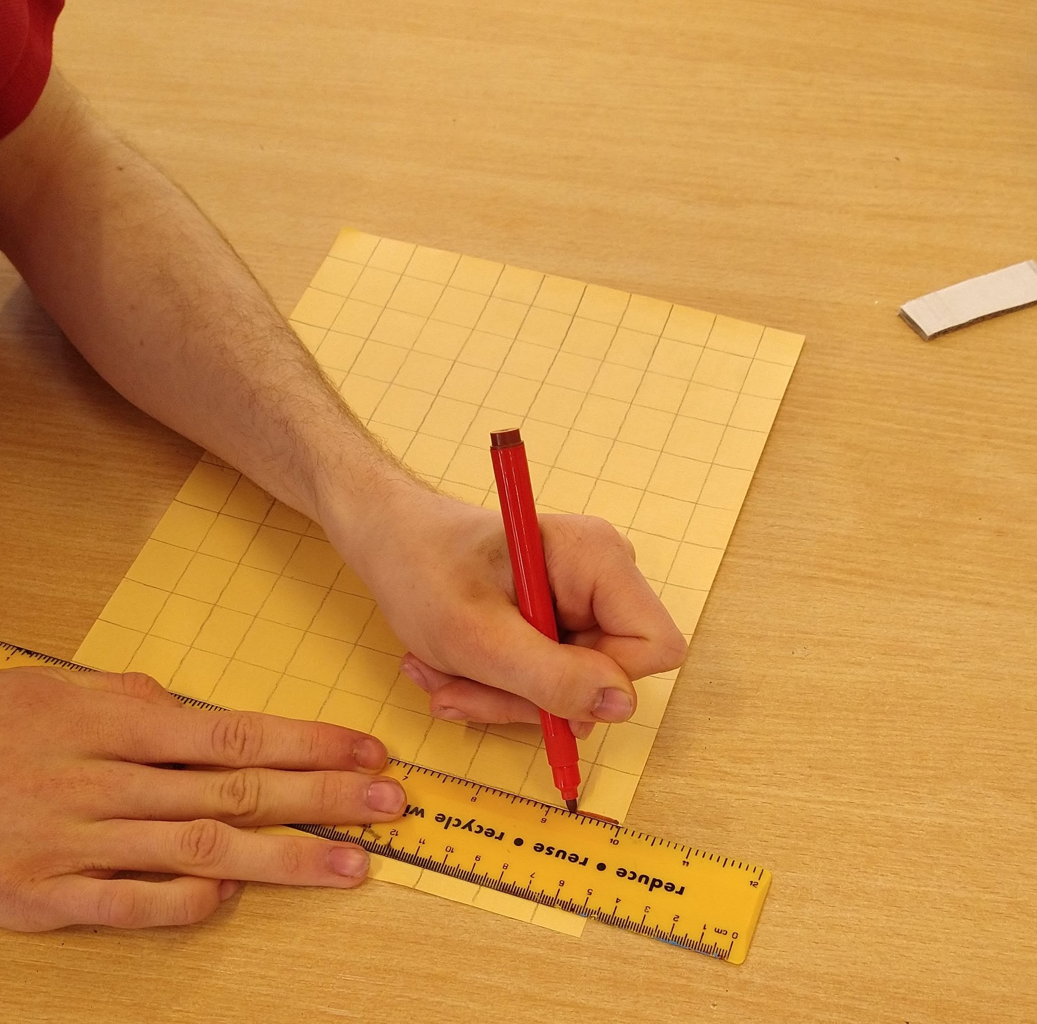
Use the brown felt tip pen to draw a grid of squares onto your paper. We used a sheet of A4 which we then cut in half so we got two cones from one piece!
Step 7.
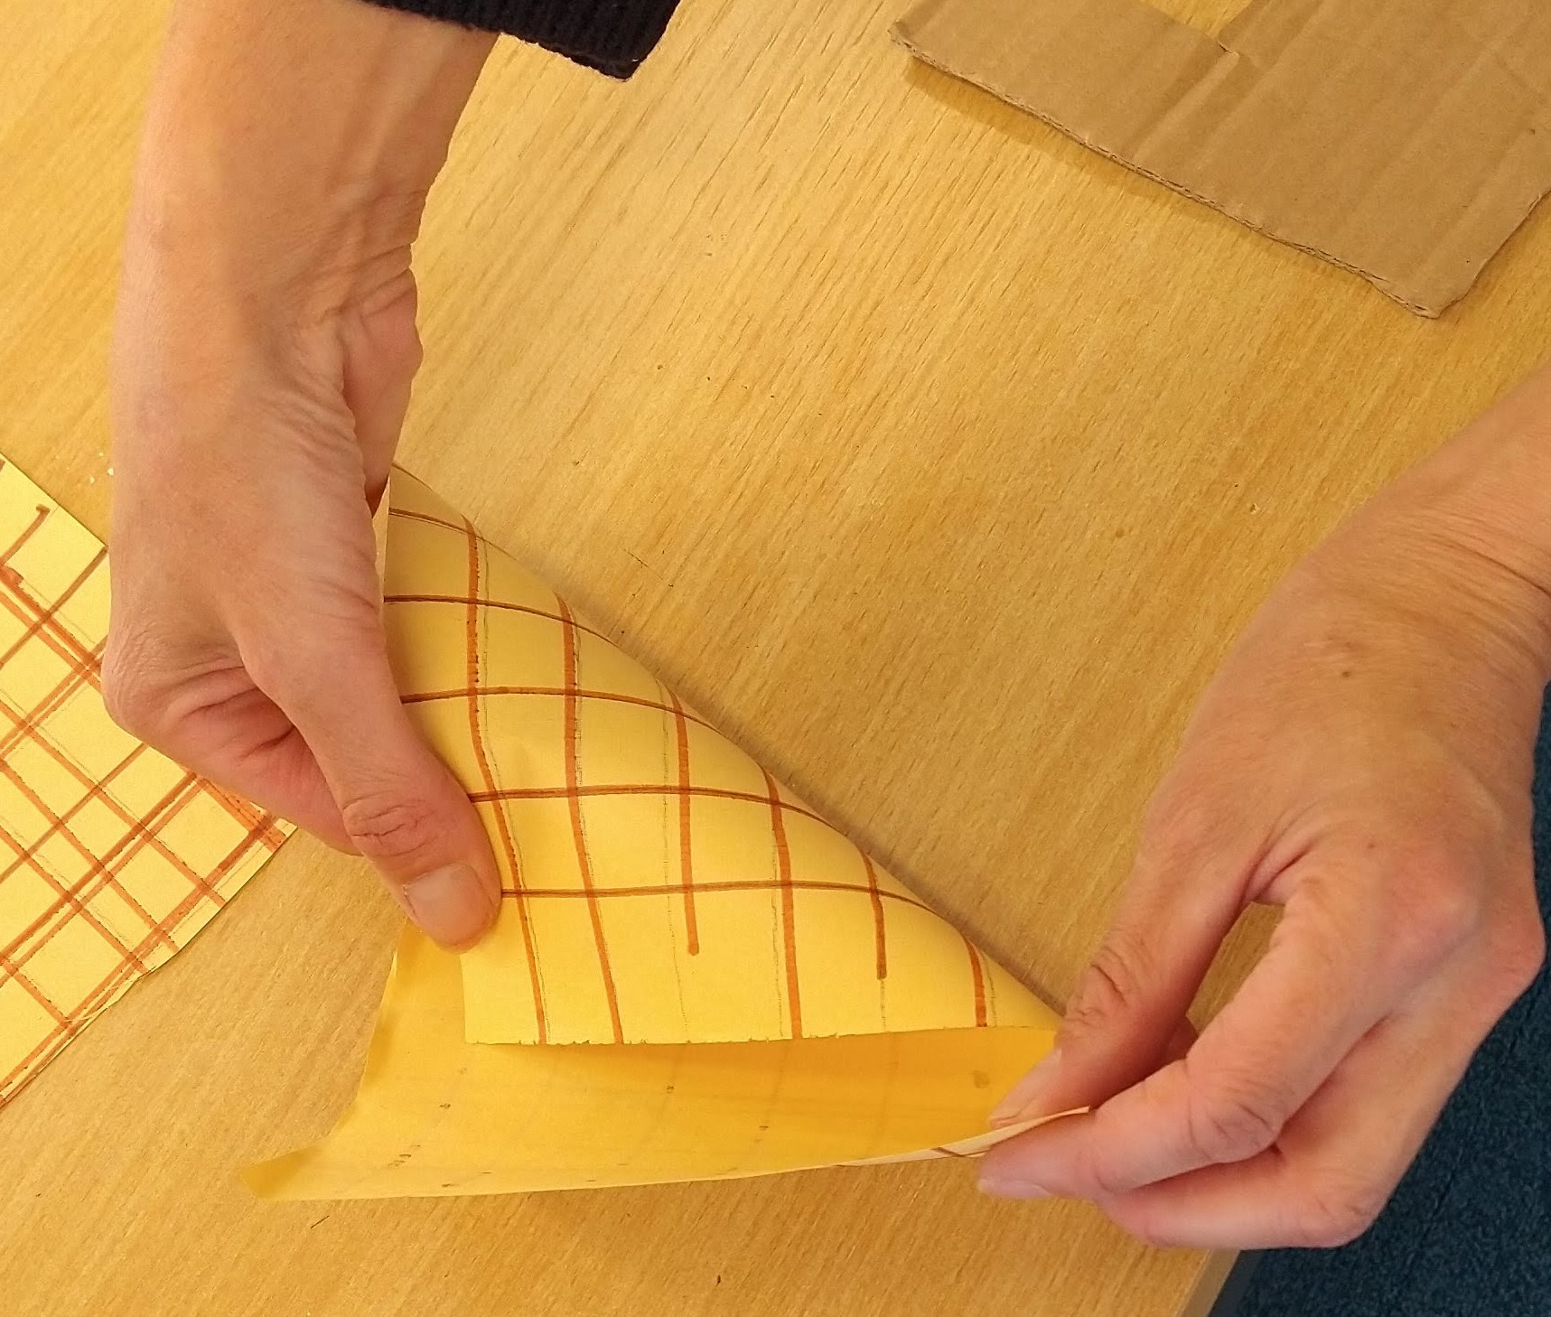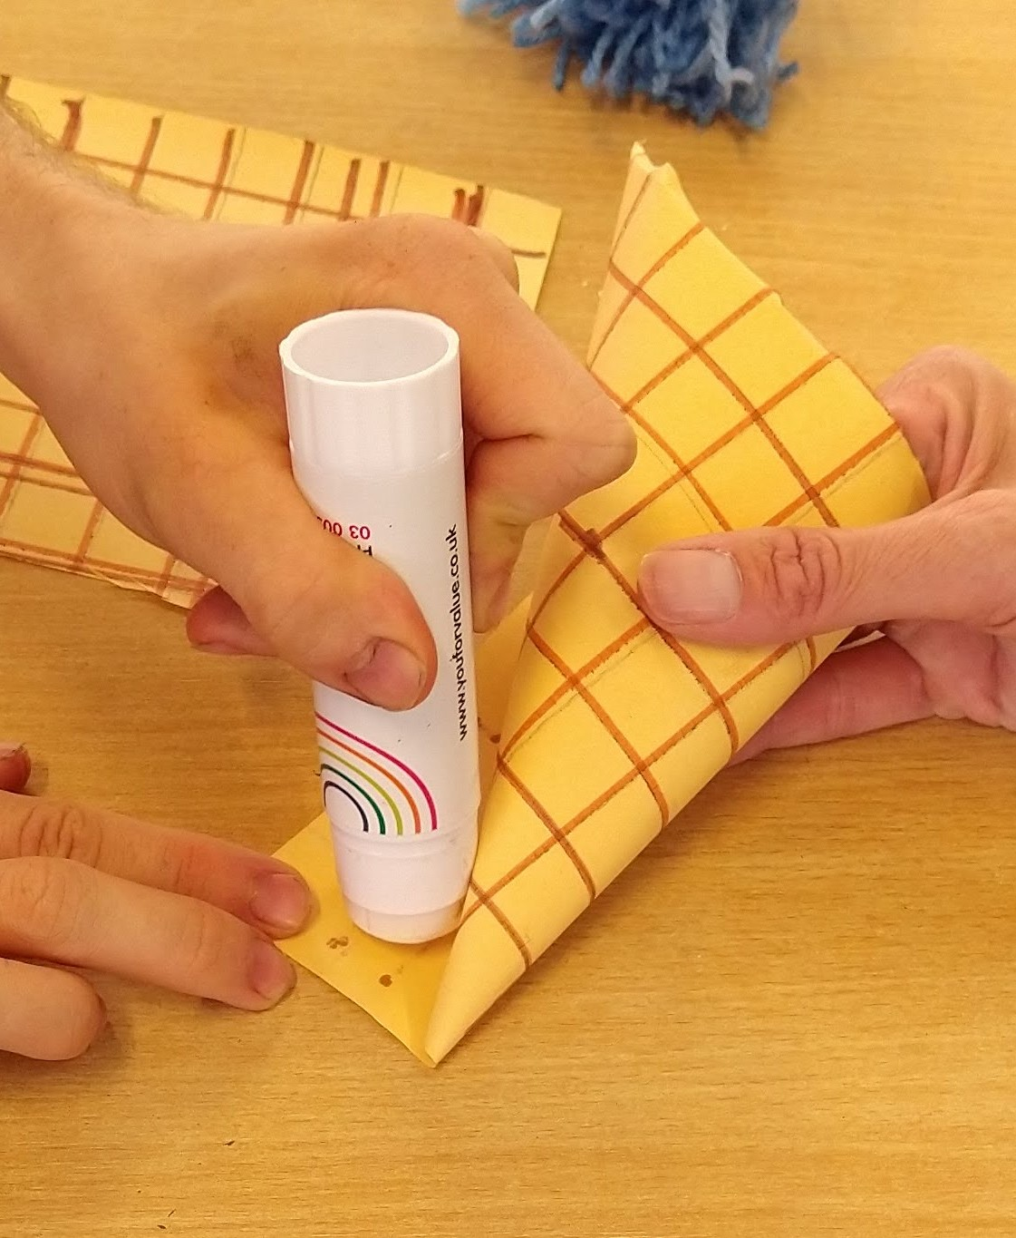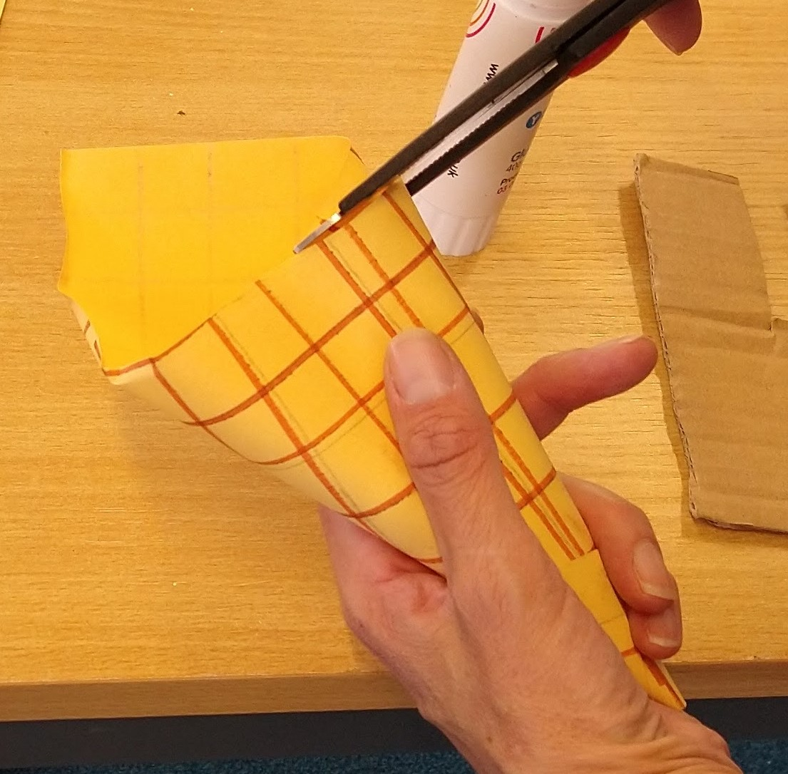
Roll your paper into a cone shape, using a bit of glue to secure it, and then trim the top.
Step 8.
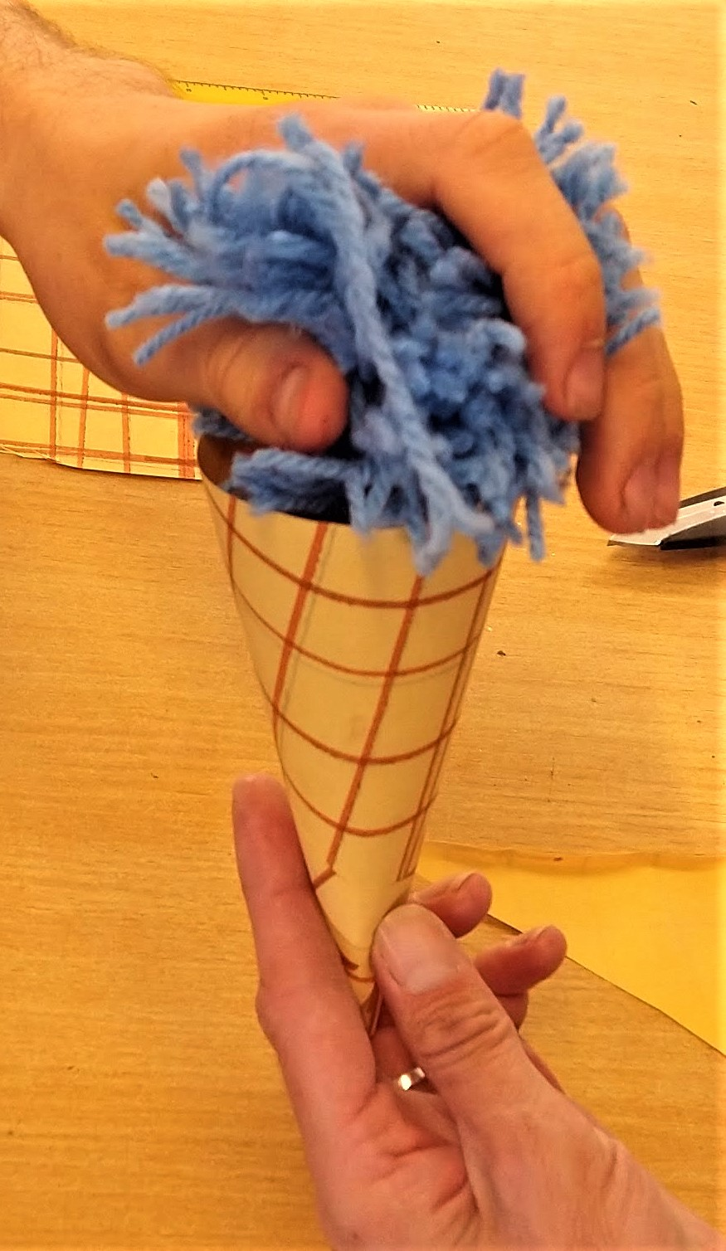
Put your 'ice cream' into your 'cone' and you're done!
Have fun and don't forget to tell us how you got on!

