Pressed Flower Pictures
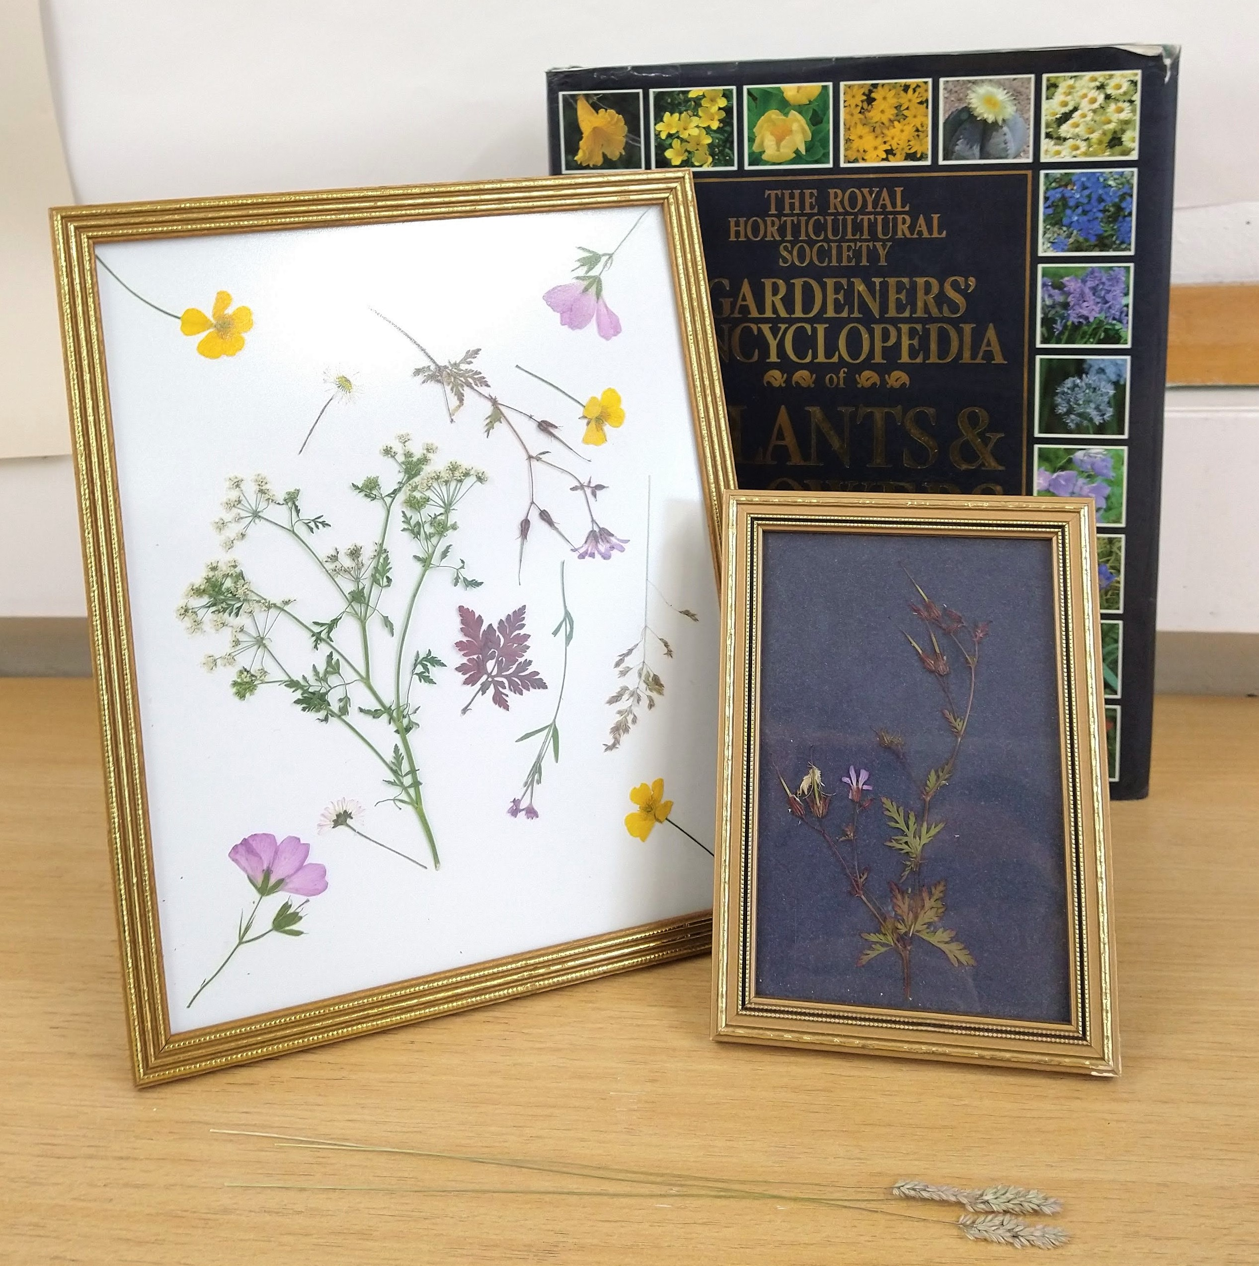
There's so many beautiful flowers around at the moment but they don't last forever! Here's an activity to help you preserve some of your favourites.

You will need:
- Flowers and leaves*
- A couple of heavy books (not really precious ones)
- Paper towels/sheets of kitchen roll
- A picture frame, an old one is fine
- Card cut to the size of your picture frame
- Glue stick

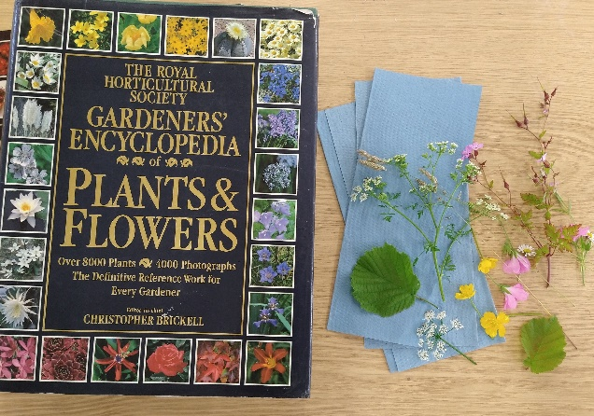
*Remember to be very careful when collecting flowers; it’s best not to pick wildflowers unless you are certain it is a common one and there’s lots of it. Also, watch out for nettles! Thinner flowers work best for this, anything too thick won’t fit between the pages of your book.

Step 1.
Dry your flowers
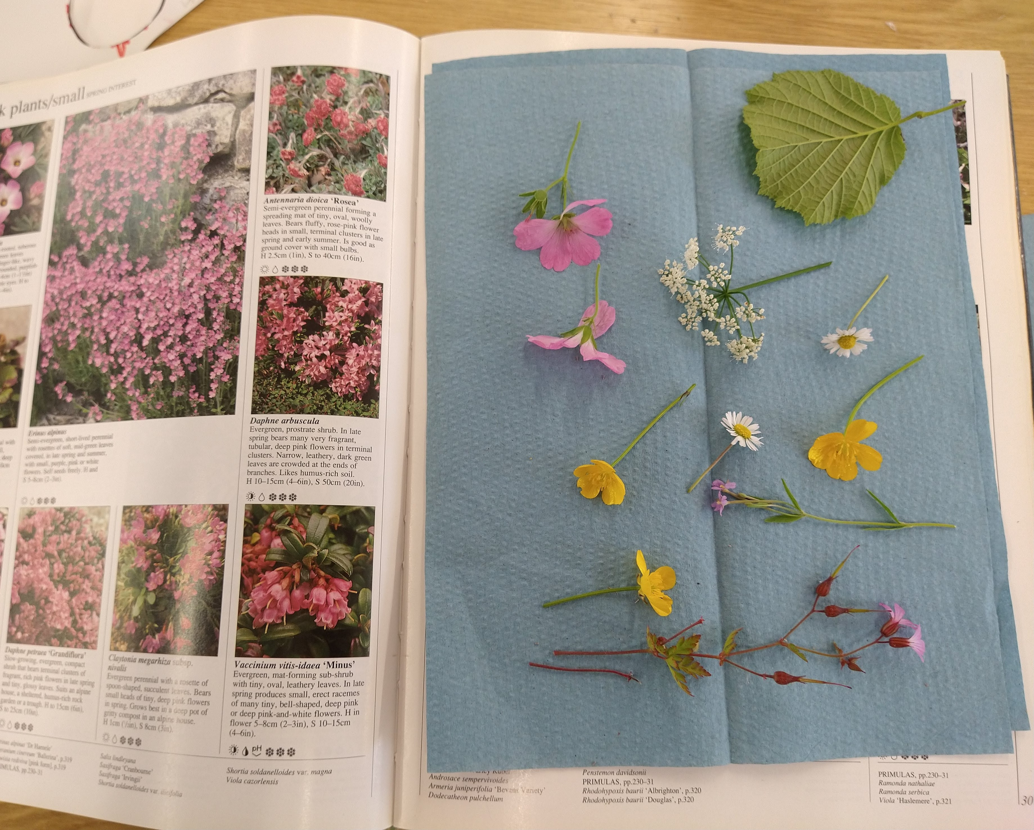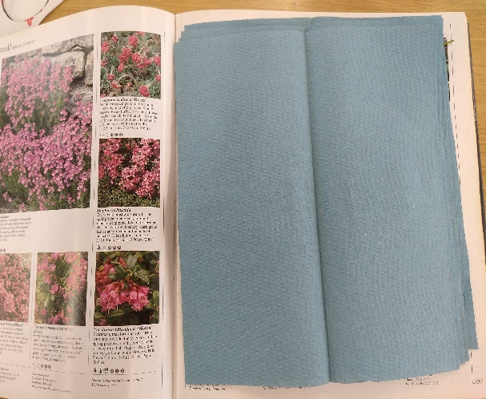
Open your heavy book somewhere near the middle and lay your chosen flowers and leaves between layers of paper towels. The paper towels help the flowers dry out and also protect the pages of your book. Space them out and try not to let them overlap. You can put several sheets of towels and flowers in one book, just remember to space them out.

Step 2.
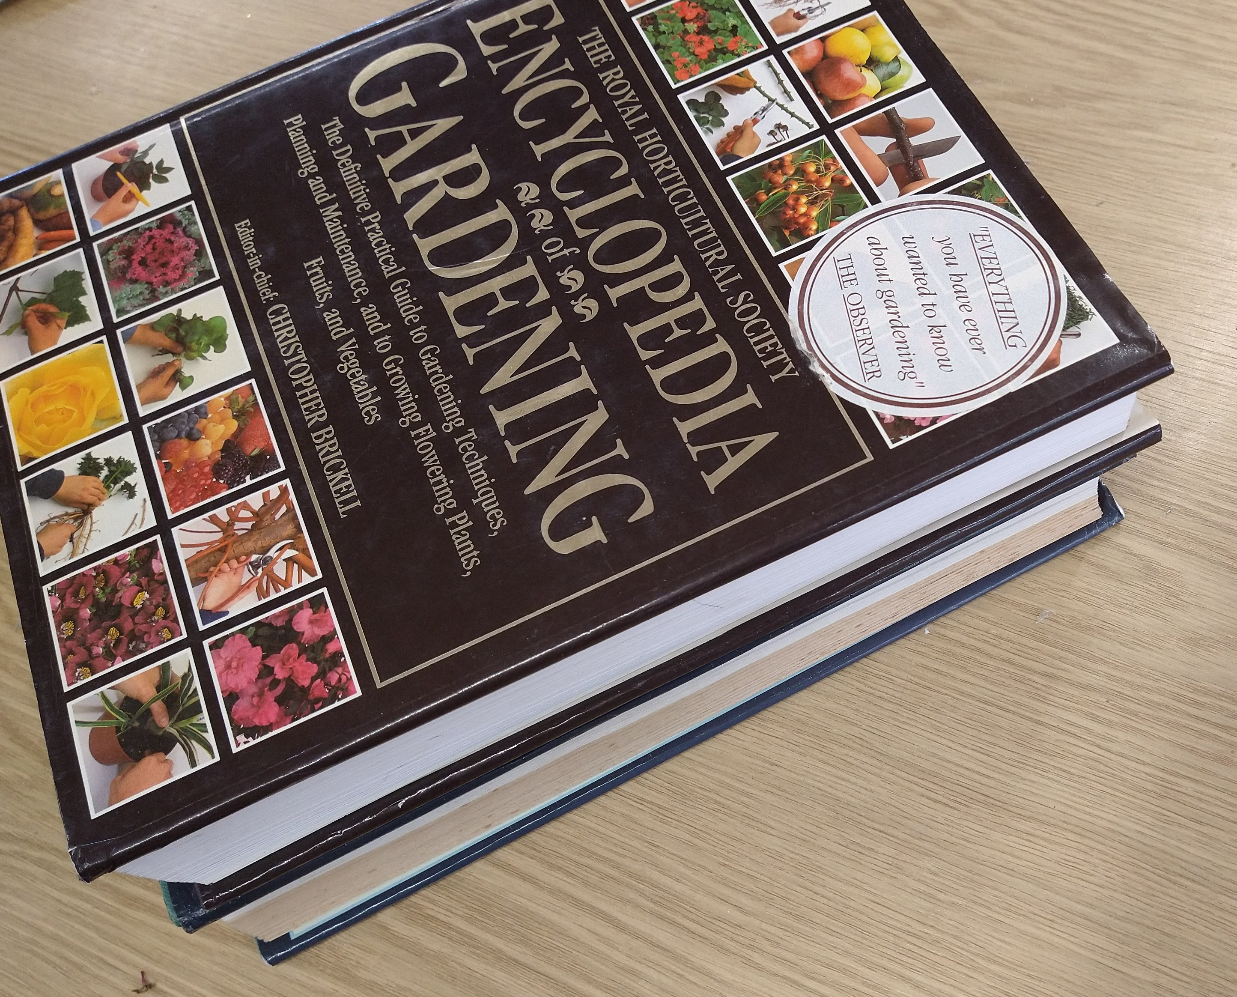
Close the book and if you can put another heavy book on top. Leave for a couple of weeks to let the flowers flatten and dry out. When the flowers are dried out you’re ready to make your picture.

Step 3.
Make your Picture
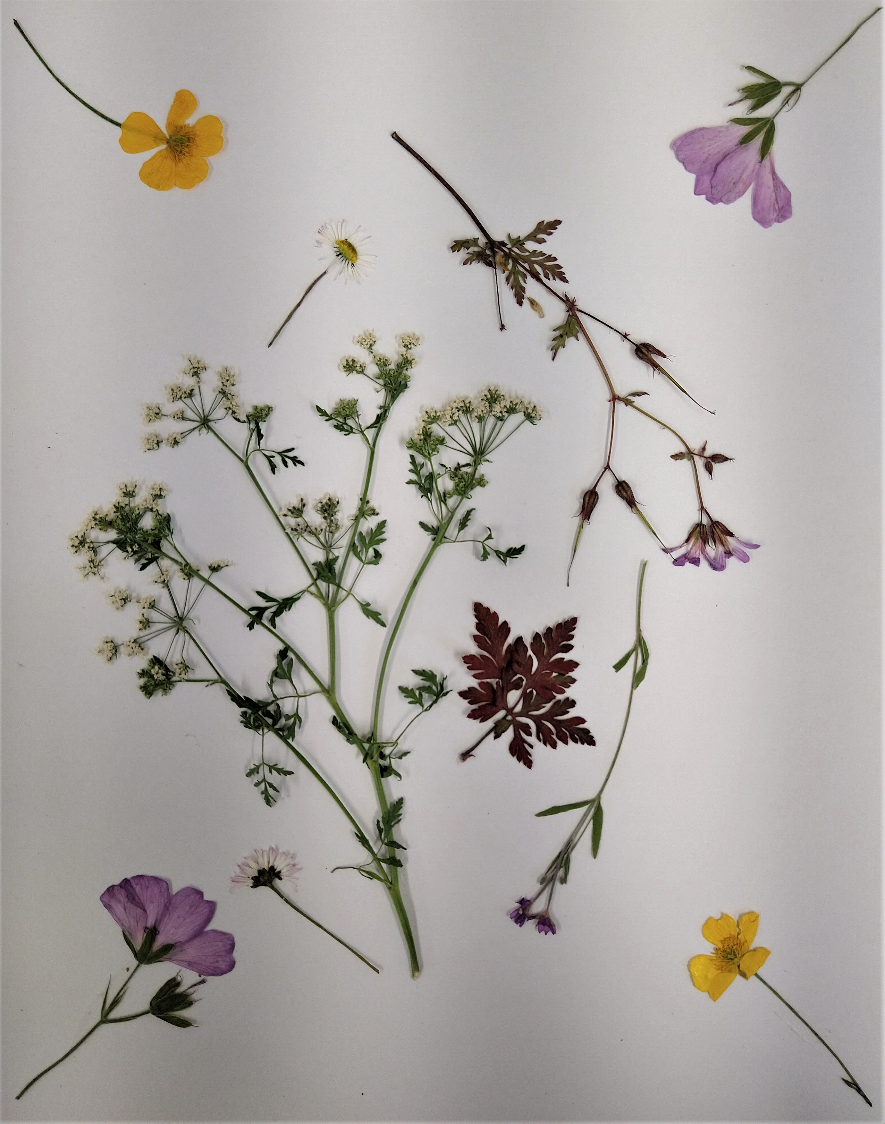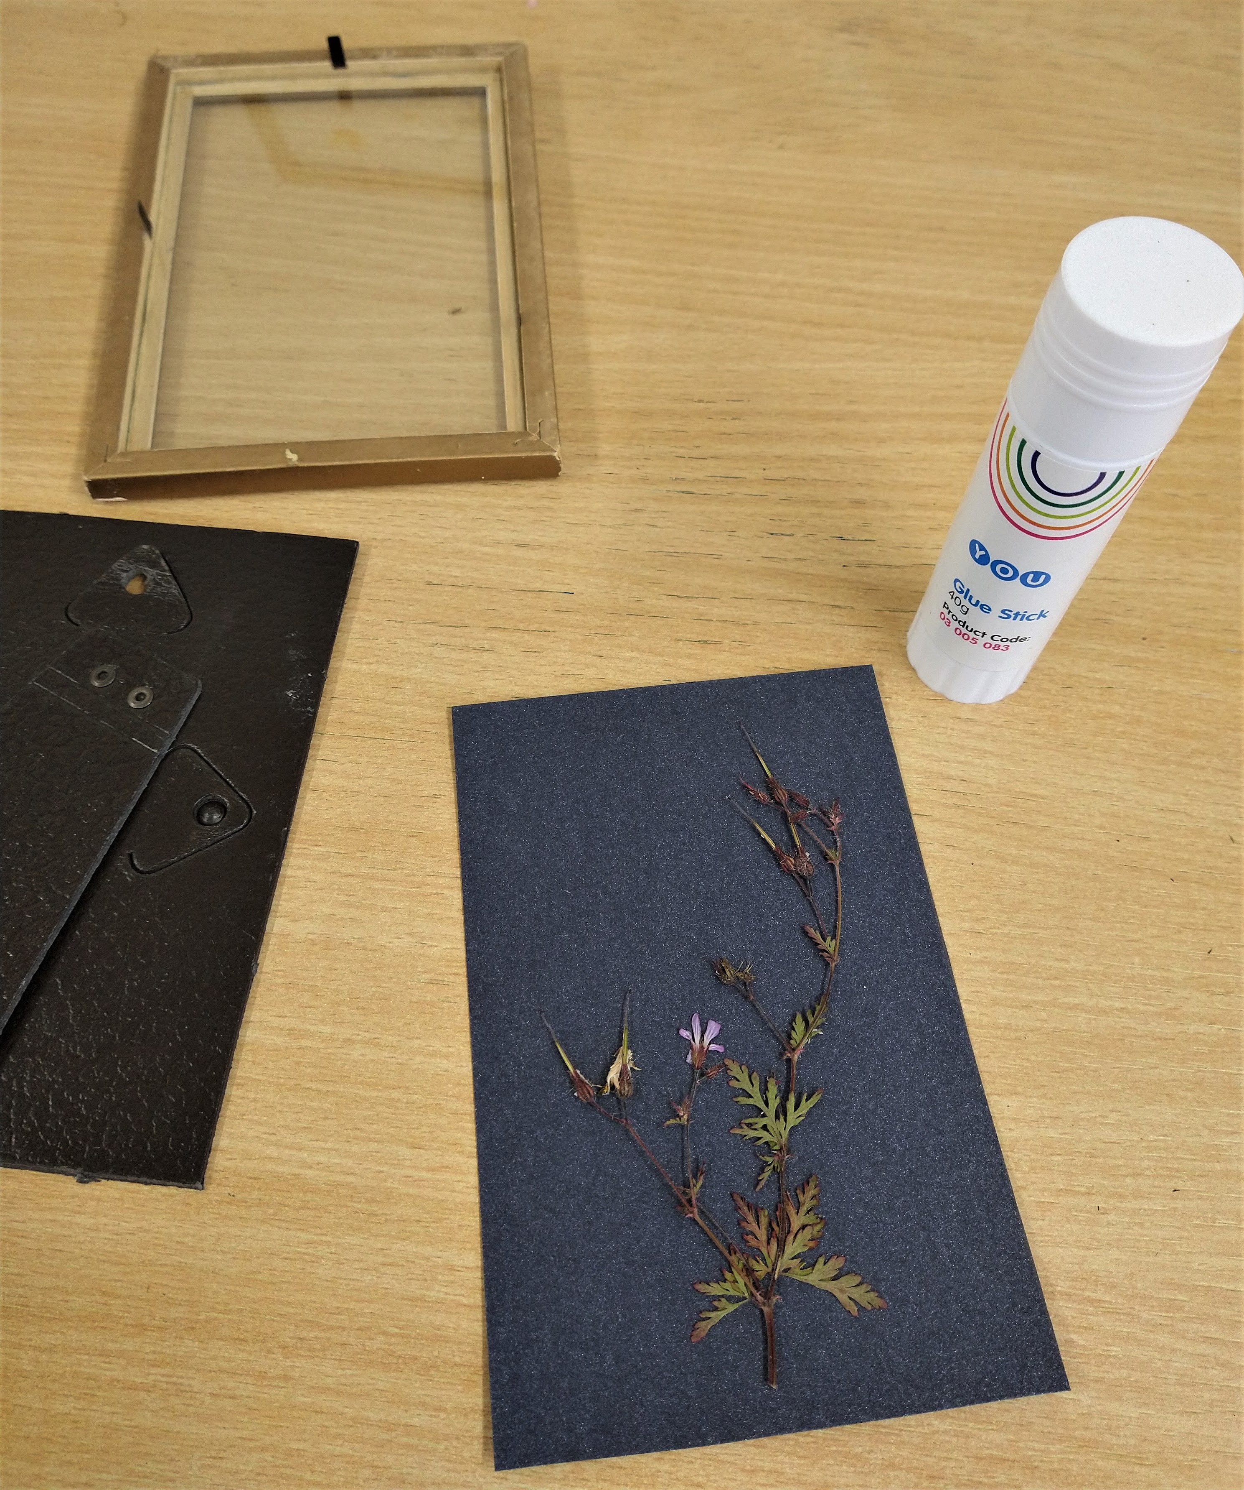

On your piece of card arrange your dried flowers. Keep moving them around until you are happy with the arrangement. Use a little bit of glue to secure them in place.
Step 4.
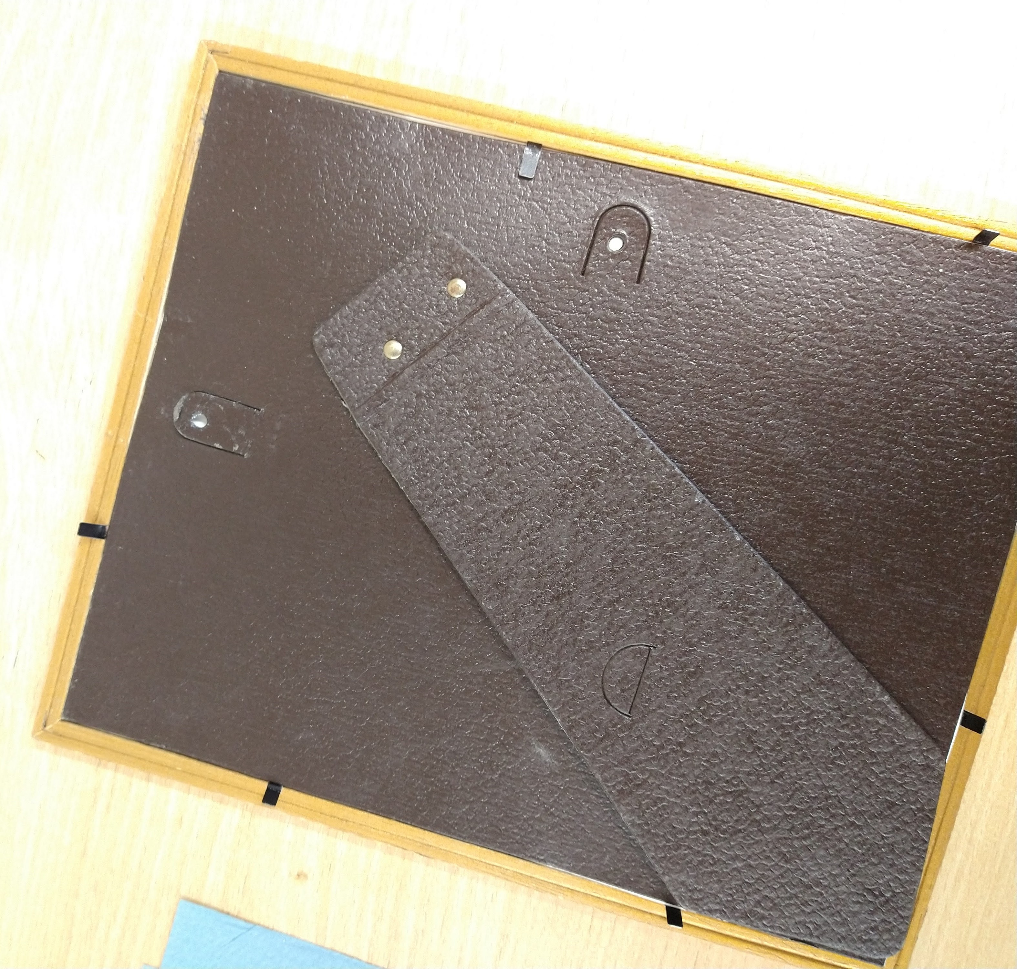
Carefully put the glass from the picture frame on top of your arrangement and then secure the whole ‘sandwich’ back into the picture frame.
Step 5.
Hang your picture up and admire!
Have fun and don’t forget to show us how you get on!

