Autumn Nature Garland
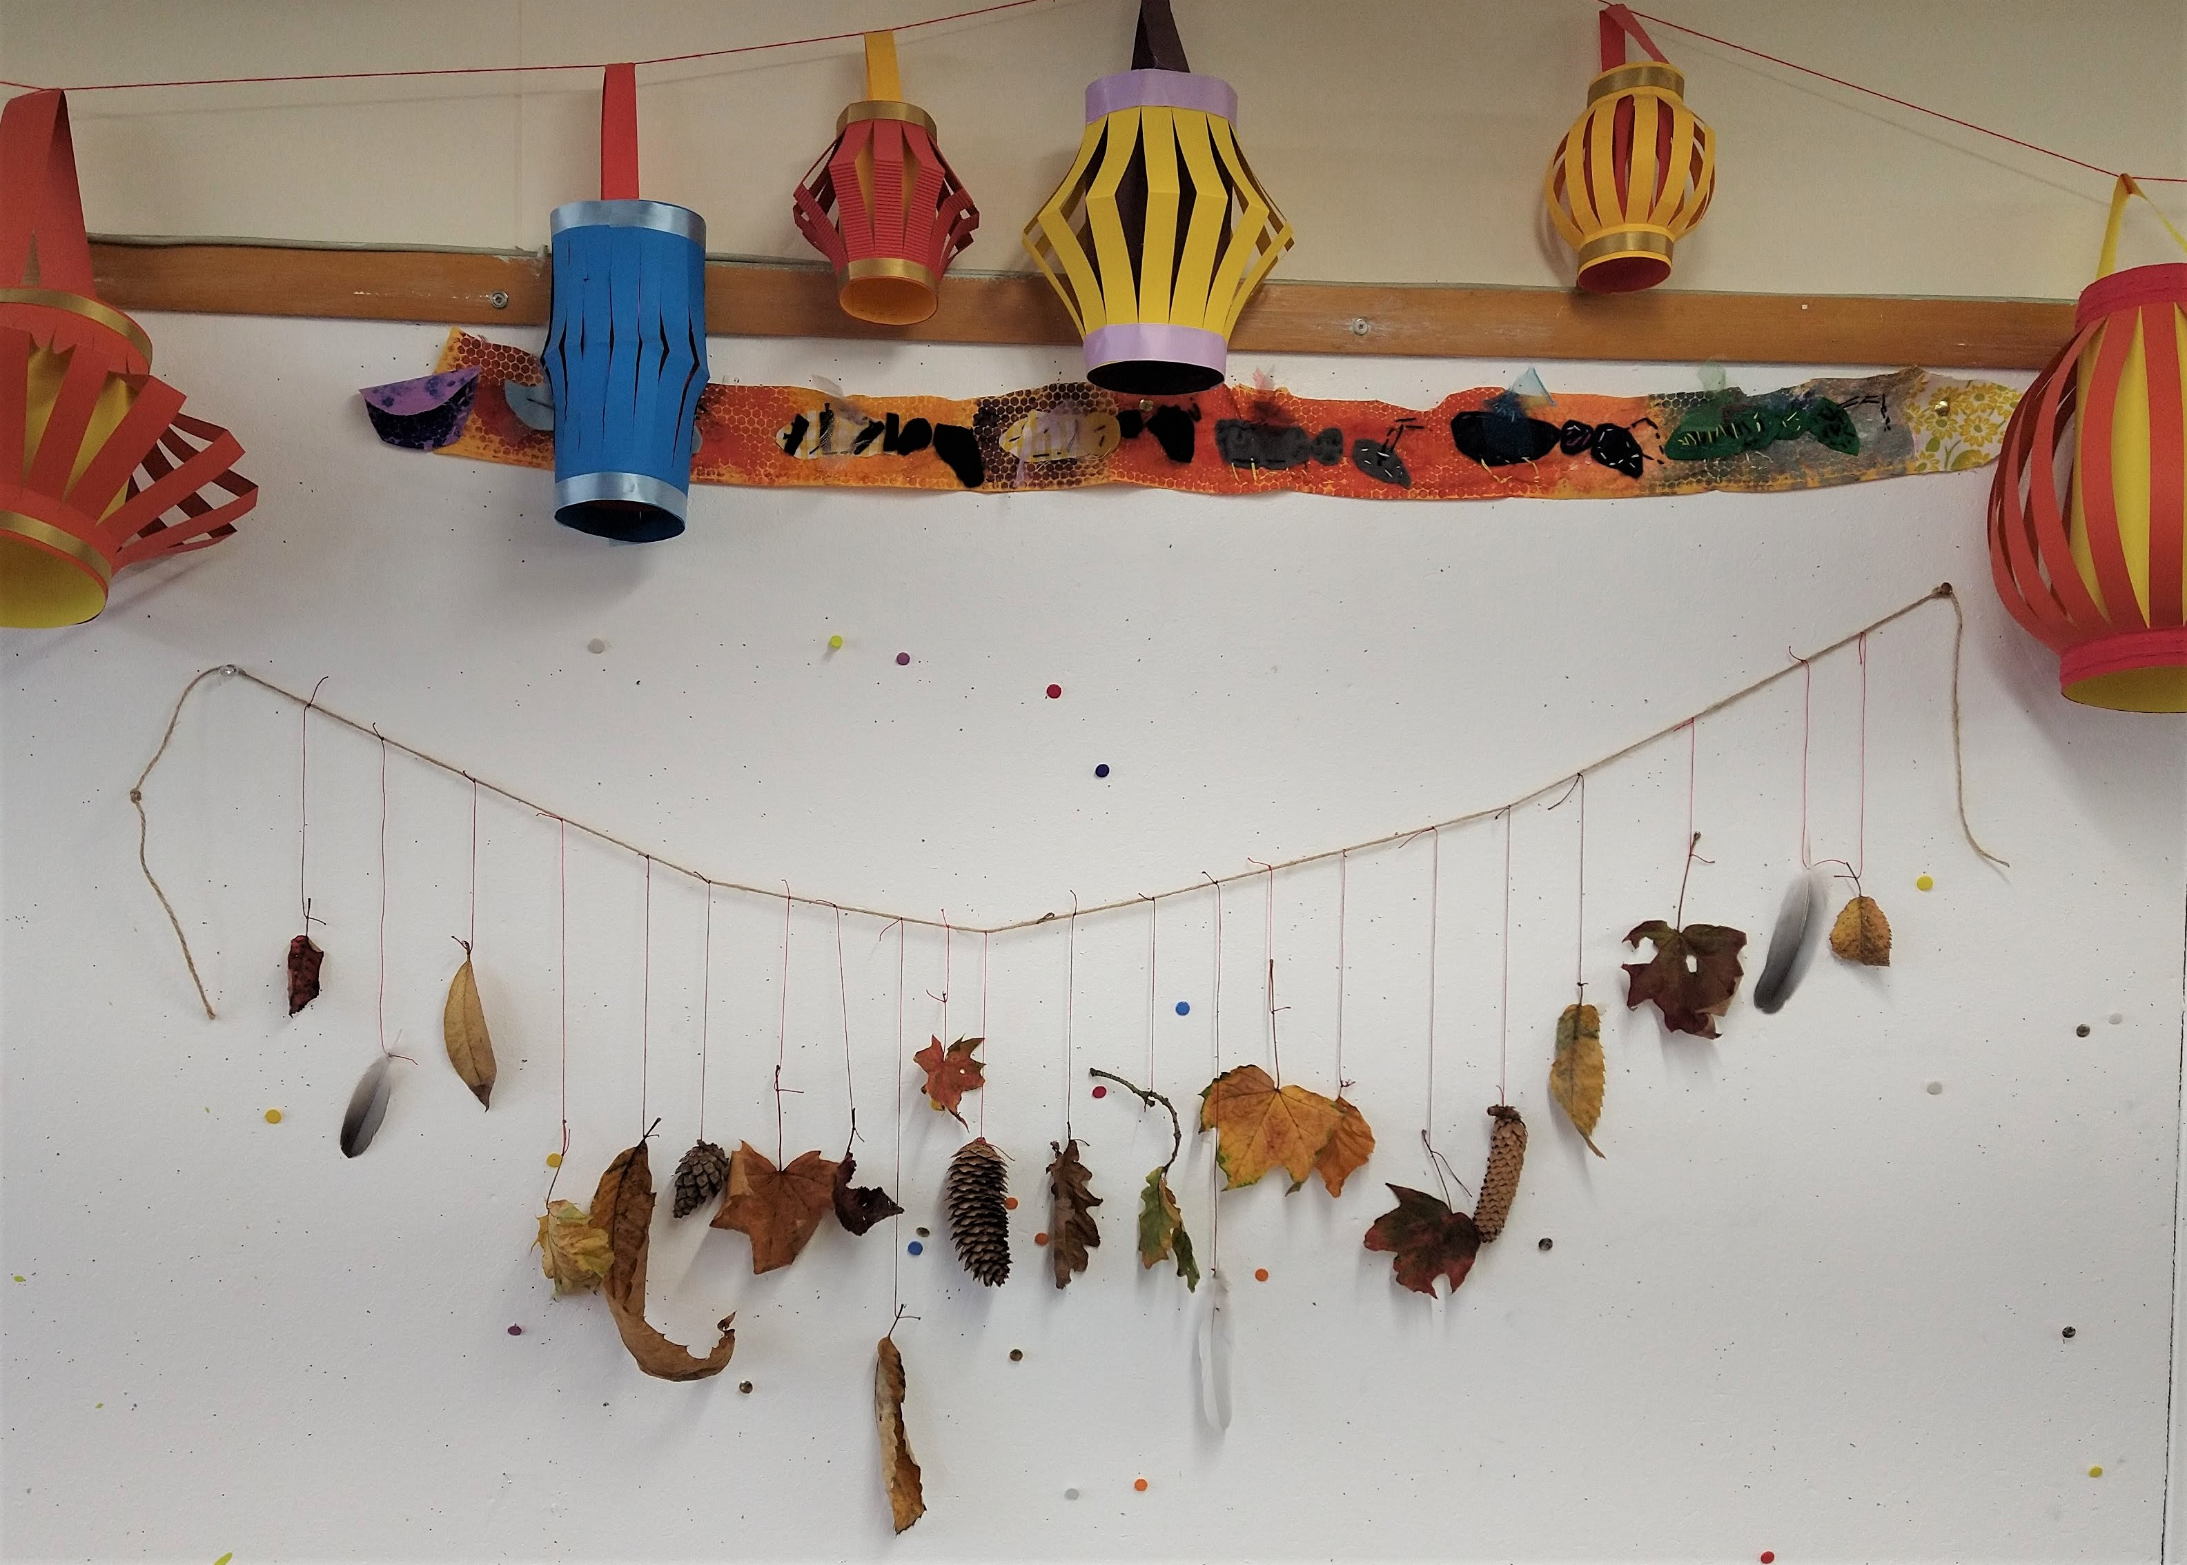
The seasons are changing and we're now officially in autumn so we thought we'd share a seasonal craft idea with you. This week we'll show you how to make a garland for your home to celebrate the new season.
You'll need to head outside and collect a few bits and pieces for this craft; leaves, pine cones, feathers or whatever catches your eye! There are lots of beautiful colours around at the moment so take some time to enjoy your surroundings. Remember to always be safe and careful when collecting things and if in doubt leave it alone!
You will need:
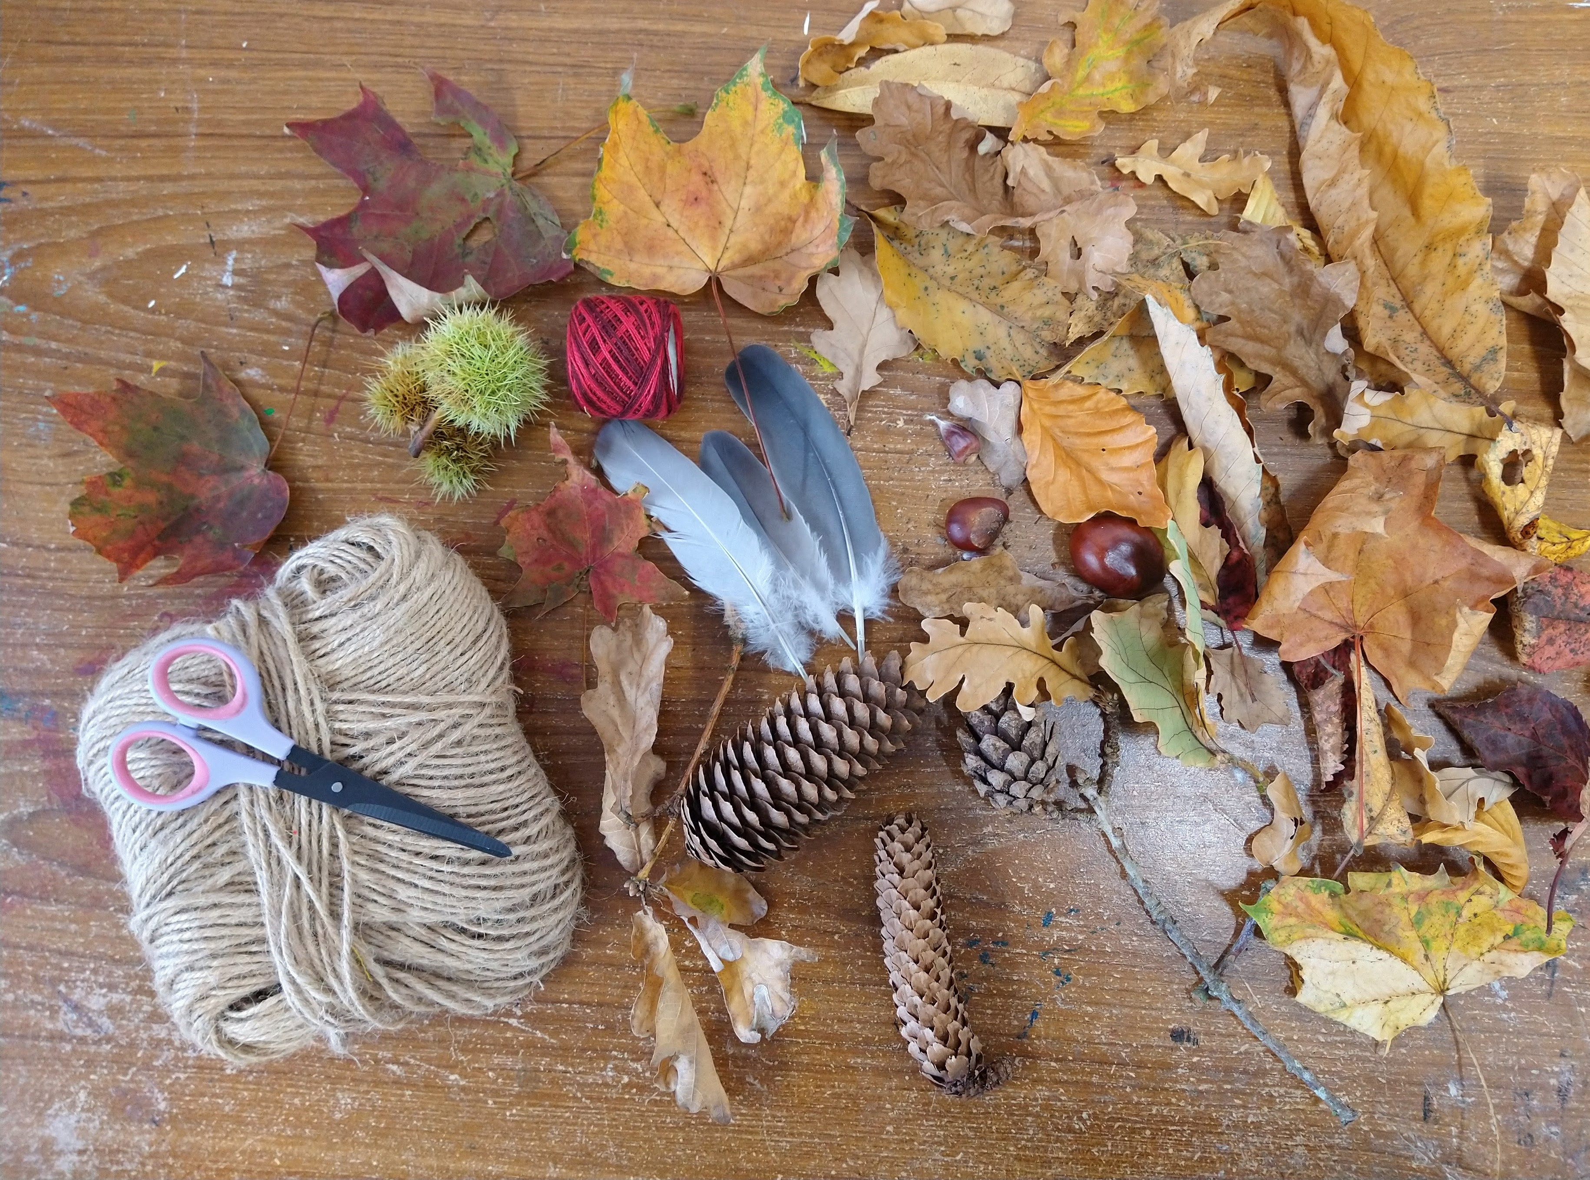
- String or Twine
- Thread
- An assortment of natural objects you've collected such as leaves, pine cones, feathers and so on
- Scissors
Step 1.
Spend a bit of time looking at what you've collected and organising your collection, you might separate things by colour, shape or just choose to mix everything up. Lay your collection out in a line, try laying them out in different arrangements so you can decide how you'd like your garland to look.
Step 2.
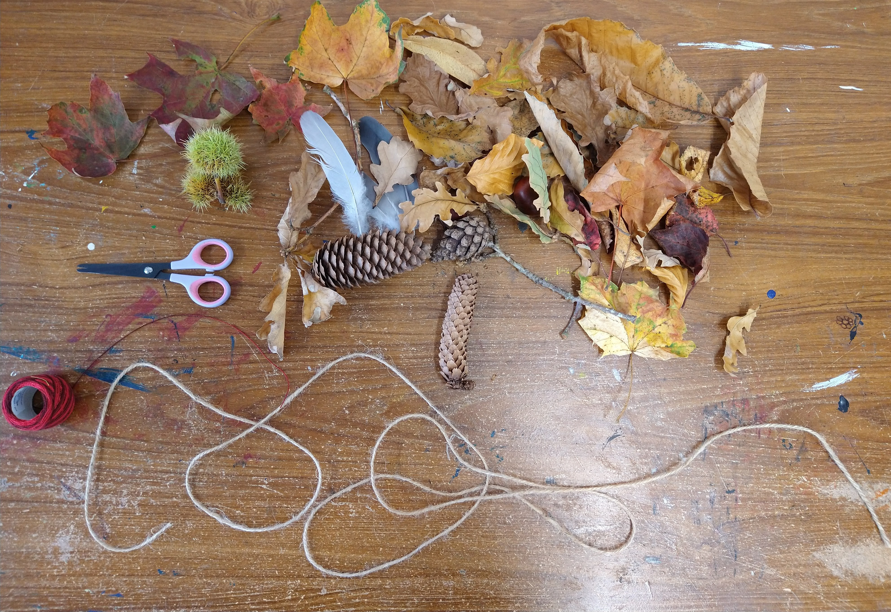
Cut a piece of string or twine a bit longer than you want the garland to be. This will form the base of your garland.
Step 3.
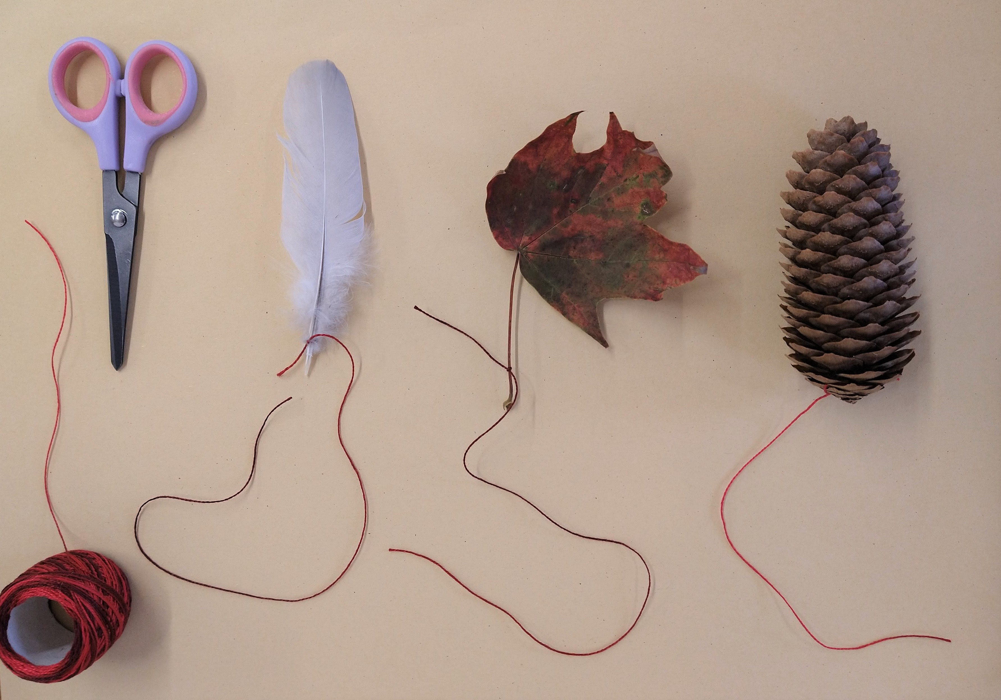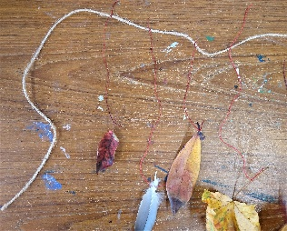
Use the thread to tie each of your objects onto the string. Try and have the objects hanging down at slightly different lengths for a more natural look. Leave a bit of string clear at each end of the garland.
Step 4.
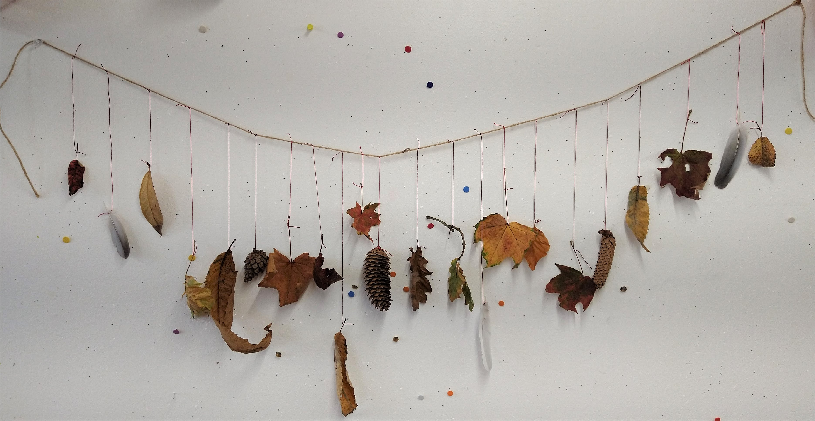
Use the clear ends of the string to hang your garland up. Admire your hard work!

