Button Necklaces
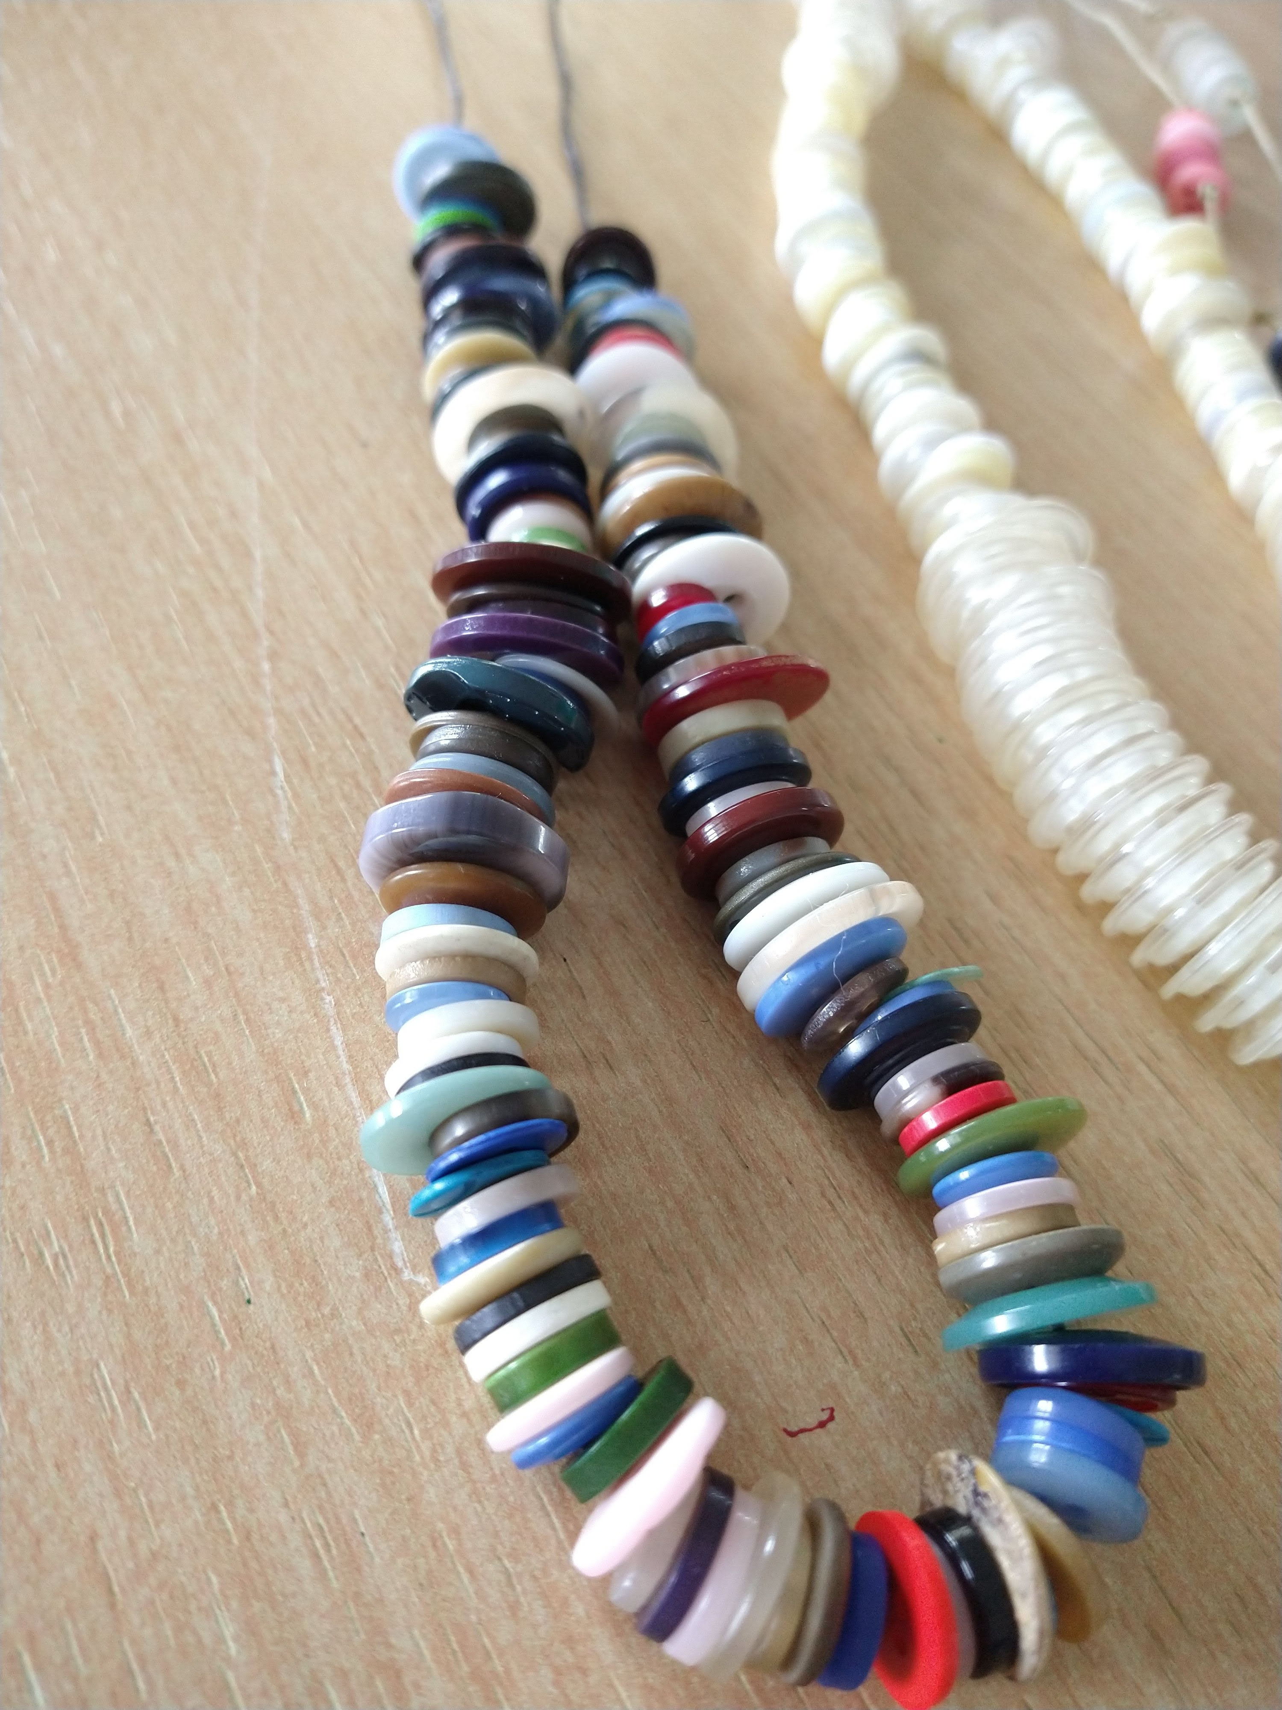
We love our very large collection of buttons at Heathlands! We’re going to show you how to use some of them to create lovely necklaces.

You will need:
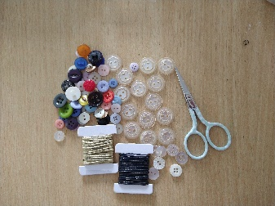
- Buttons
- Cord or strong thread
- Scissors

Step 1.
Cut a piece of cord the length you’d like your necklace to be, remember to make it long enough to go over your head once it’s finished! Our cord was about 65 cm long.
Step 2.
Tie a knot about 5 cm down from one end, this will stop all your buttons sliding straight off!
Step 3.
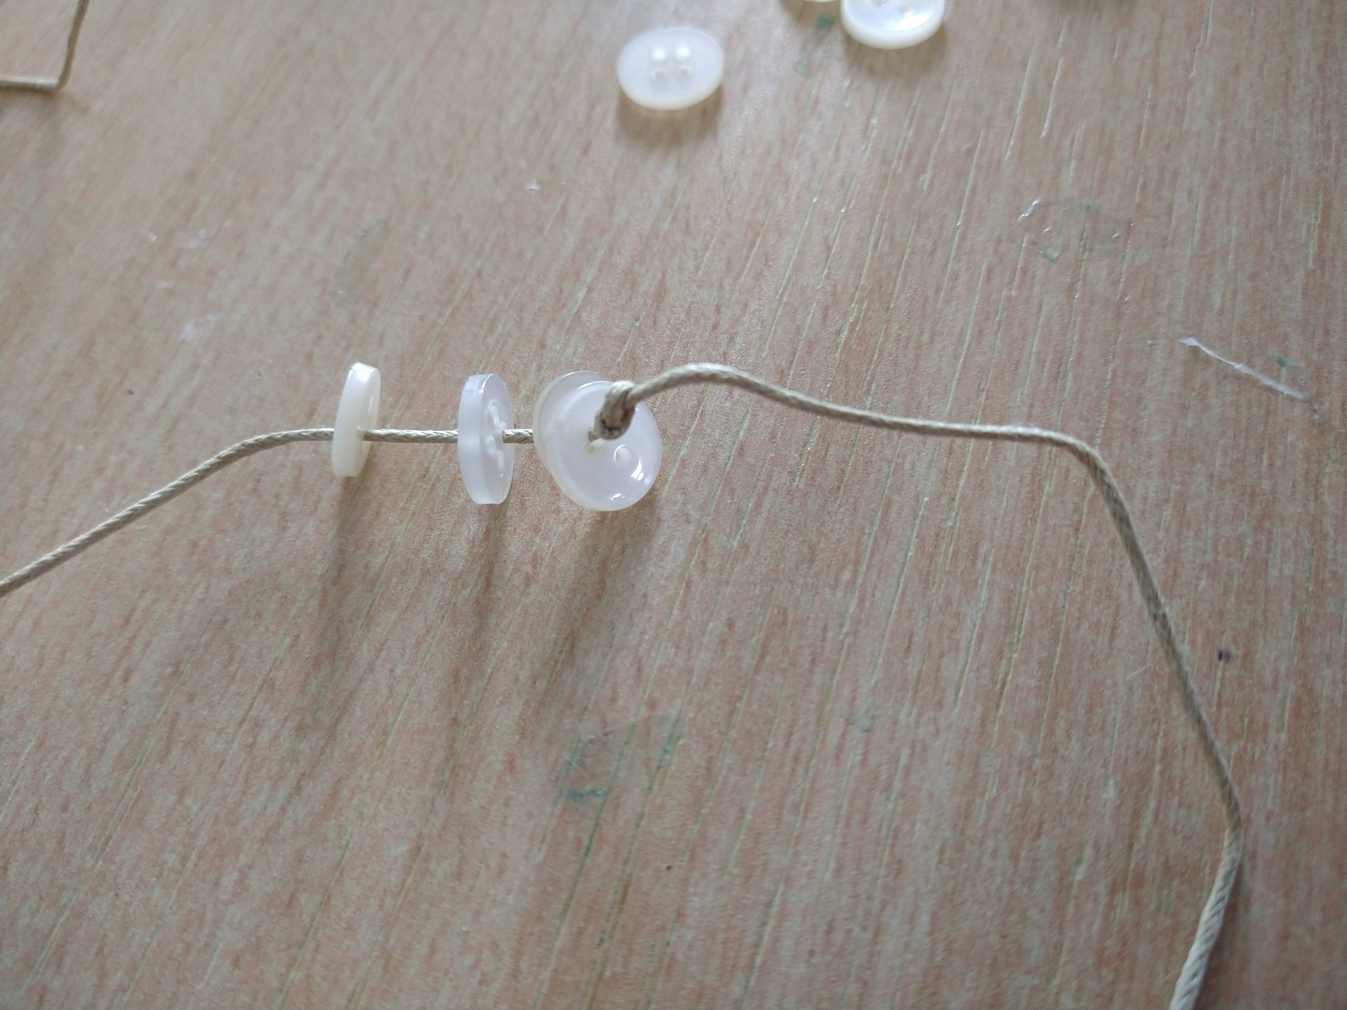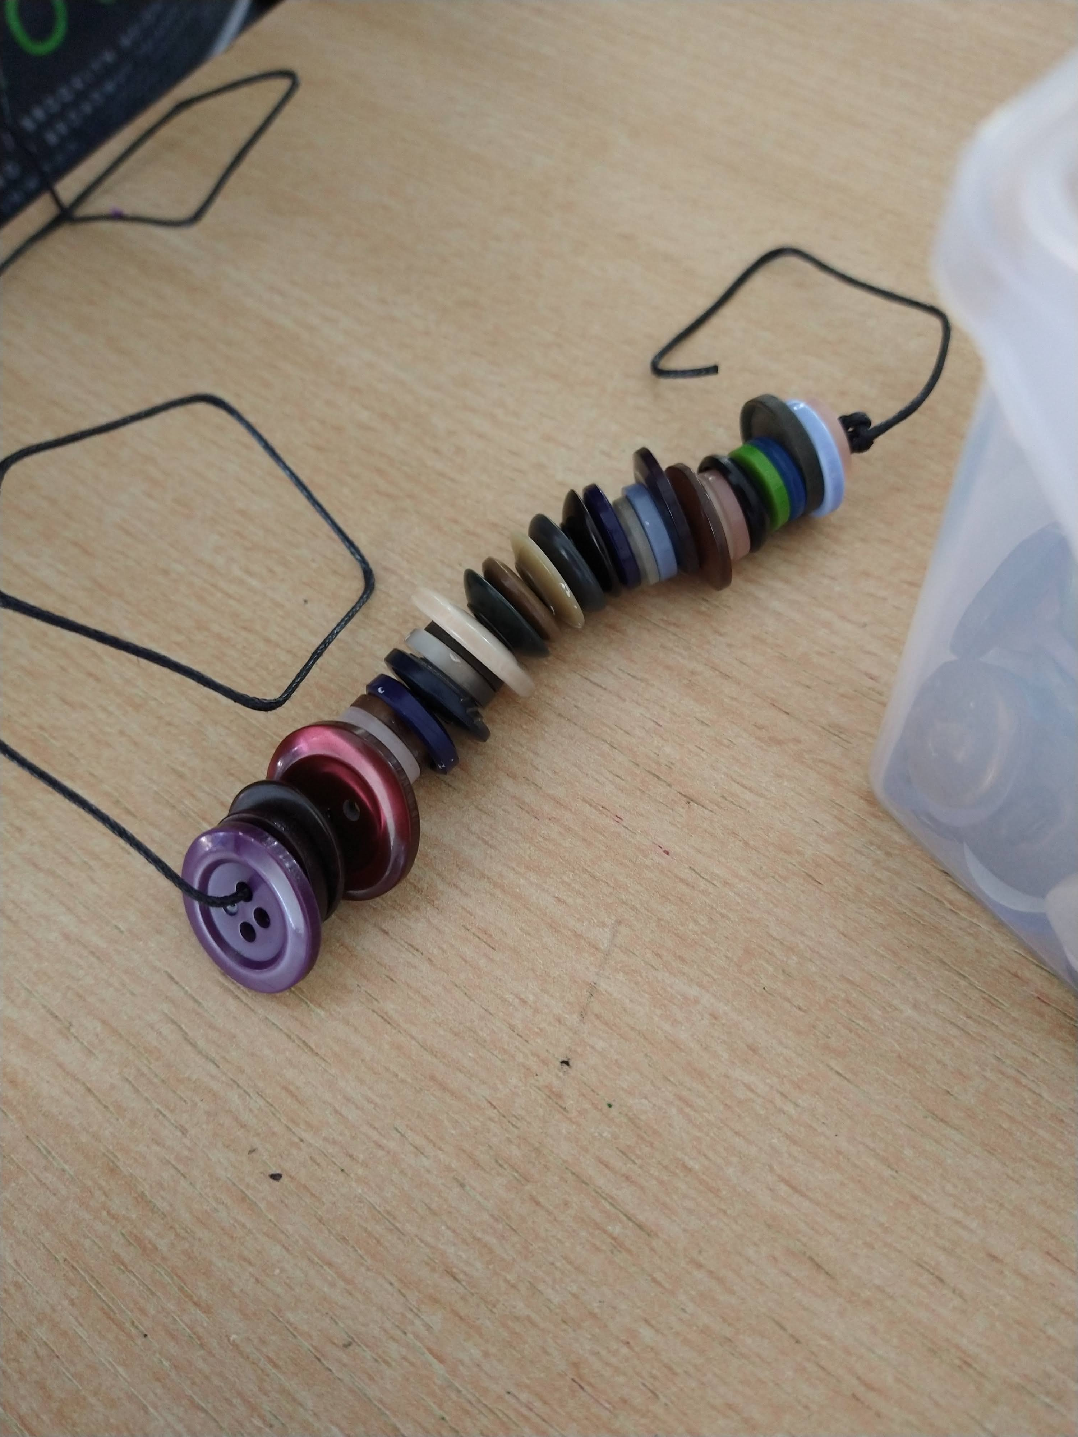
Start threading your buttons on like beads. You can cover your whole cord with beads or use knots to separate groups of buttons.

Step 4.
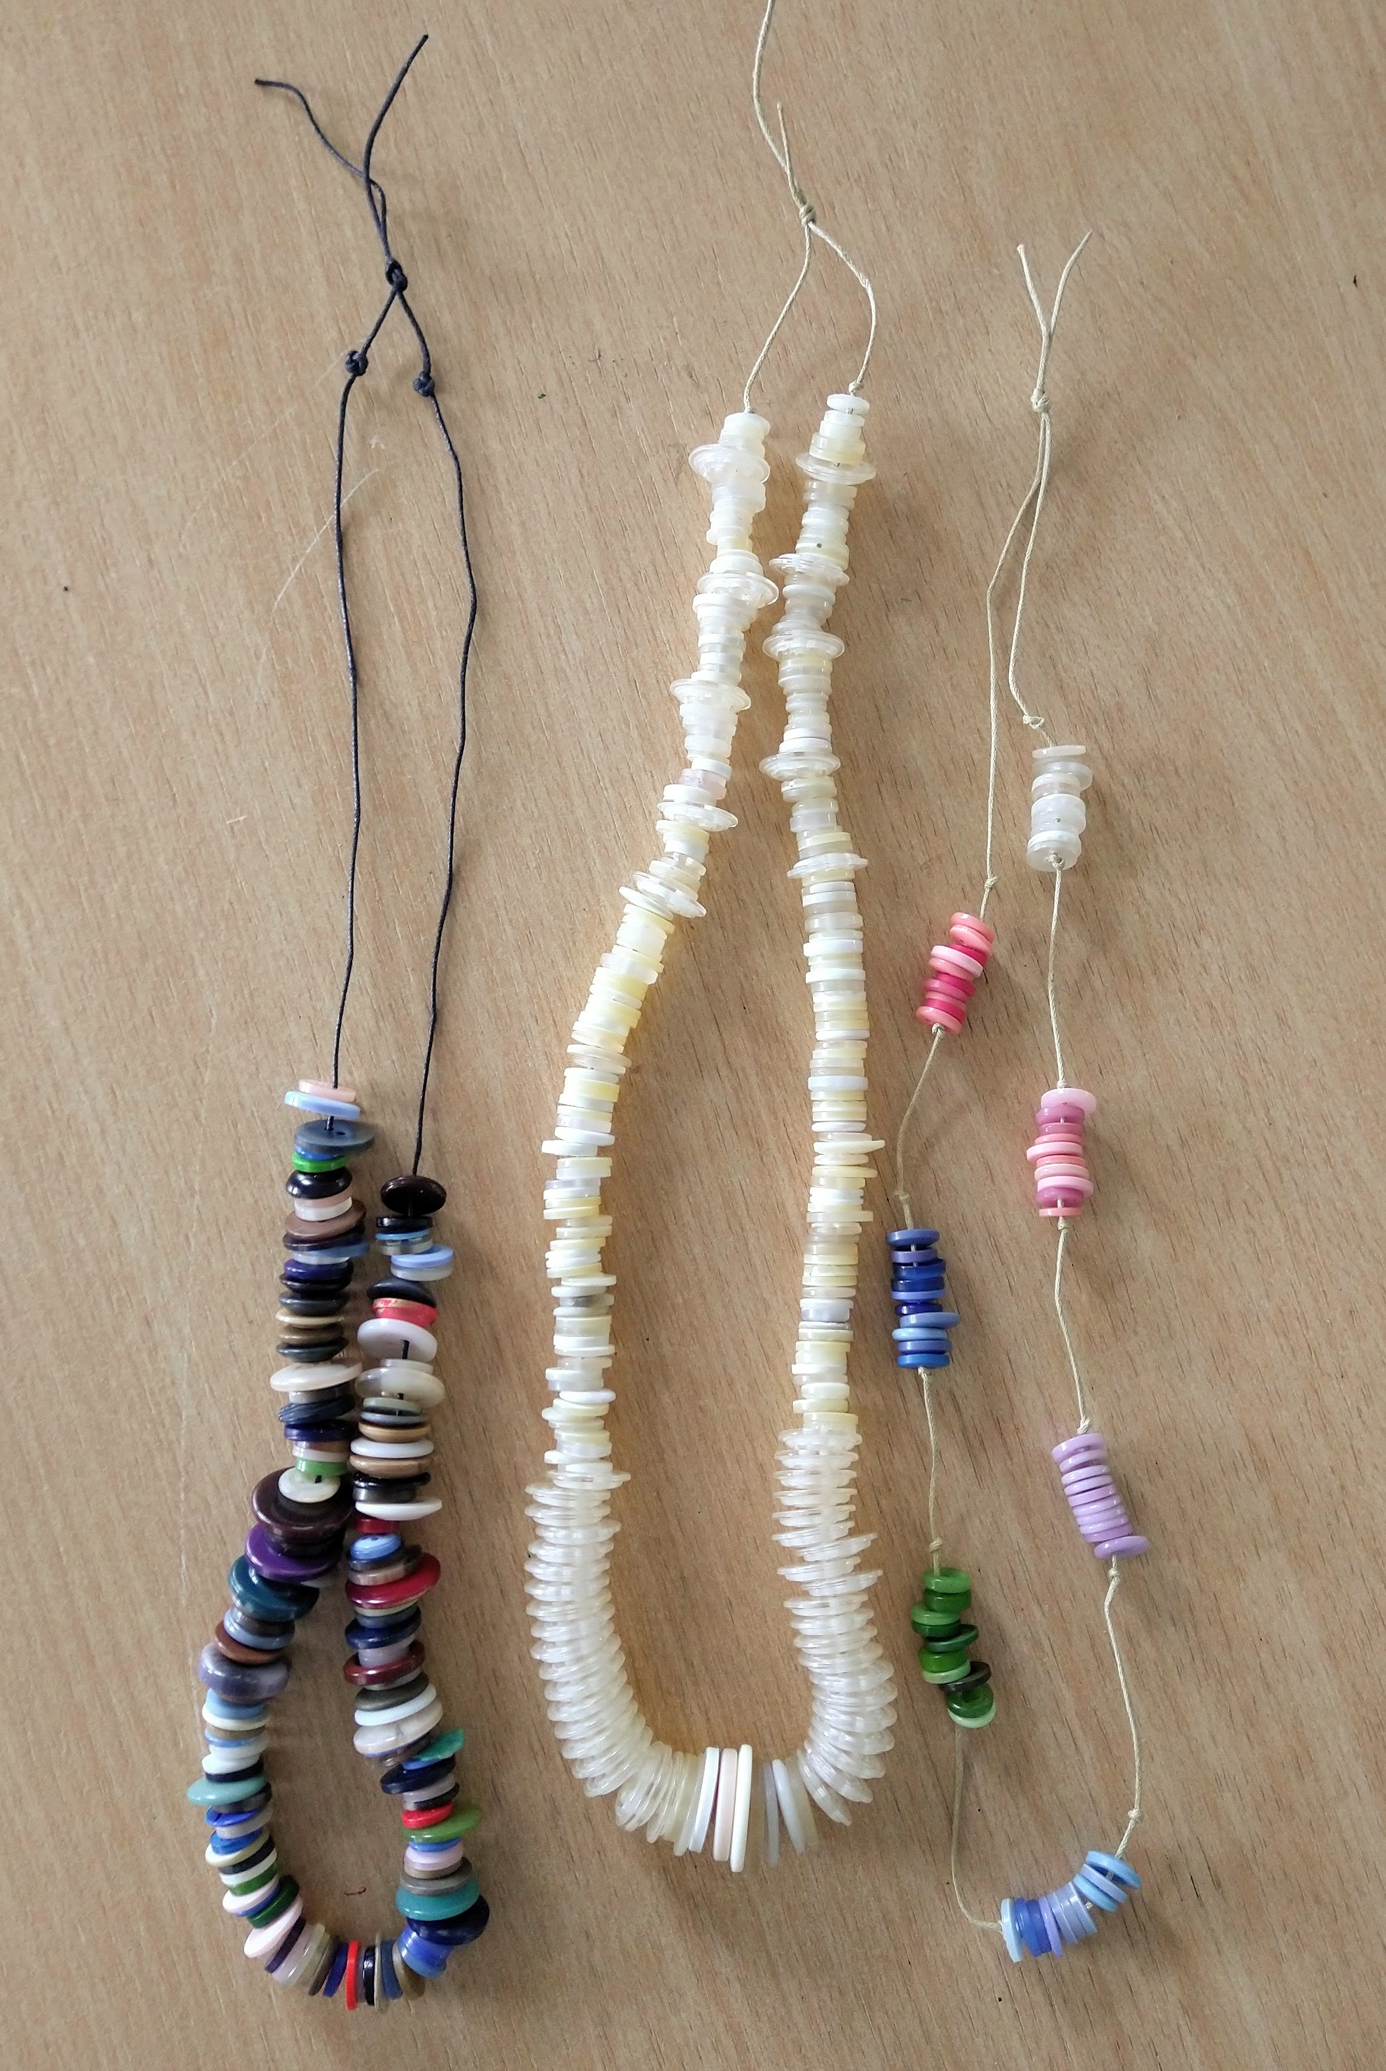
When you’re happy with your button arrangements tie the two ends of your cord together and try your necklace on.

Have fun and don’t forget to show us your makes!

