Cress heads
Cress is a very fast growing plant and is great in salads, sandwiches or as a garnish. Why not make a funny face to grow your cress in?
You will need:
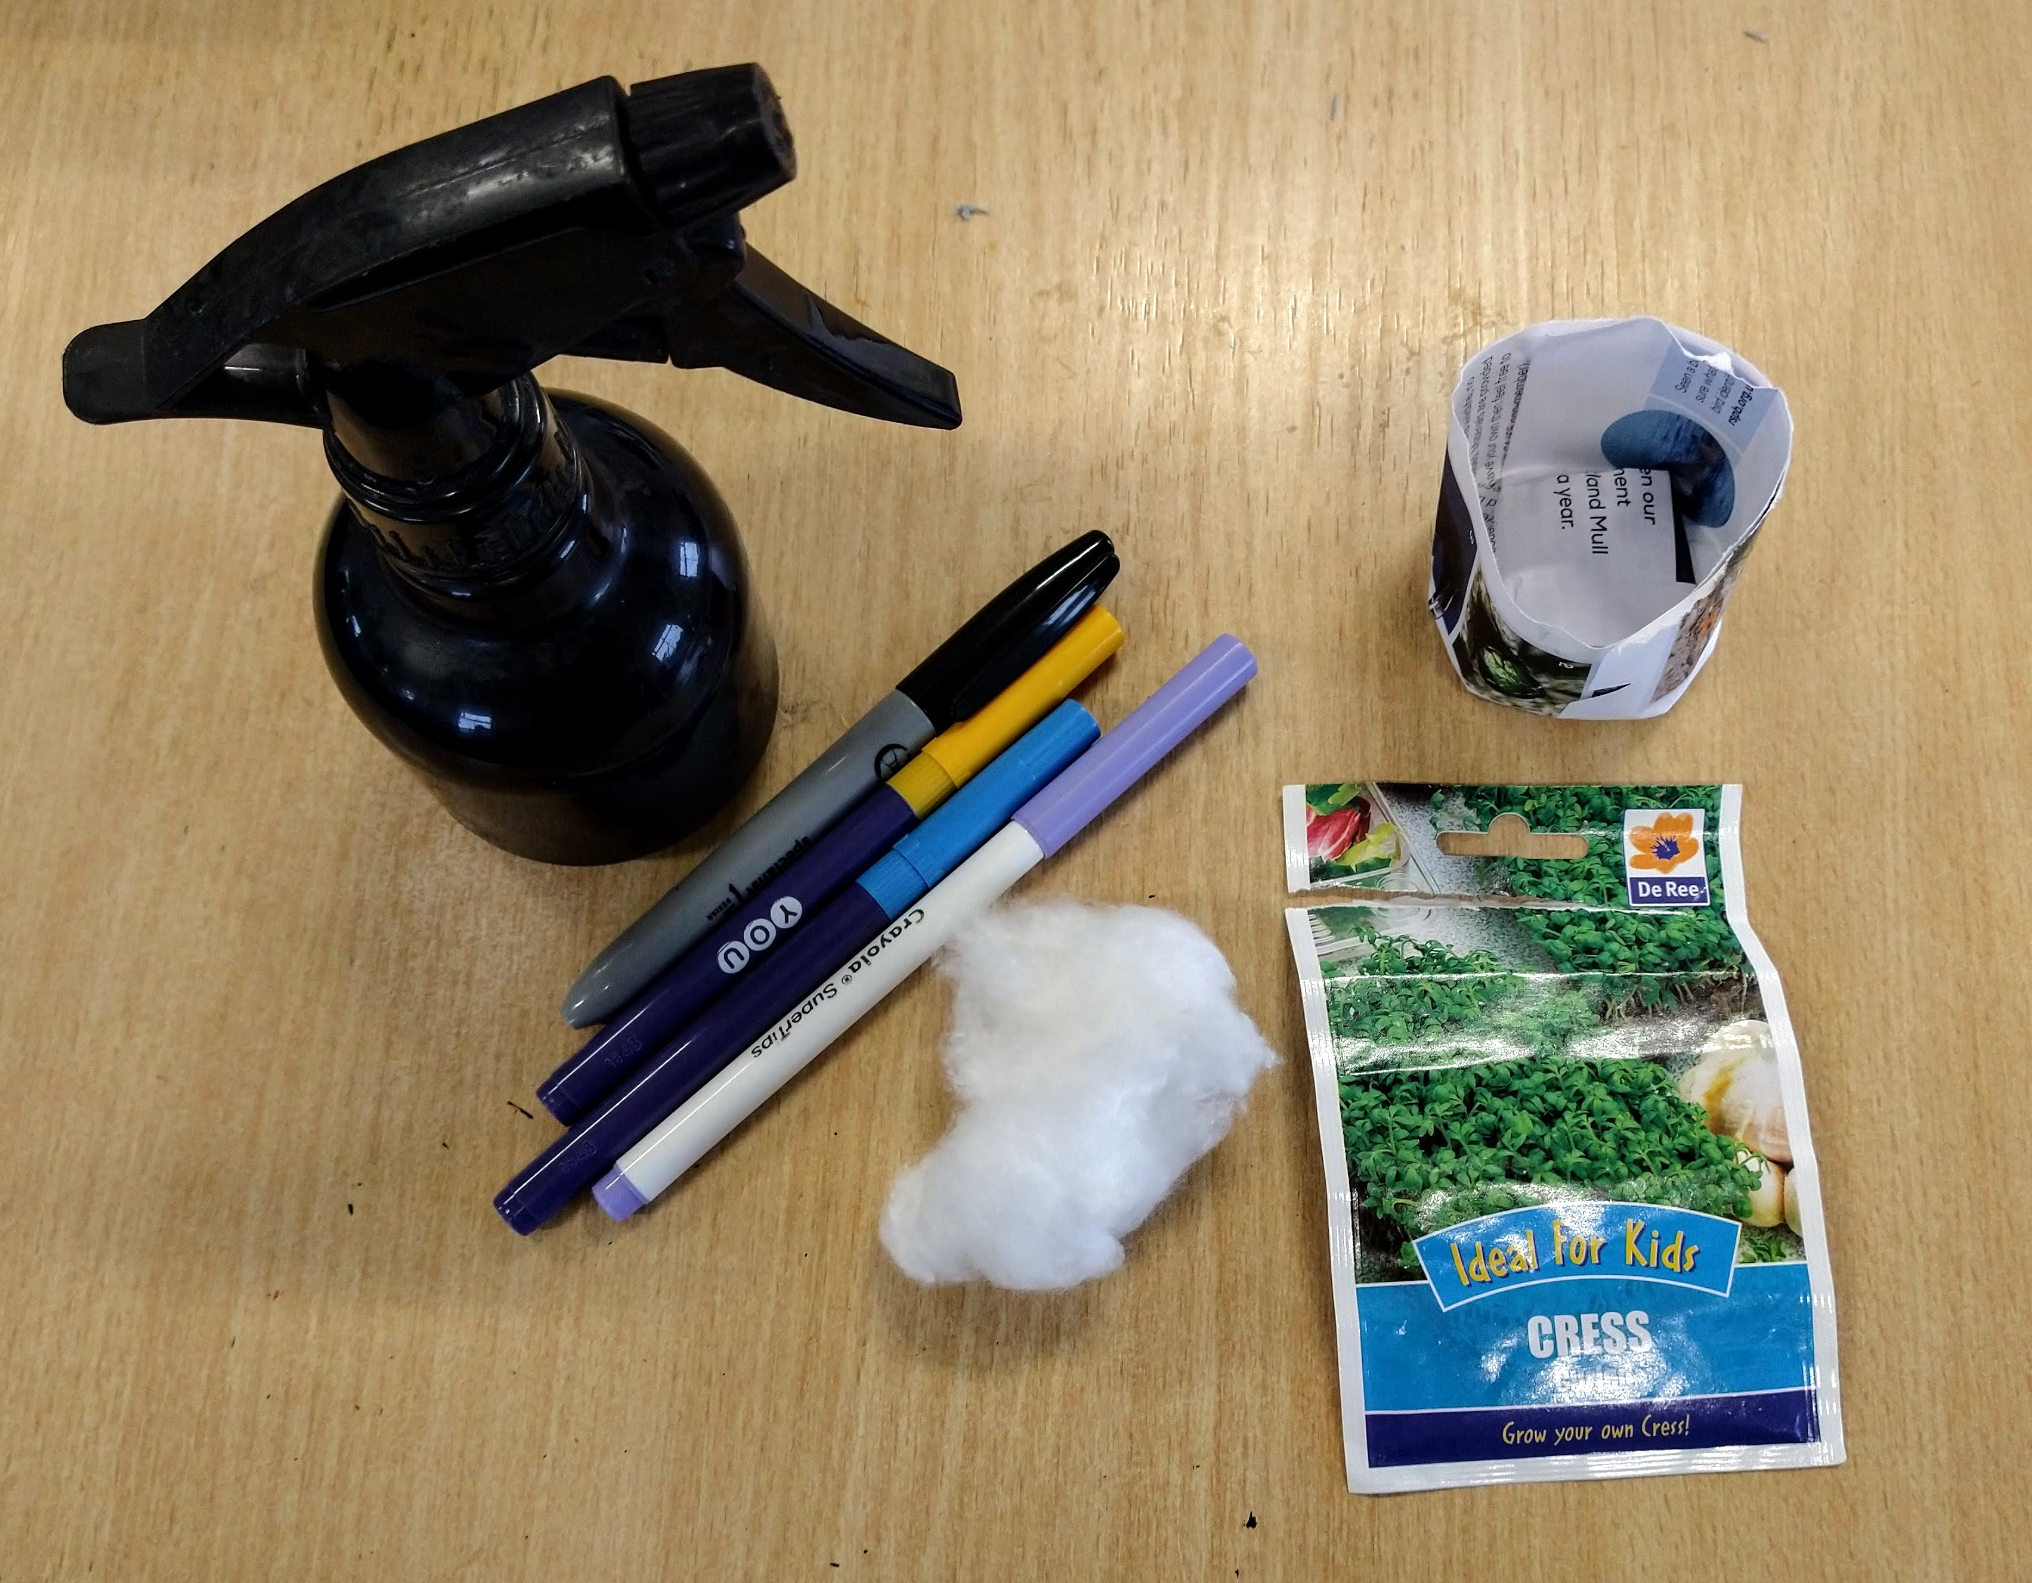
- Paper pot* or empty yogurt pot (or similar container)
- Permanent marker
- Cotton wool
- Cress seeds
- Water
*You can find a video we made showing you how to make a paper plant pot on our YouTube channel.
Step 1.
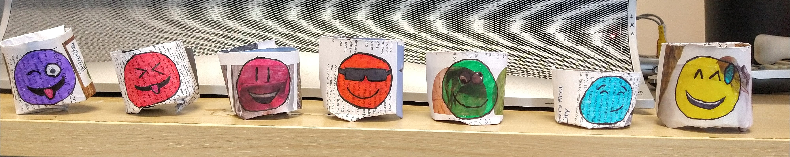
Use the permanent marker to make a funny face on your pot.
Step 2.
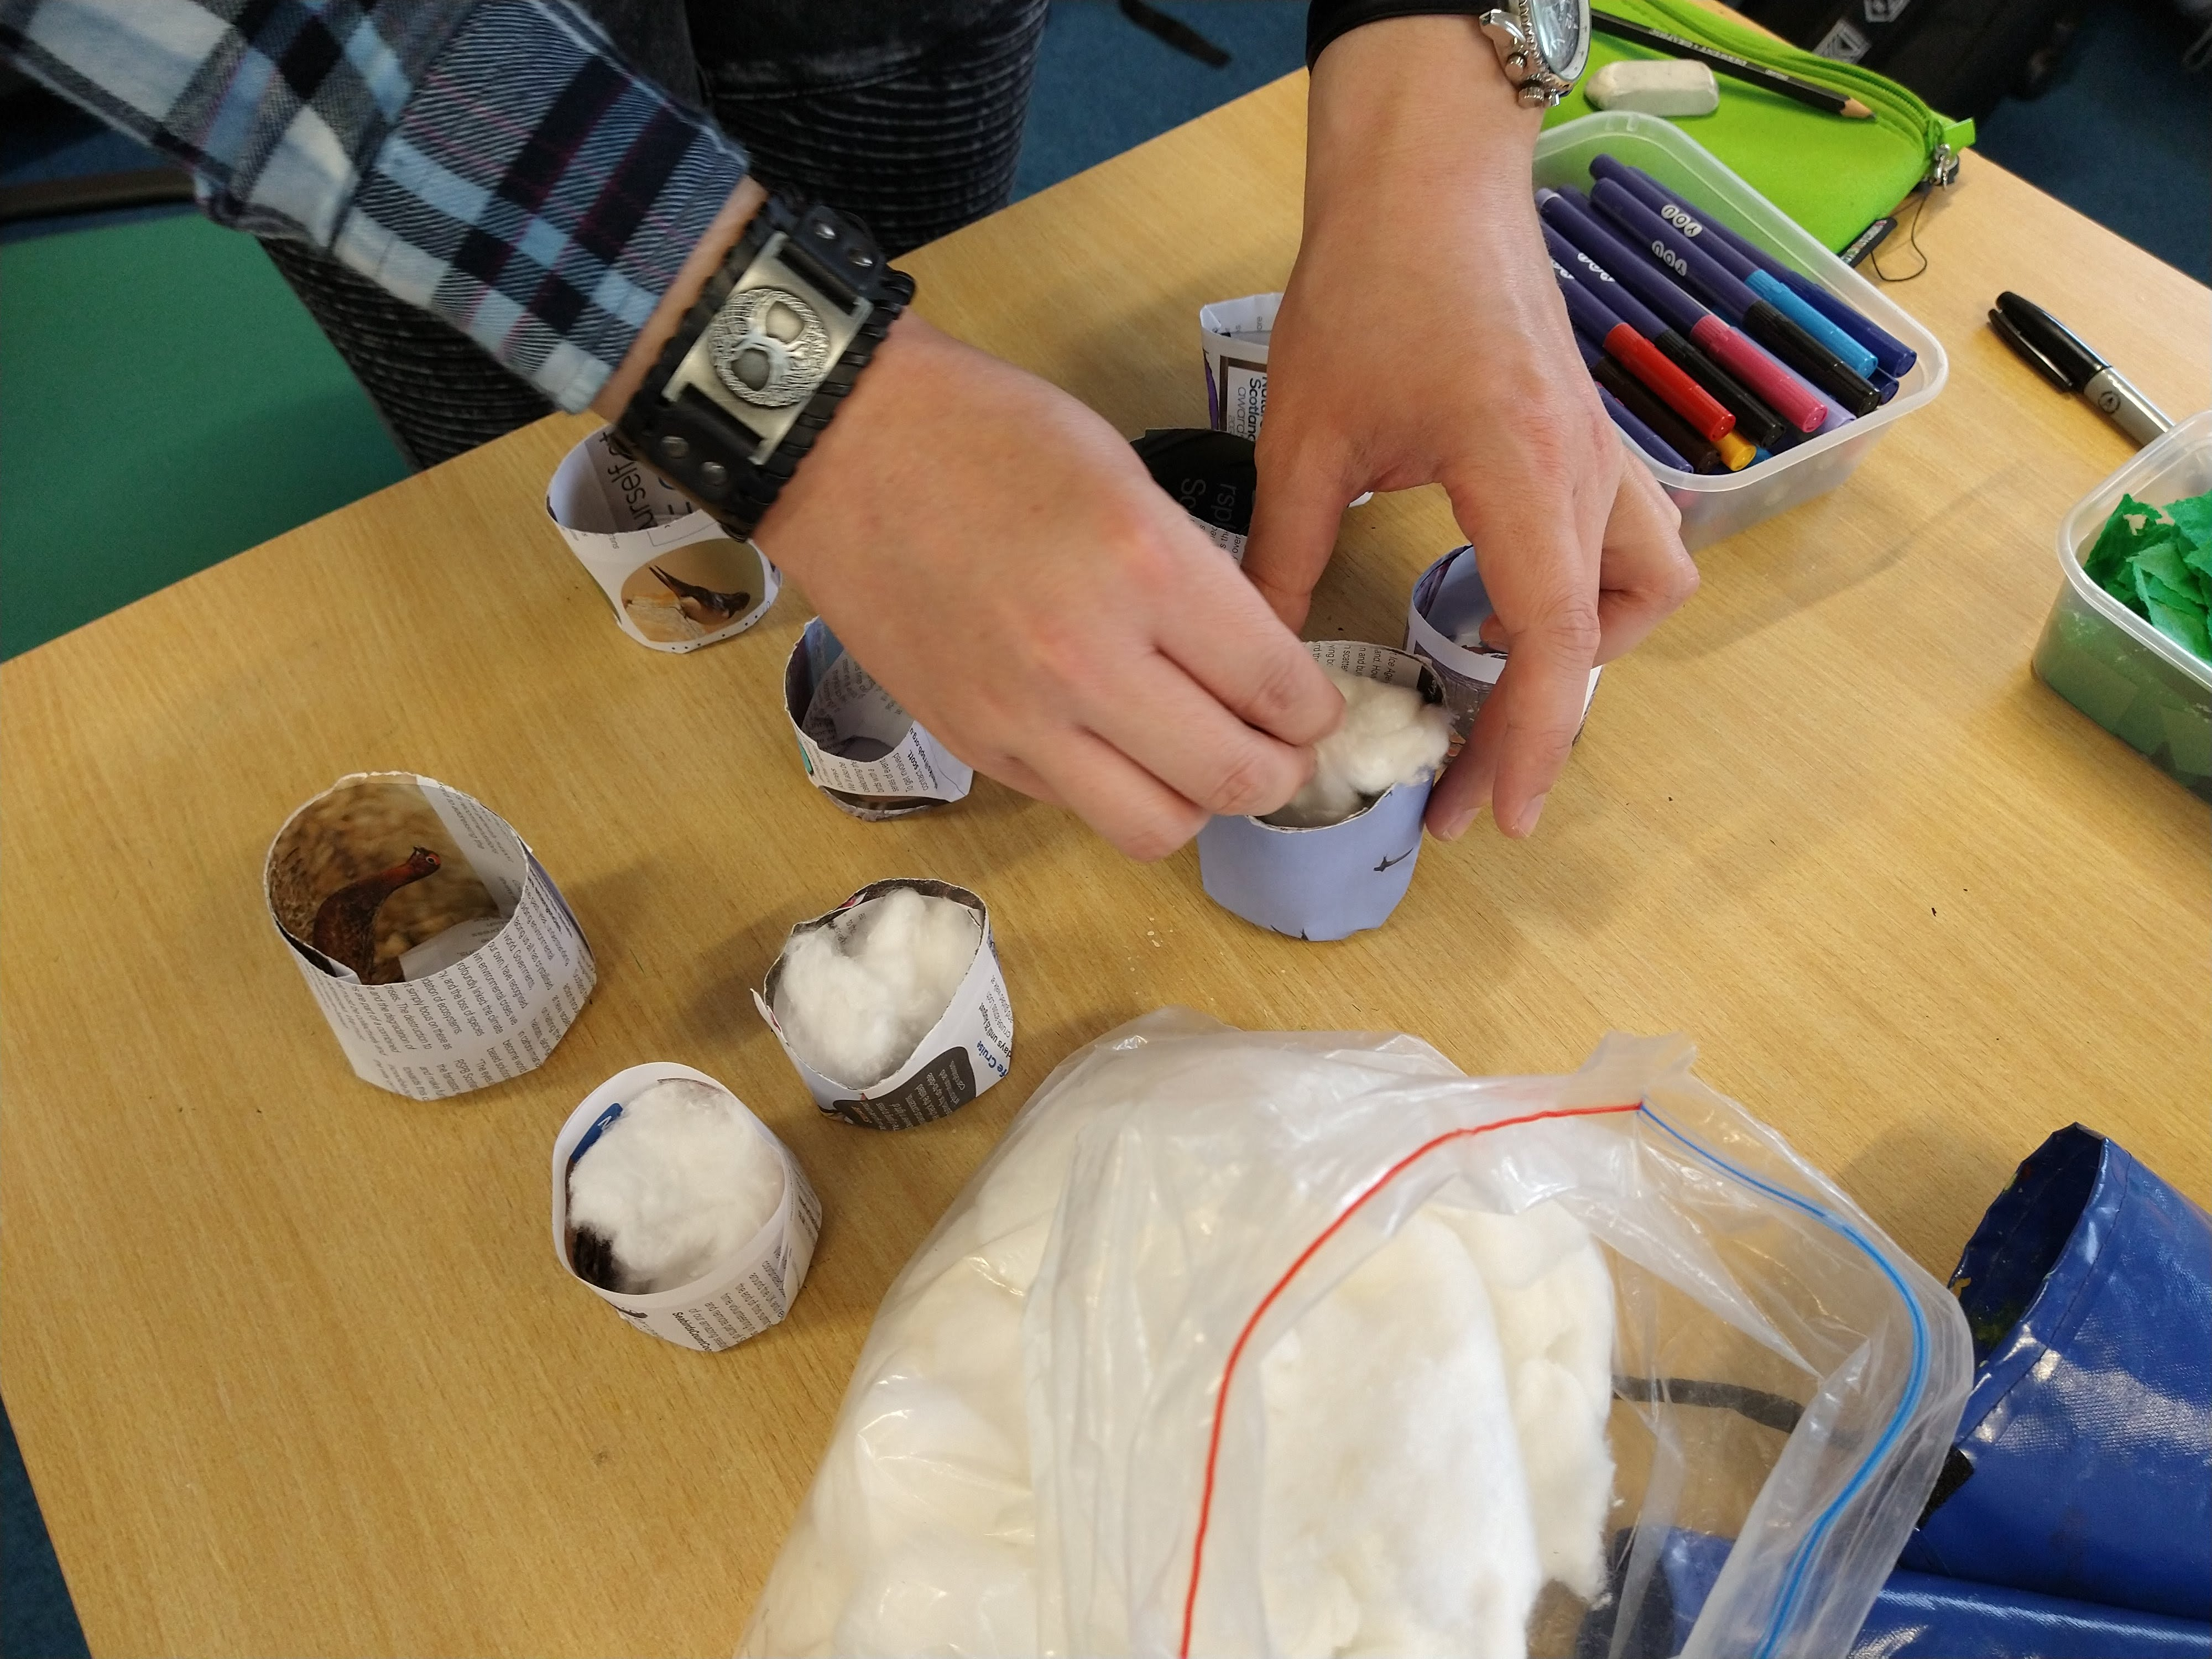
Fill the pot with cotton wool and slowly add water until the cotton wool is damp, not soaking.
Step 3.
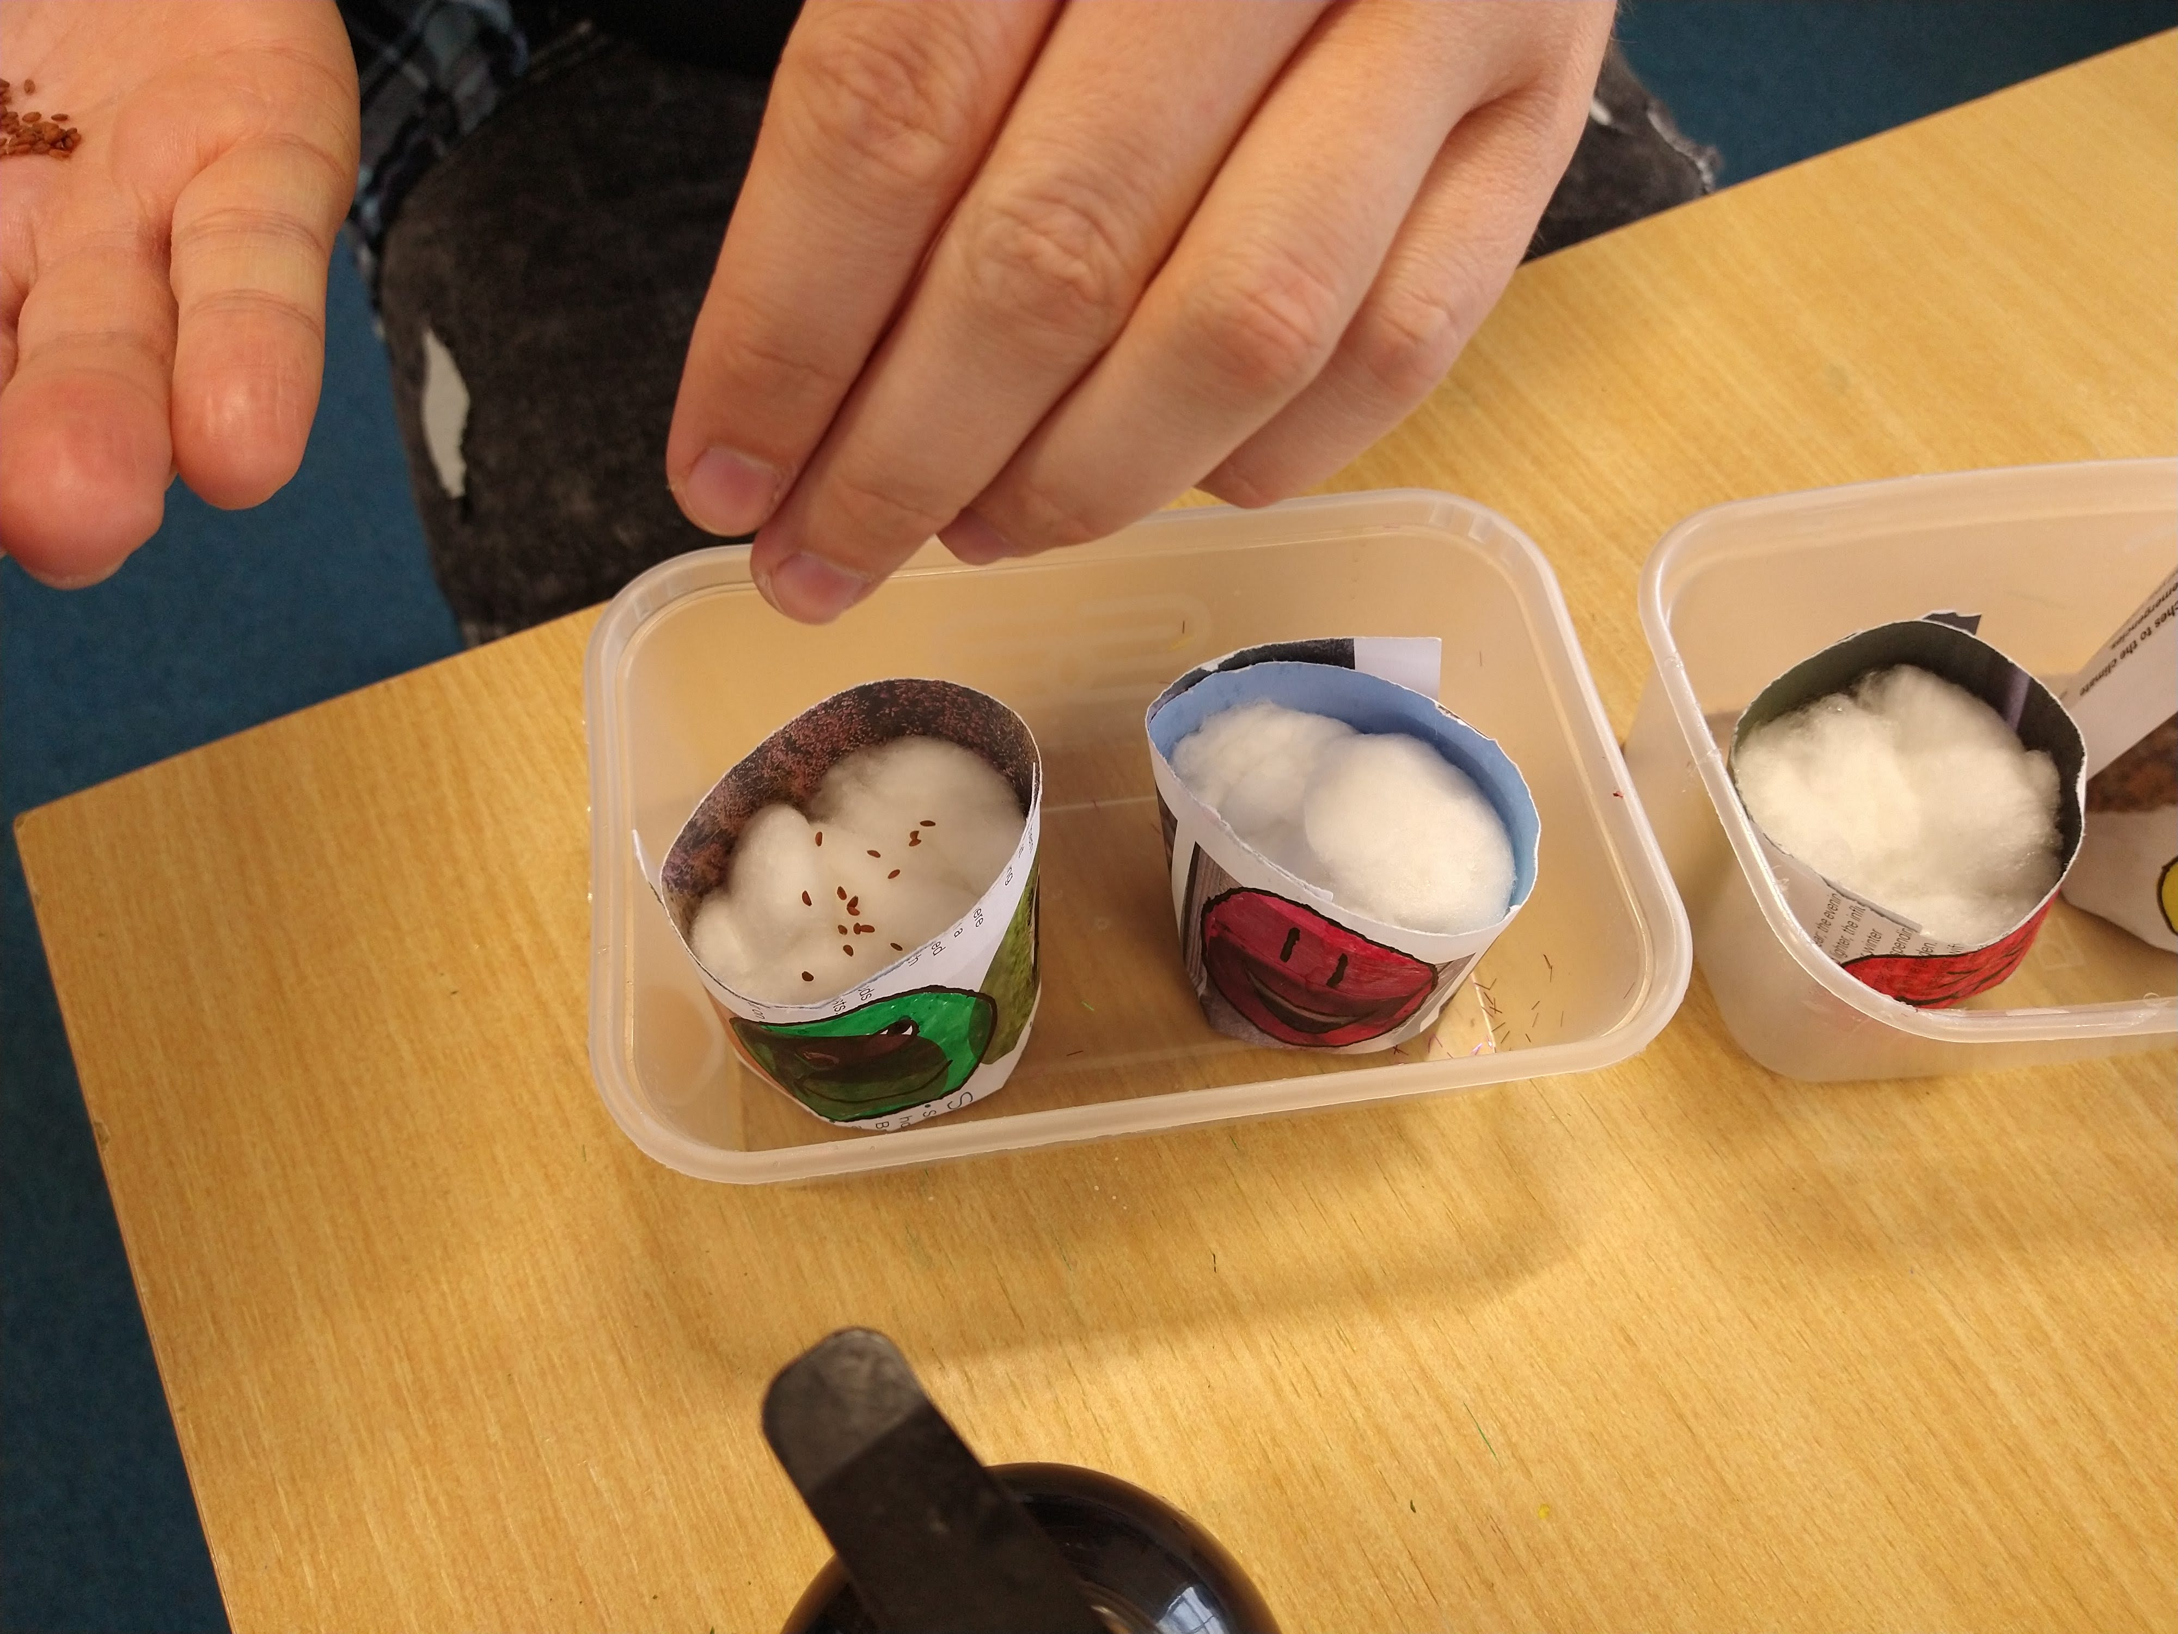
Sprinkle the cress seeds over the surface of the cotton wool.
Step 4.
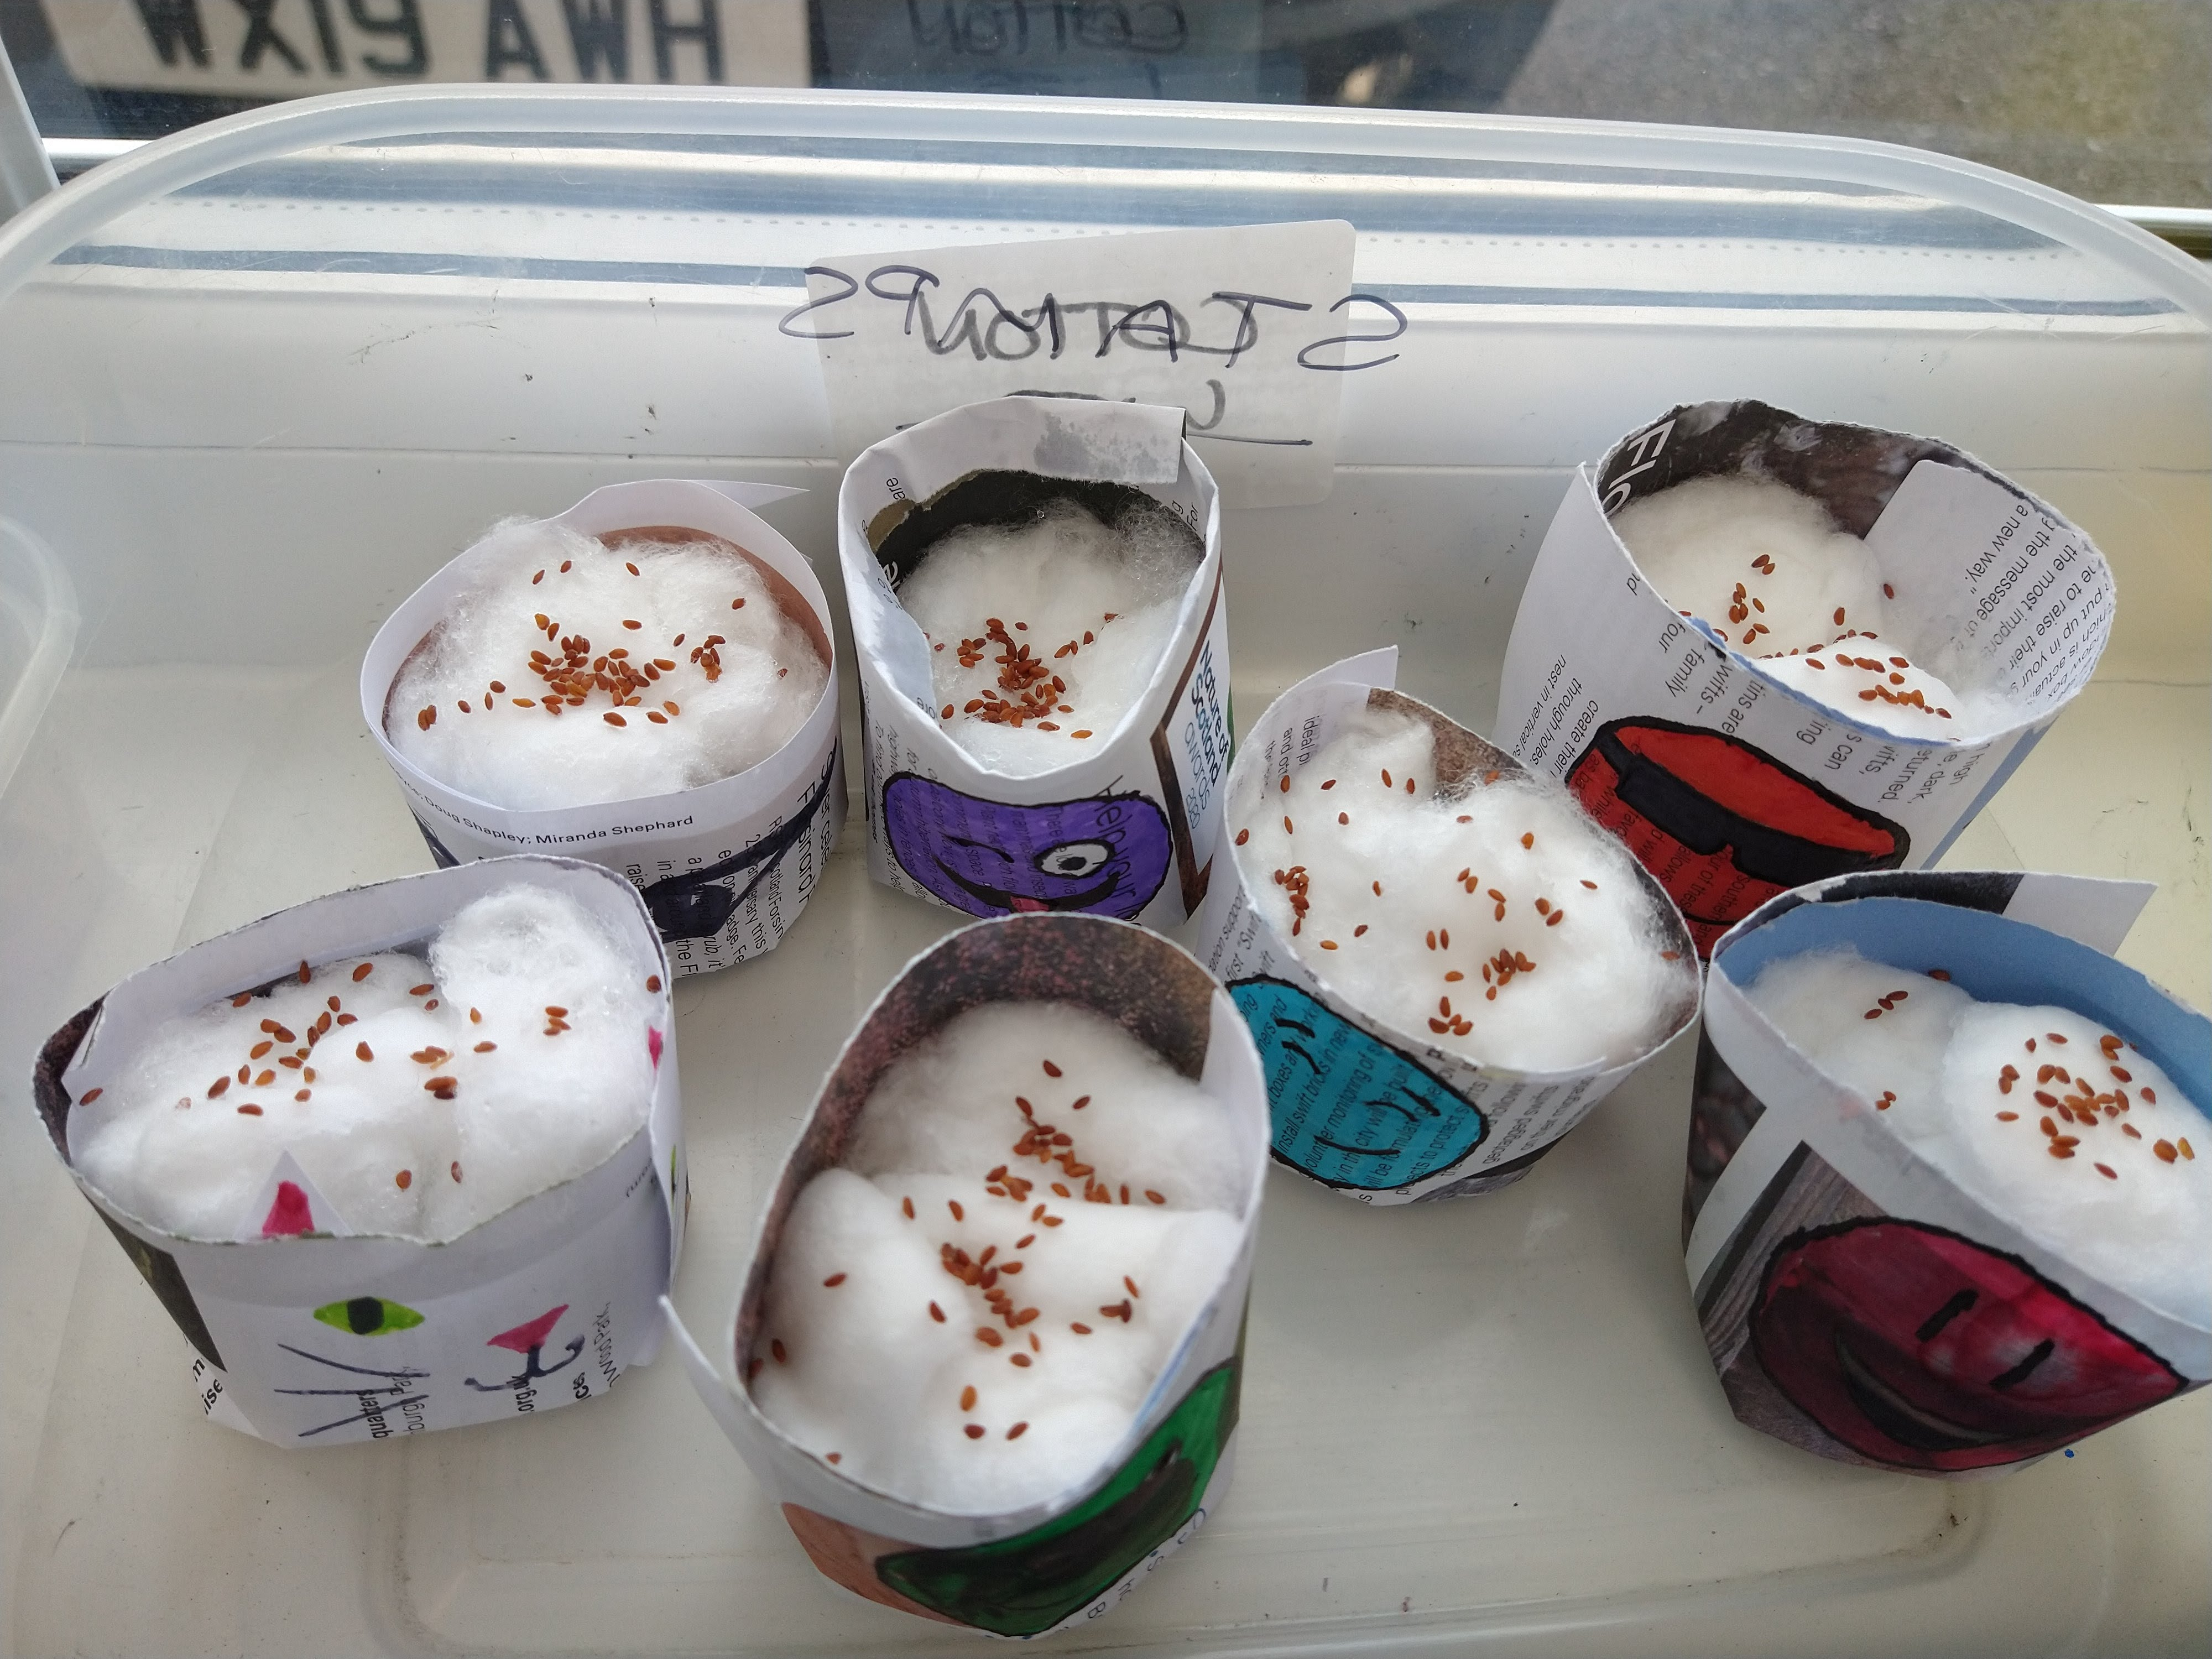
Place your pot in a warm, light place such as a window sill and wait for the cress to germinate! Keep the cotton wool damp, the seeds should start sprouting in a few days.
Step 5.
When the cress seedlings get to a few centimetres long then you can snip them off and enjoy them in a salad or sandwich.
Have fun and don't forget to show us how you get on!

