Firework Scraperboard
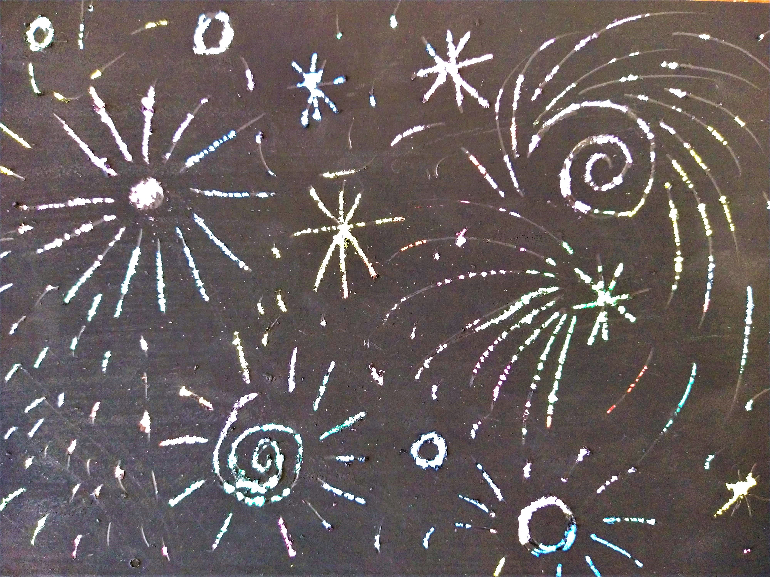
Remember remember the 5th of November; gunpowder, treason and plot! This week we're sharing a fun craft you can try at home to create a beautiful firework picture.
You will need:
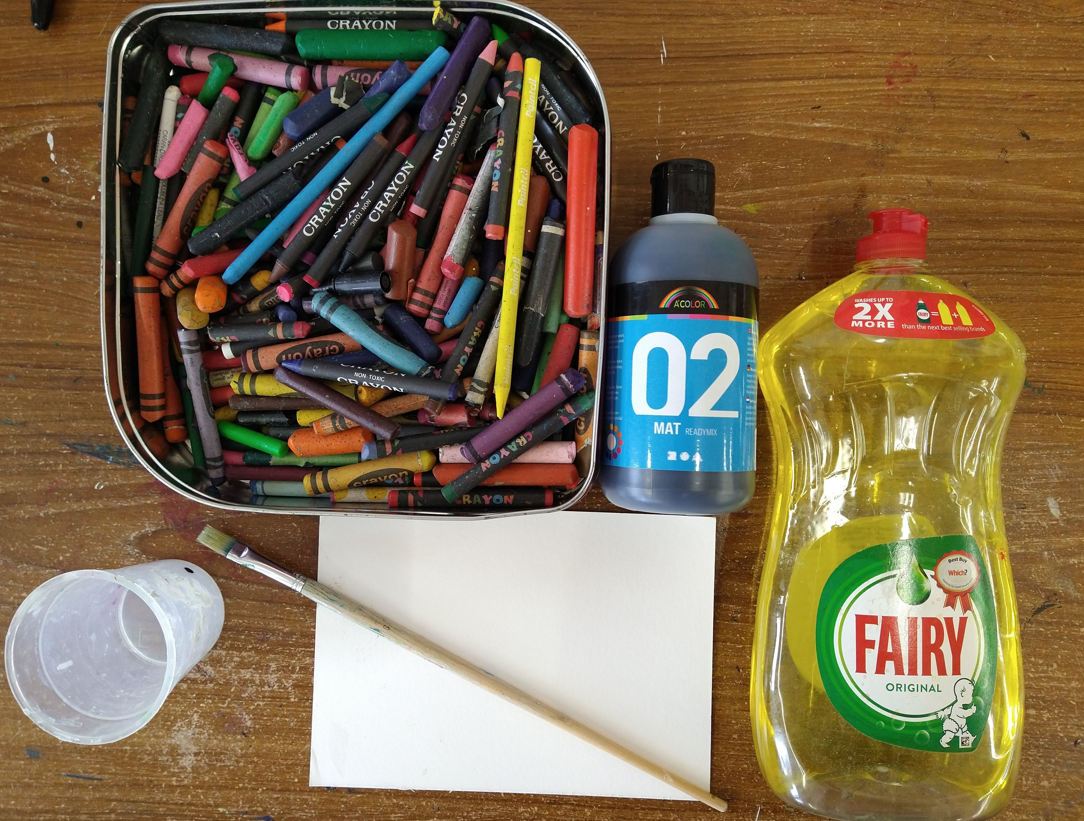
- Thick card (we used a bit of old mountboard)
- Wax crayons
- Black paint (we used poster paint)
- Washing up liquid
- Brush
- A knitting needle or similar pointy thing
Step 1.
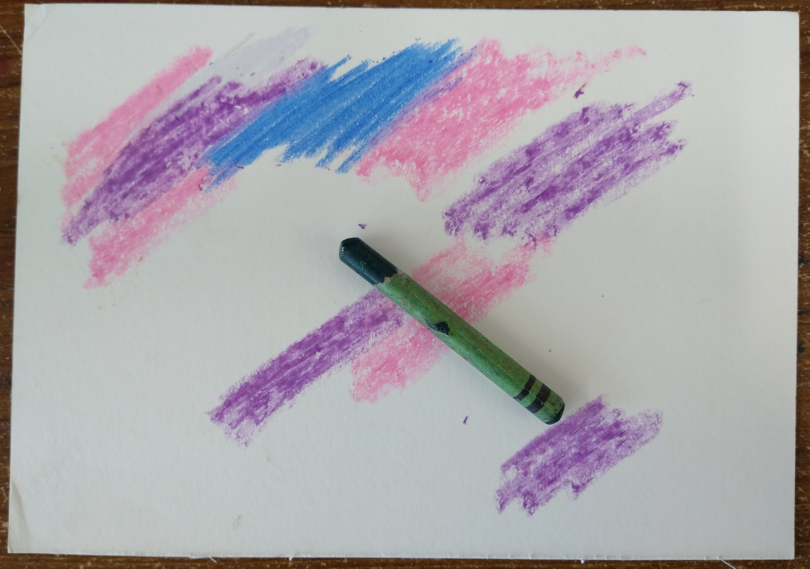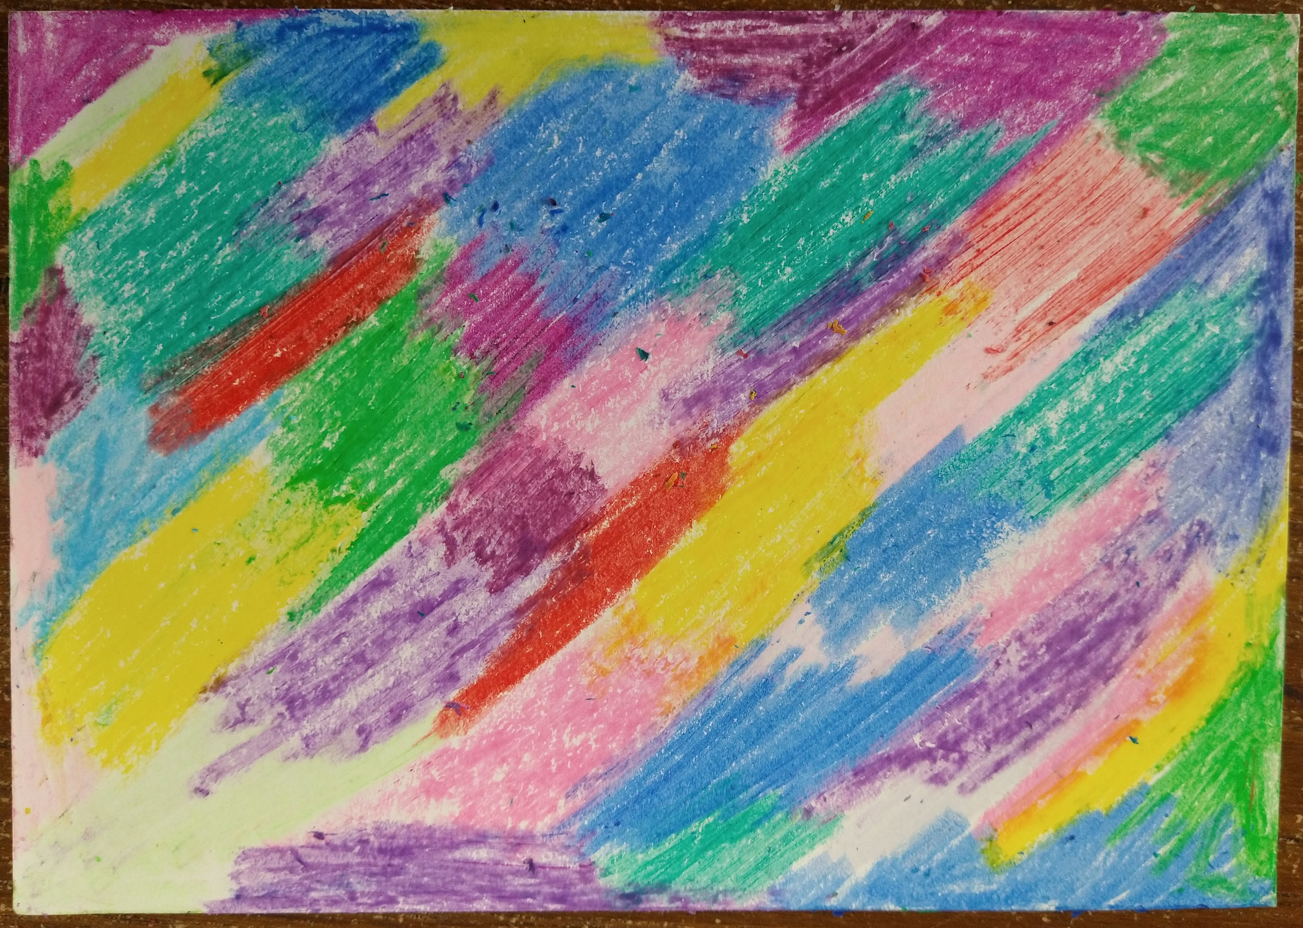
Cover your card with your wax crayons, we did lots of patches of different colours. Make sure you get a really thick layer of colour down.
Step 2.
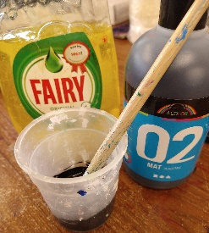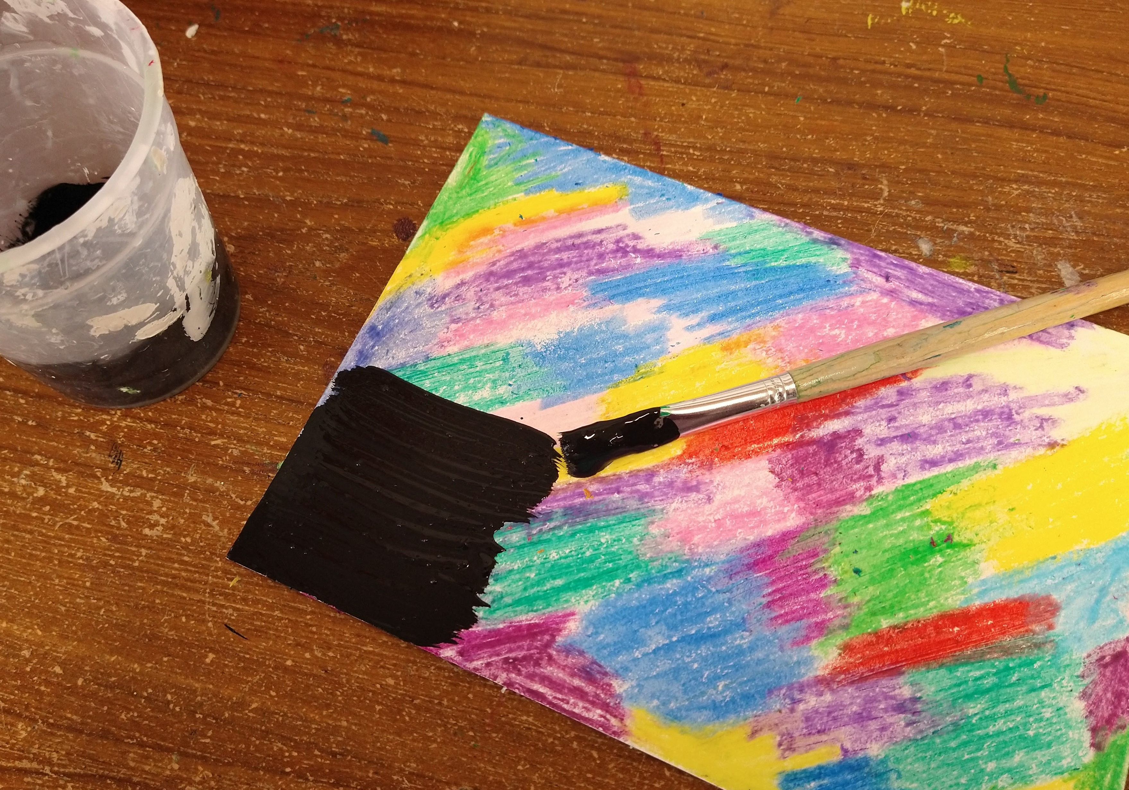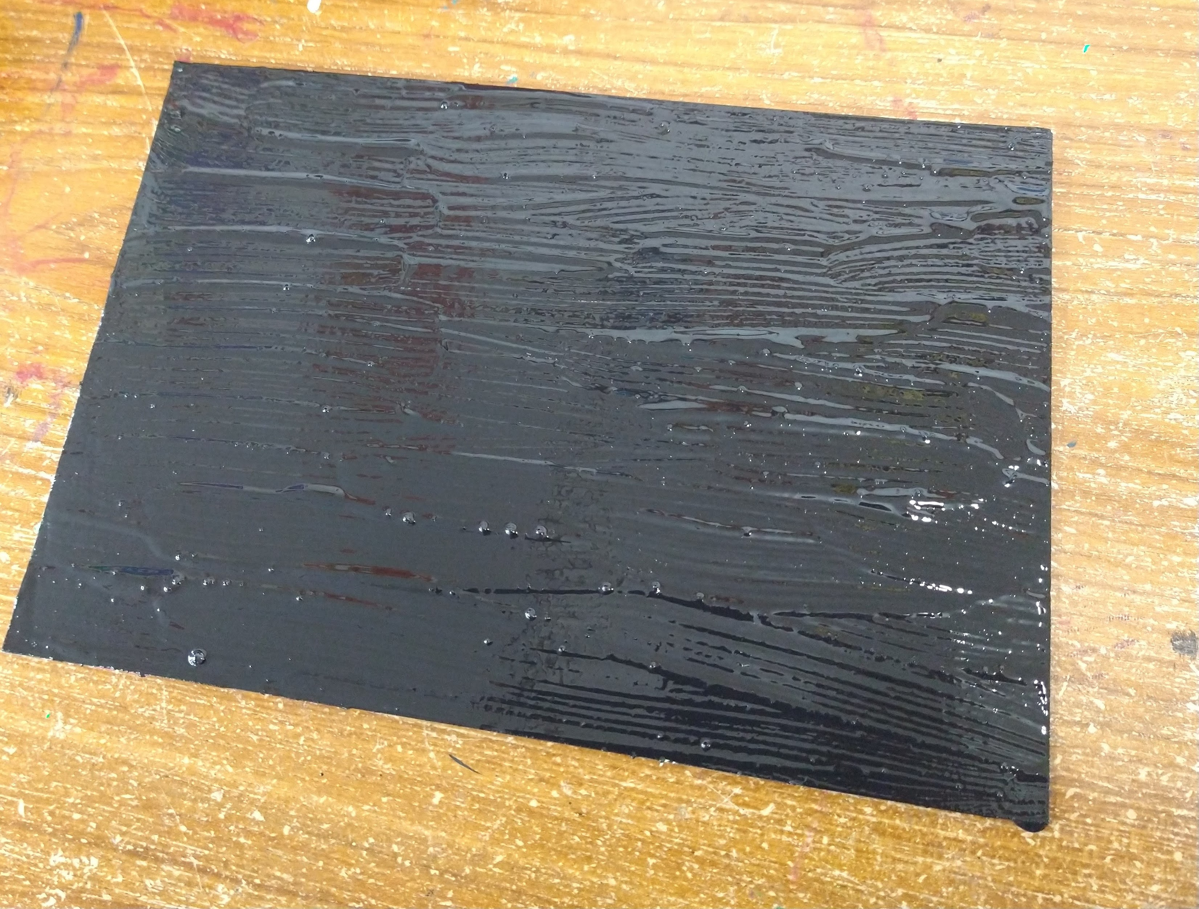
Mix a little bit of washing up liquid in with your black paint. Paint a thick coat of this mixture over the top and then leave it to dry.
Step 3.
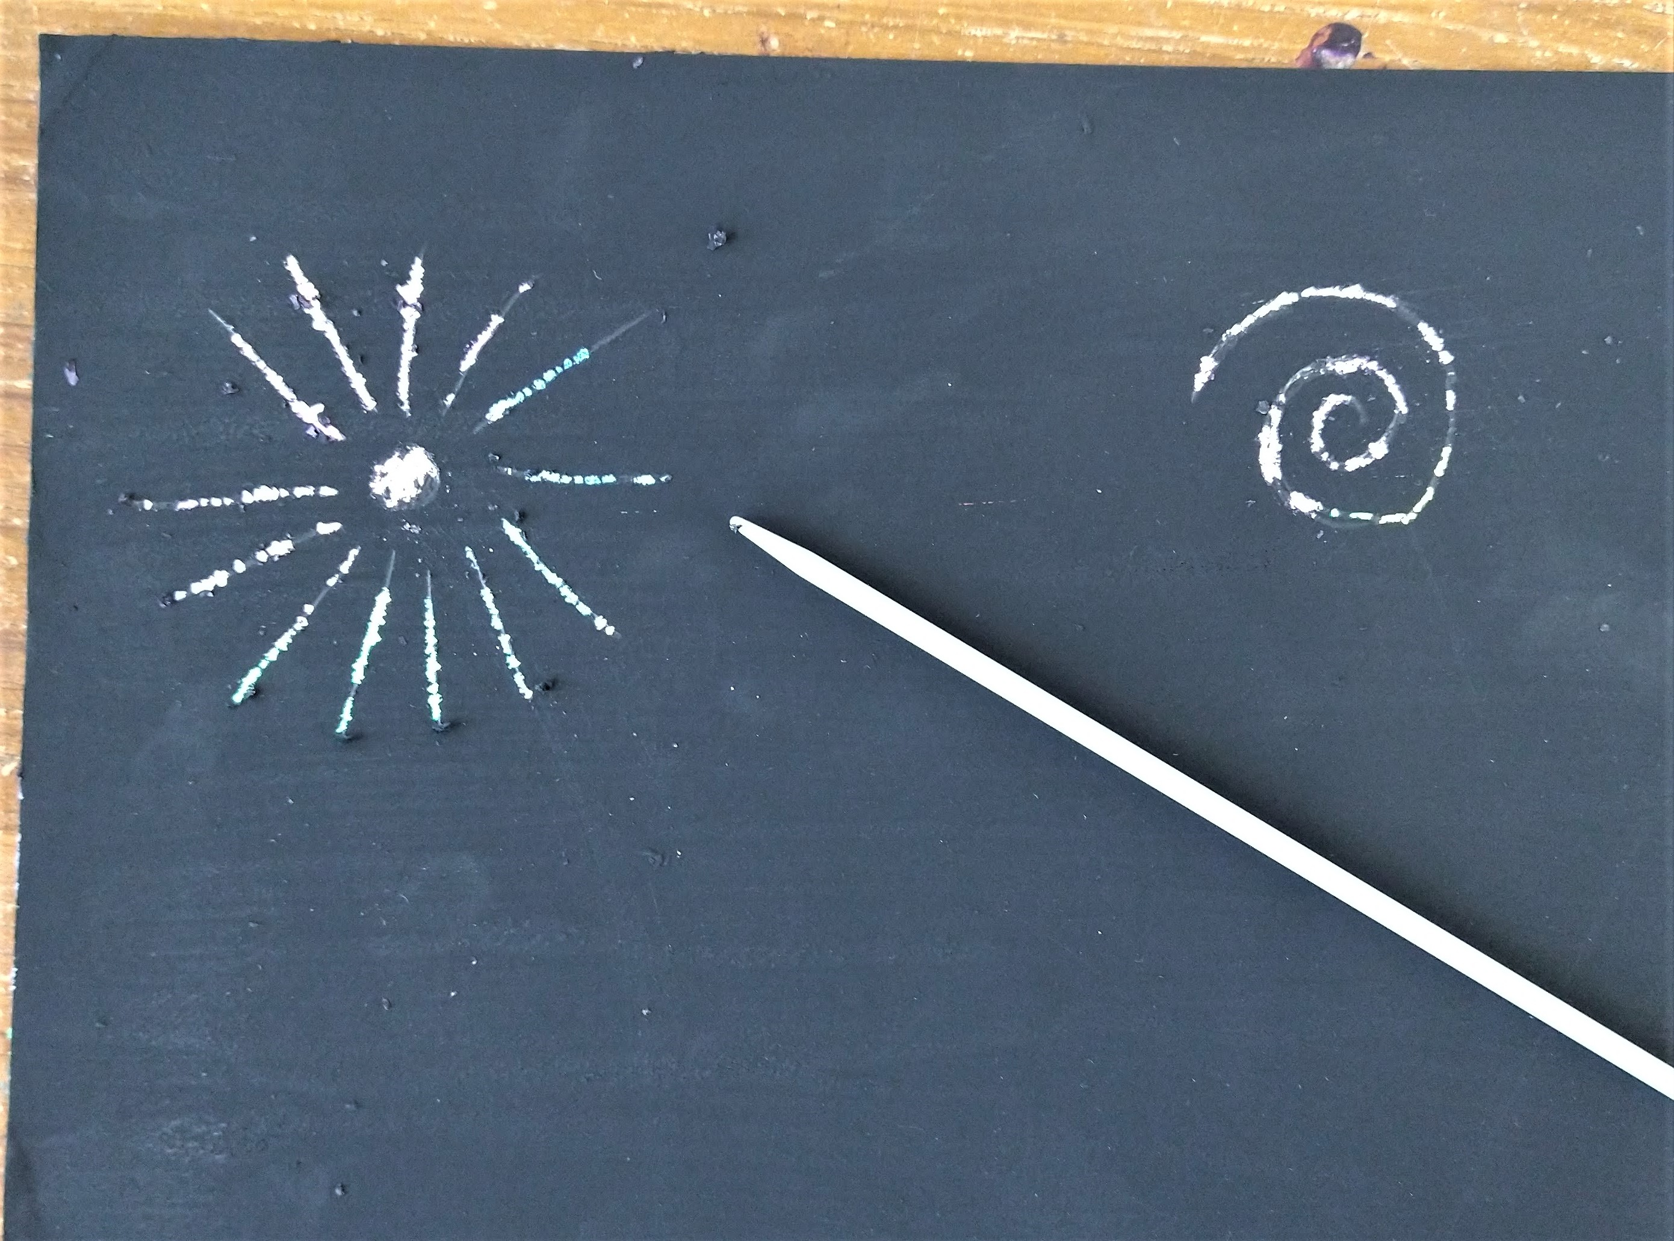
When the paint is totally dry use the knitting needle (or similar pointy implement) to scratch designs into the paint, revealing the colours below. Try making different types of mark to represent different types of fireworks.
Have fun and don't forget to show us how you get on!

