How to make Paper Beads
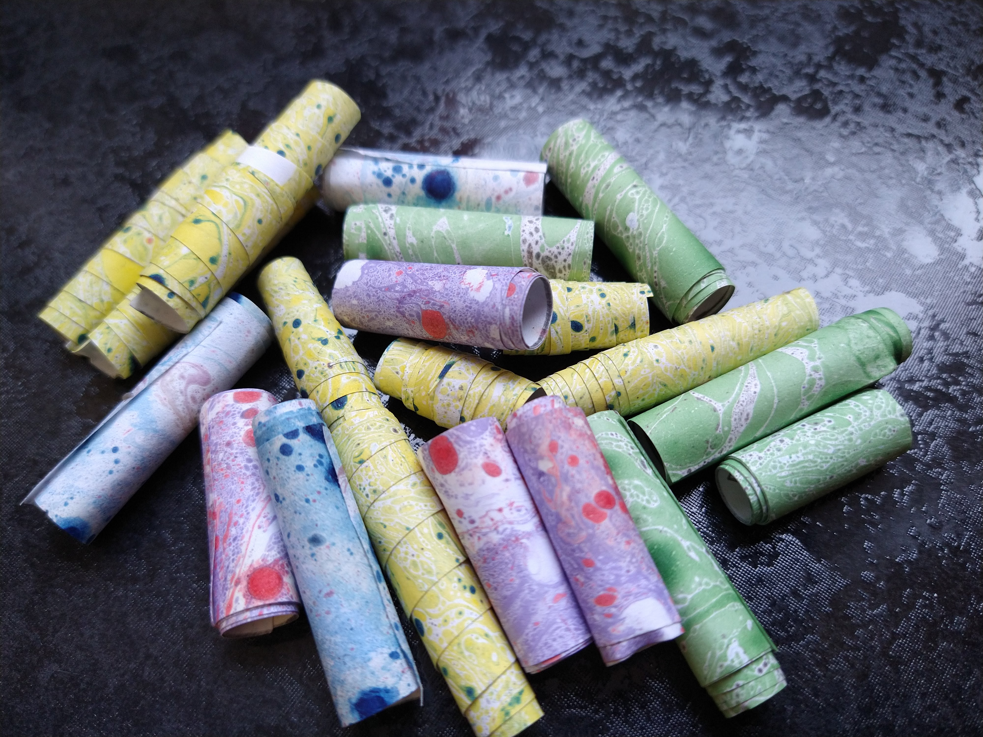
Making paper beads is really easy and a good way to use up bits of decorative paper or pretty magazine pages.
You will need:
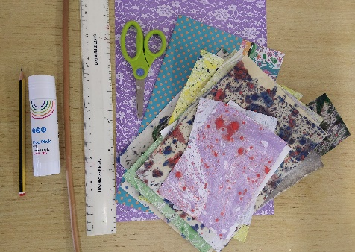
- Paper (magazine pages, patterned paper or anything you want to use up)
- Pencil
- Ruler
- Scissors
- Glue
- Stick or something similar to roll your beads on.

Step 1.
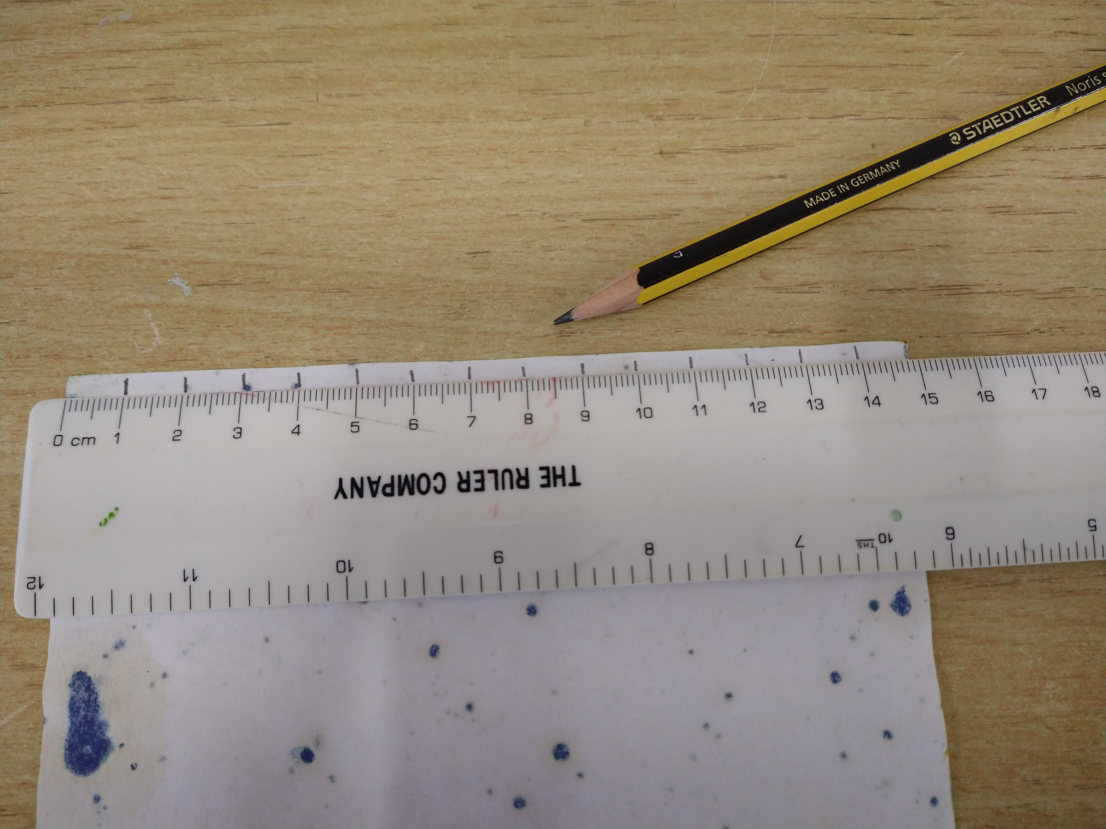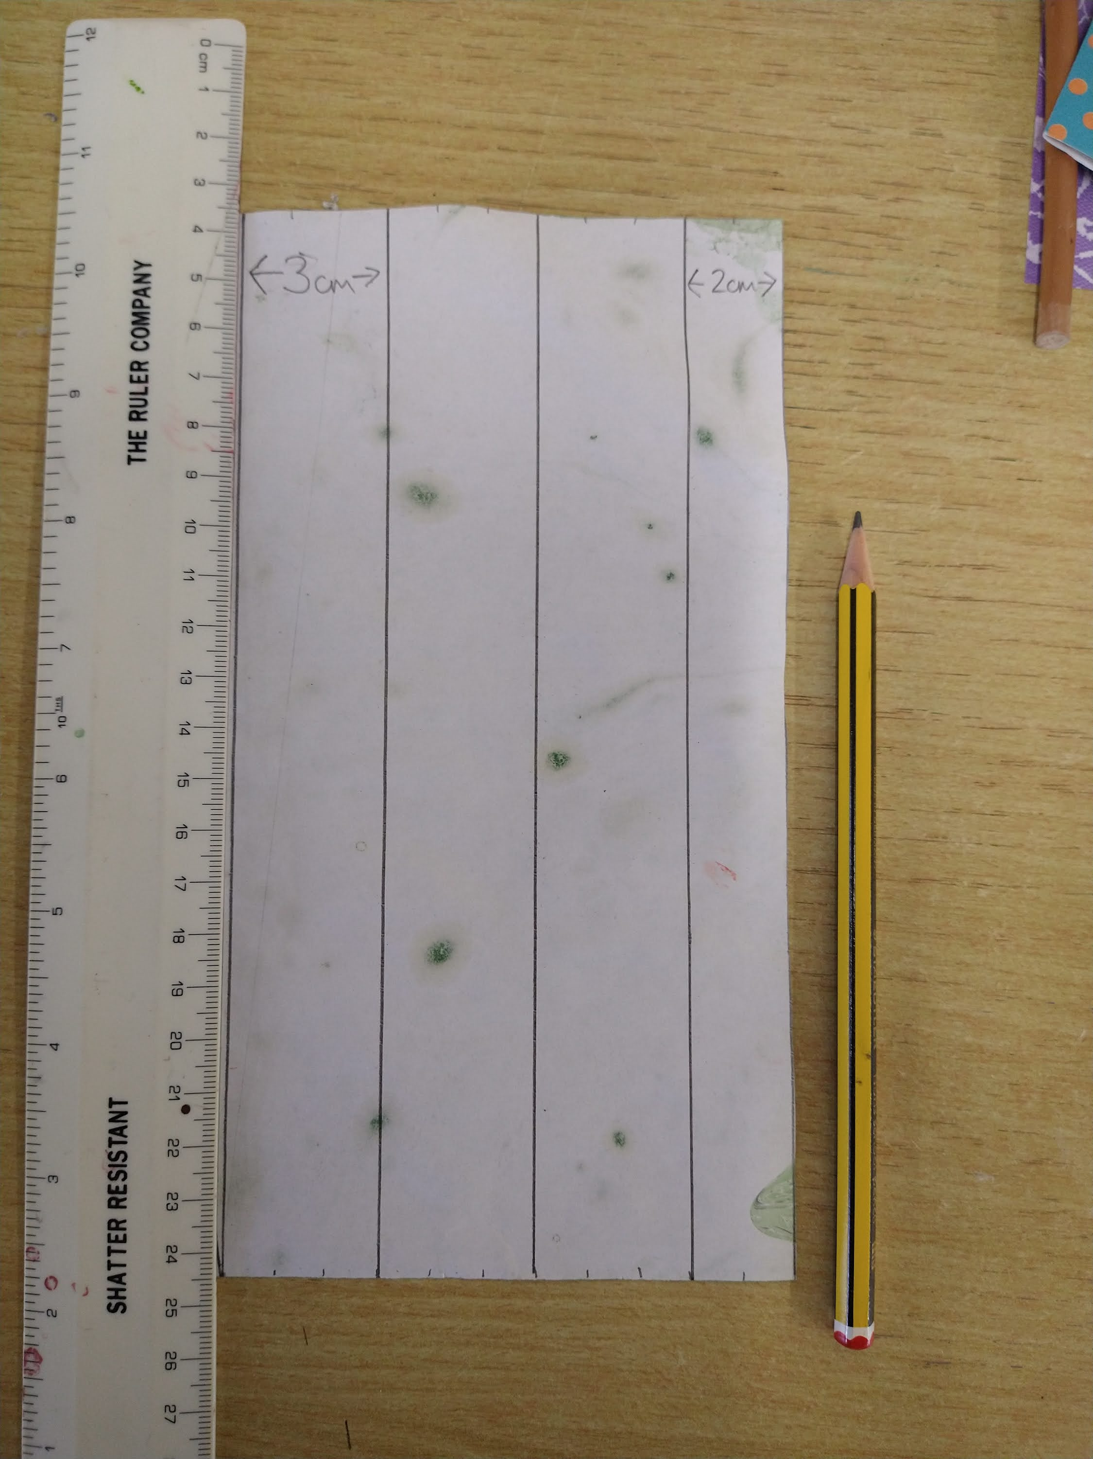
On the back of your paper use the ruler and pencil to mark out strips. The wider the strips you mark out the wider your bead will be.
We made marks along the top and bottom of our paper and then joined them up with the ruler and pencil to make our strips.

Step 2.
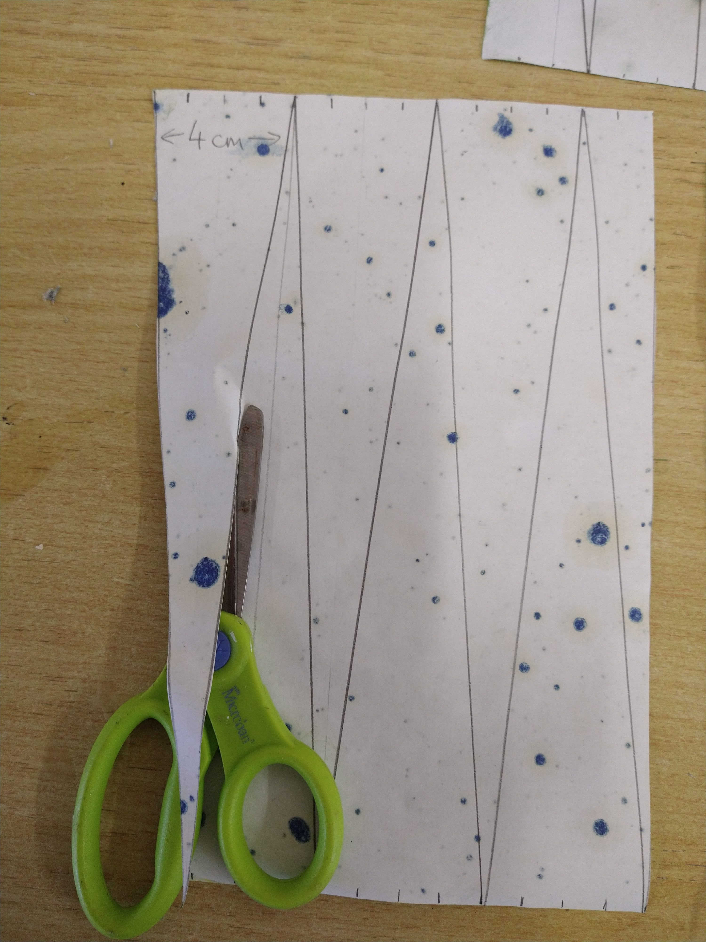
Cut out your strips.
Step 3.
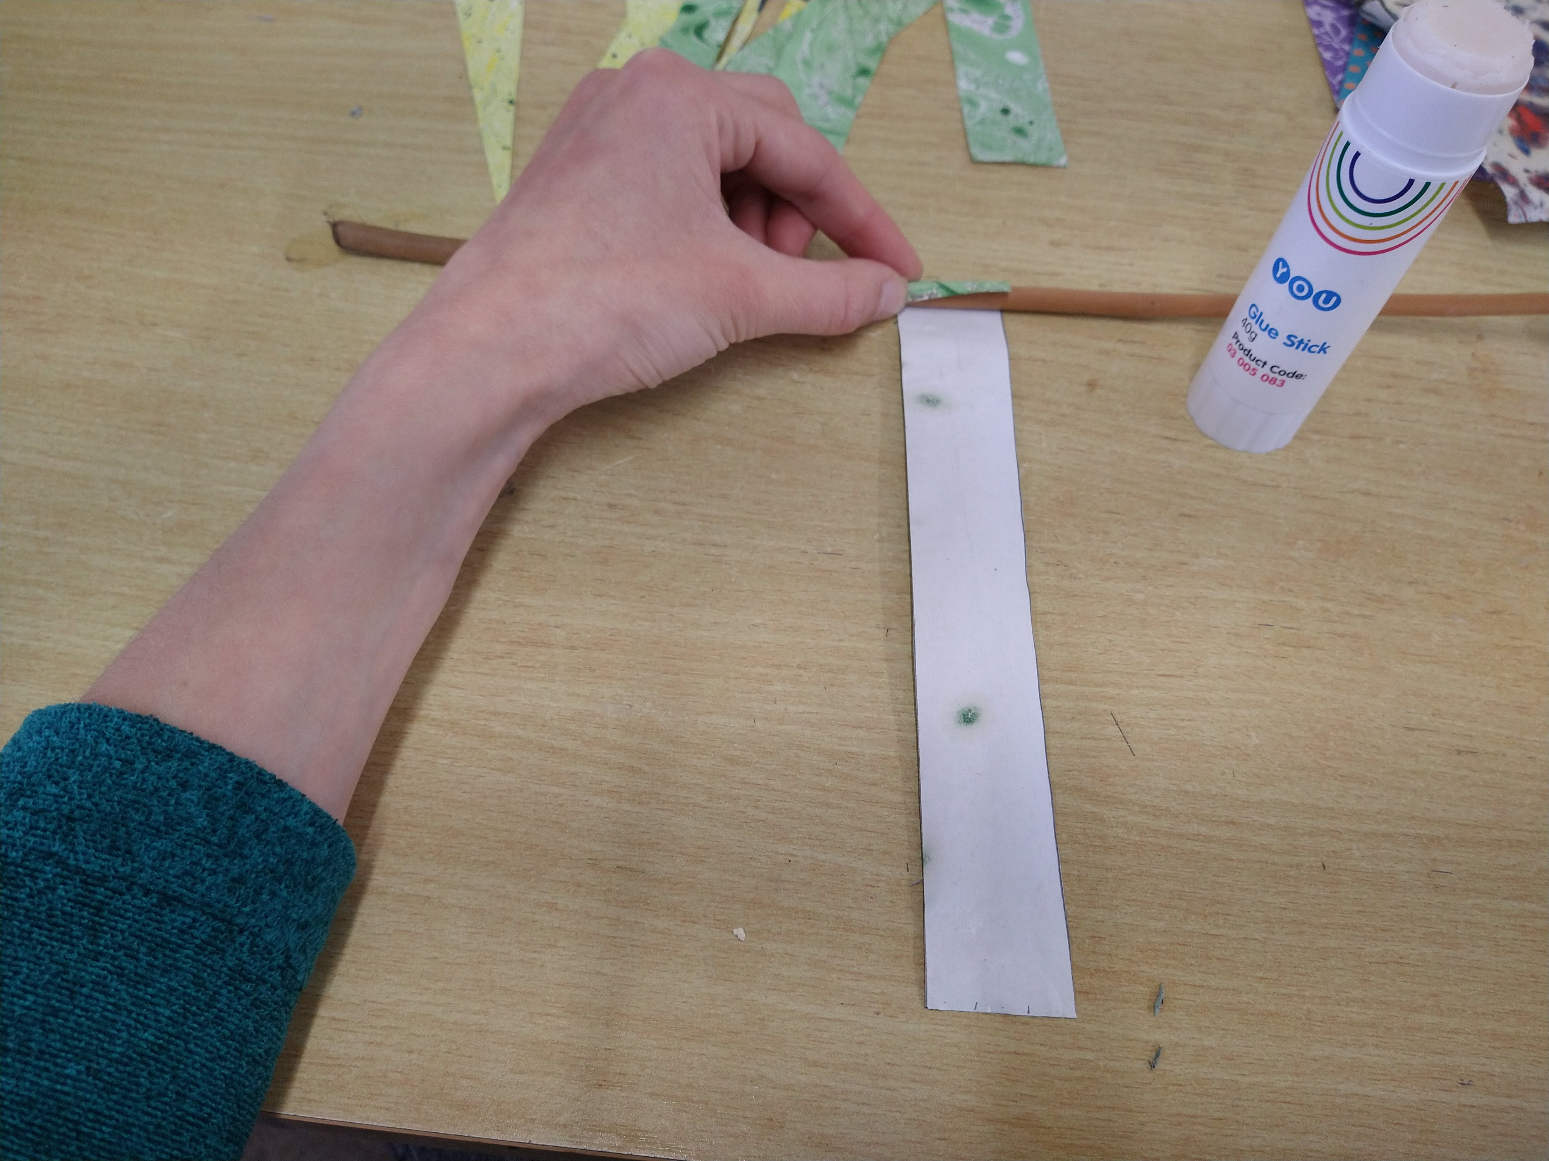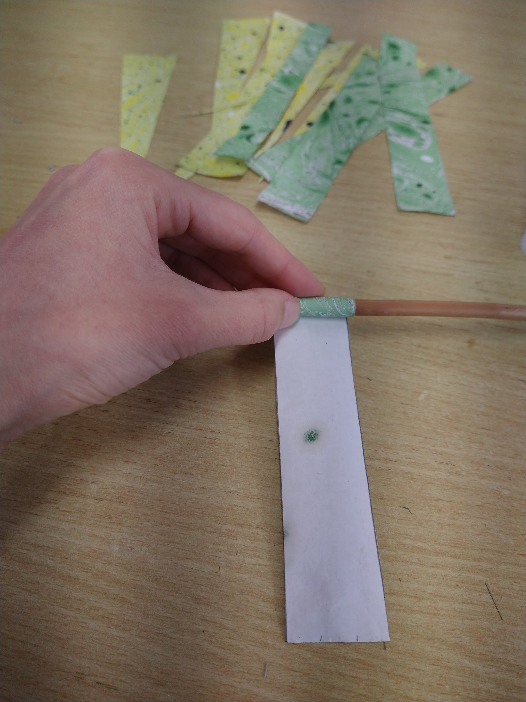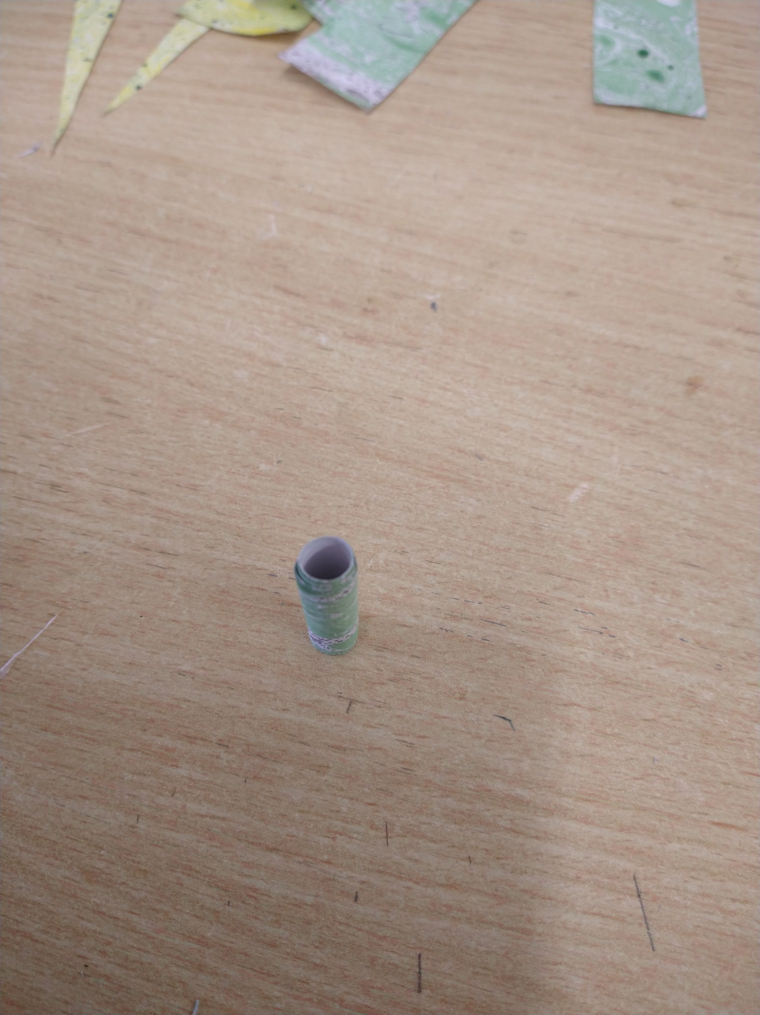
Place a strip of paper face down in front of you and cover it in glue, leaving a small section (about 1-2 cm) at the top un-glued.
Place your stick on this un-glued section and then begin rolling the strip of paper around the stick.
Keep rolling till the end of the strip then slide the roll off the stick. You’ve made your first bead! Keep going and make some more.
Step 4.
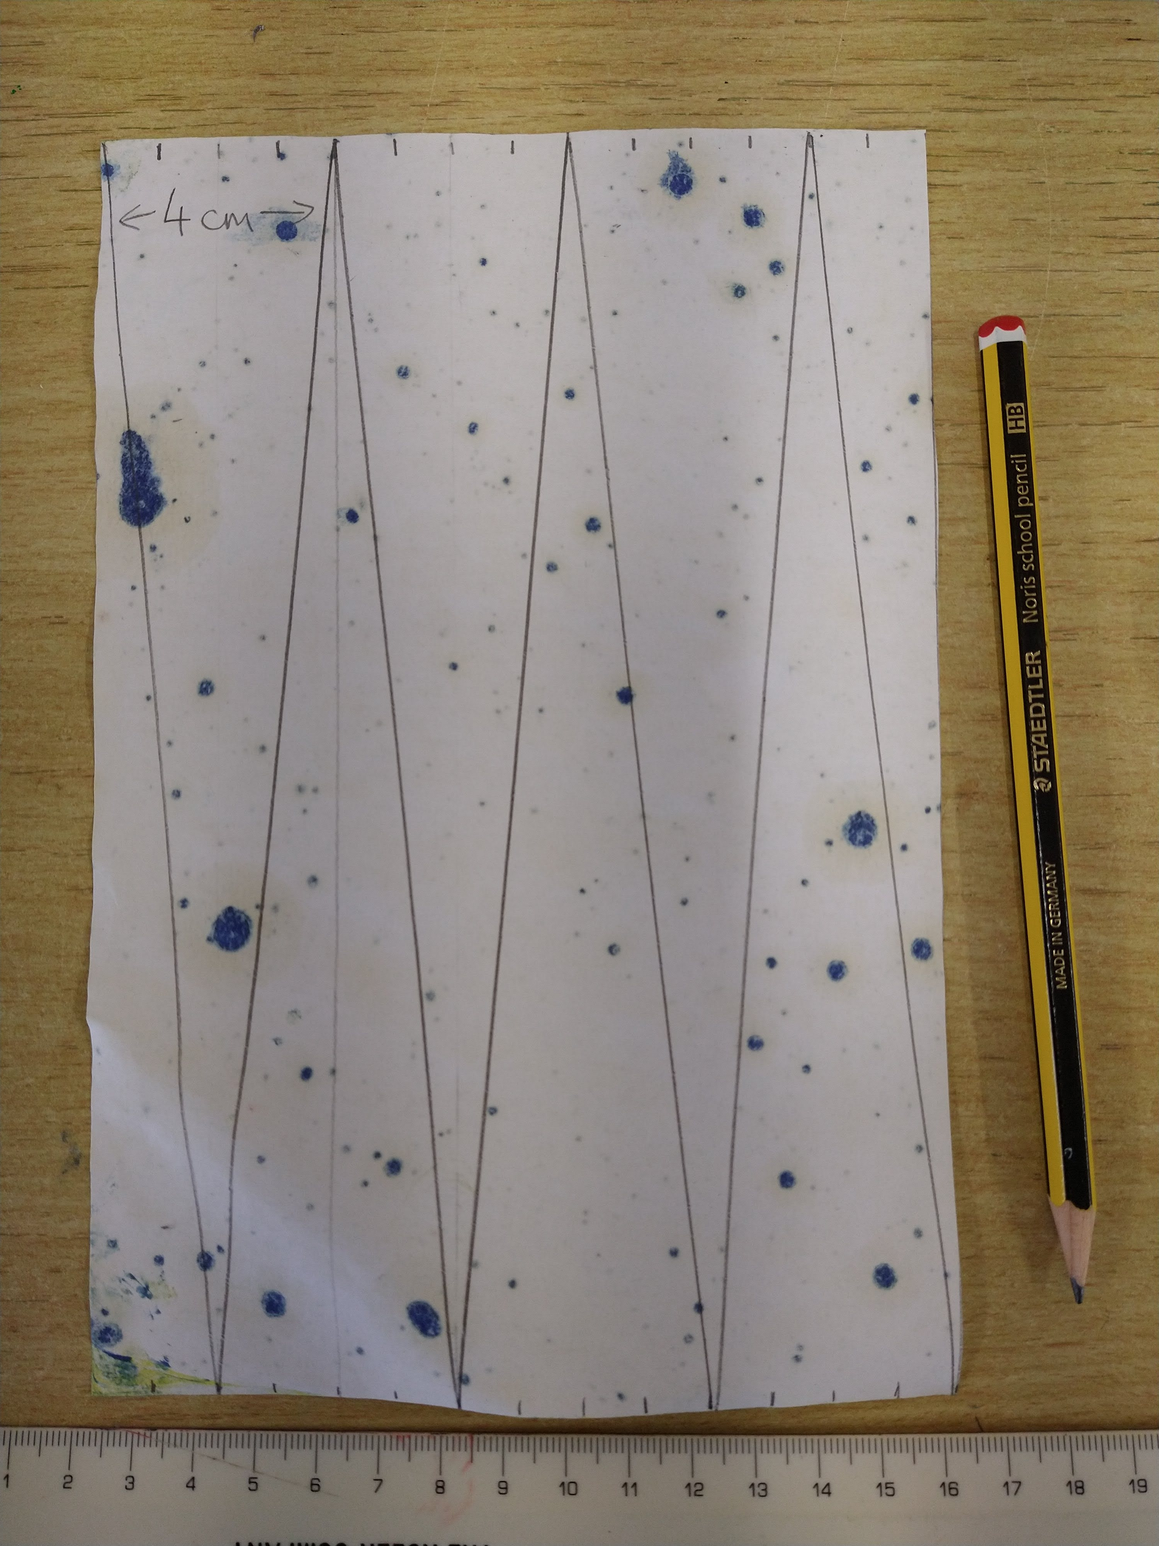
You can try this technique with triangles as well as strips of paper. Why not make a few of each type of bead?
Have fun and don’t forget to show us how you get on!
