Gluten Free ORANGE & ALMOND CAKE

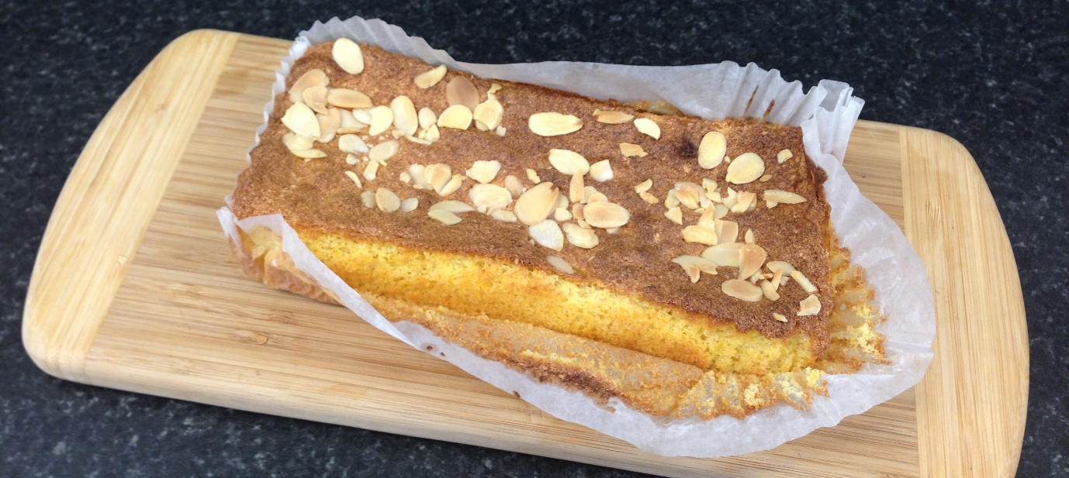

2 Oranges washed & chopped in pieces, skin & pith as well as flesh
5 Eggs separated into yolks and whites
200grs Unrefined golden caster sugar
225grs Ground almonds
Decoration Flaked almonds and icing sugar

- Preheat oven to 160°C and line 2-3 loaf tins with paper.
- Place chopped Oranges in pan with a little water. Cover and stew gently till soft and liquid has evaporated. Leave to cool. Liquidise in processor or use a small stick blender (Whatever you have).
- Whisk egg whites till stiff then gradually add half the sugar to create a meringue.
- Whisk egg yolks with remaining half of caster sugar till pale and thick.
- Gradually whisk in the pureed oranges to the egg yolk and sugar mixture then fold in the ground almonds.
- Gradually fold in the meringue.
- Now gently add the mixture to the lined loaf tins. Level the tops, sprinkle on flaked almonds and bake.
- Cool on drying racks.
- Remember, if necessary cover. Oven time always varies dependant on the oven but look for 40mins to 1hour.

