Paper Cat frieze
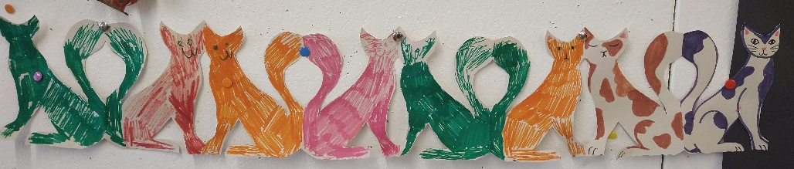
How would you like a frieze of cats to decorate your house with? Here's how to make your own!
You will need:
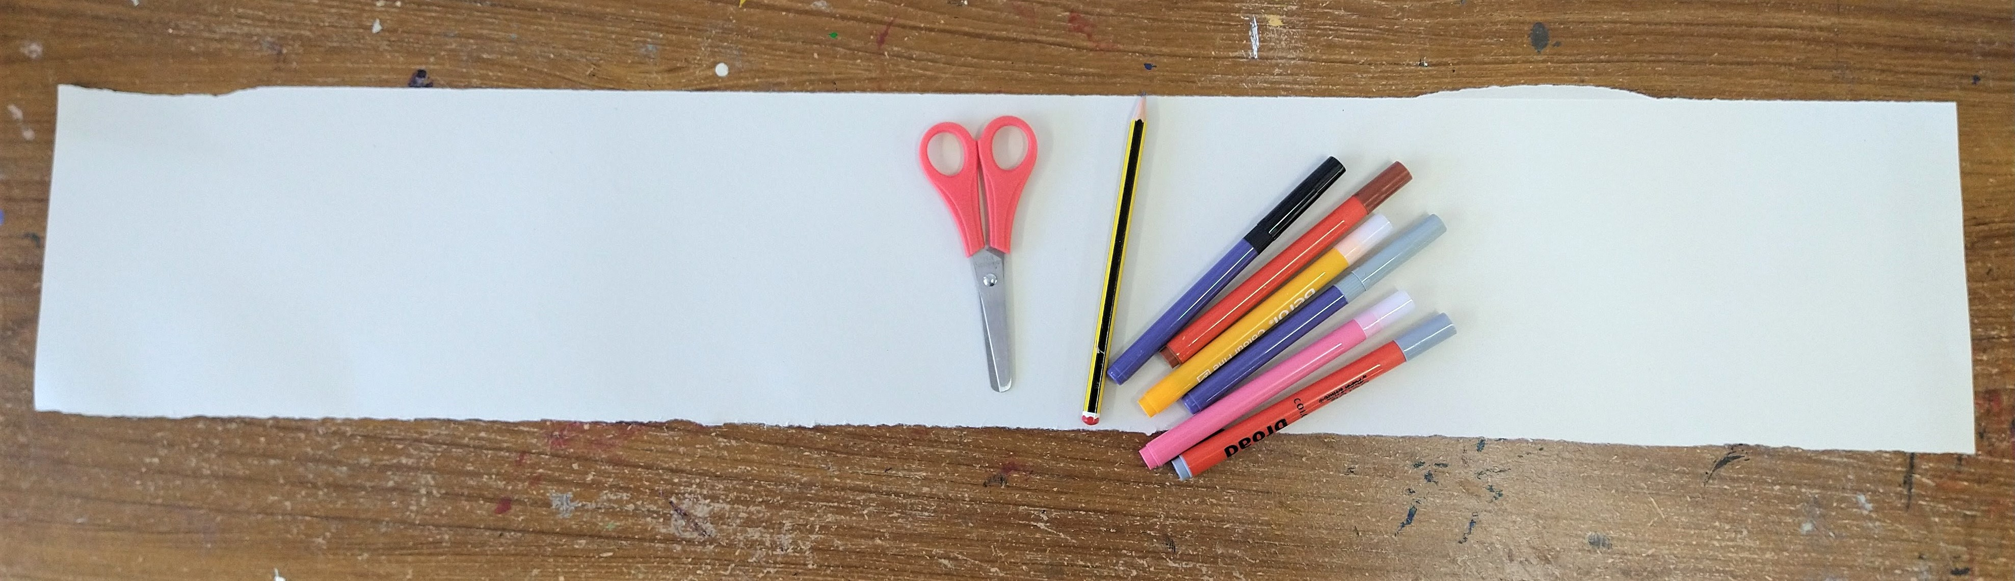
- A long strip of paper (ours was about 15 x 85 cm)
- Scissors
- Pencil
- Felt tip pens or coloured pencils

Step 1.
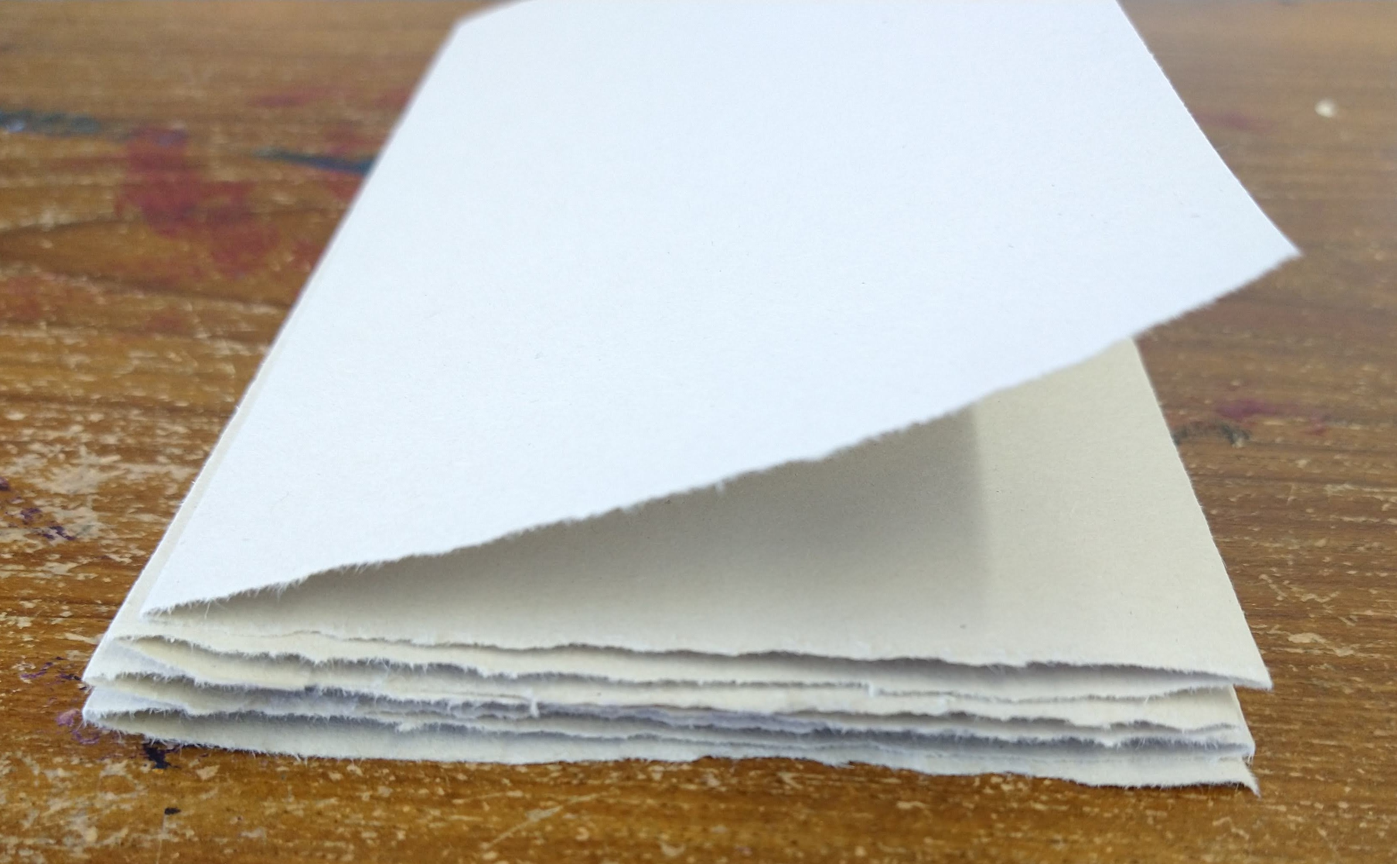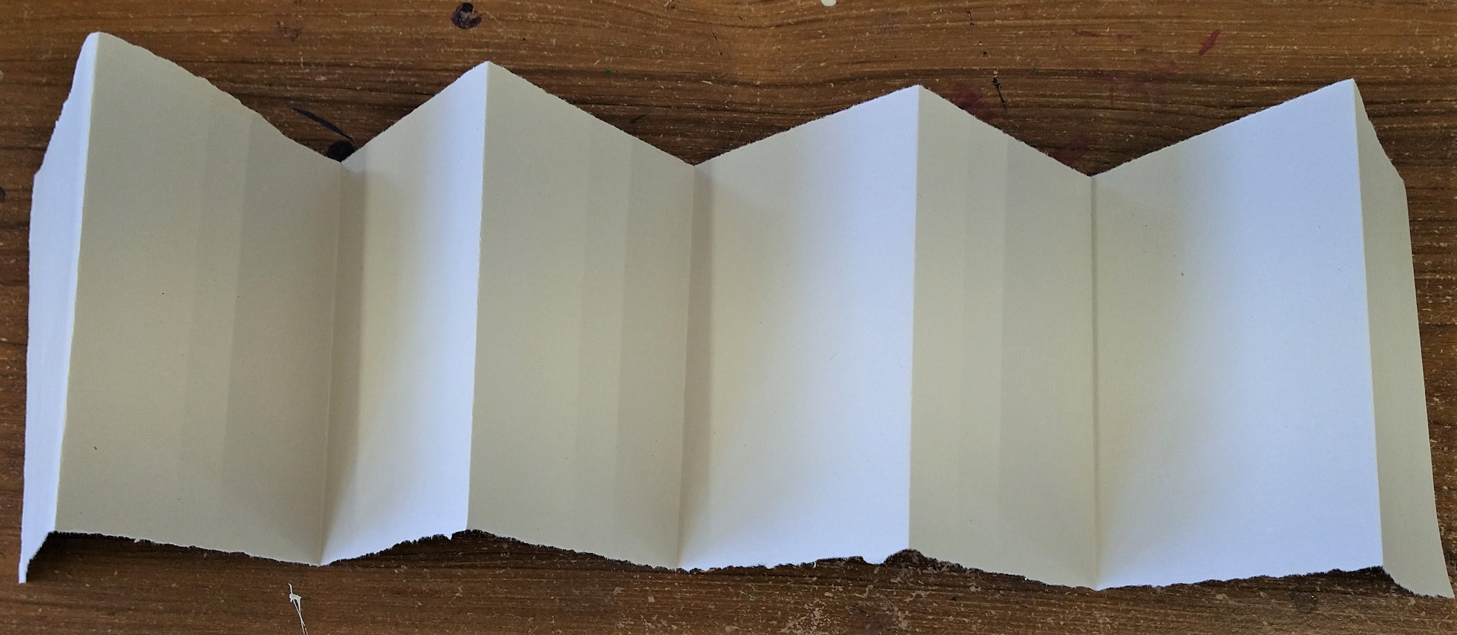
Fold your strip of paper into a concertina. Our concertina folds were about 10 cm wide. Don't worry if you end up with one end a bit short, you can just trim this off. Leave the concertina folded up.
Step 2.
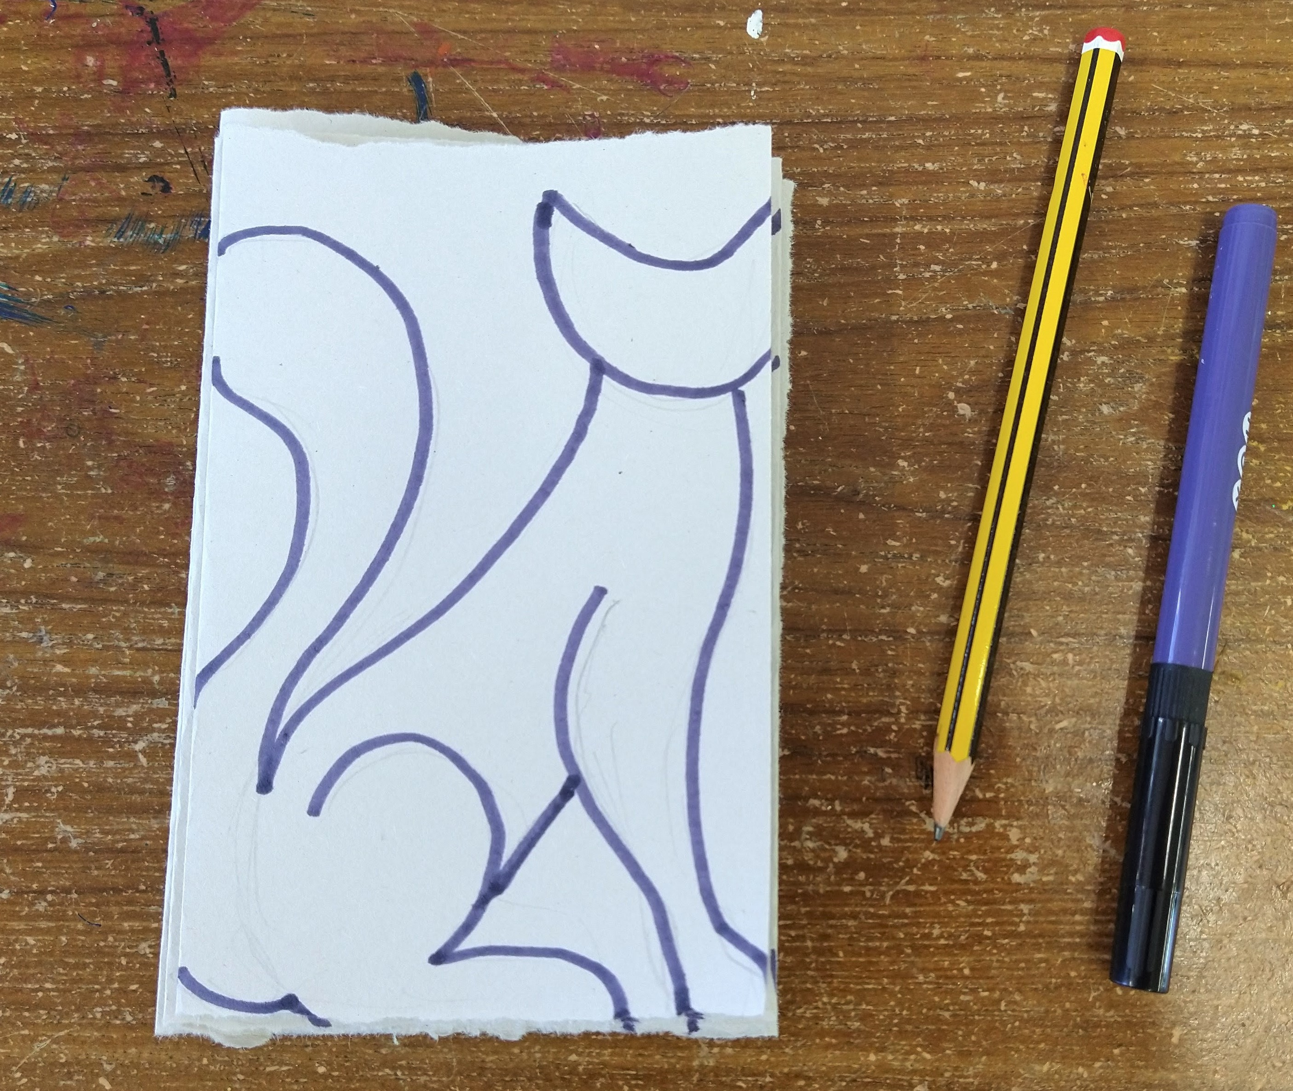
Draw a cat onto the top fold, you can use our template as a guide to help you. Make sure that part of the cat 'joins' on each folded edge, this is what will hold the frieze together.
Step 3.
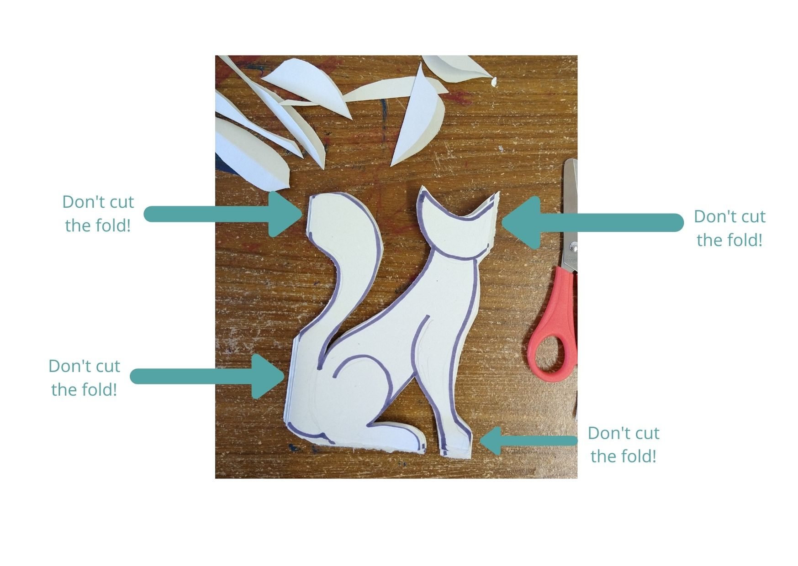
Cut the cat out, make sure not to cut through all of the folded edges!
Step 4.
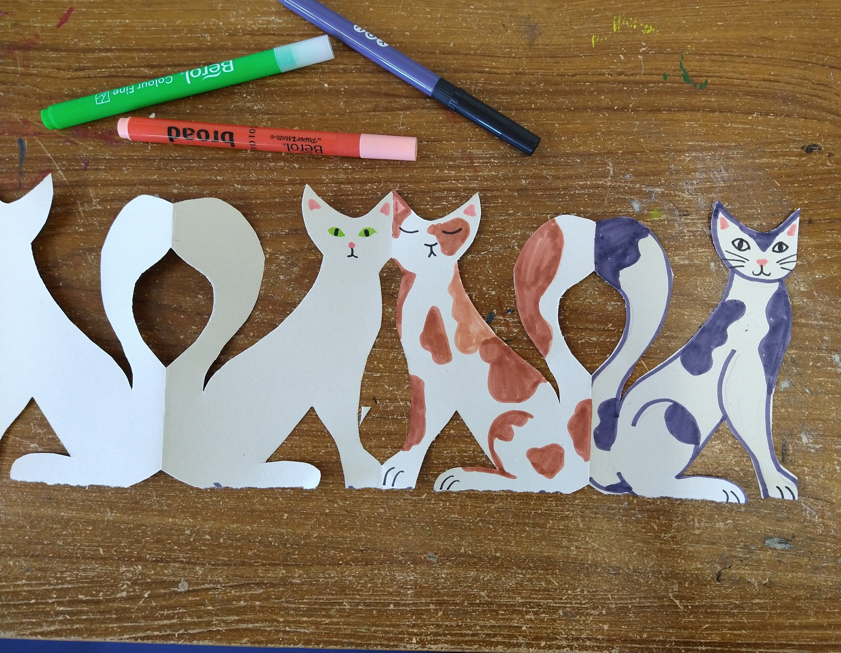
Open up your frieze and decorate each cat.
Step 5.
Hang your cat frieze up and admire your hard work!

