Rag Wreath
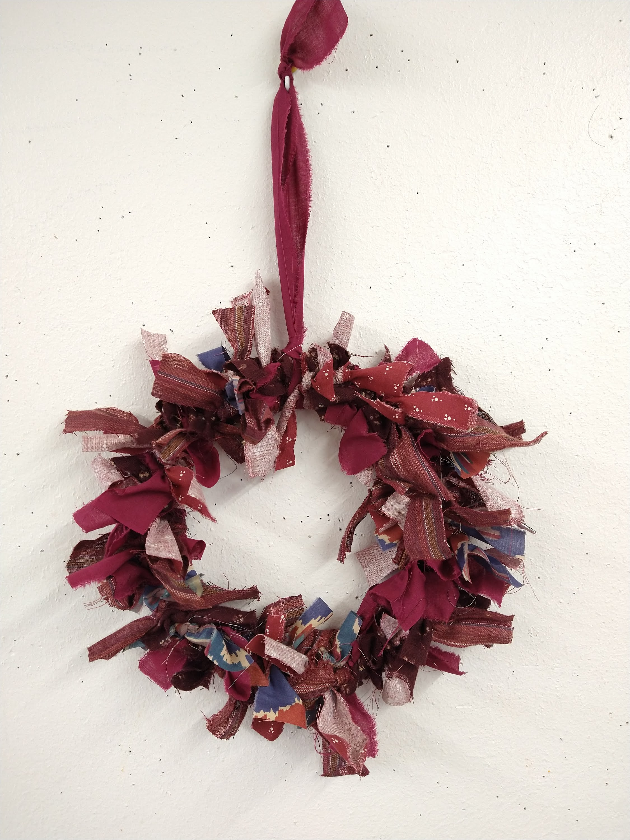
Here's a really simple but effective way of making a wreath using strips of fabric and knots. By changing the colours and materials you use you can make wreaths for all seasons!
You will need:
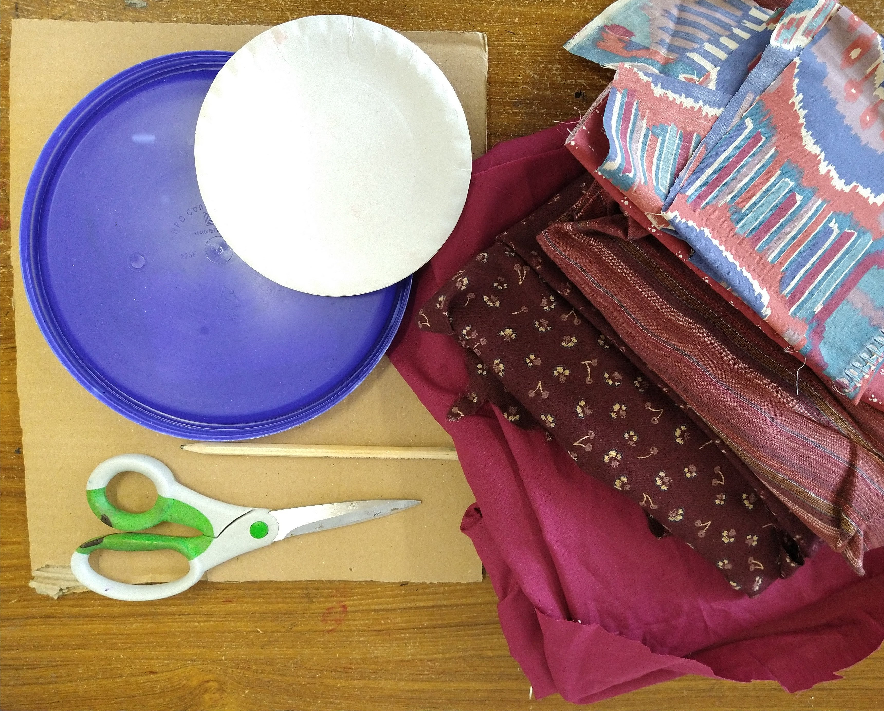
- Fabric (we used several pieces in co-ordinating colours)
- Cardboard
- Scissors
- Plates or similar to use as a template, one smaller than the other
- Pencil
Step 1.
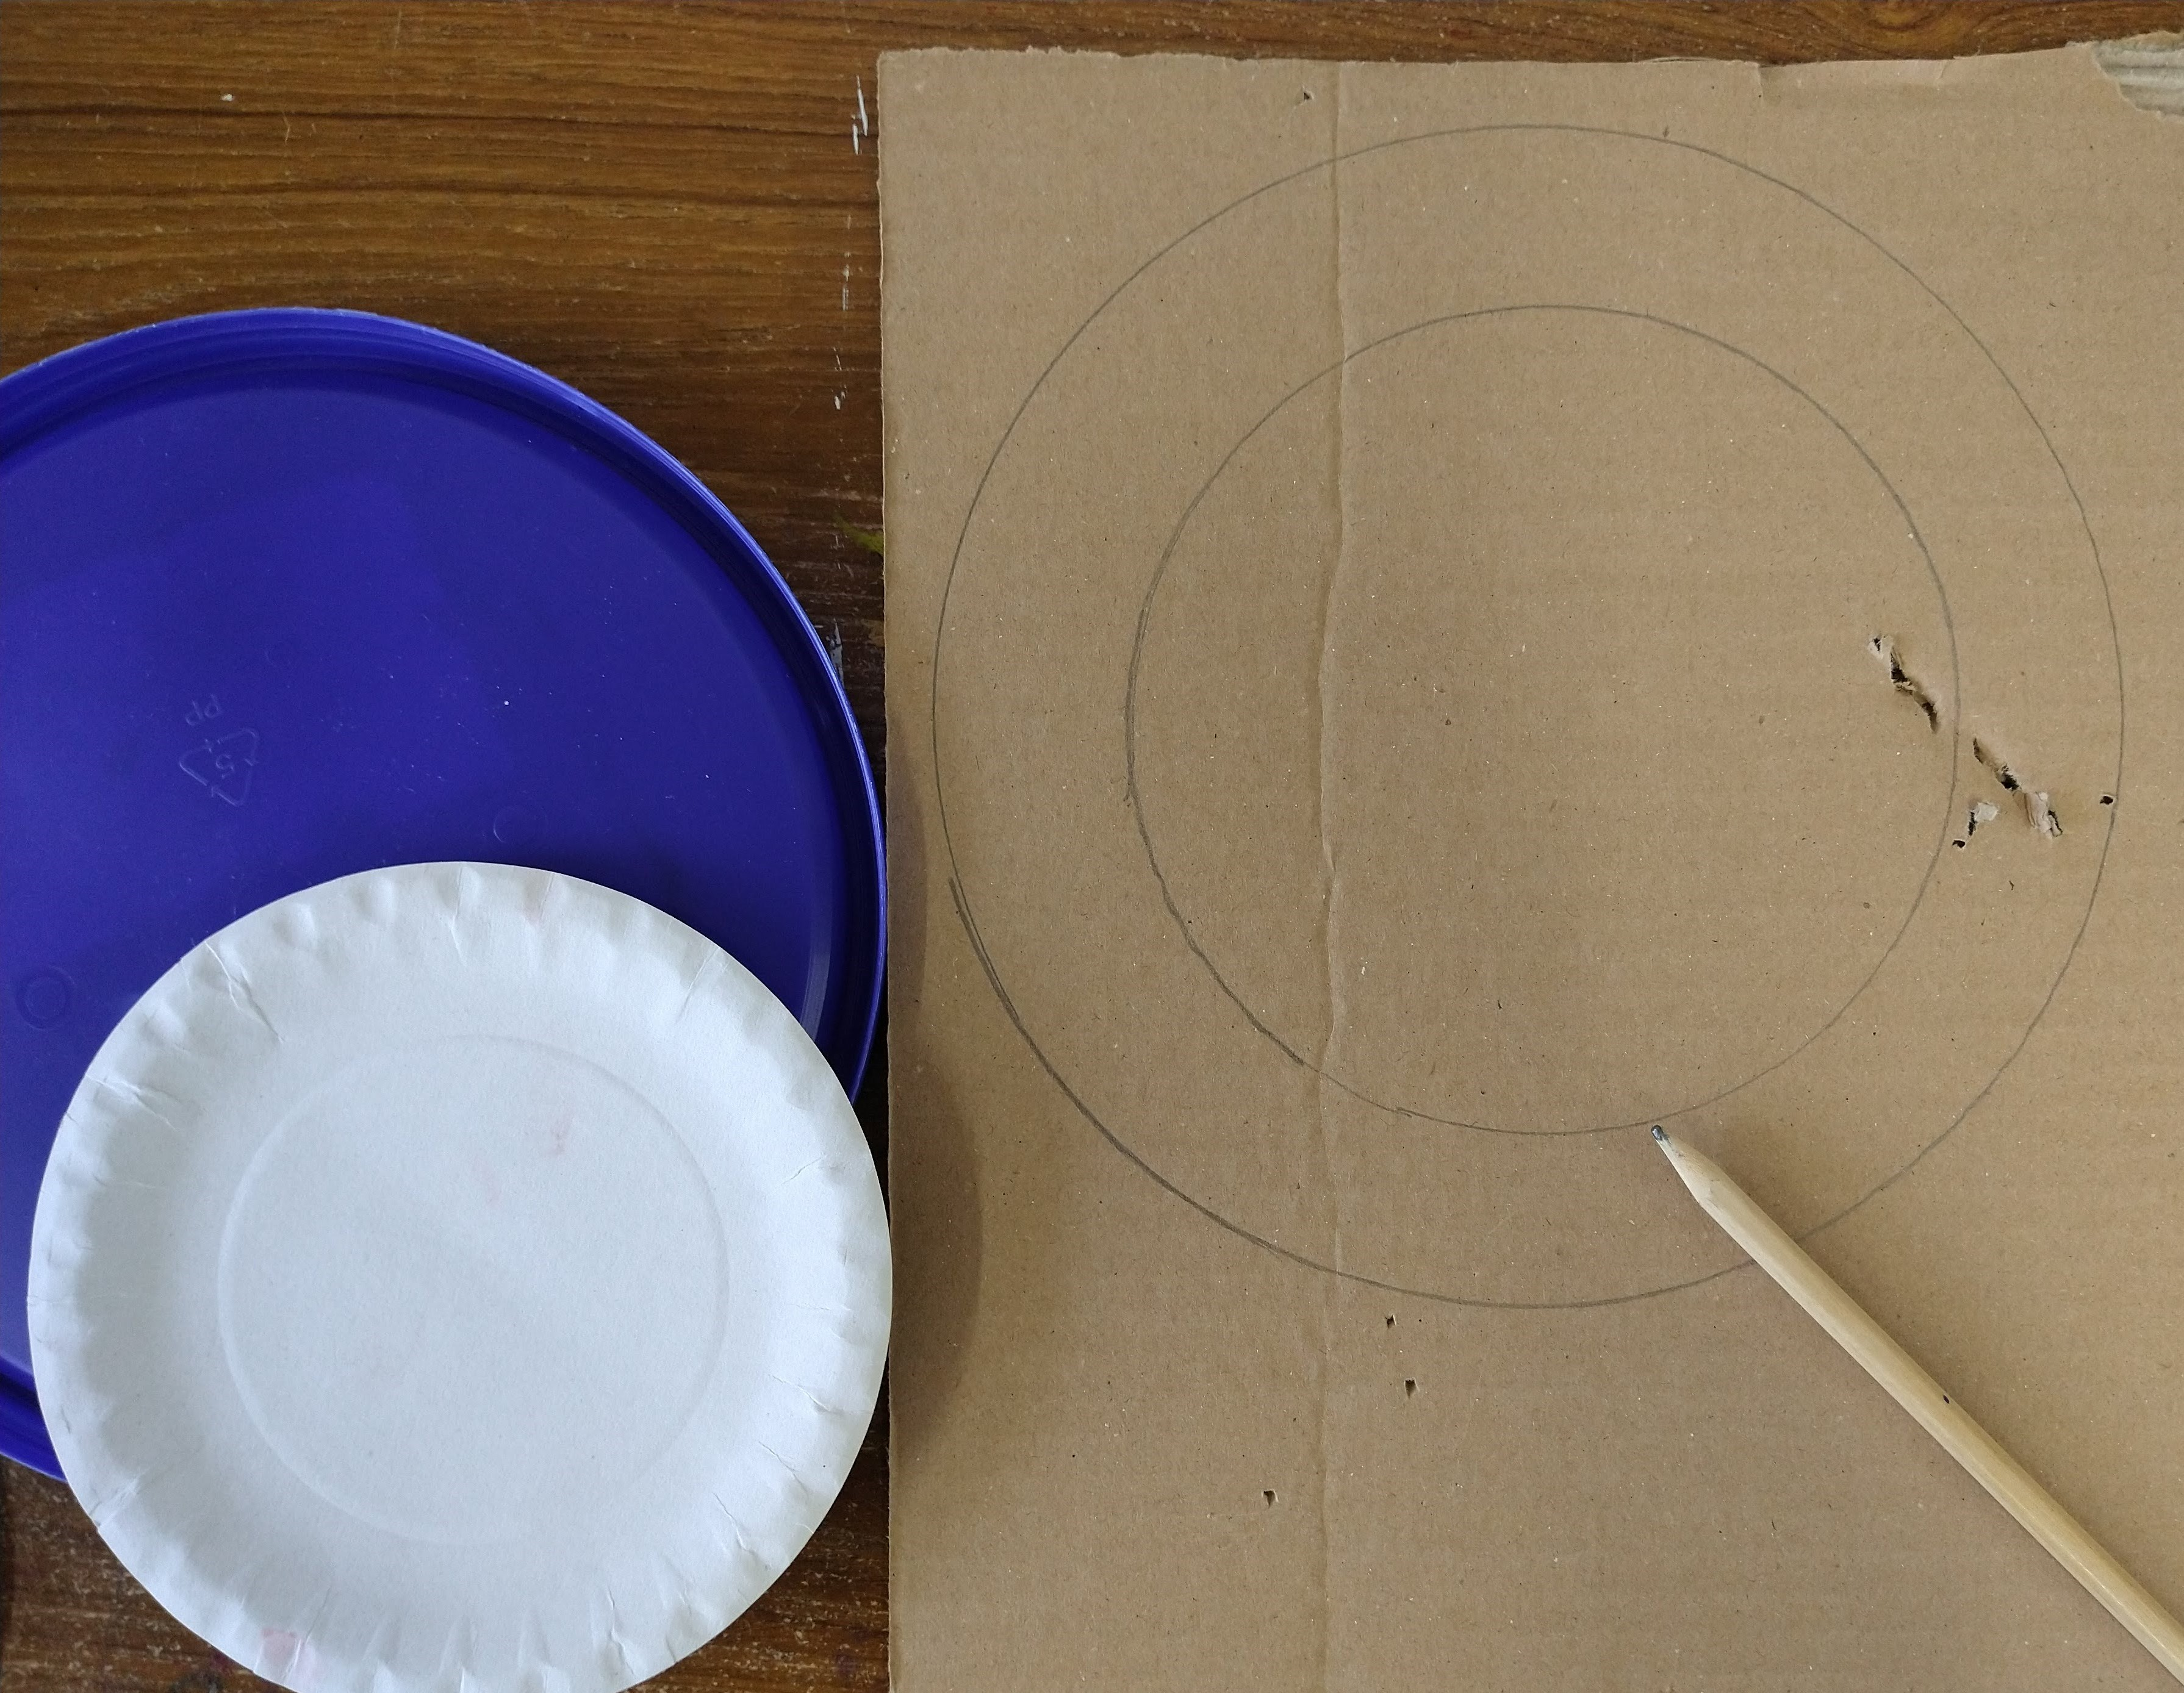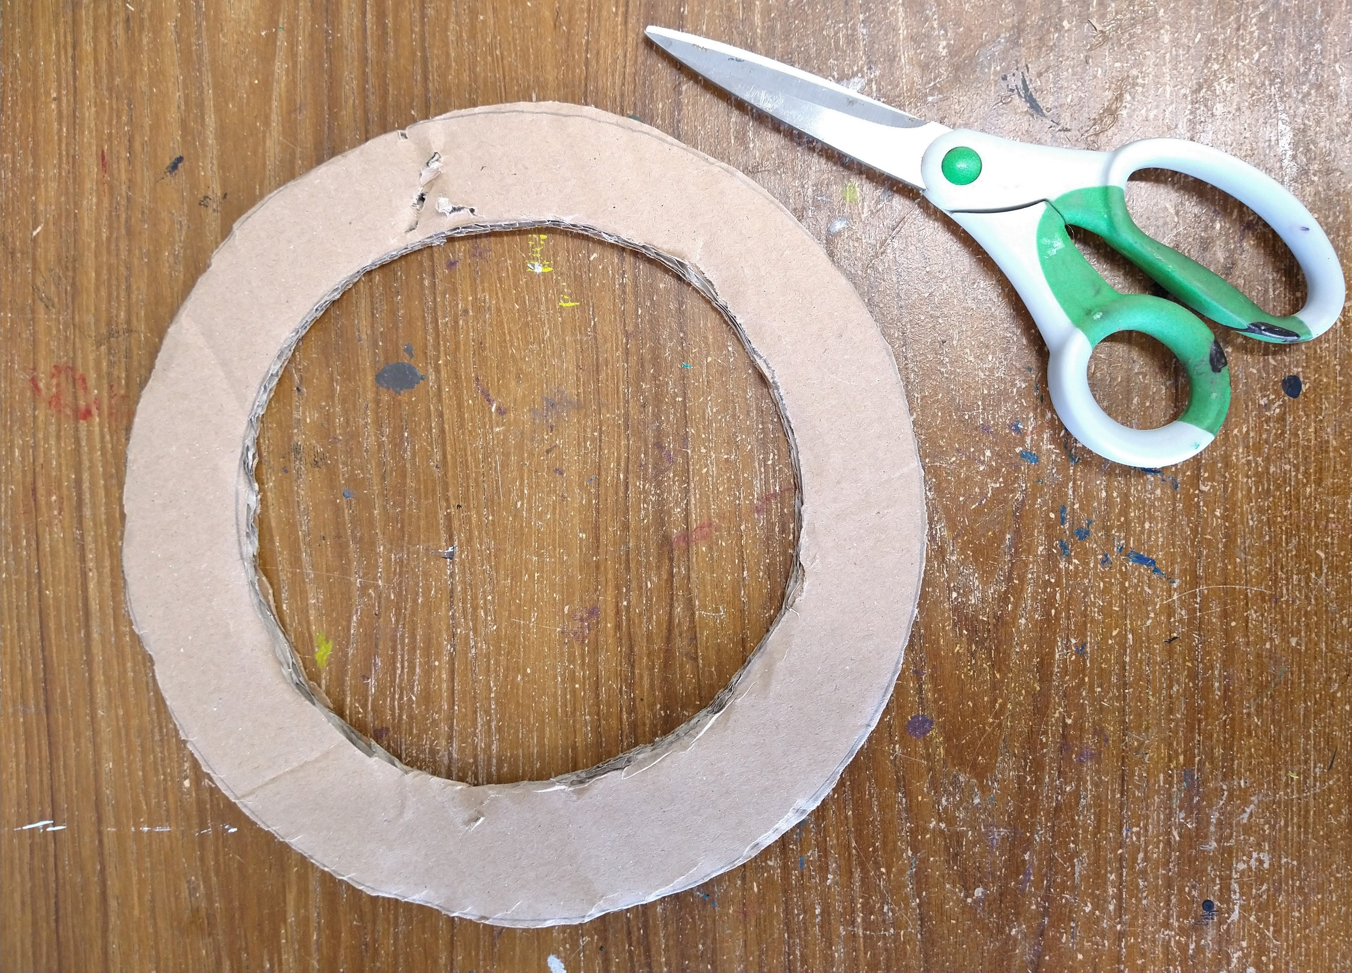
First we're going to make the ring for our wreath using the cardboard. Use the plates to draw two circles, one inside the other, and then cut out the cardboard ring. Our ring is about 4 cm wide.
Step 2.
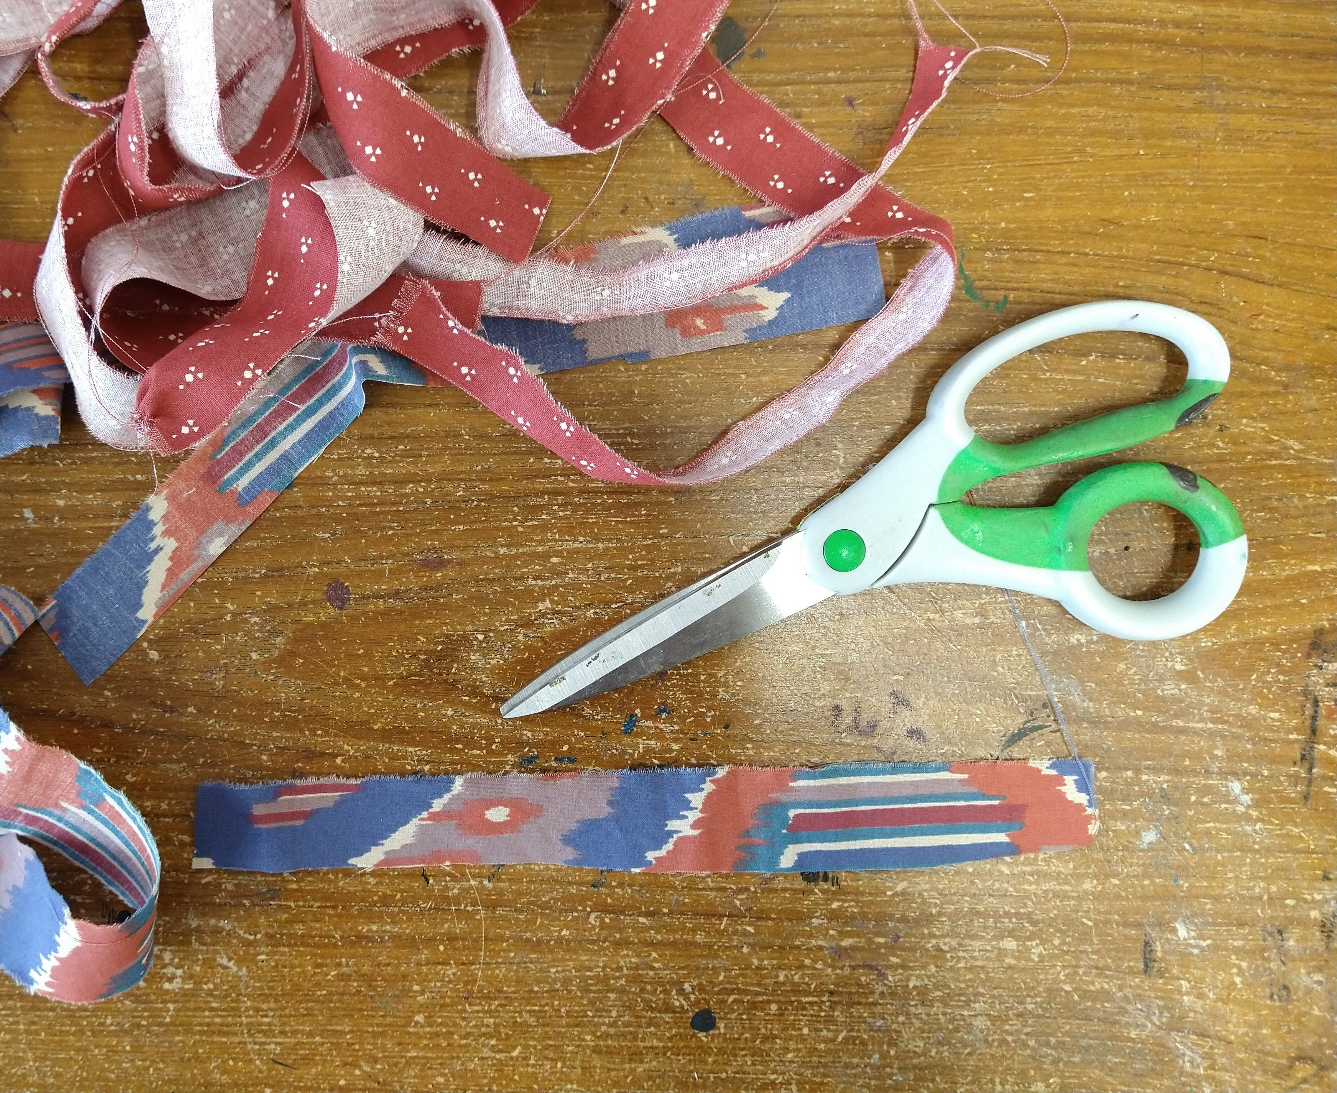
Cut or rip your fabric into strips about 2 cm wide and then cut into pieces about 20 cm long. Leave one strip long enough to use as a hanging loop.
Step 3.
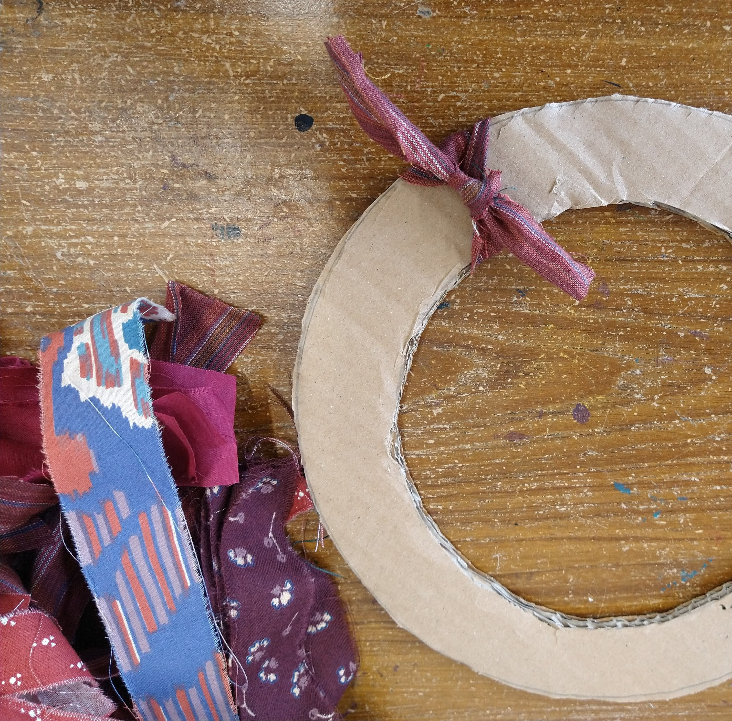
Take a piece of fabric and tie it around the cardboard ring. Use a double knot so it's nice and secure.
Step 4.
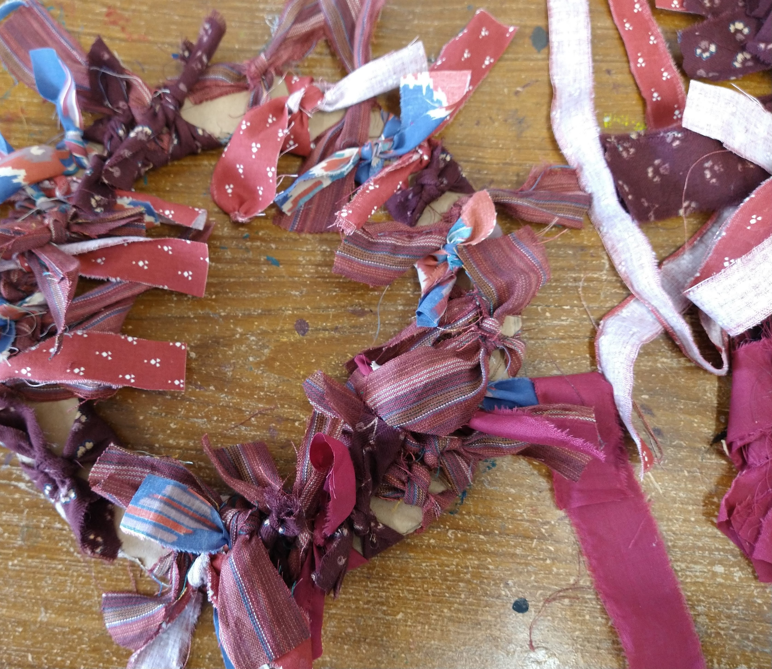
Keep tying pieces of fabric onto the ring until it is full. Use the longer piece of fabric to make a hanging loop (tie it on.)
Step 5.
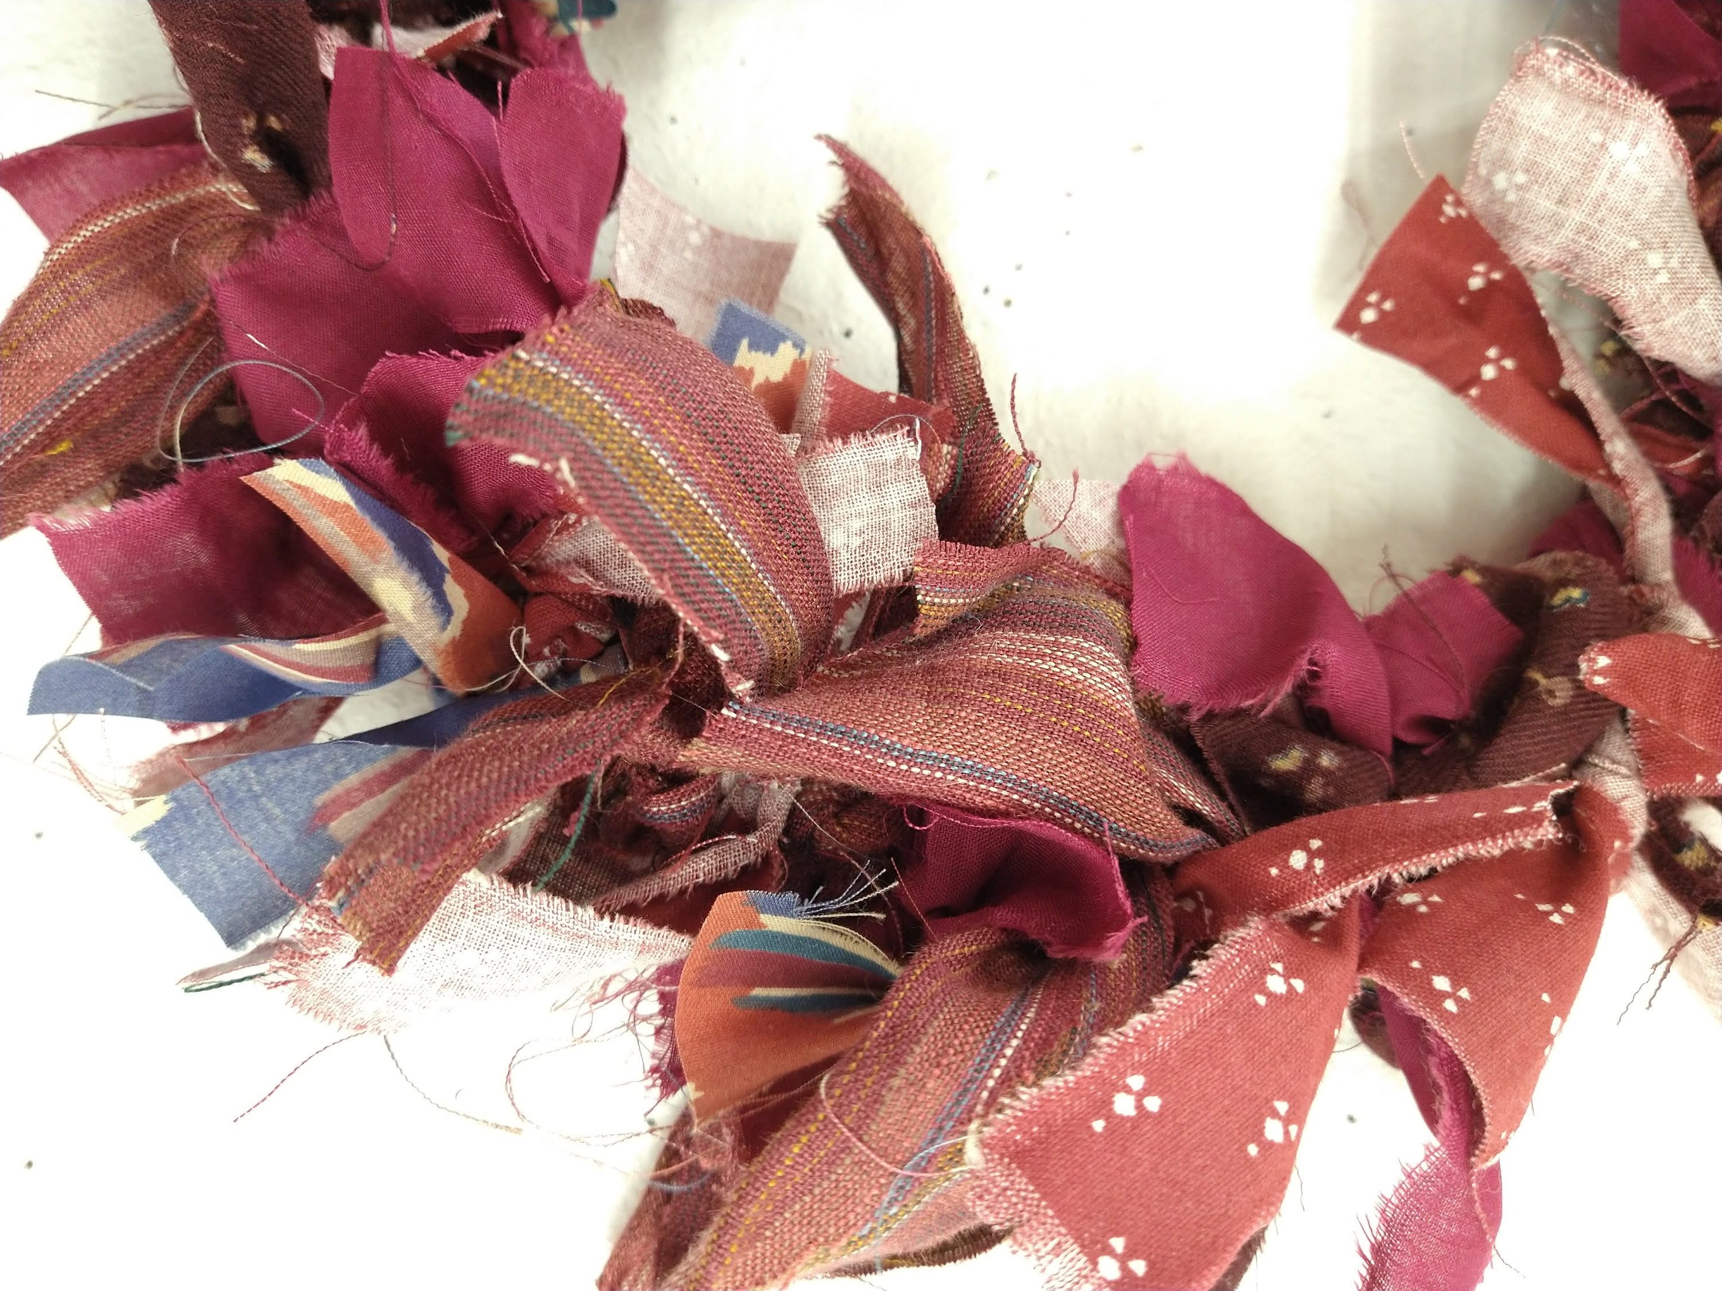
Give any extra-long bits a trim to tidy it up. You could also add some extra embellishments such as buttons or feathers if you'd like.
Hang it up and admire your hard work!
Have fun and don't forget to show us how you get on!

