Remembrance Day Poppy Origami

Here at Heathlands we are very proud of the support our members have given to the poppy appeal over the years. For many years now we have staffed the poppy appeal table at our local ASDA but due to restrictions this year we cannot. So instead we are making poppies to sell here!
Here are our origami instructions for you to make your own poppy at home. You will need:
x1 15cm square of red paper
x 1 10cm square of black paper

How to make it:
Fold your red paper in half lengthways in both directions and then again diagonally. Four folds in total. Repeat this with your black paper.
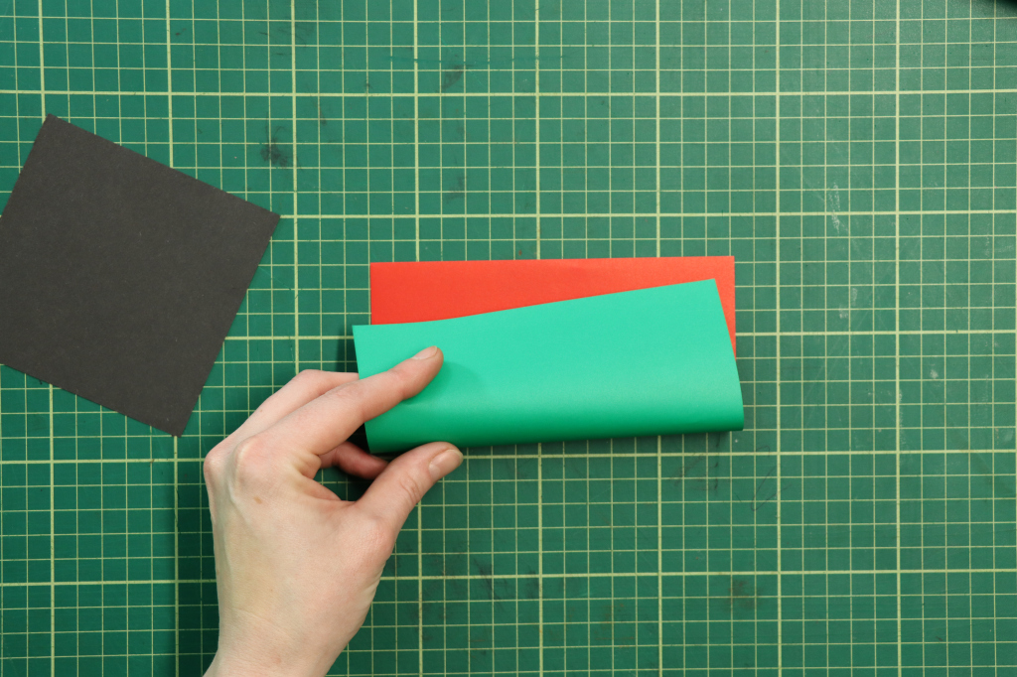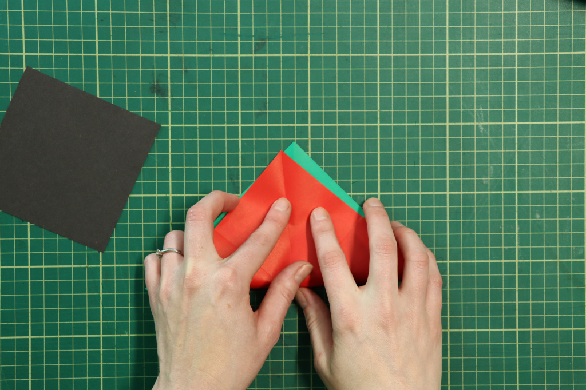
With your paper in half diagonally, fold in the widest points to match the top points. Again repeat this for the black piece.
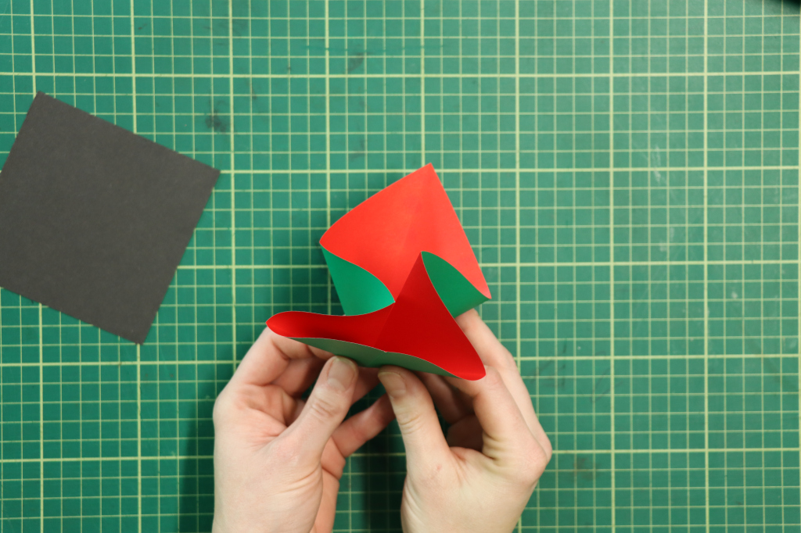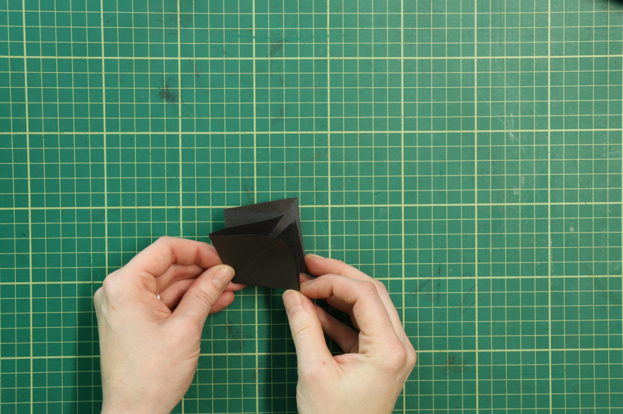
Insert the black piece of paper into the red as above, taking care to make sure all the folds match.
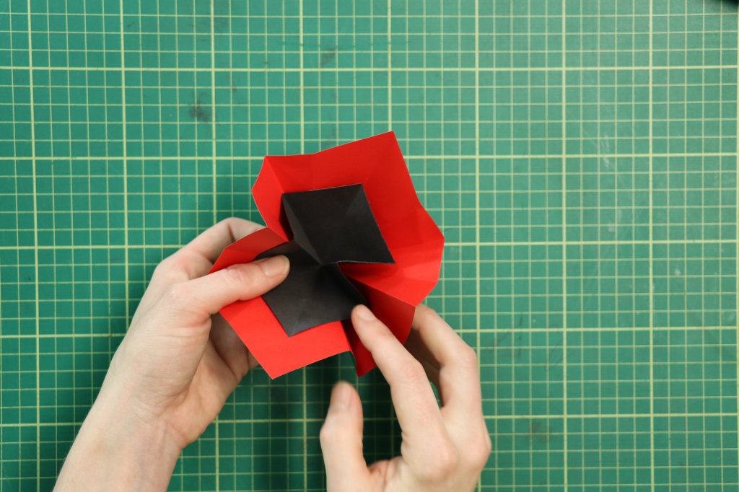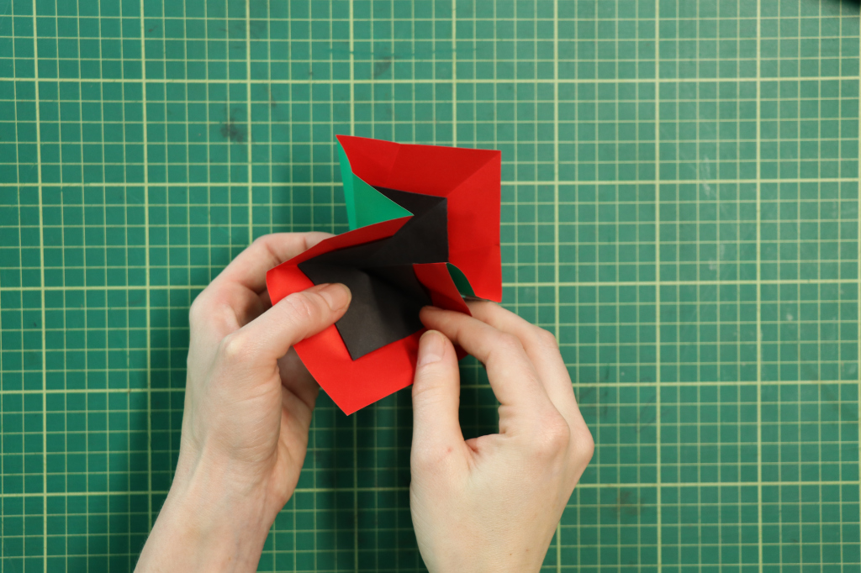
With the closed folds facing towards you and the open end away, turn up each flap, folding it to the middle. Repeat this, turn your work over and repeat again on the other side.
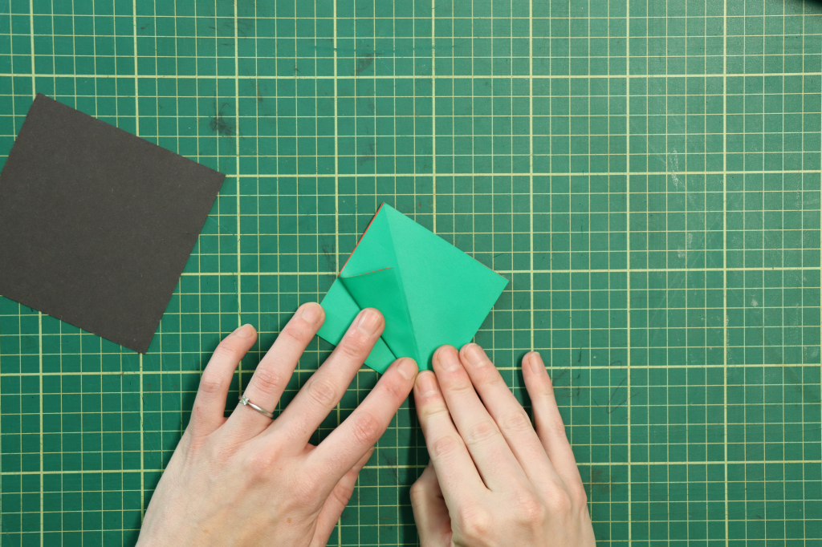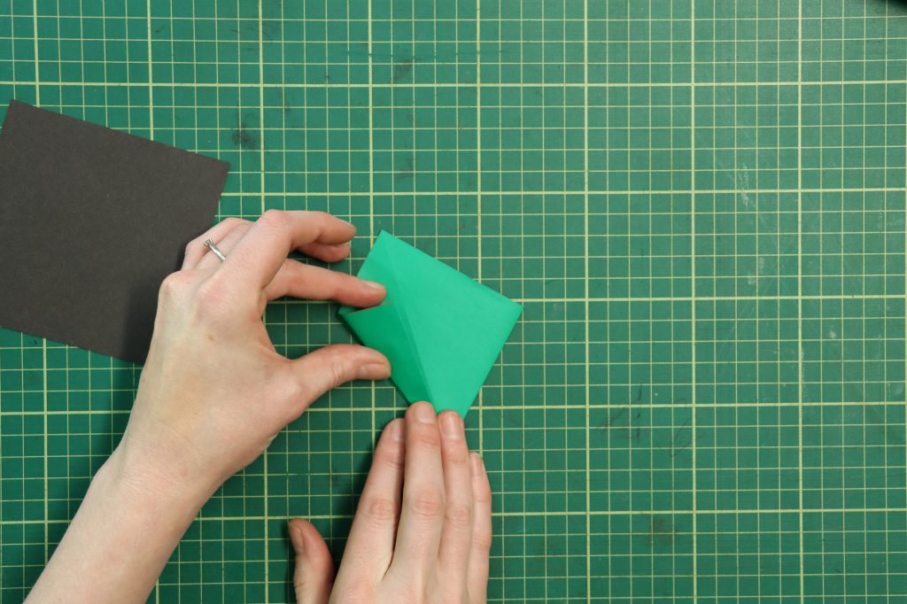
Fold your work in half from top to bottom, so the top point meets the bottom.
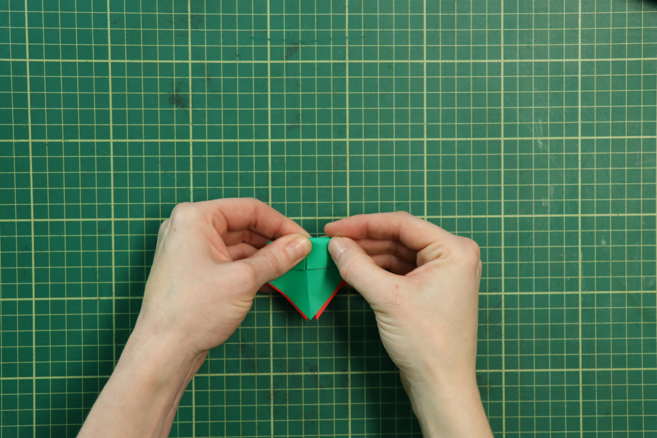

Open this fold out so that the top layer goes up, the next layer turns outward and the bottom layer remains down.
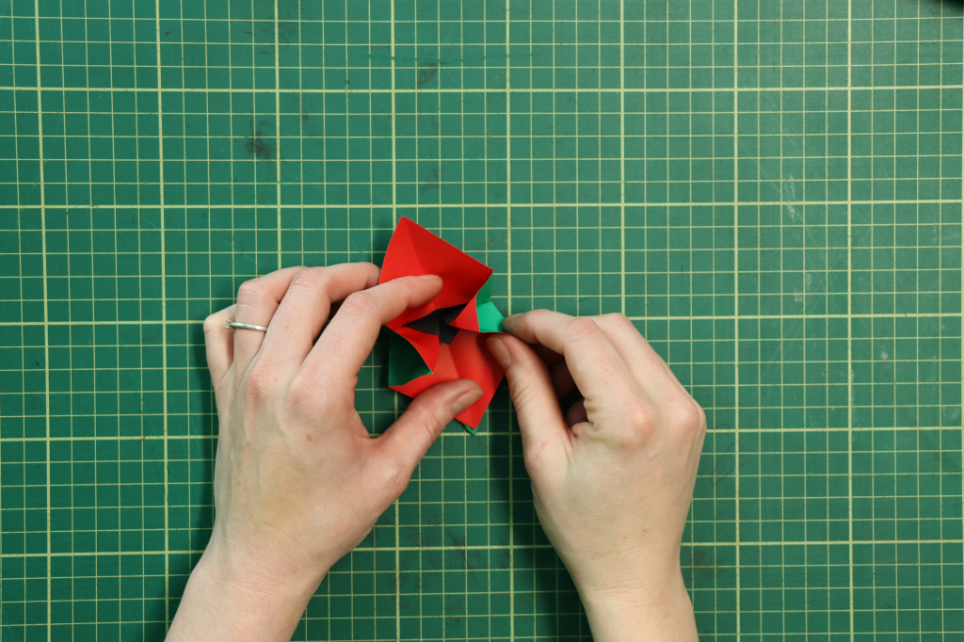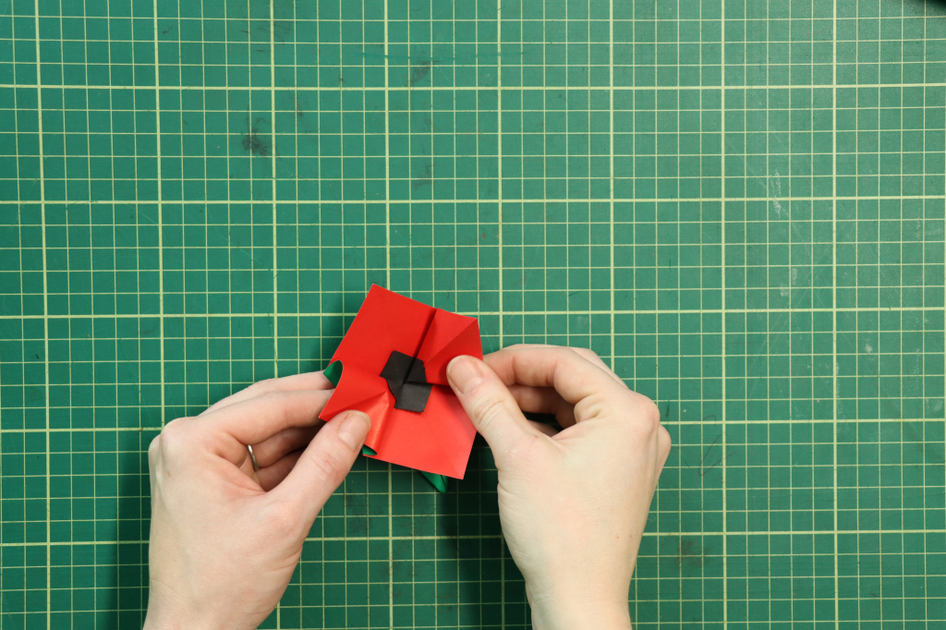
Flatten out your poppy and turn back the points of the petals and points on the centre to "round" the flower of.
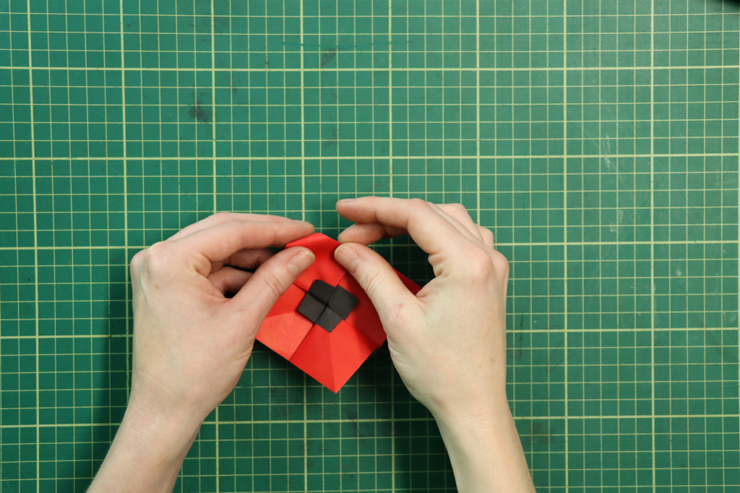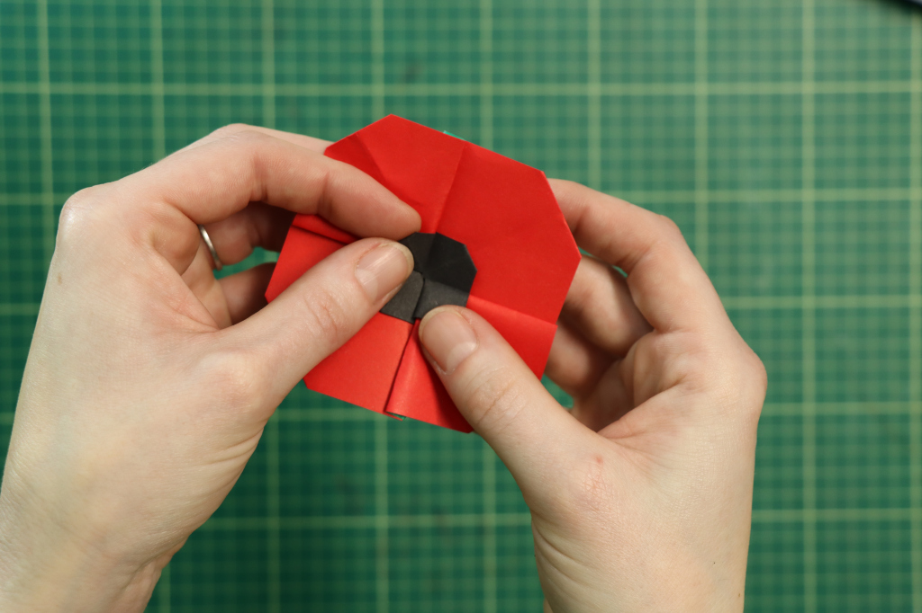
And your poppy is complete!
