Stained glass window cards
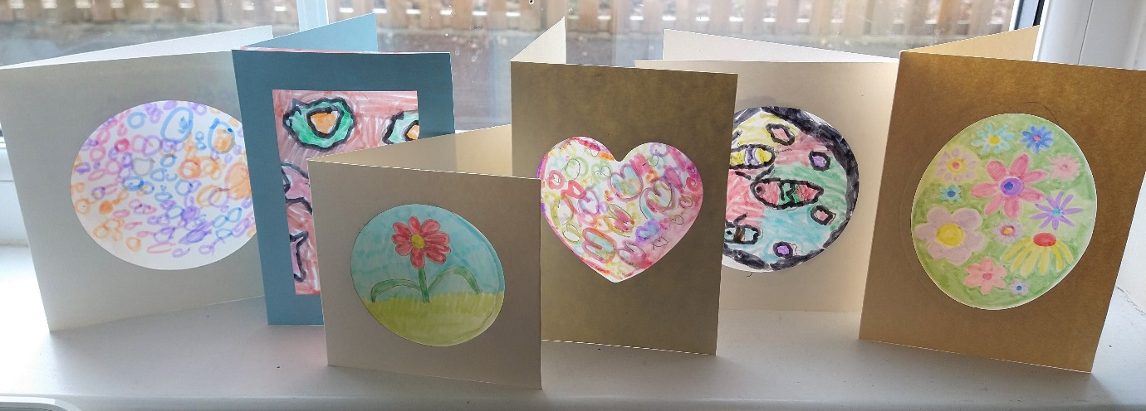
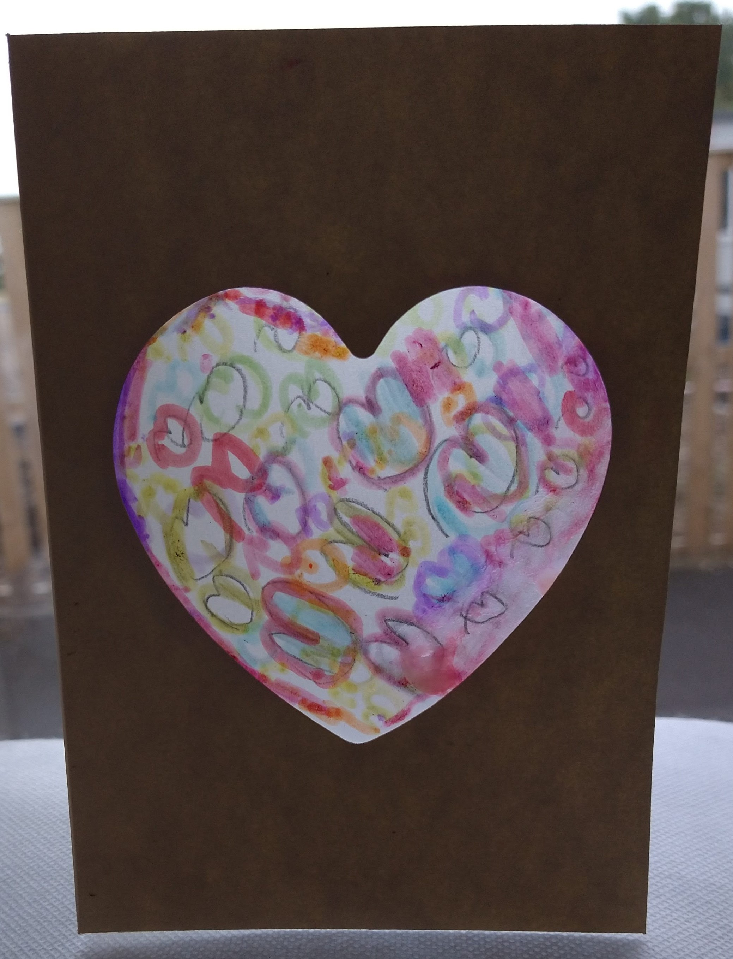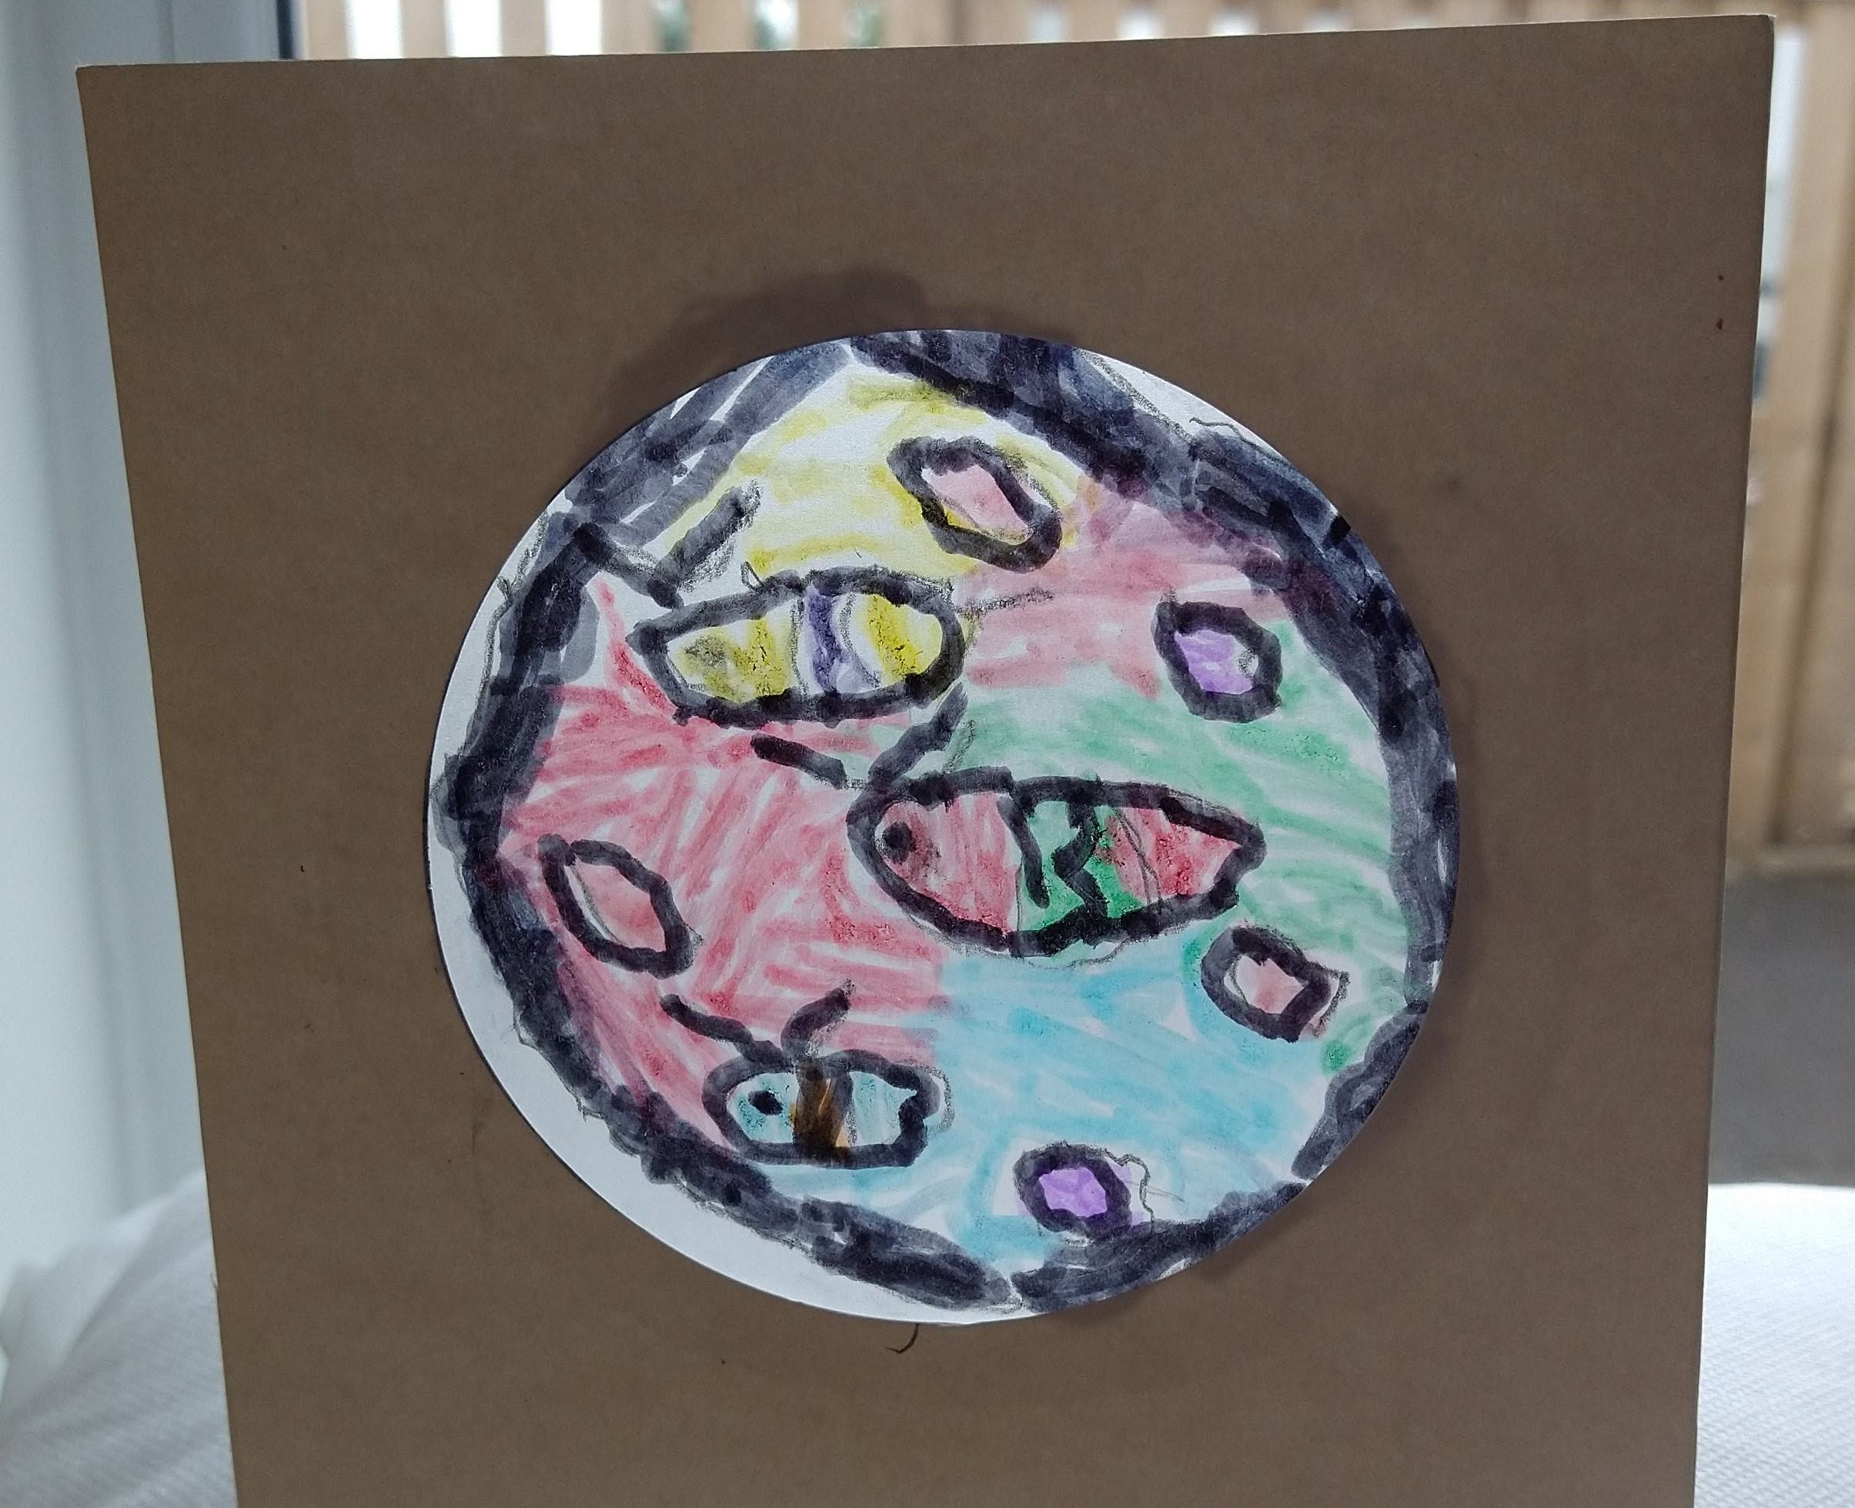
These stained glass effect cards are created using tracing paper and felt tip pens and look really effective displayed in a window. Kim and Abbie helped make this tutorial, we hope you enjoy it!
You will need:
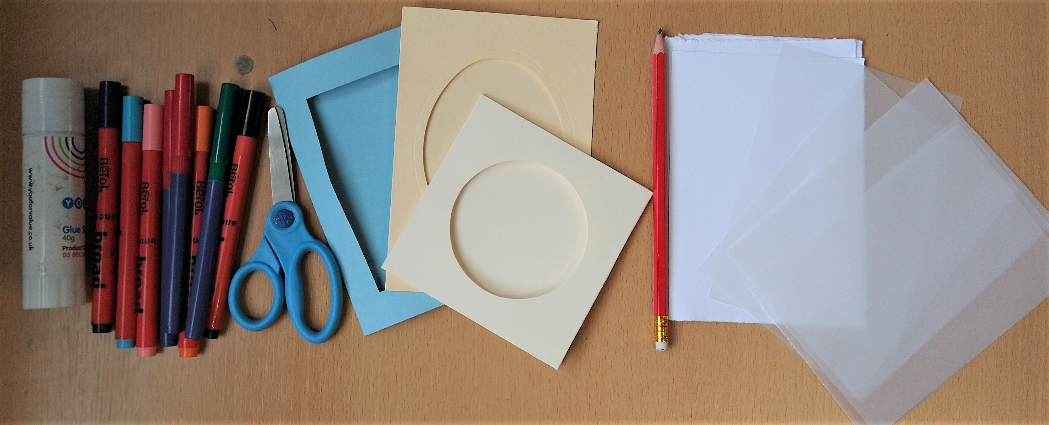
- Tracing paper
- Felt tip pens
- Window cards (cards with a window already cut in or make your own!)
- Pencil
- Scrap paper (to practice your design)
- Glue stick
Step 1.
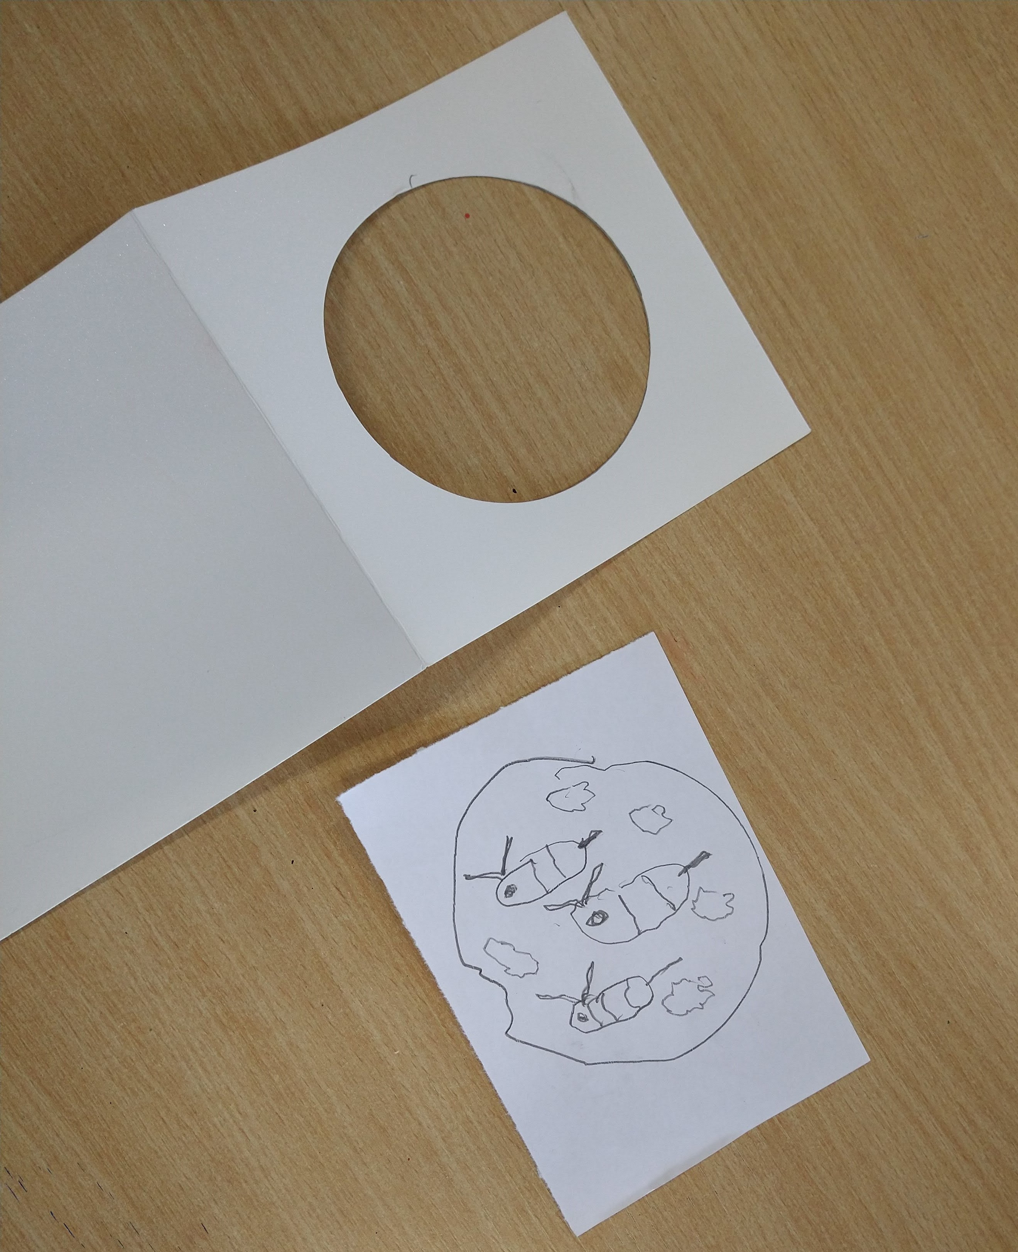
Place the 'window' of your card on top of your scrap paper and trace the window shape. You can then practice your design in this shape, you could repeat this several times to make several designs. Simple designs that you can divide into colourful sections work best, have a look at our examples to give you some ideas.
Step 2.
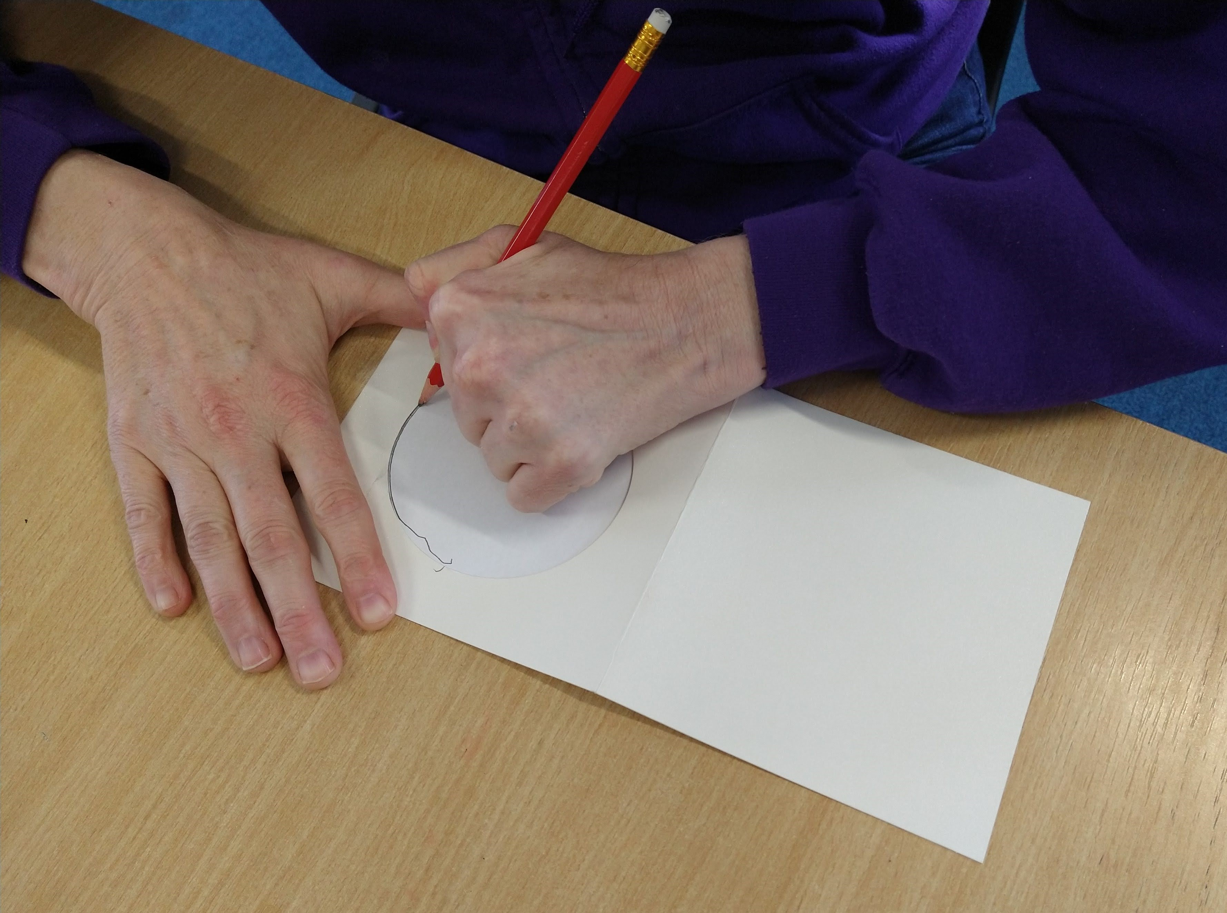
Put your 'window' on top of the tracing paper and using the pencil lightly trace the shape of the window.
Step 3.
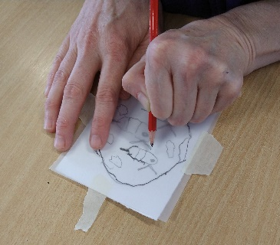
Place your design (on the scrap paper) underneath the tracing paper, matching it up with the window shape you traced. You can now use this as a guide to copy your design onto the tracing paper, use the pencil to lightly trace the design.
Step 4.
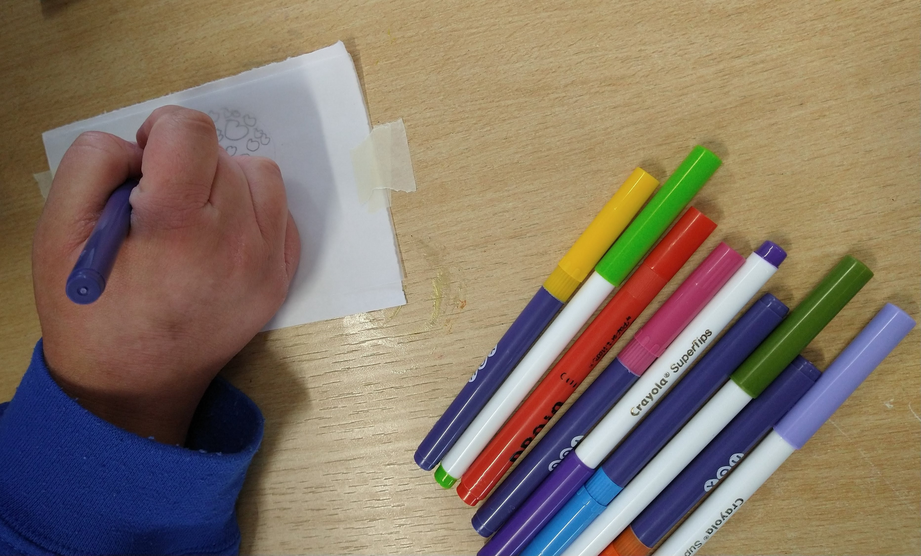
Use the felt tip pens to colour in your design, try to choose strong bright colours for the best results.
Step 5.
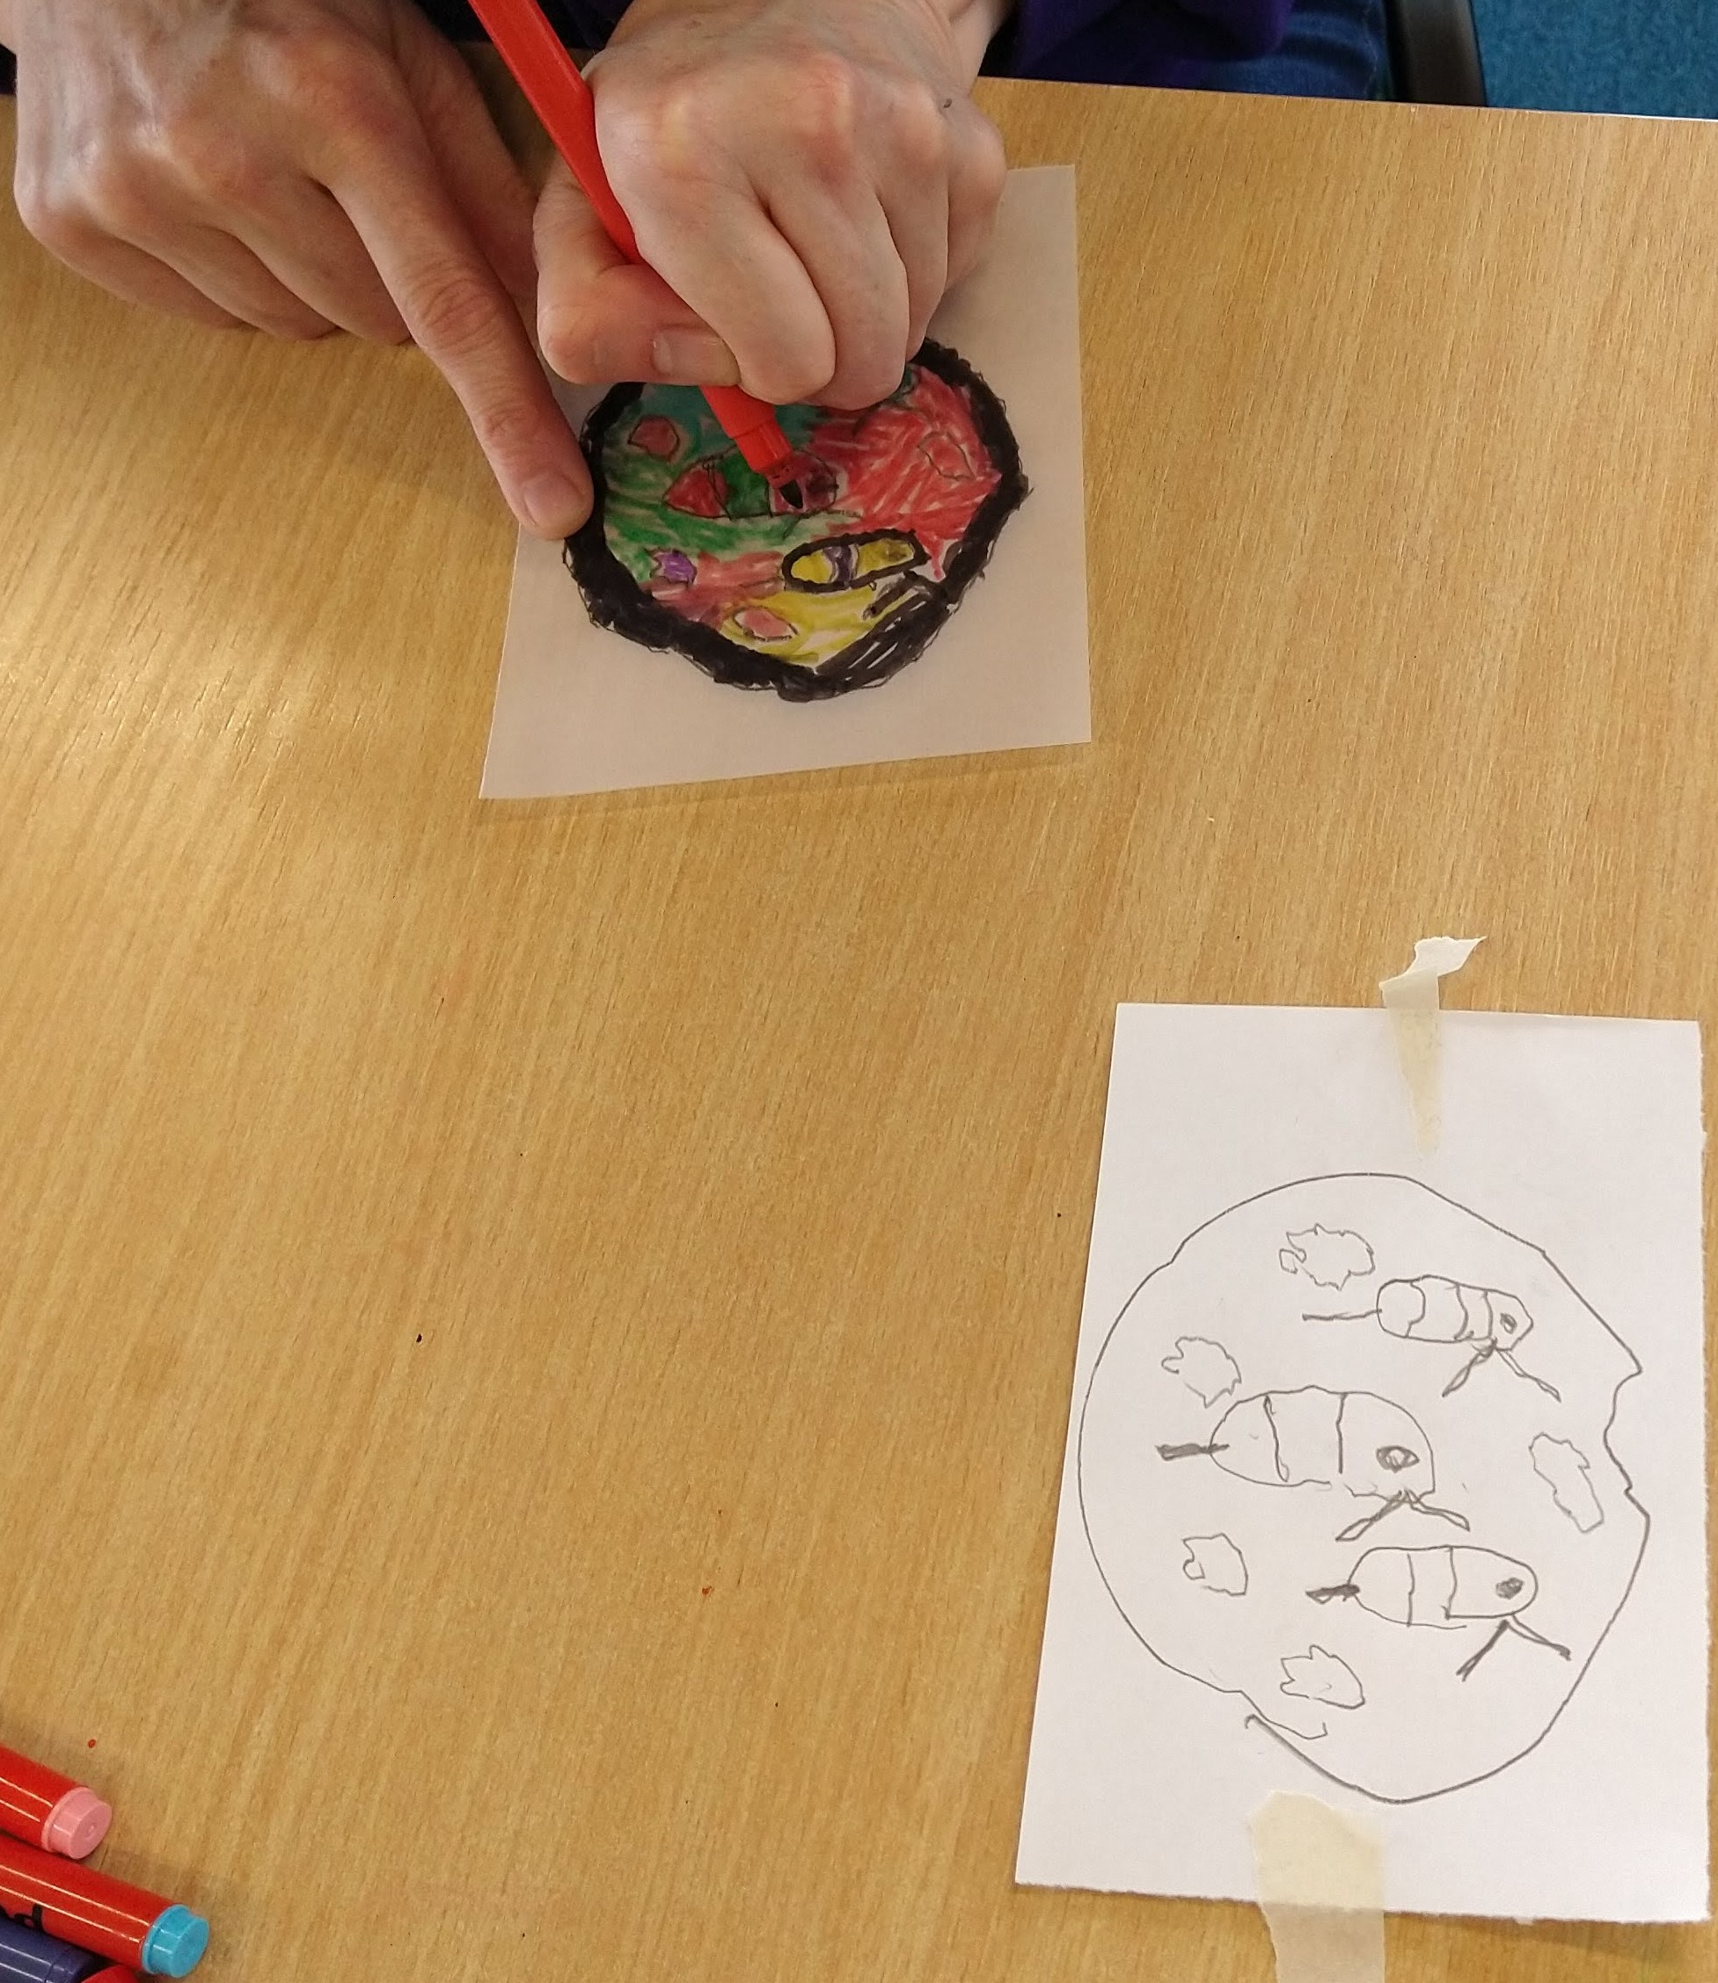
To really make it look like stained glass you can outline each colourful section with a black pen.
Step 6.
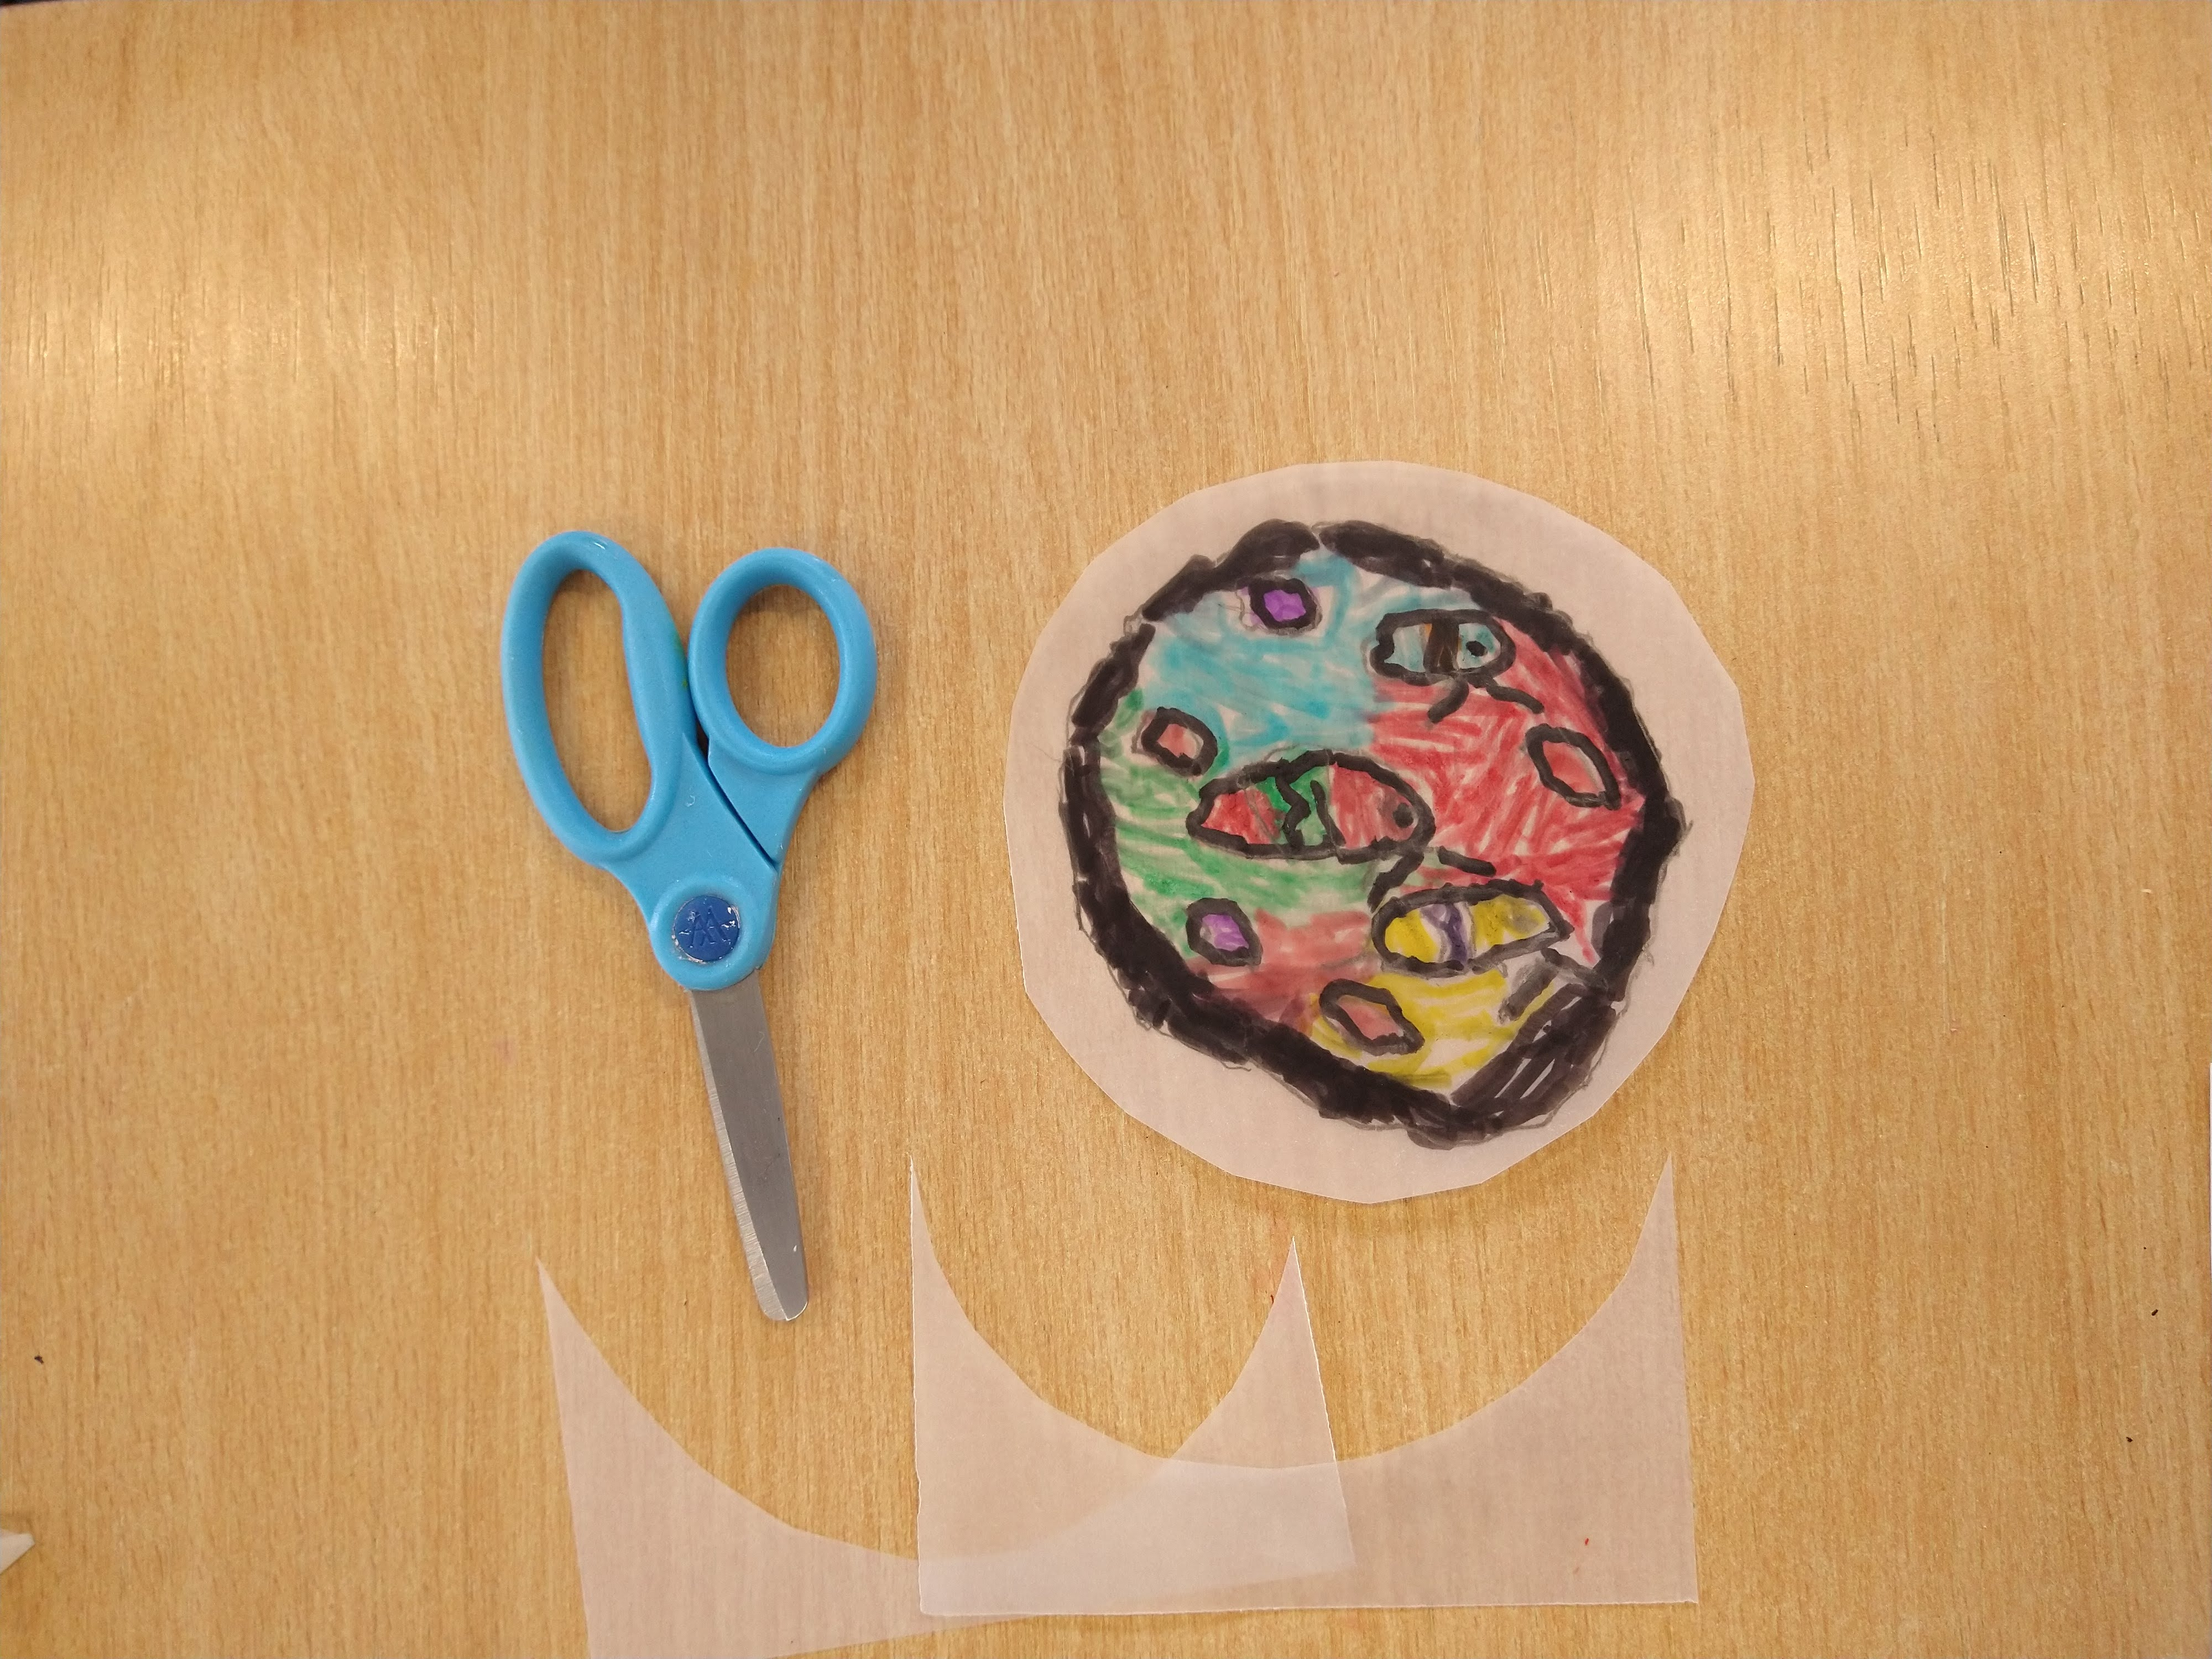
Cut your completed stained glass window out, leaving about 1-2 cm border all the way around.
Step 7.
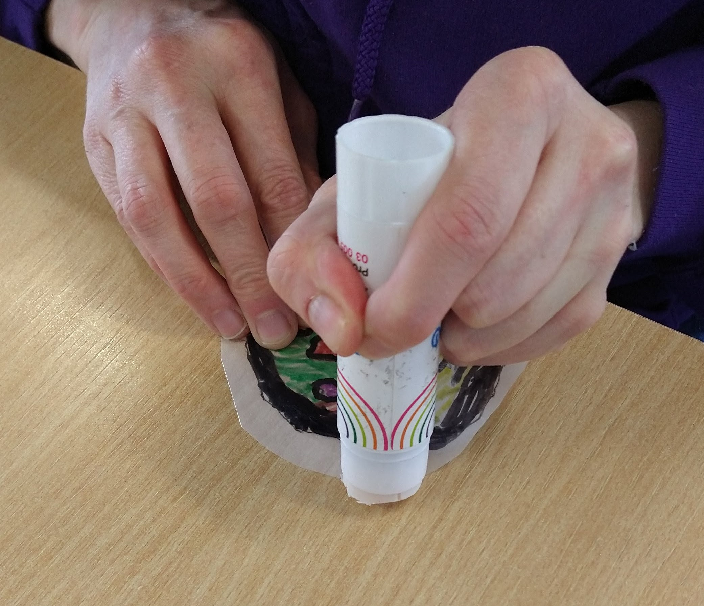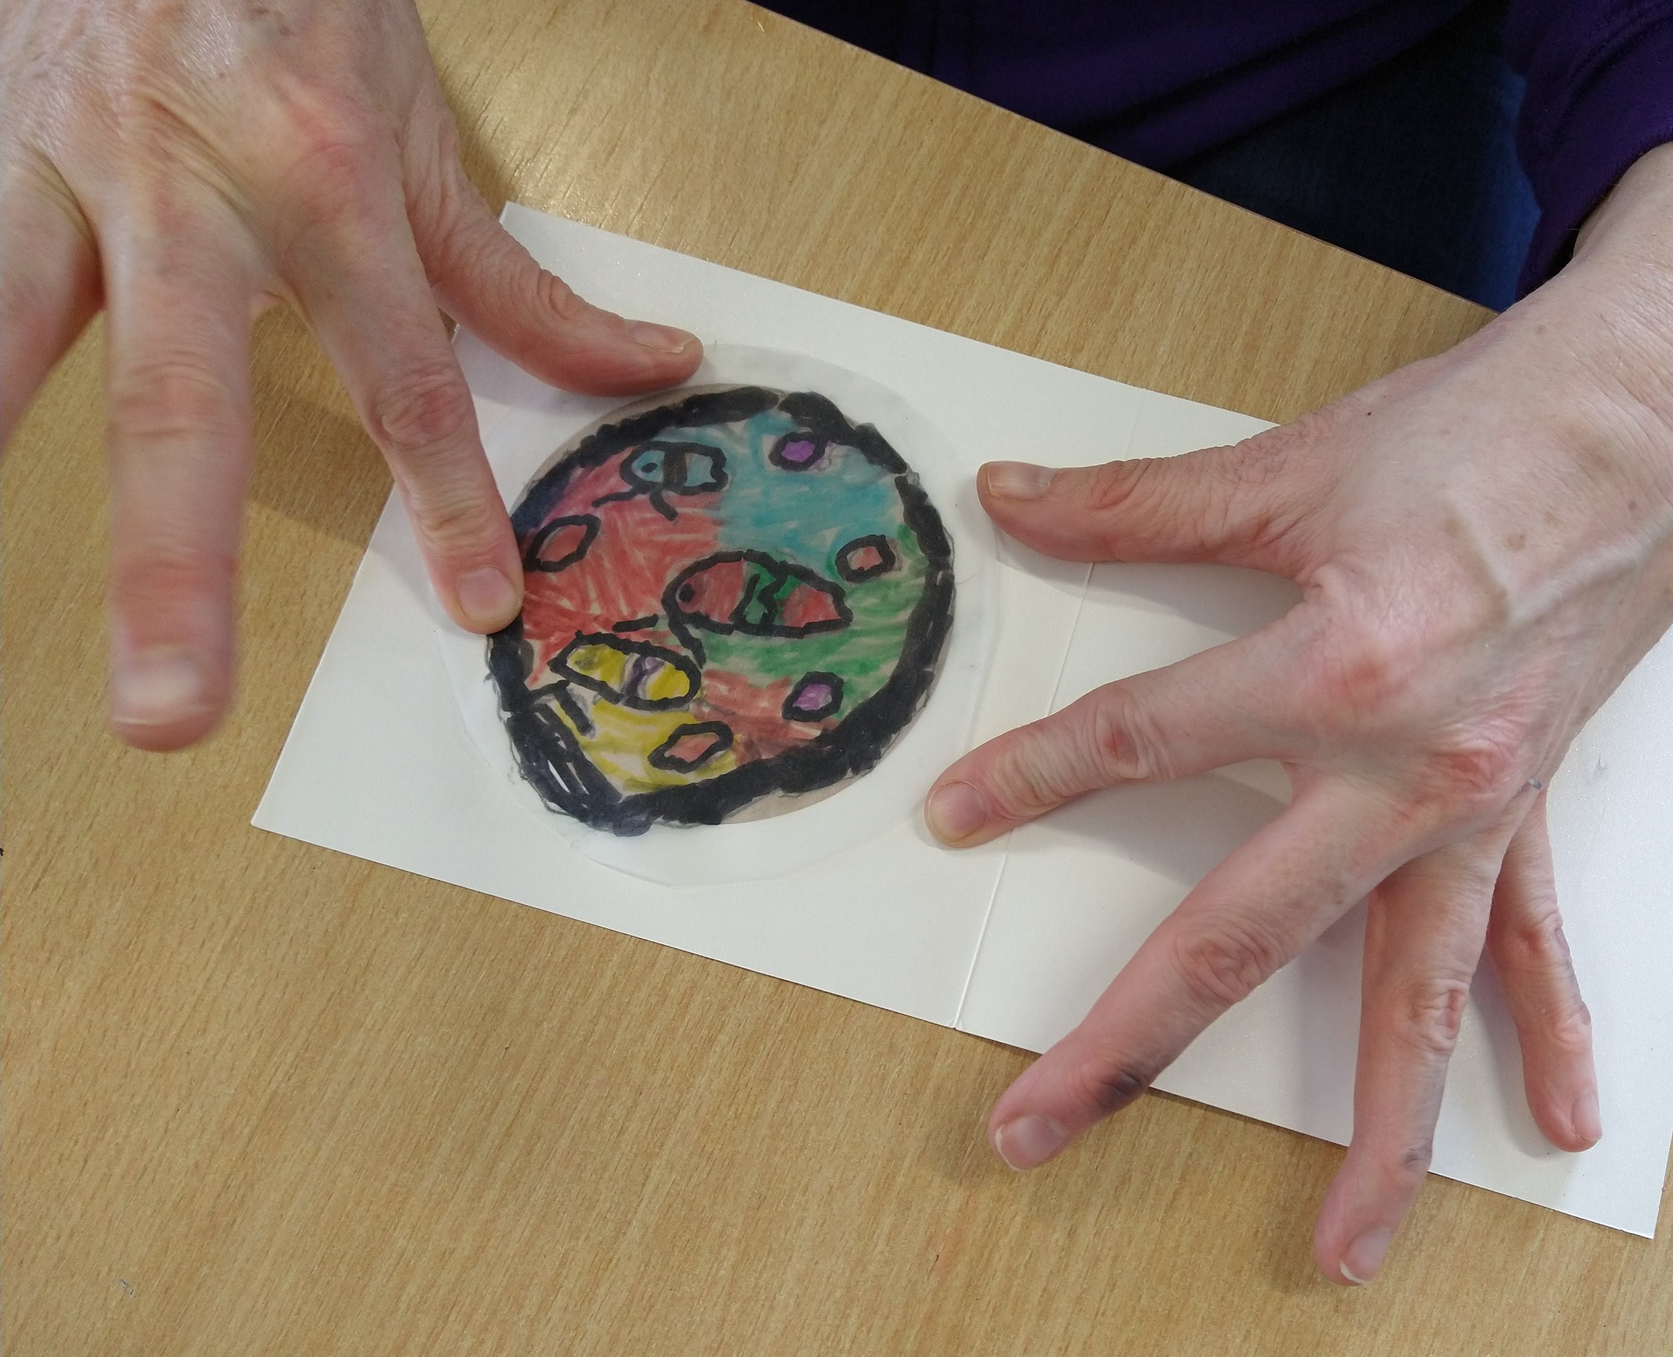
Put some glue on the border of the tracing paper and glue it into the window of the card.

Have fun and don't forget to show us how you get on!

