Terrifying Tassels!
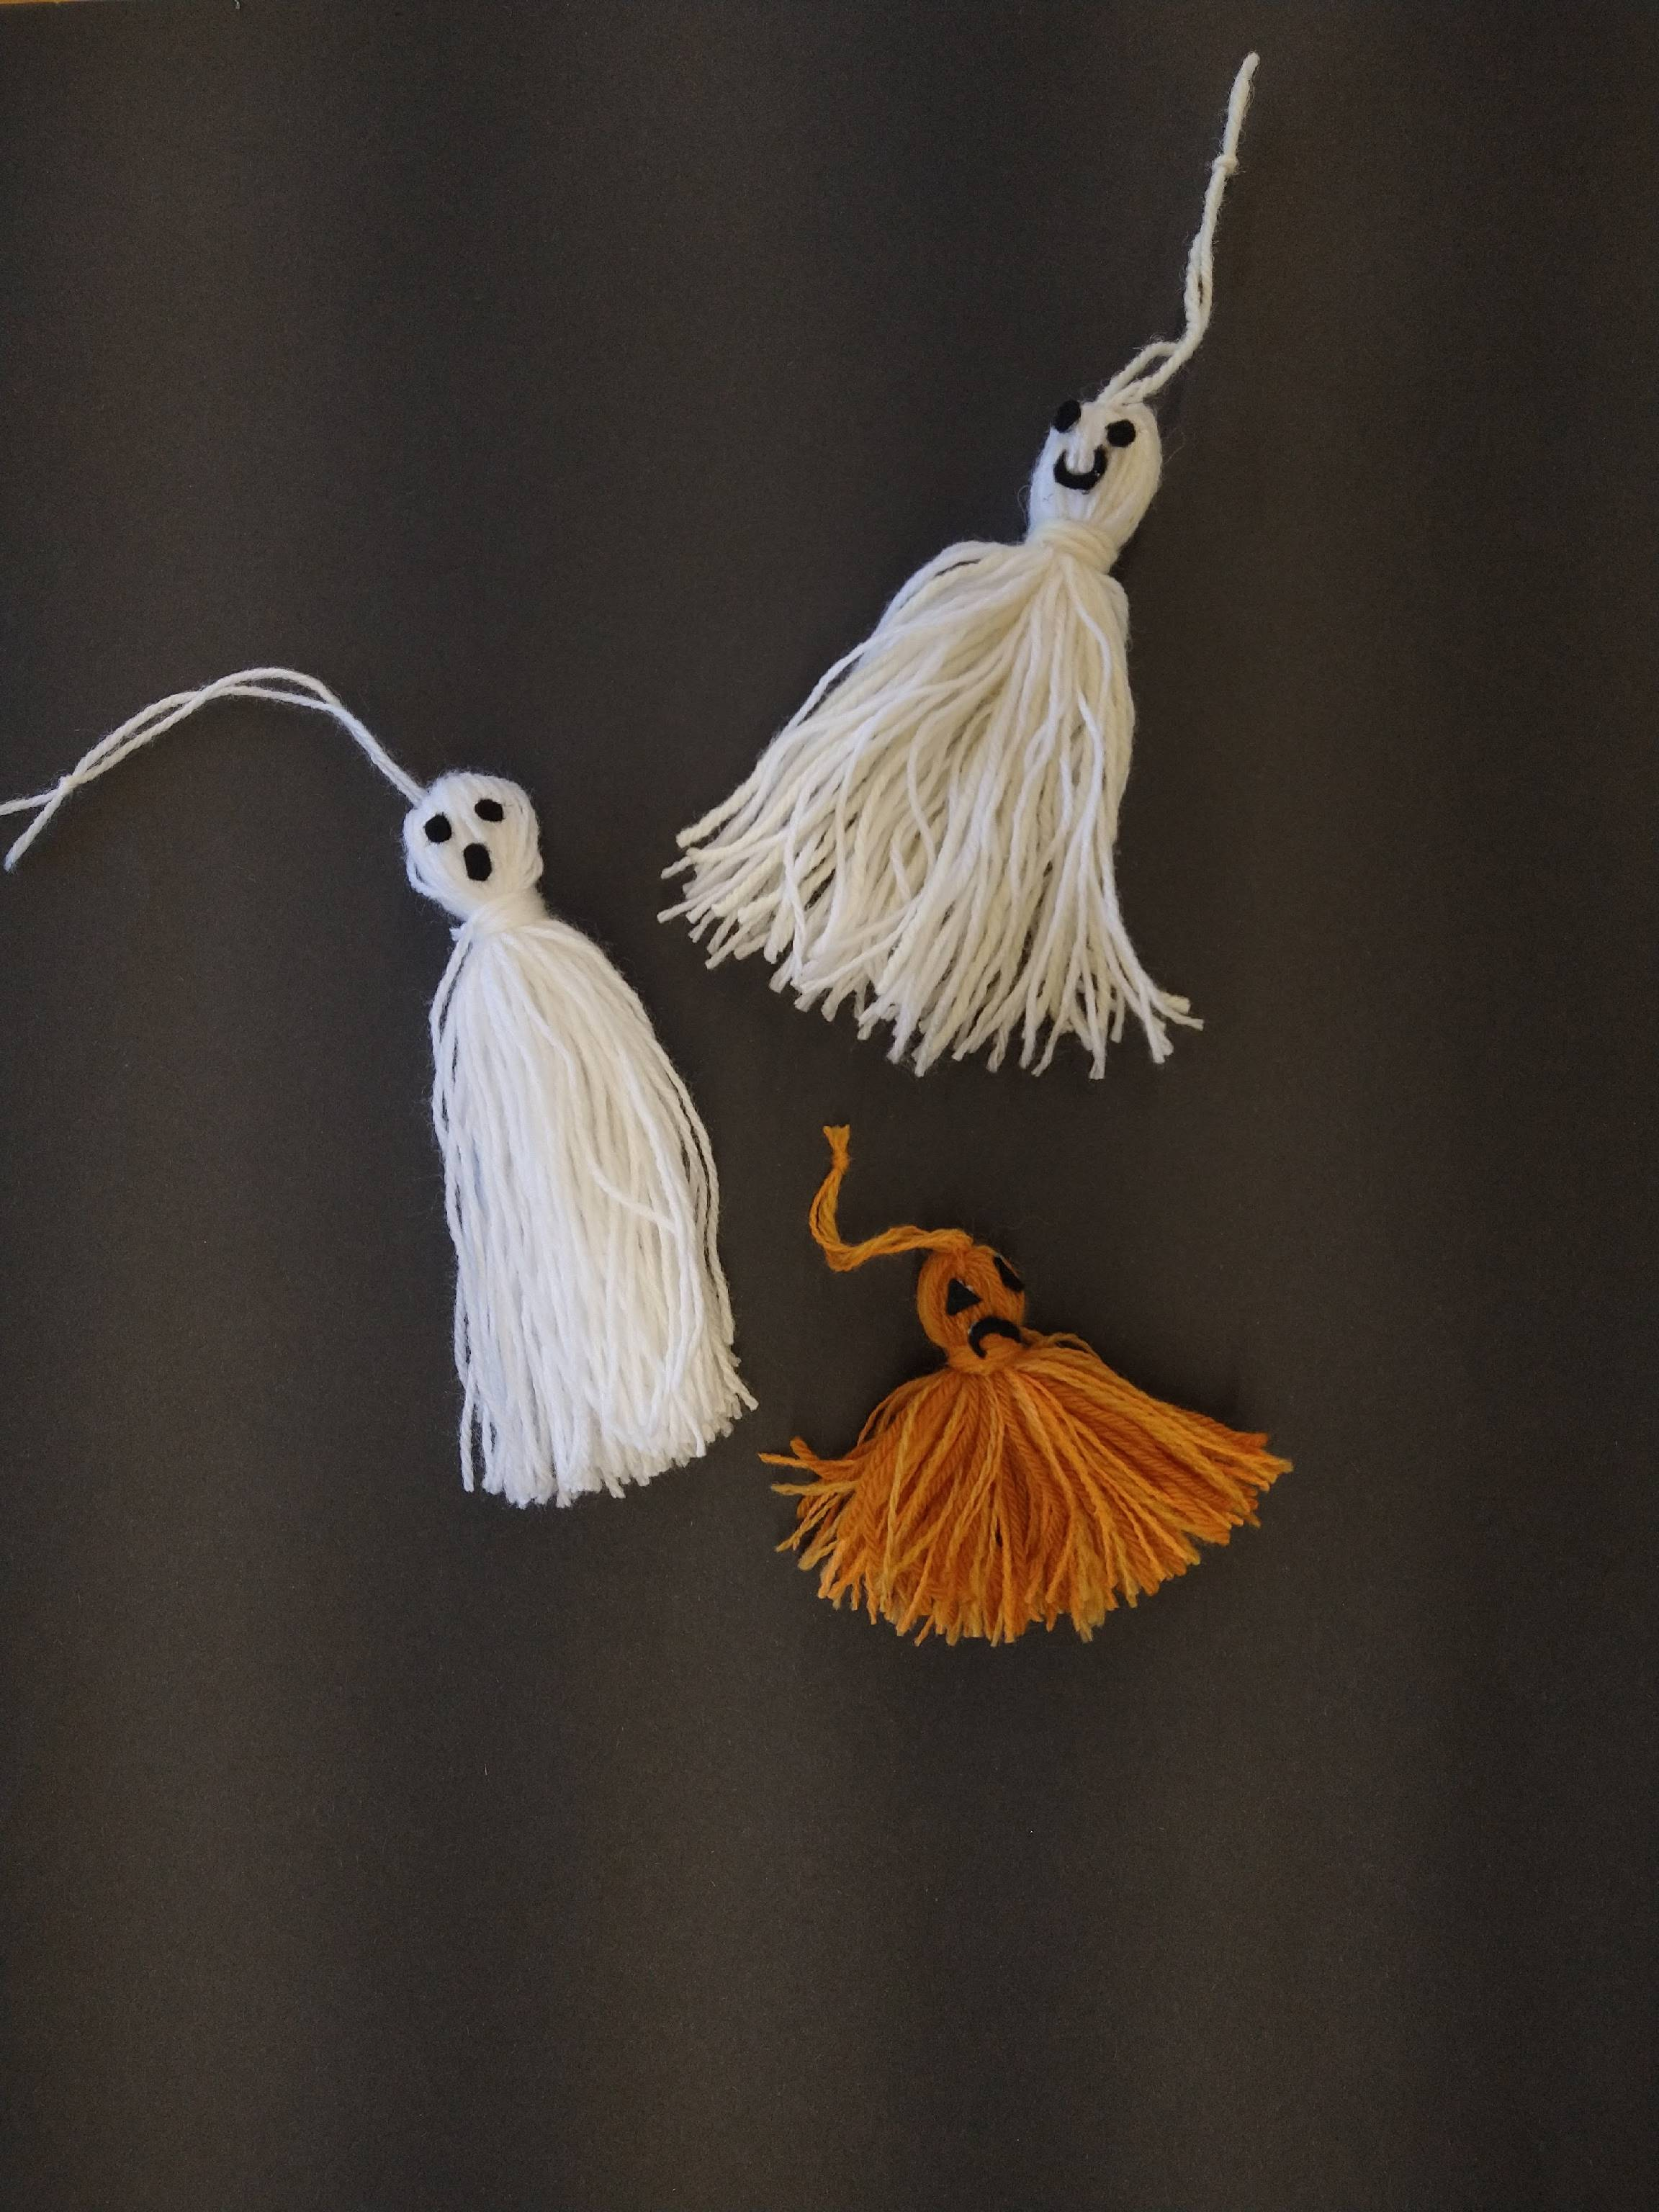
Do you remember a while back we shared a post showing how to make tassels? We thought we'd re-visit that idea to make some terrifying Halloween decorations!
You will need:
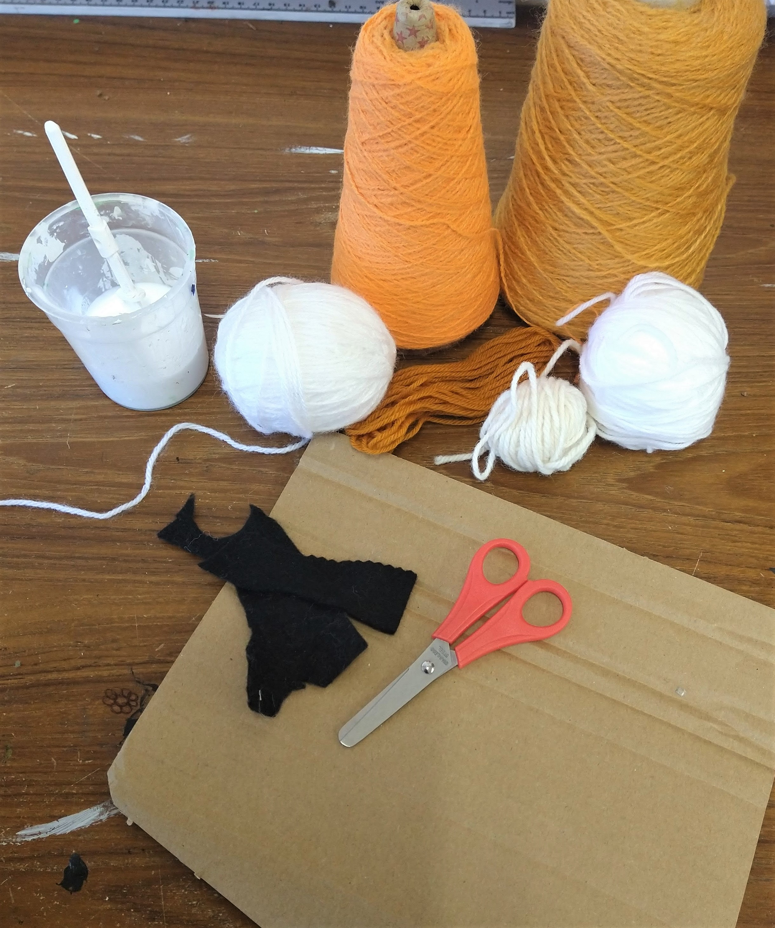
- Yarn (white for ghosts, orange for pumpkins)
- A piece of cardboard (ours was about 17 x 7 cm for the ghost and 9 x 7 cm for the pumpkin)
- Scissors
- Felt scraps
- Glue (PVA or fabric glue is best)
- Yarn or thick thread
Step 1.
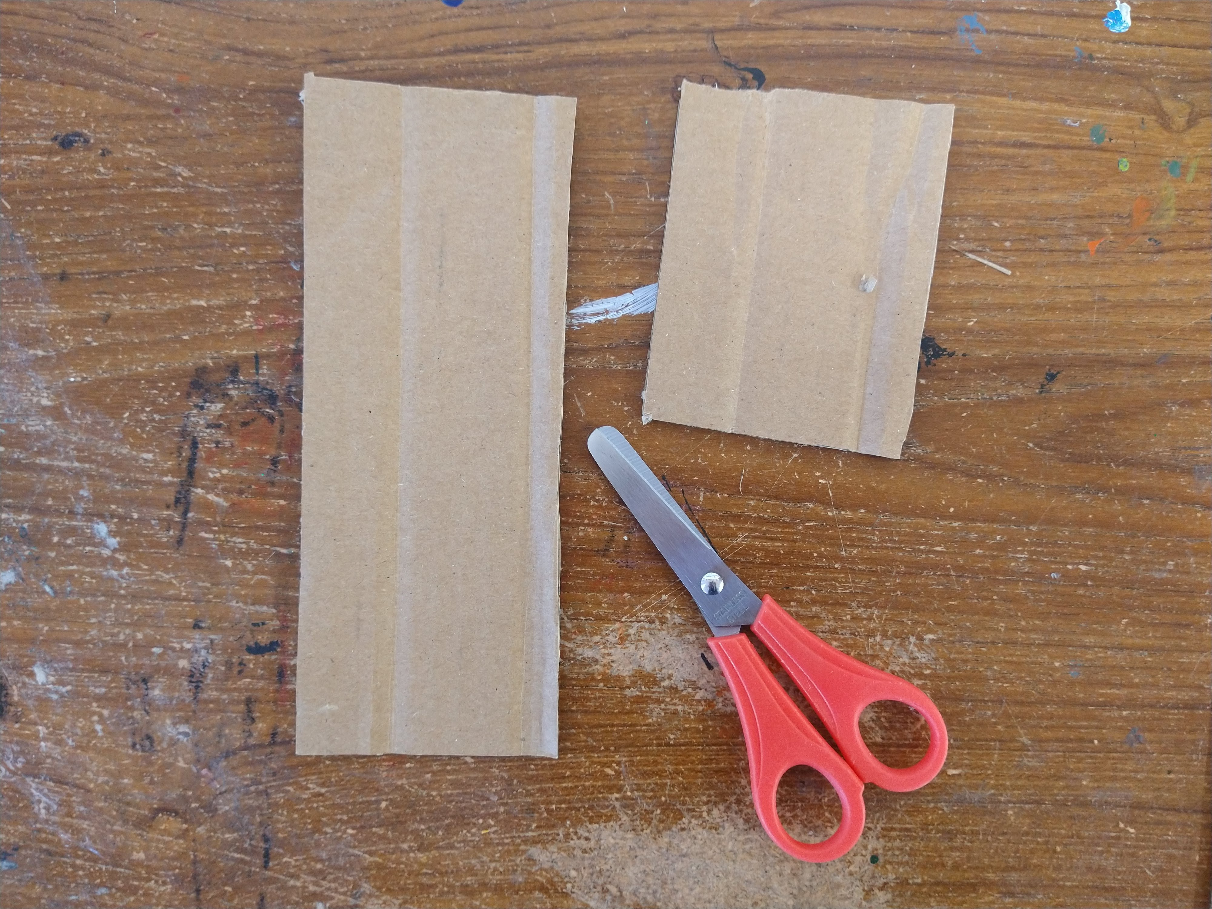
Cut your cardboard to size, the length of your piece of cardboard determines the length of the tassel.
Step 2.
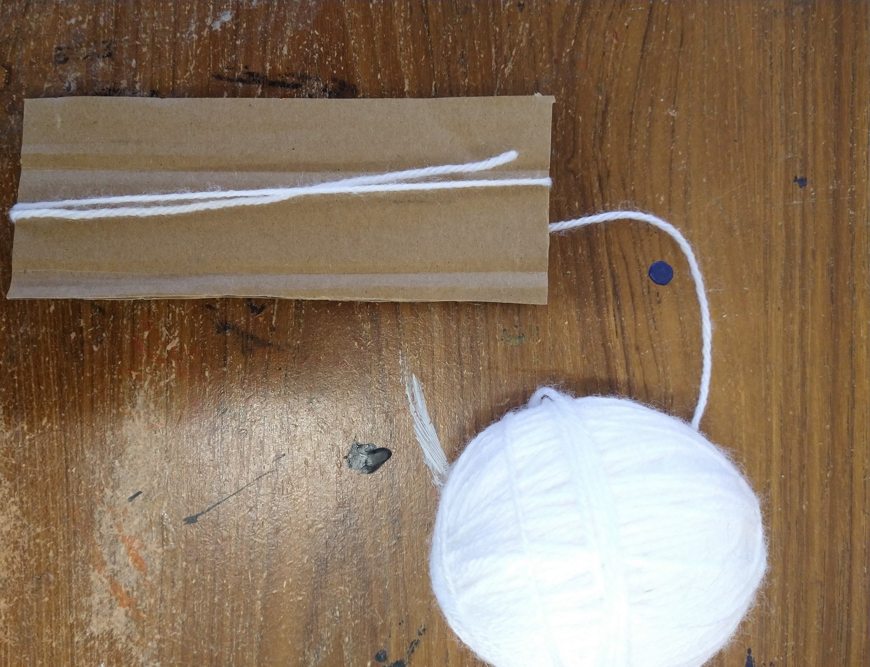
Begin wrapping your yarn around your cardboard.
Step 3.
Keep wrapping! The more wraps you have the thicker your tassel will be.
Step 4.
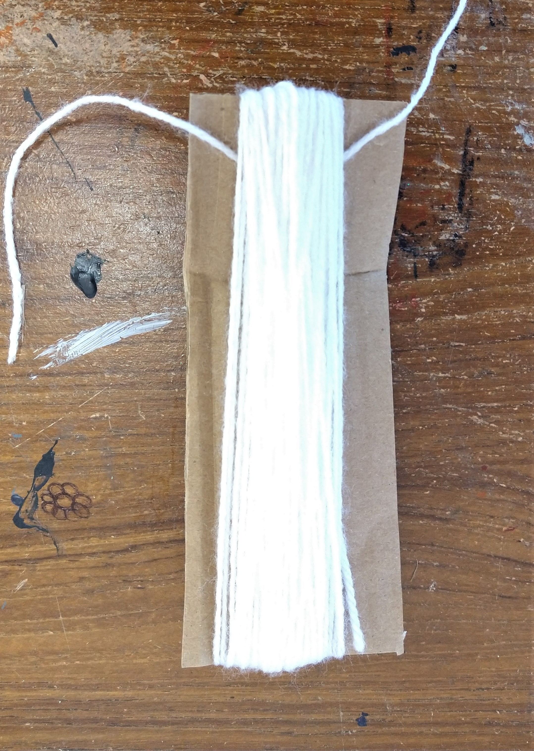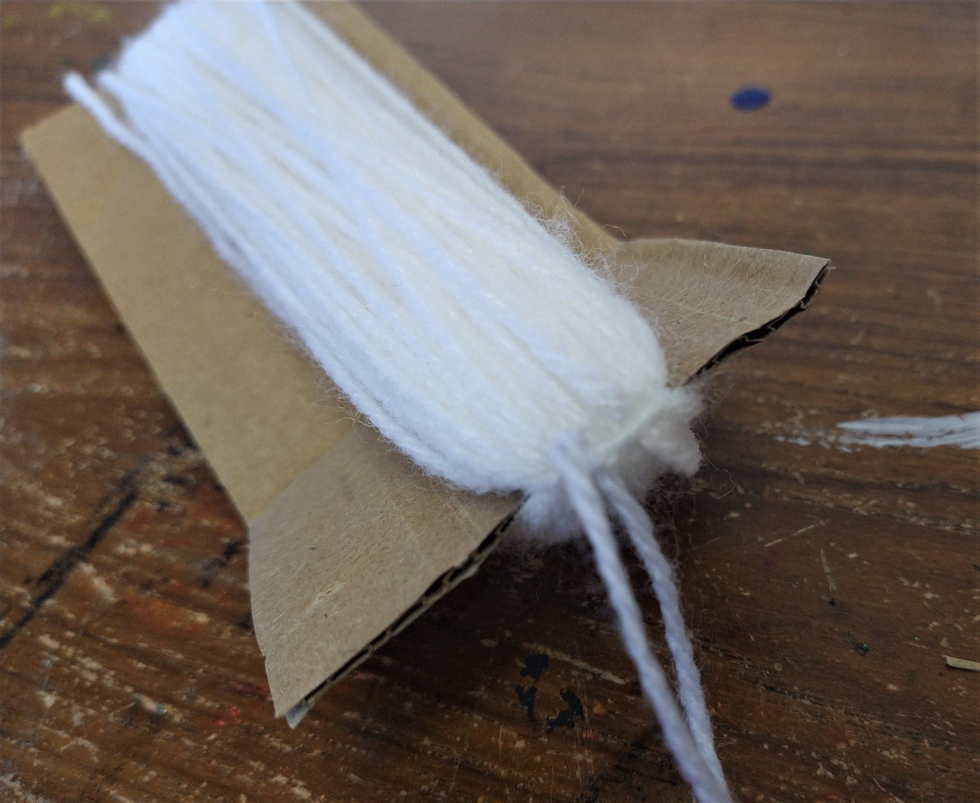
Cut a piece of yarn or thread and slide it under one half of the wraps. Tie the wraps tightly together at one end. Leave the ends of the yarn you've used to tie it up to hang the tassel up with
Step 5.
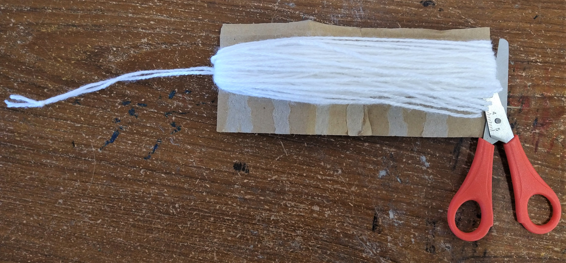
Cut the wraps at the opposite end of the cardboard.
Step 6.
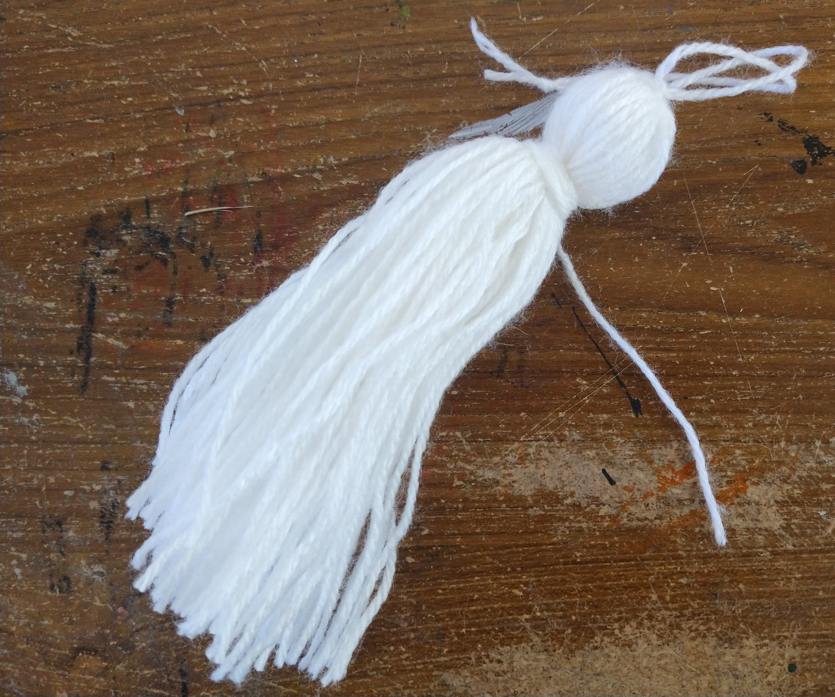
Cut another piece of yarn and use it wrap a section of the tassel about 3 cm from the top to make a head.
Step 7.
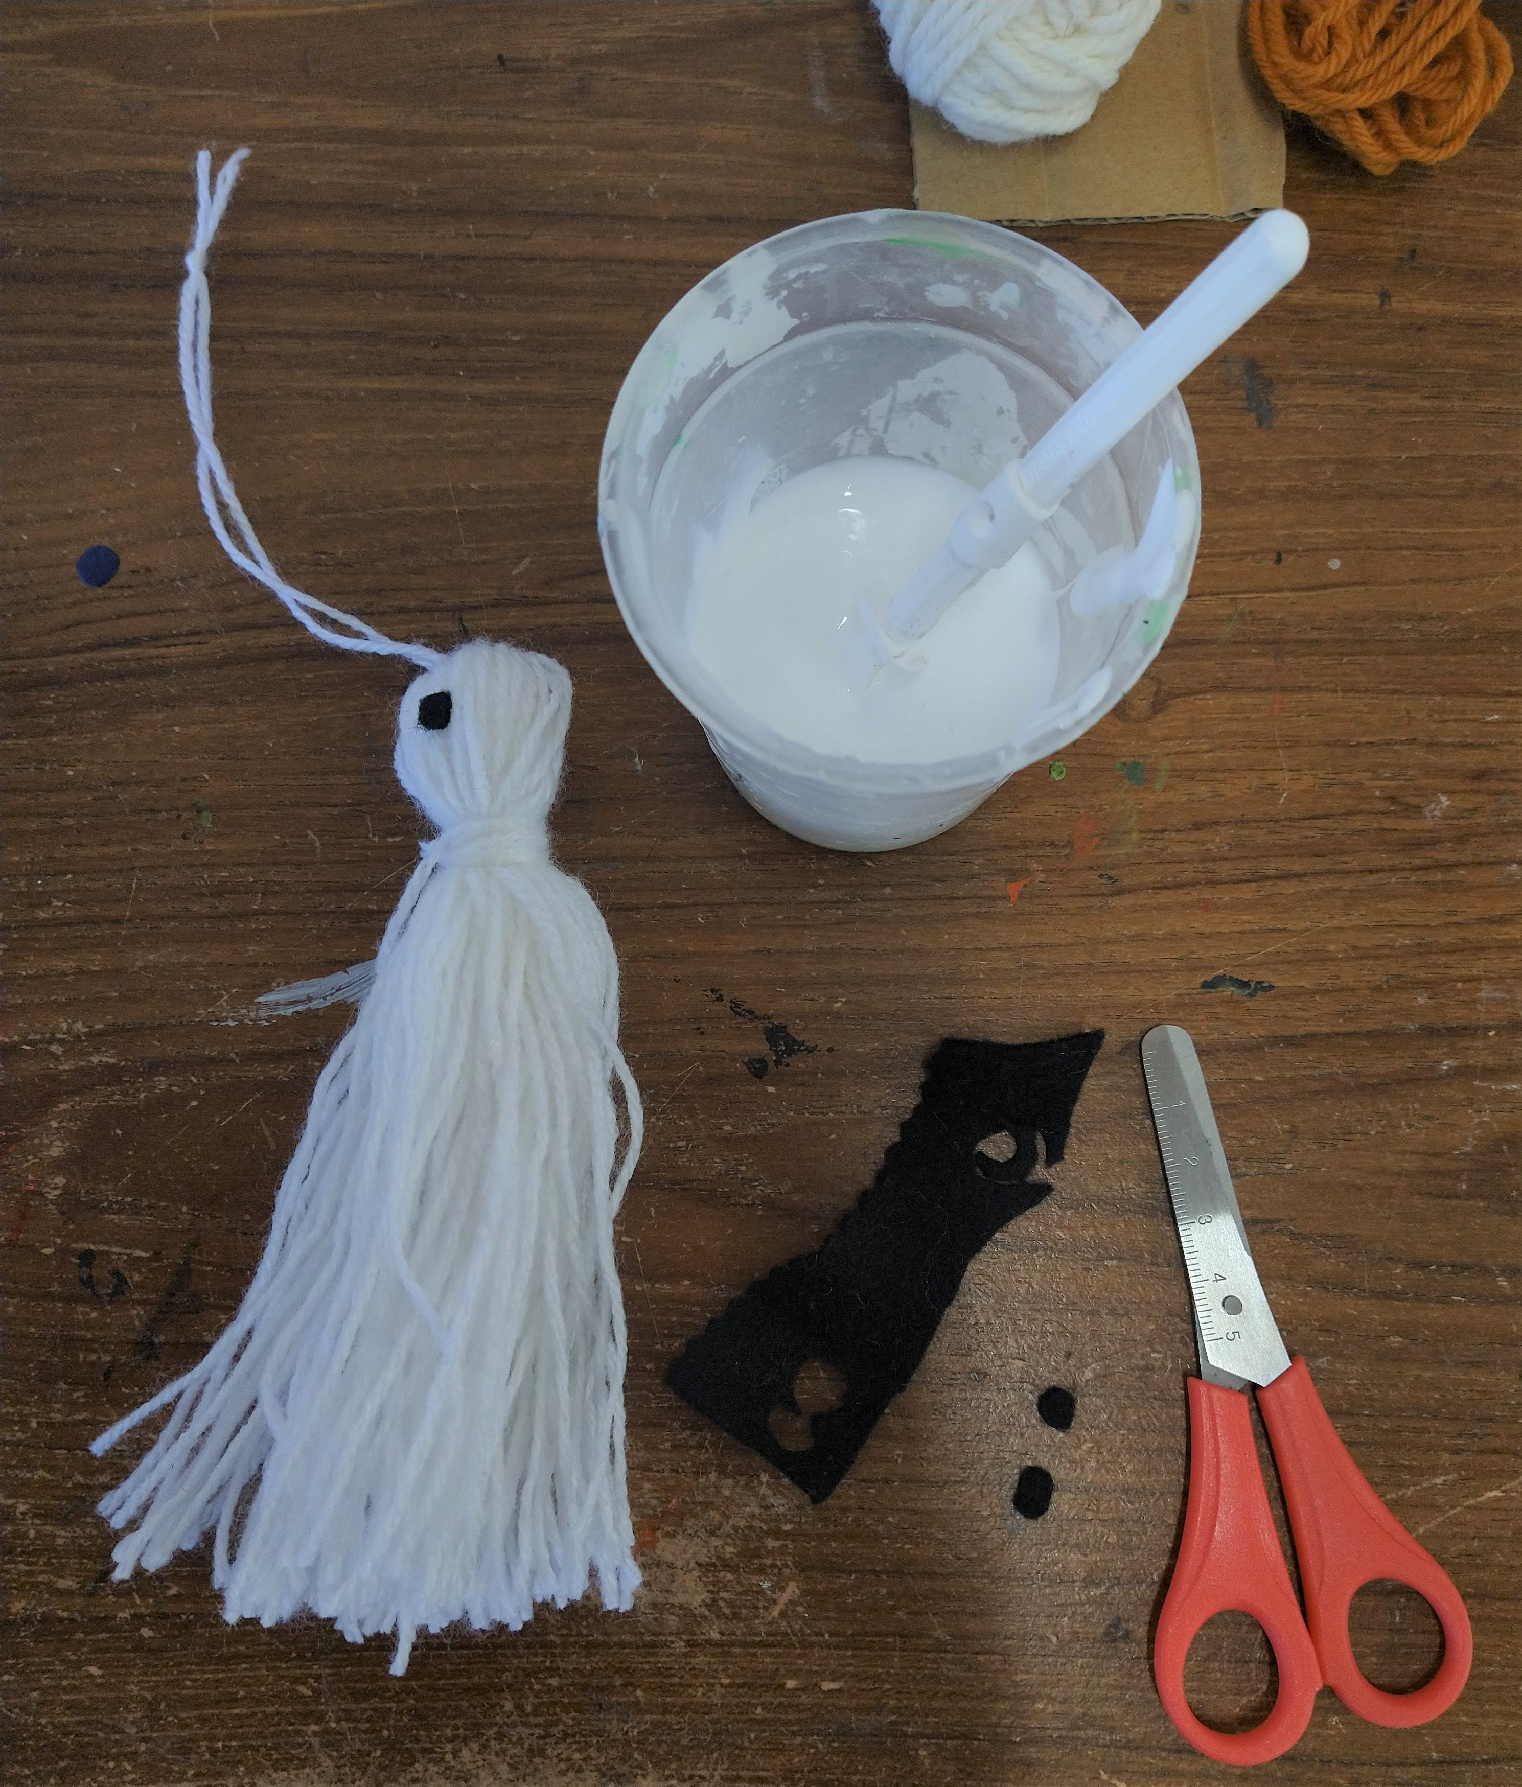
Cut eyes and a mouth from the felt and stick them onto the 'head' to make a face.
Step 8.
Hang up your spooky creations and enjoy!

